# Race: AQU | 2025-04-26 | Race #1 | Post: 19:10 | Track: AQUEDUCT

Track: AQUEDUCT

|  |  |  |  |  |  |
| --- | --- | --- | --- | --- | --- |
| Program # | Horse Name | Morn Odds | GCSF | Model Score | Win Prob (%) |
| 1 | Costa Terra | 7-5 | 1.0 | 2.39 | 20.87 |
| 1A | Alternate Reality | 7-5 | 5.0 | 1.69 | 12.89 |
| 2 | Magnificent Mile | 6-1 | 6.0 | 1.32 | 10.04 |
| 3 | Smile Mon | 9-2 | 4.0 | 1.79 | 13.87 |
| 4 | Just Call Ray | 8-1 | 7.0 | 0.91 | 7.58 |
| 5 | Tabeguache | 4-1 | 2.0 | 2.34 | 20.19 |
| 6 | Power Seeker | 7-2 | 3.0 | 1.86 | 14.55 |

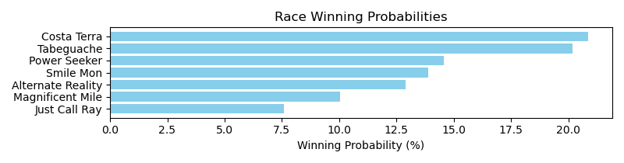

Exacta advice: box [1,5,6] (6 tickets)

NOTE: GCSF - Global Combined Speed Figure

# Race: AQU | 2025-04-26 | Race #2 | Post: 19:42 | Track: AQUEDUCT

Track: AQUEDUCT

|  |  |  |  |  |  |
| --- | --- | --- | --- | --- | --- |
| Program # | Horse Name | Morn Odds | GCSF | Model Score | Win Prob (%) |
| 1 | Pop Coyer | 12-1 | 5.0 | 1.36 | 14.19 |
| 2 | Brew Pub | 6-1 | 4.0 | 1.41 | 14.66 |
| 3 | Amundson | 9-5 | 2.0 | 1.68 | 17.65 |
| 4 | Montebello | 5-2 | 3.0 | 1.66 | 17.49 |
| 5 | Forward Move | 3-1 | 1.0 | 1.88 | 20.27 |
| 6 | dh-Horse Be With You | 8-1 | 6.0 | 1.12 | 12.04 |
| 7 | Boss Three O Two | 20-1 | 7.0 | -0.60 | 3.69 |

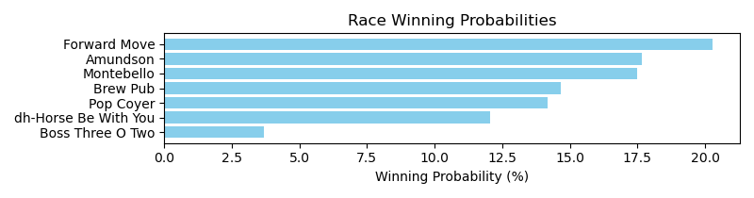

Exacta advice: key 5 → [3,4] (2 tickets)

NOTE: GCSF - Global Combined Speed Figure

# Race: AQU | 2025-04-26 | Race #3 | Post: 20:16 | Track: AQUEDUCT

Track: AQUEDUCT

|  |  |  |  |  |  |
| --- | --- | --- | --- | --- | --- |
| Program # | Horse Name | Morn Odds | GCSF | Model Score | Win Prob (%) |
| 1 | McDiesel | 12-1 | 6.0 | 0.10 | 7.45 |
| 2 | Executive Order | 9-5 | 2.0 | 1.53 | 20.03 |
| 3 | Just Clarity | 6-1 | 5.0 | 0.28 | 8.45 |
| 4 | Good Question | 12-1 | 3.0 | 0.97 | 13.61 |
| 5 | Shoot the Nickel | 5-2 | 1.0 | 2.19 | 31.37 |
| 6 | Tapwrits Temper | 8-1 | 7.0 | -0.19 | 6.11 |
| 7 | Enduring Spirit | 7-2 | 4.0 | 0.90 | 12.98 |

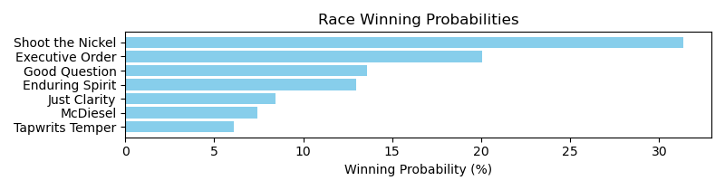

Exacta advice: key 5 → 2 (1 ticket)

NOTE: GCSF - Global Combined Speed Figure

# Race: AQU | 2025-04-26 | Race #4 | Post: 20:48 | Track: AQUEDUCT

Track: AQUEDUCT

|  |  |  |  |  |  |
| --- | --- | --- | --- | --- | --- |
| Program # | Horse Name | Morn Odds | GCSF | Model Score | Win Prob (%) |
| 1 | Ice Time | 15-1 | 7.0 | 0.25 | 5.41 |
| 1A | Big Rich | 15-1 | 9.0 | -0.53 | 3.17 |
| 2 | Active Duty | 9-2 | 4.0 | 1.15 | 10.00 |
| 3 | Indianquest | 30-1 | 10.0 | -0.58 | 3.05 |
| 4 | Prove Worthy | 5-2 | 2.0 | 2.10 | 19.33 |
| 5 | Portos | 5-1 | 1.0 | 2.49 | 25.25 |
| 6 | Bold Victory | 9-2 | 3.0 | 1.24 | 10.69 |
| 7 | Blame It On Daddy | 7-2 | 5.0 | 1.05 | 9.37 |
| 8 | Provision | 10-1 | 6.0 | 0.90 | 8.44 |
| 9 | First Trumpet | 20-1 | 8.0 | 0.22 | 5.30 |

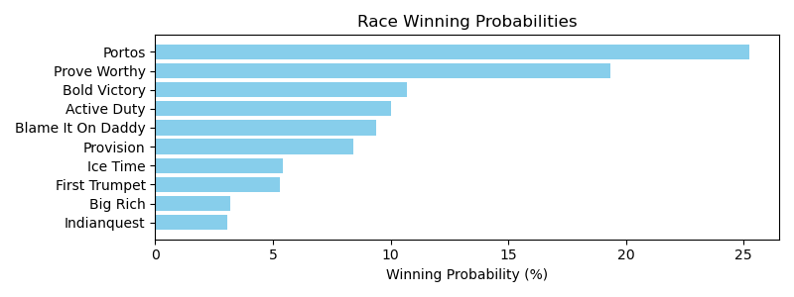

Exacta advice: key 5 → 4 (1 ticket)

NOTE: GCSF - Global Combined Speed Figure

# Race: AQU | 2025-04-26 | Race #5 | Post: 21:19 | Track: AQUEDUCT

Track: AQUEDUCT

|  |  |  |  |  |  |
| --- | --- | --- | --- | --- | --- |
| Program # | Horse Name | Morn Odds | GCSF | Model Score | Win Prob (%) |
| 1 | The Splendid One | 20-1 | 4.0 | 1.36 | 9.64 |
| 2 | Sabby Sunset | 6-1 | 8.0 | 1.12 | 8.18 |
| 3 | Eleni | 8-1 | 3.0 | 1.91 | 14.01 |
| 4 | Margaux Treasure | 7-2 | 1.0 | 2.05 | 15.43 |
| 5 | Syl's Pleasure | 8-1 | 2.0 | 2.02 | 15.14 |
| 6 | Going for Glory | 6-1 | 6.0 | 1.18 | 8.52 |
| 7 | TEMPER'S TA'DA | 9-2 | 10.0 | 0.65 | 5.91 |
| 8 | Khali's Storm | 10-1 | 7.0 | 1.18 | 8.48 |
| 9 | Moontown | 9-2 | 9.0 | 0.68 | 6.03 |
| 10 | Fifi La Fume | 20-1 | 5.0 | 1.21 | 8.67 |

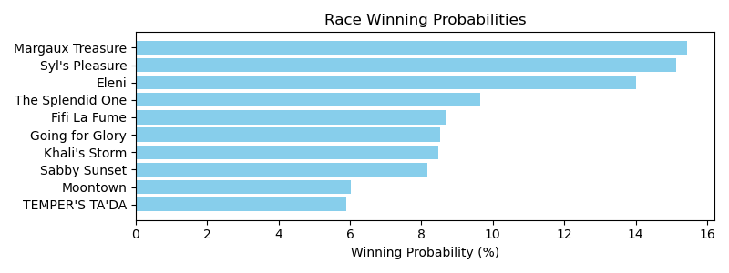

Exacta advice: box [4,5,3] (6 tickets)

NOTE: GCSF - Global Combined Speed Figure

# Race: AQU | 2025-04-26 | Race #6 | Post: 21:50 | Track: AQUEDUCT

Track: AQUEDUCT

|  |  |  |  |  |  |
| --- | --- | --- | --- | --- | --- |
| Program # | Horse Name | Morn Odds | GCSF | Model Score | Win Prob (%) |
| 1 | Septarian | 3-1 | 4.0 | 1.71 | 14.32 |
| 2 | End of Romance (IRE) | 5-1 | 3.0 | 1.89 | 16.16 |
| 3 | Dream On | 4-1 | 5.0 | 1.71 | 14.31 |
| 4 | Revolutionnaire (FR) | 5-1 | 1.0 | 2.28 | 21.26 |
| 5 | Cairo Caper | 6-1 | 7.0 | 0.40 | 5.80 |
| 6 | Tiz Dashing | 4-1 | 6.0 | 1.08 | 9.30 |
| 7 | Sounds Like a Plan | 6-1 | 2.0 | 2.11 | 18.85 |

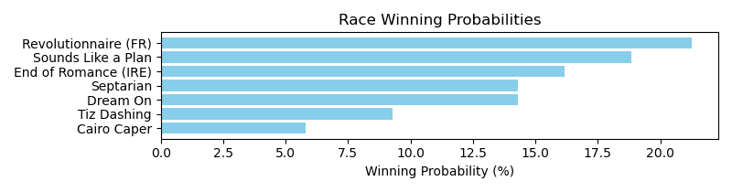

Exacta advice: key 4 → 7 (1 ticket)

NOTE: GCSF - Global Combined Speed Figure

# Race: AQU | 2025-04-26 | Race #7 | Post: 22:22 | Track: AQUEDUCT

Track: AQUEDUCT

|  |  |  |  |  |  |
| --- | --- | --- | --- | --- | --- |
| Program # | Horse Name | Morn Odds | GCSF | Model Score | Win Prob (%) |
| 1 | Long Legged Queen | 2-1 | 1.0 | 3.21 | 21.88 |
| 2 | Night Jasmine | 10-1 | 14.0 | 0.20 | 2.76 |
| 3 | JUST ADD WATER | 4-1 | 8.0 | 0.94 | 4.60 |
| 4 | Bank On Bebe | 30-1 | 12.0 | 0.39 | 3.14 |
| 5 | LACKADAISICAL | 8-1 | 13.0 | 0.30 | 2.95 |
| 6 | LUCY PLAYA | 20-1 | 16.0 | -0.42 | 1.80 |
| 7 | Vino Samara | 15-1 | 6.0 | 1.36 | 6.12 |
| 8 | Inflammabelle | 20-1 | 11.0 | 0.84 | 4.29 |
| 9 | WIDDERSHINS | 30-1 | 15.0 | -0.19 | 2.10 |
| 10 | Moonlight Ready | 10-1 | 9.0 | 0.92 | 4.54 |
| 11 | St. Addie | 12-1 | 10.0 | 0.86 | 4.33 |
| 12 | Will of a Womanne | 6-1 | 4.0 | 1.64 | 7.44 |
| 13 | I'm Kidding | 8-1 | 5.0 | 1.45 | 6.50 |
| 14 | Work Away | 6-1 | 3.0 | 1.83 | 8.46 |
| 15 | KAY CUP | 9-5 | 7.0 | 1.27 | 5.76 |
| 16 | Three Nines Fine | 12-1 | 2.0 | 2.49 | 13.33 |

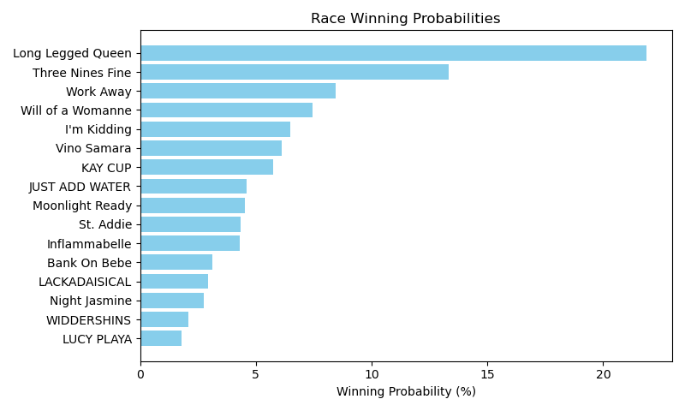

Exacta advice: key 1 → 16 (1 ticket)

NOTE: GCSF - Global Combined Speed Figure

# Race: AQU | 2025-04-26 | Race #8 | Post: 22:54 | Track: AQUEDUCT

Track: AQUEDUCT

|  |  |  |  |  |  |
| --- | --- | --- | --- | --- | --- |
| Program # | Horse Name | Morn Odds | GCSF | Model Score | Win Prob (%) |
| 1 | Charge Nurse | 15-1 | 9.0 | -0.16 | 4.29 |
| 2 | Grace Reformed | 5-2 | 4.0 | 1.09 | 10.16 |
| 3 | Top of the Table | 8-1 | 5.0 | 1.01 | 9.63 |
| 4 | Lady Arwen | 10-1 | 6.0 | 0.84 | 8.57 |
| 5 | Mitole's Girl | 12-1 | 1.0 | 2.29 | 23.30 |
| 6 | Embraceable Gal | 4-1 | 3.0 | 1.40 | 12.55 |
| 7 | Carol T | 8-1 | 7.0 | 0.27 | 5.80 |
| 8 | Follow Your Arrow | 10-1 | 10.0 | -0.36 | 3.74 |
| 9 | Chasing Daylight | 12-1 | 8.0 | 0.18 | 5.44 |
| 10 | Splashy | 5-1 | 2.0 | 1.79 | 16.51 |

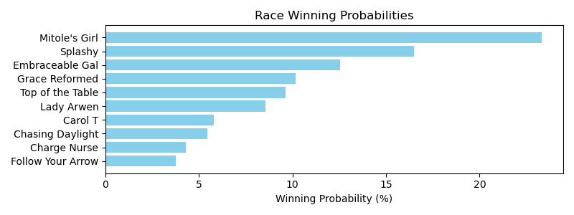

Exacta advice: key 5 → 10 (1 ticket)

NOTE: GCSF - Global Combined Speed Figure

# Race: AQU | 2025-04-26 | Race #9 | Post: 23:26 | Track: AQUEDUCT

Track: AQUEDUCT

|  |  |  |  |  |  |
| --- | --- | --- | --- | --- | --- |
| Program # | Horse Name | Morn Odds | GCSF | Model Score | Win Prob (%) |
| 1 | Bobby M's Girl | 6-1 | 5.0 | 0.91 | 5.65 |
| 2 | Lady Wisdom | 15-1 | 10.0 | -0.00 | 3.00 |
| 3 | Cara's Dreamweaver | 30-1 | 14.0 | -0.48 | 2.16 |
| 4 | Tongue Twister | 9-2 | 3.0 | 1.72 | 9.81 |
| 5 | Lucky and Gorgeous | 50-1 | 13.0 | -0.47 | 2.17 |
| 6 | Bertrille | 15-1 | 12.0 | -0.43 | 2.25 |
| 7 | Power and Glory | 30-1 | 15.0 | -0.51 | 2.12 |
| 8 | Walk With Me | 15-1 | 7.0 | 0.72 | 4.96 |
| 9 | Summer Whirl | 7-2 | 4.0 | 1.51 | 8.54 |
| 10 | Last Glory | 30-1 | 9.0 | 0.08 | 3.18 |
| 11 | Firsttimeinforever | 5-2 | 2.0 | 1.91 | 11.23 |
| 12 | Spool | 6-1 | 1.0 | 3.38 | 30.77 |
| 13 | Galley Head | 12-1 | 8.0 | 0.47 | 4.16 |
| 14 | Red Burgundy | 6-1 | 6.0 | 0.89 | 5.55 |
| 15 | Higher Force | 20-1 | 11.0 | -0.18 | 2.66 |
| 16 | Lookin to Rock | 50-1 | 16.0 | -0.77 | 1.78 |

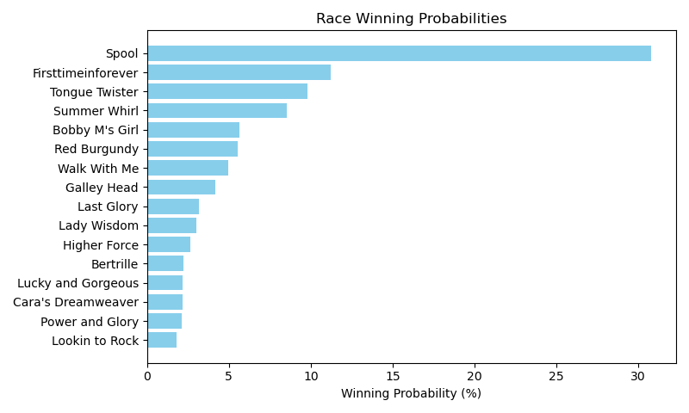

Exacta advice: key 12 → 11 (1 ticket)

NOTE: GCSF - Global Combined Speed Figure

# Race: AQU | 2025-04-26 | Race #10 | Post: 23:56 | Track: AQUEDUCT

Track: AQUEDUCT

|  |  |  |  |  |  |
| --- | --- | --- | --- | --- | --- |
| Program # | Horse Name | Morn Odds | GCSF | Model Score | Win Prob (%) |
| 1 | Barnstorming | 6-1 | 3.0 | 1.59 | 10.16 |
| 2 | Scat Tu Tap | 8-1 | 8.0 | 0.73 | 5.61 |
| 3 | Mr Flowers | 5-1 | 1.0 | 2.15 | 14.95 |
| 4 | Because the Night | 50-1 | 11.0 | 0.53 | 4.90 |
| 5 | Miztertonic | 4-1 | 6.0 | 0.94 | 6.53 |
| 6 | Leftembehind | 10-1 | 13.0 | 0.41 | 4.51 |
| 7 | Omey Island | 15-1 | 7.0 | 0.86 | 6.17 |
| 8 | Neon Bordeaux | 12-1 | 12.0 | 0.41 | 4.53 |
| 9 | King Moonracer | 30-1 | 14.0 | 0.10 | 3.64 |
| 10 | Nostalgic One | 7-2 | 4.0 | 0.96 | 6.59 |
| 11 | Your Mission | 20-1 | 9.0 | 0.72 | 5.61 |
| 12 | Toscano | 8-1 | 5.0 | 0.96 | 6.59 |
| 13 | Outtawaterbury | 10-1 | 10.0 | 0.68 | 5.44 |
| 14 | Brigade Commander | 9-2 | 2.0 | 1.72 | 11.16 |
| 15 | Broderick | 30-1 | 15.0 | 0.09 | 3.63 |

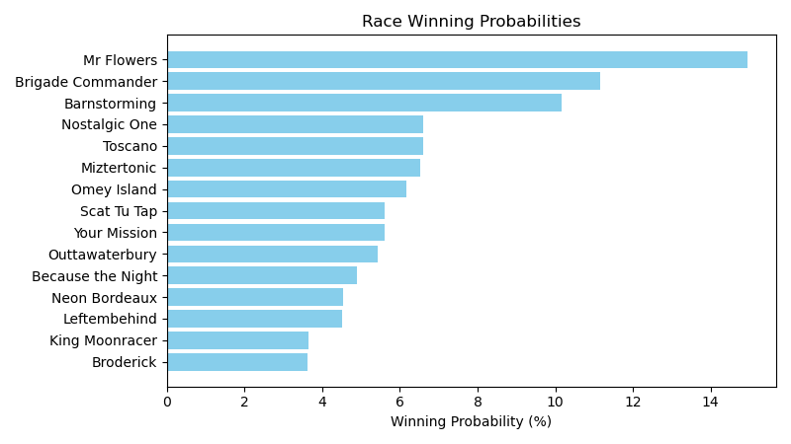

Exacta advice: key 3 → 14 (1 ticket)

NOTE: GCSF - Global Combined Speed Figure

# Race: AQU | 2025-04-27 | Race #1 | Post: 19:10 | Track: AQUEDUCT

Track: AQUEDUCT

|  |  |  |  |  |  |
| --- | --- | --- | --- | --- | --- |
| Program # | Horse Name | Morn Odds | GCSF | Model Score | Win Prob (%) |
| 1 | Lord Captain | 6-1 | 4.0 | 0.98 | 13.55 |
| 2 | O P Firecracker | 13-8 | 1.0 | 1.96 | 26.64 |
| 3 | Centavo | 4-1 | 5.0 | 0.89 | 12.74 |
| 4 | Commandperformance | 5-1 | 3.0 | 1.00 | 13.81 |
| 5 | Khafre | 3-1 | 2.0 | 1.18 | 15.64 |
| 6 | Retail Man | 12-1 | 6.0 | 0.64 | 10.72 |
| 7 | Allaboutthemoney | 20-1 | 7.0 | -0.00 | 6.91 |

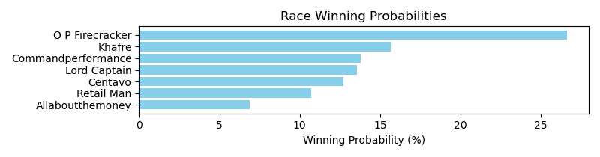

Exacta advice: key 2 → 5 (1 ticket)

NOTE: GCSF - Global Combined Speed Figure

# Race: AQU | 2025-04-27 | Race #2 | Post: 19:42 | Track: AQUEDUCT

Track: AQUEDUCT

|  |  |  |  |  |  |
| --- | --- | --- | --- | --- | --- |
| Program # | Horse Name | Morn Odds | GCSF | Model Score | Win Prob (%) |
| 1 | Army Gal | 5-2 | 6.0 | 0.76 | 9.22 |
| 2 | Fortuna Mia | 9-2 | 4.0 | 1.06 | 11.36 |
| 3 | Twirling Beauty | 5-1 | 2.0 | 2.03 | 22.16 |
| 4 | Allenhurst | 20-1 | 3.0 | 1.09 | 11.56 |
| 5 | Briland | 7-5 | 1.0 | 2.73 | 35.81 |
| 6 | Nilo's Rose | 5-1 | 5.0 | 0.86 | 9.90 |

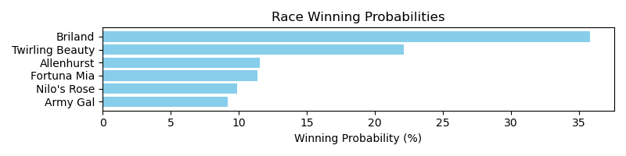

Exacta advice: key 5 → 3 (1 ticket)

NOTE: GCSF - Global Combined Speed Figure

# Race: AQU | 2025-04-27 | Race #3 | Post: 20:16 | Track: AQUEDUCT

Track: AQUEDUCT

|  |  |  |  |  |  |
| --- | --- | --- | --- | --- | --- |
| Program # | Horse Name | Morn Odds | GCSF | Model Score | Win Prob (%) |
| 1 | Messi the Magician | 20-1 | 7.0 | 0.05 | 4.55 |
| 2 | Waralo | 4-1 | 2.0 | 2.15 | 19.17 |
| 3 | On the Hill | 6-1 | 4.0 | 1.51 | 12.41 |
| 4 | Runandscore | 2-1 | 5.0 | 1.08 | 9.21 |
| 5 | Schlomo | 5-2 | 1.0 | 3.08 | 36.56 |
| 6 | Stewie | 4-1 | 3.0 | 1.58 | 12.98 |
| 7 | Thank You Jon | 15-1 | 6.0 | 0.23 | 5.13 |

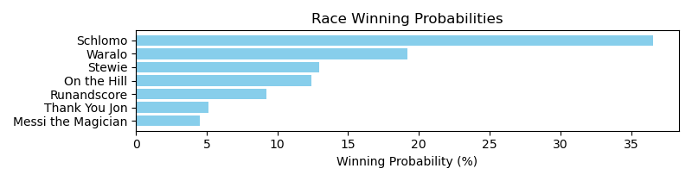

Exacta advice: key 5 → 2 (1 ticket)

NOTE: GCSF - Global Combined Speed Figure

# Race: AQU | 2025-04-27 | Race #4 | Post: 20:48 | Track: AQUEDUCT

Track: AQUEDUCT

|  |  |  |  |  |  |
| --- | --- | --- | --- | --- | --- |
| Program # | Horse Name | Morn Odds | GCSF | Model Score | Win Prob (%) |
| 1 | I'm Solo N in Love | 15-1 | 10.0 | -0.62 | 3.09 |
| 1A | Solo Empire | 15-1 | 9.0 | -0.32 | 3.79 |
| 2 | New York Panther | 20-1 | 7.0 | 0.51 | 6.69 |
| 3 | The Paddock Pastor | 5-1 | 4.0 | 1.34 | 11.90 |
| 4 | Courtly Banker | 6-1 | 3.0 | 1.36 | 12.03 |
| 5 | Smooth Breeze | 5-2 | 1.0 | 1.97 | 18.39 |
| 6 | Royal Browne | 5-1 | 5.0 | 1.26 | 11.25 |
| 7 | Willintoriskitall | 10-1 | 8.0 | 0.35 | 6.02 |
| 8 | Wait for Me | 8-1 | 2.0 | 1.84 | 16.70 |
| 9 | Pay the Juice | 4-1 | 6.0 | 1.11 | 10.14 |

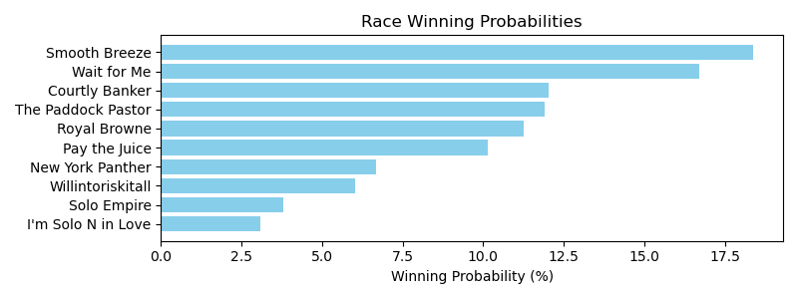

Exacta advice: key 5 → 8 (1 ticket)

NOTE: GCSF - Global Combined Speed Figure

# Race: AQU | 2025-04-27 | Race #5 | Post: 21:19 | Track: AQUEDUCT

Track: AQUEDUCT

|  |  |  |  |  |  |
| --- | --- | --- | --- | --- | --- |
| Program # | Horse Name | Morn Odds | GCSF | Model Score | Win Prob (%) |
| 1 | FLOY JOY | 15-1 | 13.0 | 0.30 | 2.92 |
| 2 | Perugia | 5-2 | 2.0 | 2.64 | 14.64 |
| 3 | Purest Performance | 30-1 | 9.0 | 0.89 | 4.39 |
| 4 | Wild Mischief | 4-1 | 1.0 | 2.73 | 15.50 |
| 5 | Mega Changer | 15-1 | 12.0 | 0.30 | 2.92 |
| 6 | Sunshine Lily | 12-1 | 3.0 | 2.15 | 10.45 |
| 7 | Mommy's Turn | 5-1 | 8.0 | 1.02 | 4.79 |
| 8 | Miss Uproar | 20-1 | 7.0 | 1.53 | 6.81 |
| 9 | Lady Delilah | 15-1 | 5.0 | 1.73 | 7.82 |
| 10 | Julita | 8-1 | 4.0 | 2.05 | 9.70 |
| 11 | Inamorata | 10-1 | 10.0 | 0.79 | 4.10 |
| 12 | BODEGAS | 12-1 | 14.0 | 0.15 | 2.63 |
| 13 | Broken Zipper | 30-1 | 15.0 | -0.16 | 2.12 |
| 14 | Je T'adore | 30-1 | 11.0 | 0.61 | 3.61 |
| 15 | Lollipops | 7-2 | 6.0 | 1.69 | 7.59 |

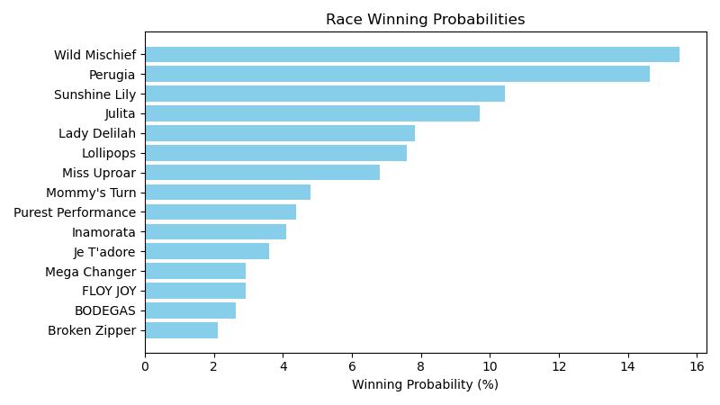

Exacta advice: box [4,2,6] (6 tickets)

NOTE: GCSF - Global Combined Speed Figure

# Race: AQU | 2025-04-27 | Race #6 | Post: 21:50 | Track: AQUEDUCT

Track: AQUEDUCT

|  |  |  |  |  |  |
| --- | --- | --- | --- | --- | --- |
| Program # | Horse Name | Morn Odds | GCSF | Model Score | Win Prob (%) |
| 1 | Miss Tiramisu | 9-2 | 1.0 | 2.98 | 31.01 |
| 2 | LADY LOOIE | 15-1 | 8.0 | 0.40 | 5.23 |
| 3 | GARDEN OF GRACE | 8-1 | 6.0 | 0.73 | 6.59 |
| 4 | TOP SPIN ACE | 5-1 | 5.0 | 1.03 | 8.07 |
| 5 | MUNNINGS EXPRESS | 4-1 | 4.0 | 1.27 | 9.55 |
| 6 | KAY CUP | 5-2 | 2.0 | 2.54 | 22.85 |
| 7 | APERITIF | 20-1 | 7.0 | 0.54 | 5.76 |
| 8 | Dear Moon | 7-2 | 3.0 | 1.47 | 10.93 |

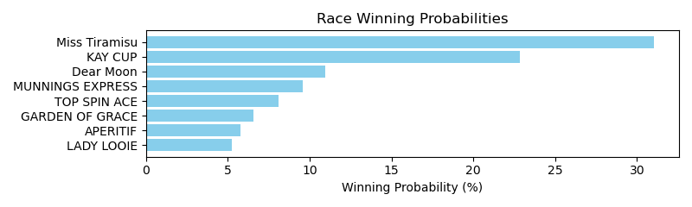

Exacta advice: key 1 → 6 (1 ticket)

NOTE: GCSF - Global Combined Speed Figure

# Race: AQU | 2025-04-27 | Race #7 | Post: 22:22 | Track: AQUEDUCT

Track: AQUEDUCT

|  |  |  |  |  |  |
| --- | --- | --- | --- | --- | --- |
| Program # | Horse Name | Morn Odds | GCSF | Model Score | Win Prob (%) |
| 1 | Ican | 20-1 | 3.0 | 2.03 | 18.45 |
| 2 | Toga d'Oro | 30-1 | 8.0 | -0.11 | 4.25 |
| 3 | Garamond | 5-1 | 4.0 | 1.49 | 12.73 |
| 4 | Keewaydin | 9-2 | 2.0 | 2.08 | 19.14 |
| 5 | Sand Devil | 6-1 | 6.0 | 1.21 | 10.54 |
| 6 | My Mitole | 20-1 | 7.0 | 0.07 | 4.81 |
| 7 | Cornucopian | 5-8 | 5.0 | 1.22 | 10.58 |
| 8 | National Law | 30-1 | 1.0 | 2.11 | 19.50 |

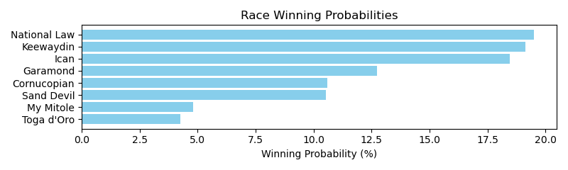

Exacta advice: box [8,4,1] (6 tickets)

NOTE: GCSF - Global Combined Speed Figure

# Race: AQU | 2025-04-27 | Race #8 | Post: 22:54 | Track: AQUEDUCT

Track: AQUEDUCT

|  |  |  |  |  |  |
| --- | --- | --- | --- | --- | --- |
| Program # | Horse Name | Morn Odds | GCSF | Model Score | Win Prob (%) |
| 1 | Icona Mama | 20-1 | 8.0 | 0.27 | 4.41 |
| 2 | Laurelin (IRE) | 2-1 | 1.0 | 3.06 | 29.92 |
| 3 | Italian Soiree | 12-1 | 7.0 | 0.29 | 4.47 |
| 4 | Shesinamood | 30-1 | 10.0 | -0.90 | 1.97 |
| 5 | Opulent Restraint (IRE) | 5-1 | 6.0 | 1.13 | 7.97 |
| 6 | Candy Quest | 6-1 | 3.0 | 1.86 | 13.18 |
| 7 | Love Cervere | 6-1 | 5.0 | 1.15 | 8.09 |
| 8 | Burner Account | 20-1 | 9.0 | 0.11 | 3.95 |
| 9 | Virgin Colada | 5-2 | 4.0 | 1.76 | 12.25 |
| 10 | Bernieandtherose | 13-8 | 2.0 | 1.93 | 13.79 |

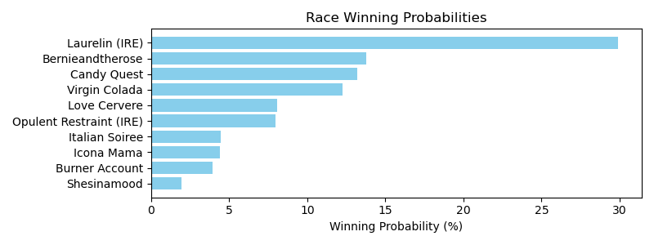

Exacta advice: key 2 → 10 (1 ticket)

NOTE: GCSF - Global Combined Speed Figure

# Race: AQU | 2025-04-27 | Race #9 | Post: 23:26 | Track: AQUEDUCT

Track: AQUEDUCT

|  |  |  |  |  |  |
| --- | --- | --- | --- | --- | --- |
| Program # | Horse Name | Morn Odds | GCSF | Model Score | Win Prob (%) |
| 1 | TANGO TANGO | 12-1 | 14.0 | -0.06 | 2.19 |
| 2 | Motel Patel | 8-1 | 4.0 | 2.28 | 10.96 |
| 3 | RHYTON | 9-2 | 9.0 | 0.48 | 3.18 |
| 4 | Roofer | 10-1 | 5.0 | 1.93 | 8.63 |
| 5 | EIGHTY GOLD | 20-1 | 12.0 | 0.03 | 2.32 |
| 6 | NOTHINGBUTNITRO | 30-1 | 16.0 | -0.51 | 1.61 |
| 7 | NO PROBLEM | 8-1 | 11.0 | 0.21 | 2.64 |
| 8 | Disco Dervish | 30-1 | 8.0 | 0.66 | 3.58 |
| 9 | Leon Blue | 2-1 | 1.0 | 3.14 | 19.81 |
| 10 | Stormy Birthday | 15-1 | 7.0 | 1.00 | 4.53 |
| 11 | Cousin Ed | 5-1 | 2.0 | 2.67 | 14.29 |
| 12 | BLUE PILL | 30-1 | 13.0 | -0.00 | 2.28 |
| 13 | Toga Dan | 8-1 | 6.0 | 1.35 | 5.79 |
| 14 | Arch's Assault | 15-1 | 10.0 | 0.42 | 3.05 |
| 15 | Mozambique | 5-2 | 3.0 | 2.54 | 13.09 |
| 16 | Kings and Queens | 8-1 | 15.0 | -0.15 | 2.05 |

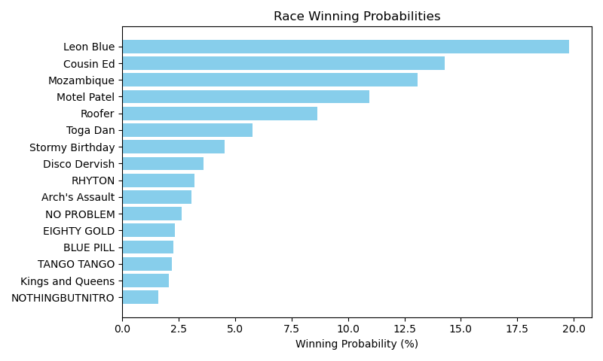

Exacta advice: key 9 → 11 (1 ticket)

NOTE: GCSF - Global Combined Speed Figure

# Race: TCD | 2025-04-26 | Race #1 | Post: 23:00 | Track: CHURCHILL DOWNS

Track: CHURCHILL DOWNS

|  |  |  |  |  |  |
| --- | --- | --- | --- | --- | --- |
| Program # | Horse Name | Morn Odds | GCSF | Model Score | Win Prob (%) |
| 1 | Tiberius Mercurius | 4-1 | 1.0 | 1.89 | 17.92 |
| 2 | Where Is Lisa | 30-1 | 11.0 | -0.32 | 3.91 |
| 3 | Coyote Road | 8-1 | 5.0 | 0.68 | 7.82 |
| 4 | Ready Pursuit | 15-1 | 9.0 | 0.07 | 5.15 |
| 5 | Peruvian Lucky | 5-1 | 4.0 | 1.23 | 11.39 |
| 6 | Improbable Story | 20-1 | 10.0 | -0.04 | 4.77 |
| 7 | Synthesis | 7-2 | 2.0 | 1.81 | 17.01 |
| 8 | Hoodlum | 3-1 | 3.0 | 1.27 | 11.71 |
| 9 | I Am the Game | 15-1 | 6.0 | 0.66 | 7.68 |
| 10 | Metatron's Muse | 8-1 | 7.0 | 0.48 | 6.82 |
| 11 | Noahs Ark | 20-1 | 8.0 | 0.25 | 5.82 |

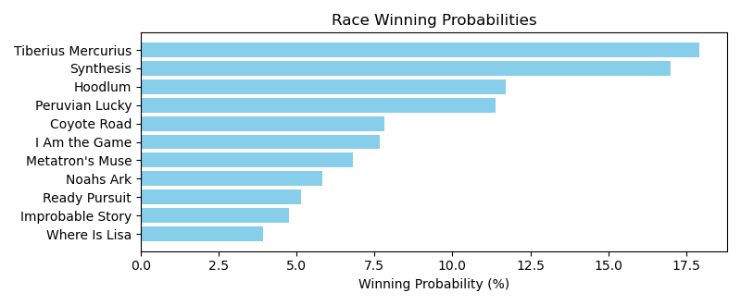

Exacta advice: box [1,7,8] (6 tickets)

NOTE: GCSF - Global Combined Speed Figure

# Race: TCD | 2025-04-26 | Race #2 | Post: 23:28 | Track: CHURCHILL DOWNS

Track: CHURCHILL DOWNS

|  |  |  |  |  |  |
| --- | --- | --- | --- | --- | --- |
| Program # | Horse Name | Morn Odds | GCSF | Model Score | Win Prob (%) |
| 1 | Jill Jitterbug | 20-1 | 5.0 | 1.15 | 9.22 |
| 2 | Neverwalkalone (BRZ) | 10-1 | 1.0 | 2.89 | 30.61 |
| 3 | Lucky Speech | 5-1 | 6.0 | 0.77 | 7.11 |
| 4 | Justifiable Belle | 3-1 | 4.0 | 1.62 | 12.73 |
| 5 | Mission of Joy | 9-5 | 2.0 | 2.31 | 20.55 |
| 6 | Vinos Angel | 30-1 | 7.0 | 0.31 | 5.18 |
| 7 | No Mo Candy | 2-1 | 3.0 | 1.82 | 14.60 |

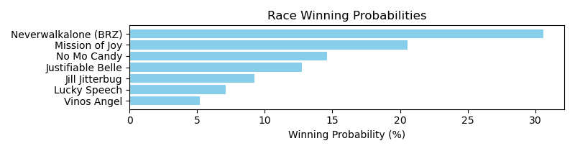

Exacta advice: key 2 → 5 (1 ticket)

NOTE: GCSF - Global Combined Speed Figure

# Race: TCD | 2025-04-26 | Race #3 | Post: 23:56 | Track: CHURCHILL DOWNS

Track: CHURCHILL DOWNS

|  |  |  |  |  |  |
| --- | --- | --- | --- | --- | --- |
| Program # | Horse Name | Morn Odds | GCSF | Model Score | Win Prob (%) |
| 1 | Cervaro Della Sala (GB) | 3-1 | 1.0 | 2.84 | 28.27 |
| 2 | Bolt On the Rocks | 5-1 | 2.0 | 2.37 | 20.52 |
| 3 | Next Up | 7-2 | 3.0 | 1.79 | 13.76 |
| 4 | Lou Anna | 15-1 | 7.0 | -0.02 | 3.96 |
| 5 | Ask Amanda | 20-1 | 6.0 | 0.62 | 6.15 |
| 6 | Beach Bunny | 15-1 | 8.0 | -0.25 | 3.37 |
| 7 | Creative Quality | 5-2 | 4.0 | 1.68 | 12.73 |
| 8 | Big Dig | 4-1 | 5.0 | 1.50 | 11.25 |

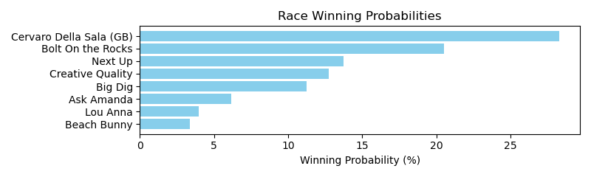

Exacta advice: key 1 → 2 (1 ticket)

NOTE: GCSF - Global Combined Speed Figure

# Race: TCD | 2025-04-26 | Race #4 | Post: 00:26 | Track: CHURCHILL DOWNS

Track: CHURCHILL DOWNS

|  |  |  |  |  |  |
| --- | --- | --- | --- | --- | --- |
| Program # | Horse Name | Morn Odds | GCSF | Model Score | Win Prob (%) |
| 1 | Our Keepsake | 9-2 | 4.0 | 1.61 | 16.12 |
| 2 | Laurie's Secret | 15-1 | 7.0 | -0.89 | 2.88 |
| 3 | Sam's Treasure | 3-1 | 2.0 | 1.78 | 18.09 |
| 4 | Outrageously | 12-1 | 6.0 | 0.95 | 10.24 |
| 5 | Twirl Around | 7-2 | 5.0 | 1.52 | 15.14 |
| 6 | Sundance Feature | 2-1 | 1.0 | 2.00 | 21.06 |
| 7 | Lord I Wonder | 6-1 | 3.0 | 1.64 | 16.47 |

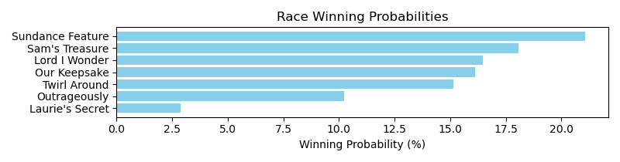

Exacta advice: key 6 → 3 (1 ticket)

NOTE: GCSF - Global Combined Speed Figure

# Race: TCD | 2025-04-26 | Race #5 | Post: 00:57 | Track: CHURCHILL DOWNS

Track: CHURCHILL DOWNS

|  |  |  |  |  |  |
| --- | --- | --- | --- | --- | --- |
| Program # | Horse Name | Morn Odds | GCSF | Model Score | Win Prob (%) |
| 1 | Redfield | 15-1 | 8.0 | 0.16 | 5.31 |
| 2 | Mucho Mojo | 4-1 | 3.0 | 1.70 | 15.38 |
| 3 | Our Dream Rye'd | 5-1 | 2.0 | 1.86 | 17.16 |
| 4 | Carolo Rapido | 5-2 | 1.0 | 2.16 | 21.01 |
| 5 | Patrolman | 8-1 | 5.0 | 0.95 | 9.19 |
| 6 | Forge in Fire | 7-2 | 4.0 | 1.50 | 13.34 |
| 7 | Evening News | 5-1 | 6.0 | 0.90 | 8.89 |
| 8 | Criminal Defense | 20-1 | 9.0 | -0.16 | 4.27 |
| 9 | Succession Gold | 20-1 | 7.0 | 0.19 | 5.45 |

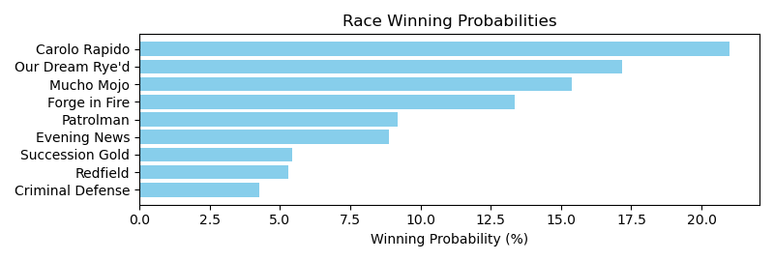

Exacta advice: key 4 → 3 (1 ticket)

NOTE: GCSF - Global Combined Speed Figure

# Race: TCD | 2025-04-26 | Race #6 | Post: 02:04 | Track: CHURCHILL DOWNS

Track: CHURCHILL DOWNS

|  |  |  |  |  |  |
| --- | --- | --- | --- | --- | --- |
| Program # | Horse Name | Morn Odds | GCSF | Model Score | Win Prob (%) |
| 1 | Pop Paul | 15-1 | 11.0 | 0.17 | 2.72 |
| 2 | Shadow Coast | 5-1 | 5.0 | 1.30 | 5.90 |
| 3 | Holster | 9-2 | 1.0 | 3.07 | 19.98 |
| 4 | Tapakena | 4-1 | 3.0 | 2.82 | 16.87 |
| 5 | Lemon Sohn | 12-1 | 8.0 | 0.73 | 4.00 |
| 6 | Skynet | 20-1 | 6.0 | 1.13 | 5.28 |
| 7 | Demand | 20-1 | 10.0 | 0.35 | 3.09 |
| 8 | TUN TAVERN | 30-1 | 12.0 | -0.55 | 1.65 |
| 9 | Daiquiri Sommelier | 10-1 | 7.0 | 0.96 | 4.68 |
| 10 | Sinister Smile | 7-2 | 2.0 | 2.84 | 17.09 |
| 11 | Classy War | 5-1 | 4.0 | 2.71 | 15.60 |
| 12 | Strategist | 30-1 | 9.0 | 0.38 | 3.14 |

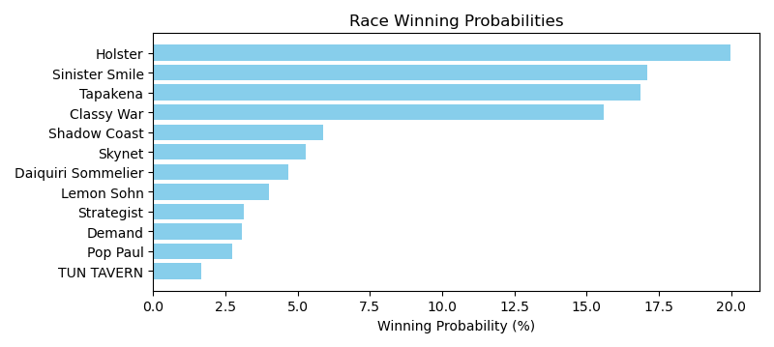

Exacta advice: key 3 → [10,4] (2 tickets)

NOTE: GCSF - Global Combined Speed Figure

# Race: TCD | 2025-04-26 | Race #7 | Post: 02:37 | Track: CHURCHILL DOWNS

Track: CHURCHILL DOWNS

|  |  |  |  |  |  |
| --- | --- | --- | --- | --- | --- |
| Program # | Horse Name | Morn Odds | GCSF | Model Score | Win Prob (%) |
| 1 | Antonia's Flowers | 8-1 | 8.0 | 0.56 | 3.39 |
| 2 | Plaza Cue | 5-2 | 1.0 | 3.38 | 23.59 |
| 3 | Halfin | 15-1 | 5.0 | 2.34 | 11.57 |
| 4 | Churning Berni | 4-1 | 3.0 | 2.63 | 14.13 |
| 5 | Kiss Me Again | 7-2 | 2.0 | 2.73 | 15.11 |
| 6 | Ashes and Diamonds | 9-2 | 7.0 | 1.95 | 8.85 |
| 7 | Maddienlizzyshonor | 12-1 | 6.0 | 2.18 | 10.31 |
| 8 | Vino Tiempo | 5-1 | 4.0 | 2.52 | 13.04 |

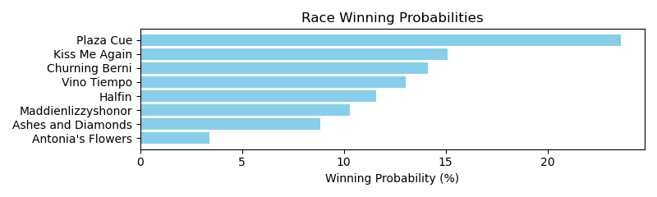

Exacta advice: key 2 → 5 (1 ticket)

NOTE: GCSF - Global Combined Speed Figure

# Race: TCD | 2025-04-26 | Race #8 | Post: 03:09 | Track: CHURCHILL DOWNS

Track: CHURCHILL DOWNS

|  |  |  |  |  |  |
| --- | --- | --- | --- | --- | --- |
| Program # | Horse Name | Morn Odds | GCSF | Model Score | Win Prob (%) |
| 1 | Smooth Waves | 7-2 | 2.0 | 1.58 | 11.46 |
| 2 | Talent Show | 6-1 | 1.0 | 2.40 | 20.13 |
| 3 | Faire Plaisir | 8-1 | 6.0 | 0.85 | 6.93 |
| 4 | Bread to Run | 9-2 | 5.0 | 1.12 | 8.34 |
| 5 | Sweet Voyage | 15-1 | 9.0 | 0.13 | 4.24 |
| 6 | Choate | 15-1 | 10.0 | -0.01 | 3.85 |
| 7 | Cheyenne Moon | 15-1 | 12.0 | -0.23 | 3.29 |
| 8 | Angel of Faith | 4-1 | 3.0 | 1.52 | 11.01 |
| 9 | Life Advice | 5-1 | 7.0 | 0.66 | 6.11 |
| 10 | Hold My Halo | 15-1 | 8.0 | 0.48 | 5.38 |
| 11 | Tizntshelovely | 15-1 | 13.0 | -0.32 | 3.11 |
| 12 | Malibu Smart | 5-1 | 4.0 | 1.44 | 10.43 |
| 13 | Taco Cat Backwards | 20-1 | 14.0 | -0.95 | 2.01 |
| 14 | What If | 20-1 | 11.0 | -0.06 | 3.72 |

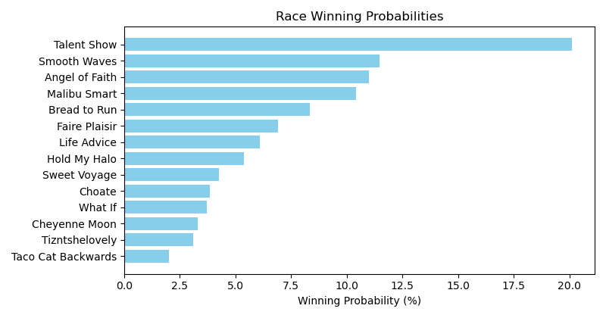

Exacta advice: key 2 → 1 (1 ticket)

NOTE: GCSF - Global Combined Speed Figure

# Race: TCD | 2025-04-26 | Race #9 | Post: 03:40 | Track: CHURCHILL DOWNS

Track: CHURCHILL DOWNS

|  |  |  |  |  |  |
| --- | --- | --- | --- | --- | --- |
| Program # | Horse Name | Morn Odds | GCSF | Model Score | Win Prob (%) |
| 1 | Non Violence | 9-2 | 3.0 | 1.39 | 14.35 |
| 2 | Sandy Bottom | 5-2 | 4.0 | 1.29 | 13.47 |
| 3 | Lady Moscato | 10-1 | 5.0 | 0.91 | 10.37 |
| 4 | Tripolina | 10-1 | 2.0 | 1.64 | 17.12 |
| 5 | Miuccia | 8-1 | 6.0 | 0.87 | 10.09 |
| 6 | Harbor Springs | 3-1 | 1.0 | 1.77 | 18.74 |
| 7 | Girls Weekend | 12-1 | 8.0 | 0.46 | 7.59 |
| 8 | Mink's Palace | 4-1 | 7.0 | 0.59 | 8.28 |

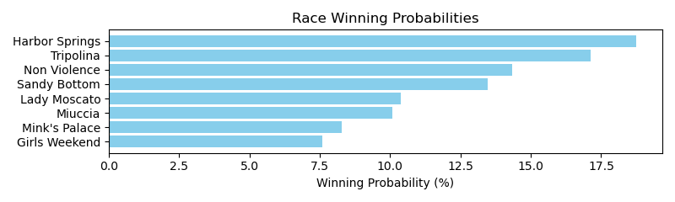

Exacta advice: key 6 → 4 (1 ticket)

NOTE: GCSF - Global Combined Speed Figure

# Race: TCD | 2025-04-26 | Race #10 | Post: 04:10 | Track: CHURCHILL DOWNS

Track: CHURCHILL DOWNS

|  |  |  |  |  |  |
| --- | --- | --- | --- | --- | --- |
| Program # | Horse Name | Morn Odds | GCSF | Model Score | Win Prob (%) |
| 1 | Studeny | 6-1 | 3.0 | 2.72 | 14.55 |
| 2 | OUTDOOR CAT | 12-1 | 9.0 | 0.75 | 3.73 |
| 3 | Evan On Earth | 7-5 | 1.0 | 3.57 | 26.11 |
| 4 | BIG ROG | 20-1 | 10.0 | 0.59 | 3.36 |
| 5 | BERNIEDOTT | 15-1 | 8.0 | 0.83 | 3.95 |
| 6 | Outofpi | 12-1 | 5.0 | 1.92 | 8.38 |
| 7 | Where Y'at | 15-1 | 7.0 | 1.03 | 4.52 |
| 8 | Shepherd | 9-2 | 2.0 | 3.12 | 19.09 |
| 9 | Sergeant Capps | 8-1 | 4.0 | 2.12 | 9.61 |
| 10 | Vino Dominus | 6-1 | 6.0 | 1.60 | 6.71 |

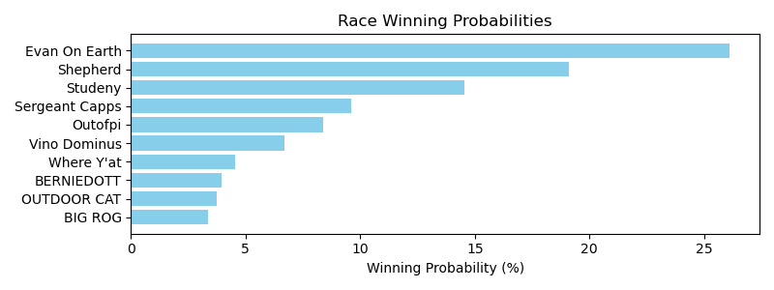

Exacta advice: key 3 → 8 (1 ticket)

NOTE: GCSF - Global Combined Speed Figure

# Race: TCD | 2025-04-29 | Race #1 | Post: 18:45 | Track: CHURCHILL DOWNS

Track: CHURCHILL DOWNS

|  |  |  |  |  |  |
| --- | --- | --- | --- | --- | --- |
| Program # | Horse Name | Morn Odds | GCSF | Model Score | Win Prob (%) |
| 1 | Nikolaou | 7-2 | 3.0 | 1.54 | 17.66 |
| 2 | Paynter's Canvas | 10-1 | 4.0 | 0.65 | 9.55 |
| 3 | Harvard | 5-2 | 1.0 | 2.11 | 26.08 |
| 4 | Business Model | 2-1 | 2.0 | 1.76 | 20.60 |
| 5 | Show Time | 6-1 | 6.0 | 0.58 | 9.15 |
| 6 | Twirling Troillet | 8-1 | 5.0 | 0.61 | 9.32 |
| 7 | Couperin | 15-1 | 7.0 | 0.32 | 7.64 |

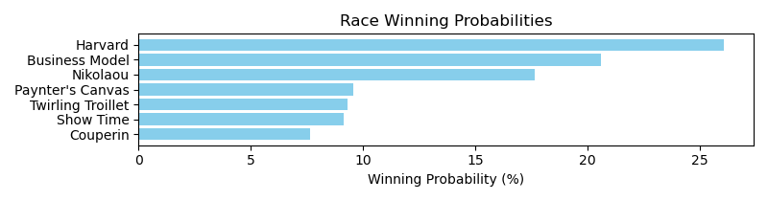

Exacta advice: key 3 → 4 (1 ticket)

NOTE: GCSF - Global Combined Speed Figure

# Race: TCD | 2025-04-29 | Race #2 | Post: 19:14 | Track: CHURCHILL DOWNS

Track: CHURCHILL DOWNS

|  |  |  |  |  |  |
| --- | --- | --- | --- | --- | --- |
| Program # | Horse Name | Morn Odds | GCSF | Model Score | Win Prob (%) |
| 1 | Sweet Sib | 6-1 | 6.0 | 1.37 | 6.00 |
| 2 | Miss Collected | 6-1 | 2.0 | 2.78 | 15.91 |
| 3 | Readytoriskitall | 5-2 | 1.0 | 3.50 | 26.09 |
| 4 | Bouji Is a Word | 30-1 | 10.0 | 0.45 | 3.19 |
| 5 | BETO'S BIRDIE | 30-1 | 12.0 | -0.42 | 1.76 |
| 6 | Night Cry | 30-1 | 7.0 | 1.22 | 5.44 |
| 7 | Red Royalty | 8-1 | 5.0 | 1.51 | 6.62 |
| 8 | Judy's Flyer | 8-1 | 8.0 | 1.19 | 5.31 |
| 9 | Hand It Over | 20-1 | 4.0 | 2.03 | 9.48 |
| 10 | COOLNESS | 10-1 | 9.0 | 0.60 | 3.55 |
| 11 | Genuine Article | 8-1 | 11.0 | 0.19 | 2.68 |
| 12 | Union Dame | 5-1 | 3.0 | 2.59 | 13.96 |

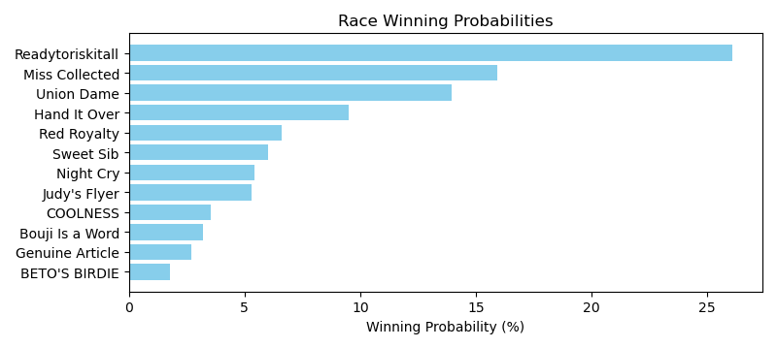

Exacta advice: key 3 → 2 (1 ticket)

NOTE: GCSF - Global Combined Speed Figure

# Race: TCD | 2025-04-29 | Race #3 | Post: 19:43 | Track: CHURCHILL DOWNS

Track: CHURCHILL DOWNS

|  |  |  |  |  |  |
| --- | --- | --- | --- | --- | --- |
| Program # | Horse Name | Morn Odds | GCSF | Model Score | Win Prob (%) |
| 1 | Gold Search | 9-2 | 4.0 | 0.72 | 9.39 |
| 2 | Rivalry | 2-1 | 3.0 | 1.20 | 13.09 |
| 3 | Son of a Gray | 15-1 | 8.0 | -0.16 | 5.13 |
| 4 | Quebrancho | 15-1 | 6.0 | -0.01 | 5.70 |
| 5 | Beer With Ice | 15-1 | 7.0 | -0.16 | 5.15 |
| 6 | Dancing Noah | 20-1 | 9.0 | -0.50 | 4.05 |
| 7 | Merlotti | 15-1 | 5.0 | 0.43 | 7.70 |
| 8 | Spoonie | 5-2 | 1.0 | 2.40 | 29.84 |
| 9 | Sackett | 20-1 | 10.0 | -1.18 | 2.55 |
| 10 | More Than Five | 5-1 | 2.0 | 1.61 | 17.41 |

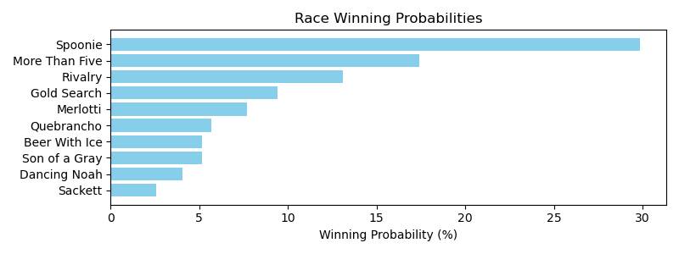

Exacta advice: key 8 → 10 (1 ticket)

NOTE: GCSF - Global Combined Speed Figure

# Race: TCD | 2025-04-29 | Race #4 | Post: 20:13 | Track: CHURCHILL DOWNS

Track: CHURCHILL DOWNS

|  |  |  |  |  |  |
| --- | --- | --- | --- | --- | --- |
| Program # | Horse Name | Morn Odds | GCSF | Model Score | Win Prob (%) |
| 1 | Full Armor | 5-1 | 6.0 | 1.57 | 7.85 |
| 2 | House United | 5-1 | 9.0 | 1.29 | 6.44 |
| 3 | Raguel | 9-2 | 4.0 | 1.61 | 8.05 |
| 4 | Funnyflame | 7-2 | 3.0 | 1.74 | 8.79 |
| 5 | Consecrated | 6-1 | 14.0 | -0.03 | 2.61 |
| 6 | Devil Anse | 20-1 | 2.0 | 1.98 | 10.36 |
| 7 | Sprint Out Pass | 8-1 | 11.0 | 1.16 | 5.91 |
| 8 | Chris's Revenge | 6-1 | 12.0 | 0.66 | 4.18 |
| 9 | Kistler | 30-1 | 13.0 | 0.03 | 2.72 |
| 10 | Warrior Wayne | 8-1 | 1.0 | 2.51 | 14.92 |
| 11 | Indy Magic | 7-2 | 10.0 | 1.18 | 5.99 |
| 12 | Cabernaydo | 9-2 | 8.0 | 1.43 | 7.09 |
| 13 | Smart Mo | 3-1 | 7.0 | 1.44 | 7.17 |
| 14 | Rachman | 5-1 | 5.0 | 1.59 | 7.92 |

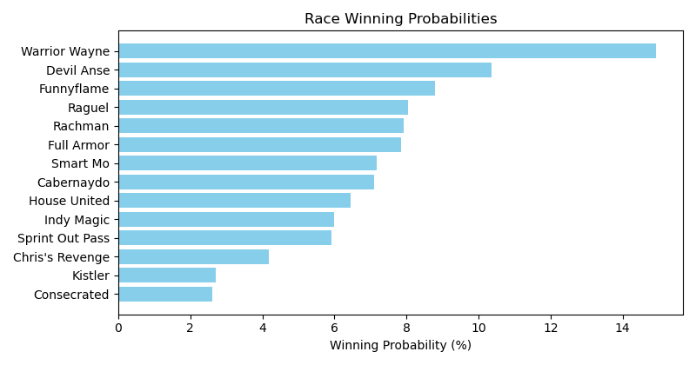

Exacta advice: key 10 → 6 (1 ticket)

NOTE: GCSF - Global Combined Speed Figure

# Race: TCD | 2025-04-29 | Race #5 | Post: 20:45 | Track: CHURCHILL DOWNS

Track: CHURCHILL DOWNS

|  |  |  |  |  |  |
| --- | --- | --- | --- | --- | --- |
| Program # | Horse Name | Morn Odds | GCSF | Model Score | Win Prob (%) |
| 1 | Fun to Run | 4-1 | 9.0 | -0.00 | 5.61 |
| 2 | Starlit Sofi | 6-1 | 4.0 | 0.92 | 10.60 |
| 3 | Krickle | 5-1 | 5.0 | 0.75 | 9.44 |
| 4 | Starcourt | 8-1 | 6.0 | 0.37 | 7.24 |
| 5 | United Forever | 8-1 | 10.0 | -0.17 | 4.98 |
| 6 | Up On the Edge | 9-2 | 2.0 | 1.11 | 12.06 |
| 7 | Ladle | 30-1 | 13.0 | -0.72 | 3.41 |
| 8 | Red Wine Lady | 20-1 | 11.0 | -0.22 | 4.84 |
| 9 | Yes to Champagne | 6-1 | 3.0 | 1.09 | 11.85 |
| 10 | Lady Riley | 15-1 | 7.0 | 0.23 | 6.56 |
| 11 | Sweet Lilibet | 30-1 | 12.0 | -0.50 | 3.97 |
| 12 | Hearts United | 12-1 | 8.0 | 0.09 | 5.96 |
| 13 | She Stopped Short | 15-1 | 1.0 | 1.27 | 13.47 |

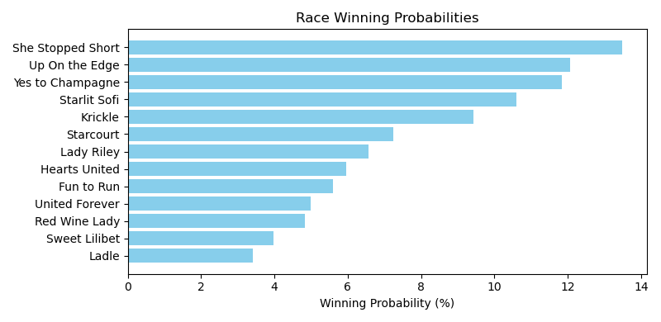

Exacta advice: key 13 → [6,9] (2 tickets)

NOTE: GCSF - Global Combined Speed Figure

# Race: TCD | 2025-04-29 | Race #6 | Post: 21:18 | Track: CHURCHILL DOWNS

Track: CHURCHILL DOWNS

|  |  |  |  |  |  |
| --- | --- | --- | --- | --- | --- |
| Program # | Horse Name | Morn Odds | GCSF | Model Score | Win Prob (%) |
| 1 | Closing Prayer | 15-1 | 8.0 | 1.05 | 5.63 |
| 2 | Didn't It Rain | 4-1 | 6.0 | 1.13 | 5.95 |
| 3 | Pour a Little More | 6-1 | 4.0 | 2.25 | 12.84 |
| 4 | My Sexy Blonde | 30-1 | 7.0 | 1.08 | 5.75 |
| 5 | Chandon | 30-1 | 9.0 | 0.83 | 4.84 |
| 6 | Ocean Ripple | 5-1 | 3.0 | 2.61 | 16.46 |
| 7 | Martingale | 5-2 | 1.0 | 3.07 | 22.64 |
| 8 | Pure Breeze | 9-2 | 5.0 | 1.46 | 7.48 |
| 9 | Well Aware | 7-2 | 2.0 | 2.77 | 18.41 |

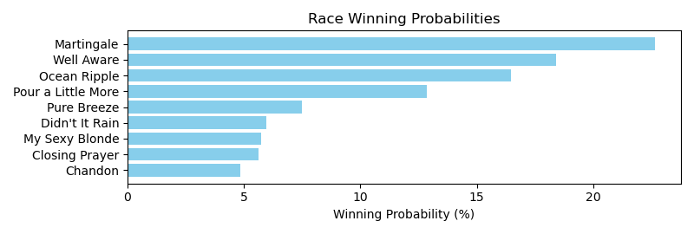

Exacta advice: key 7 → 9 (1 ticket)

NOTE: GCSF - Global Combined Speed Figure

# Race: TCD | 2025-04-29 | Race #7 | Post: 21:50 | Track: CHURCHILL DOWNS

Track: CHURCHILL DOWNS

|  |  |  |  |  |  |
| --- | --- | --- | --- | --- | --- |
| Program # | Horse Name | Morn Odds | GCSF | Model Score | Win Prob (%) |
| 1 | Fort Sam | 15-1 | 1.0 | 2.34 | 21.40 |
| 2 | Pentathlon | 5-1 | 6.0 | 1.11 | 9.21 |
| 3 | Lou's Legacy | 20-1 | 8.0 | 0.57 | 6.35 |
| 4 | G T Five Hundred | 7-2 | 5.0 | 1.46 | 11.69 |
| 5 | Risk It | 5-1 | 3.0 | 1.57 | 12.66 |
| 6 | March of Time | 13-8 | 2.0 | 2.18 | 19.18 |
| 7 | Rocketeer | 4-1 | 4.0 | 1.47 | 11.81 |
| 8 | Lil Muggs | 15-1 | 7.0 | 0.85 | 7.70 |

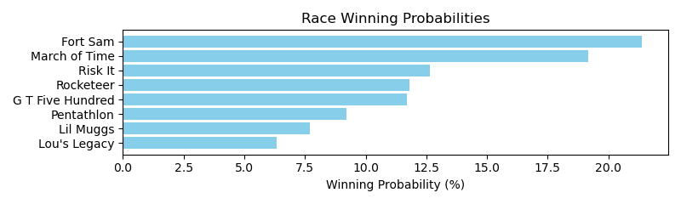

Exacta advice: key 1 → 6 (1 ticket)

NOTE: GCSF - Global Combined Speed Figure

# Race: TCD | 2025-04-29 | Race #8 | Post: 22:22 | Track: CHURCHILL DOWNS

Track: CHURCHILL DOWNS

|  |  |  |  |  |  |
| --- | --- | --- | --- | --- | --- |
| Program # | Horse Name | Morn Odds | GCSF | Model Score | Win Prob (%) |
| 1 | West Hollywood | 5-2 | 1.0 | 2.33 | 15.84 |
| 2 | Tall Boy | 12-1 | 9.0 | 1.11 | 6.86 |
| 3 | Tapit Shoes | 8-1 | 7.0 | 1.33 | 7.96 |
| 4 | dh-Out of Deductions | 5-1 | 2.0 | 2.07 | 13.22 |
| 5 | Miranda Rights | 5-1 | 6.0 | 1.34 | 8.00 |
| 6 | Higgins Boat | 7-2 | 8.0 | 1.27 | 7.63 |
| 7 | Timeout | 15-1 | 10.0 | 0.98 | 6.27 |
| 8 | Native Shaman | 12-1 | 5.0 | 1.46 | 8.72 |
| 9 | Event Detail | 12-1 | 4.0 | 1.47 | 8.74 |
| 10 | Call Protection | 10-1 | 3.0 | 1.79 | 10.93 |
| 11 | In a Jam | 8-1 | 11.0 | 0.88 | 5.83 |

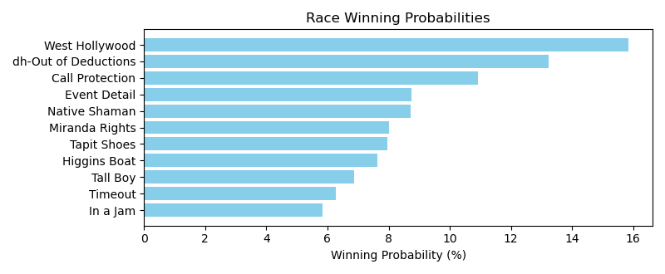

Exacta advice: key 1 → 4 (1 ticket)

NOTE: GCSF - Global Combined Speed Figure

# Race: TCD | 2025-04-29 | Race #9 | Post: 22:55 | Track: CHURCHILL DOWNS

Track: CHURCHILL DOWNS

|  |  |  |  |  |  |
| --- | --- | --- | --- | --- | --- |
| Program # | Horse Name | Morn Odds | GCSF | Model Score | Win Prob (%) |
| 1 | Desert Aire | 4-1 | 1.0 | 2.79 | 13.64 |
| 2 | Hotline Blink | 6-1 | 8.0 | 1.71 | 6.50 |
| 3 | Mubarez | 12-1 | 6.0 | 1.89 | 7.36 |
| 4 | High Five Sy | 6-1 | 3.0 | 2.19 | 9.08 |
| 5 | Dan d'Oro | 8-1 | 14.0 | 0.61 | 3.06 |
| 6 | Promissione | 8-1 | 5.0 | 2.15 | 8.82 |
| 7 | Egyptian Quest | 20-1 | 10.0 | 1.35 | 5.07 |
| 8 | Bourbon State | 15-1 | 9.0 | 1.45 | 5.42 |
| 9 | Catalina Cat | 3-1 | 4.0 | 2.16 | 8.88 |
| 10 | Jack Rabbit | 20-1 | 16.0 | -0.37 | 1.55 |
| 11 | Ghost Prince | 20-1 | 12.0 | 0.95 | 3.85 |
| 12 | Maravich | 12-1 | 13.0 | 0.84 | 3.56 |
| 13 | Bourbon Street Boy | 12-1 | 15.0 | -0.20 | 1.75 |
| 14 | Trap Line | 20-1 | 7.0 | 1.82 | 7.01 |
| 15 | Purdy Darn Good | 8-1 | 2.0 | 2.28 | 9.63 |
| 16 | Playing Cupid | 8-1 | 11.0 | 1.27 | 4.80 |

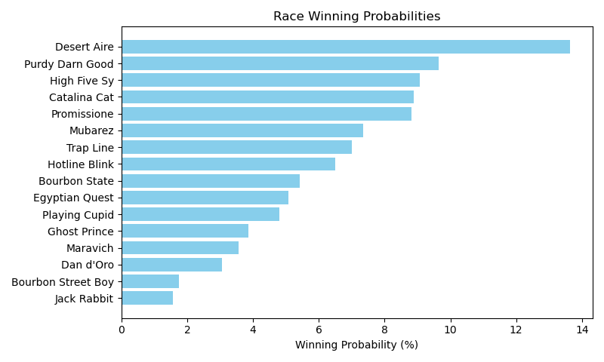

Exacta advice: key 1 → 15 (1 ticket)

NOTE: GCSF - Global Combined Speed Figure

# Race: TCD | 2025-04-30 | Race #1 | Post: 18:45 | Track: CHURCHILL DOWNS

Track: CHURCHILL DOWNS

|  |  |  |  |  |  |
| --- | --- | --- | --- | --- | --- |
| Program # | Horse Name | Morn Odds | GCSF | Model Score | Win Prob (%) |
| 1 | Marmalade Skye | 5-2 | 2.0 | 1.54 | 16.44 |
| 2 | These Apples | 3-1 | 1.0 | 1.67 | 17.99 |
| 3 | Story Hour | 4-1 | 4.0 | 1.38 | 14.78 |
| 4 | Sandra D | 10-1 | 7.0 | 0.75 | 9.54 |
| 5 | Progeny | 6-1 | 5.0 | 1.27 | 13.71 |
| 6 | Ready for Trouble | 5-1 | 3.0 | 1.53 | 16.38 |
| 7 | Always Angels | 8-1 | 6.0 | 0.97 | 11.16 |

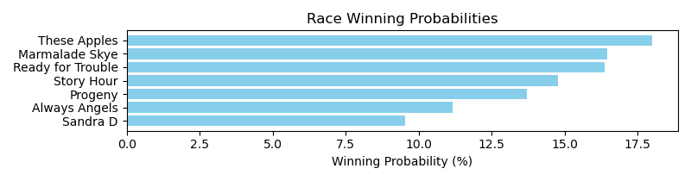

Exacta advice: key 2 → [1,6] (2 tickets)

NOTE: GCSF - Global Combined Speed Figure

# Race: TCD | 2025-04-30 | Race #2 | Post: 19:15 | Track: CHURCHILL DOWNS

Track: CHURCHILL DOWNS

|  |  |  |  |  |  |
| --- | --- | --- | --- | --- | --- |
| Program # | Horse Name | Morn Odds | GCSF | Model Score | Win Prob (%) |
| 1 | Celestial Harmony | 20-1 | 8.0 | -0.21 | 6.06 |
| 2 | SHE REIGNS | 9-2 | 3.0 | 0.29 | 8.51 |
| 3 | Givemethebeat | 12-1 | 9.0 | -0.26 | 5.85 |
| 4 | WAKUDA | 10-1 | 10.0 | -0.27 | 5.79 |
| 5 | BAFFLE | 9-2 | 6.0 | 0.05 | 7.20 |
| 6 | MOONLIGHT BEAUTY | 4-1 | 2.0 | 0.31 | 8.66 |
| 7 | SASSY C W | 7-2 | 4.0 | 0.28 | 8.45 |
| 8 | RED BERETTA | 15-1 | 7.0 | -0.10 | 6.50 |
| 9 | GOLDEN KEEN | 20-1 | 13.0 | -0.42 | 5.22 |
| 10 | VALIANT WAR GIRL | 12-1 | 11.0 | -0.28 | 5.76 |
| 11 | Little Sam's | 20-1 | 1.0 | 1.03 | 14.16 |
| 12 | STARDIALED | 10-1 | 5.0 | 0.27 | 8.39 |
| 13 | KABOOM | 12-1 | 12.0 | -0.39 | 5.33 |
| 14 | WOODALL PASS | 20-1 | 14.0 | -0.77 | 4.11 |

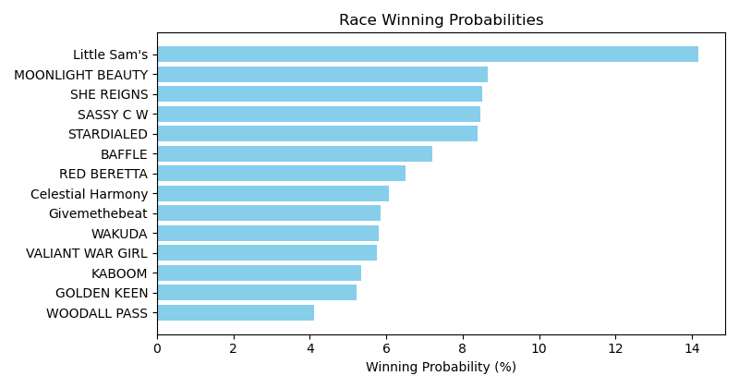

Exacta advice: key 11 → [6,2] (2 tickets)

NOTE: GCSF - Global Combined Speed Figure

# Race: TCD | 2025-04-30 | Race #3 | Post: 19:45 | Track: CHURCHILL DOWNS

Track: CHURCHILL DOWNS

|  |  |  |  |  |  |
| --- | --- | --- | --- | --- | --- |
| Program # | Horse Name | Morn Odds | GCSF | Model Score | Win Prob (%) |
| 1 | MO MOE MOW | 12-1 | 8.0 | -0.14 | 3.38 |
| 2 | Turnbuckle | 10-1 | 3.0 | 1.95 | 14.20 |
| 3 | Paved in Gold | 5-2 | 1.0 | 2.96 | 28.45 |
| 4 | STRAIGHTAWAY | 5-1 | 6.0 | 0.48 | 5.18 |
| 5 | Old Trace | 7-2 | 5.0 | 1.00 | 7.37 |
| 6 | Bourbon Street Boy | 15-1 | 9.0 | -0.44 | 2.74 |
| 7 | Winning Song | 6-1 | 2.0 | 2.81 | 25.58 |
| 8 | One Mor Story | 4-1 | 4.0 | 1.37 | 9.56 |
| 9 | Friendly Charlie | 15-1 | 7.0 | -0.06 | 3.55 |

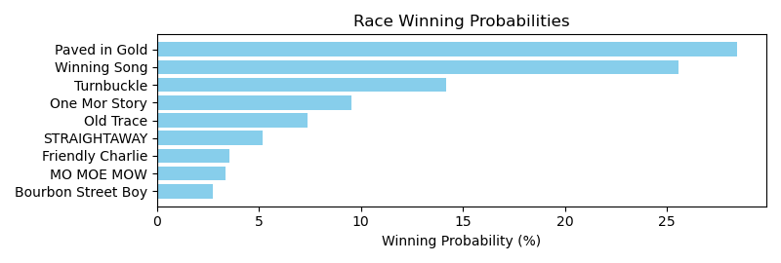

Exacta advice: key 3 → 7 (1 ticket)

NOTE: GCSF - Global Combined Speed Figure

# Race: TCD | 2025-04-30 | Race #4 | Post: 20:15 | Track: CHURCHILL DOWNS

Track: CHURCHILL DOWNS

|  |  |  |  |  |  |
| --- | --- | --- | --- | --- | --- |
| Program # | Horse Name | Morn Odds | GCSF | Model Score | Win Prob (%) |
| 1 | Shefflin | 8-1 | 15.0 | 0.16 | 2.85 |
| 2 | B D Valeski | 10-1 | 8.0 | 1.22 | 5.89 |
| 3 | Gilded Ruler | 9-2 | 3.0 | 1.64 | 7.86 |
| 4 | Test Factor | 6-1 | 5.0 | 1.51 | 7.18 |
| 5 | Bad Beat Brian | 12-1 | 7.0 | 1.25 | 6.03 |
| 6 | Edge to Edge | 15-1 | 10.0 | 0.95 | 4.91 |
| 7 | Alder | 20-1 | 11.0 | 0.88 | 4.67 |
| 8 | Clear the Air | 8-1 | 4.0 | 1.51 | 7.18 |
| 9 | Let It Ride | 6-1 | 2.0 | 2.25 | 12.00 |
| 10 | Eye Witness | 20-1 | 13.0 | 0.63 | 3.93 |
| 11 | Urban Legend | 7-2 | 1.0 | 2.67 | 15.97 |
| 12 | Dhabab (IRE) | 10-1 | 9.0 | 1.07 | 5.32 |
| 13 | Foxtrotanna | 30-1 | 14.0 | 0.31 | 3.15 |
| 14 | Five o' Somewhere | 30-1 | 16.0 | 0.01 | 2.56 |
| 15 | All Jokes Aside | 30-1 | 12.0 | 0.72 | 4.19 |
| 16 | Ambivalent | 4-1 | 6.0 | 1.31 | 6.29 |

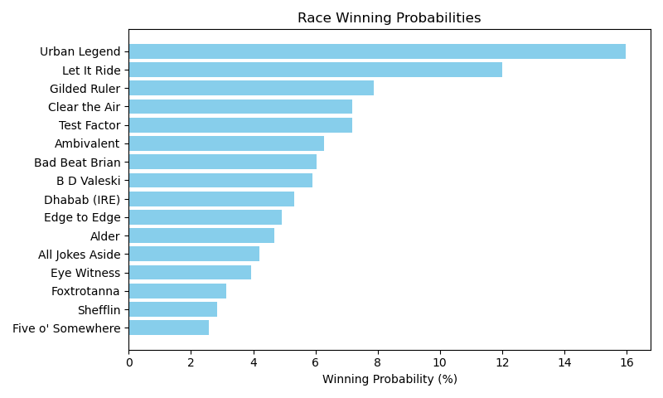

Exacta advice: key 11 → 9 (1 ticket)

NOTE: GCSF - Global Combined Speed Figure

# Race: TCD | 2025-04-30 | Race #5 | Post: 20:45 | Track: CHURCHILL DOWNS

Track: CHURCHILL DOWNS

|  |  |  |  |  |  |
| --- | --- | --- | --- | --- | --- |
| Program # | Horse Name | Morn Odds | GCSF | Model Score | Win Prob (%) |
| 1 | Another Monarch | 6-1 | 7.0 | 0.22 | 4.89 |
| 2 | Penrod | 5-1 | 4.0 | 0.53 | 6.05 |
| 3 | Farley Hall | 20-1 | 9.0 | -0.16 | 3.75 |
| 4 | Mighty Mo | 20-1 | 10.0 | -0.49 | 2.99 |
| 5 | Bottoms Up | 20-1 | 8.0 | -0.08 | 3.97 |
| 6 | Illini | 12-1 | 6.0 | 0.24 | 4.95 |
| 7 | Focusyn | 7-2 | 1.0 | 2.85 | 29.88 |
| 8 | Jackson's Roar | 20-1 | 5.0 | 0.32 | 5.25 |
| 9 | Perfect Prankster | 3-1 | 3.0 | 2.07 | 17.49 |
| 10 | Committee of One | 5-2 | 2.0 | 2.32 | 20.77 |

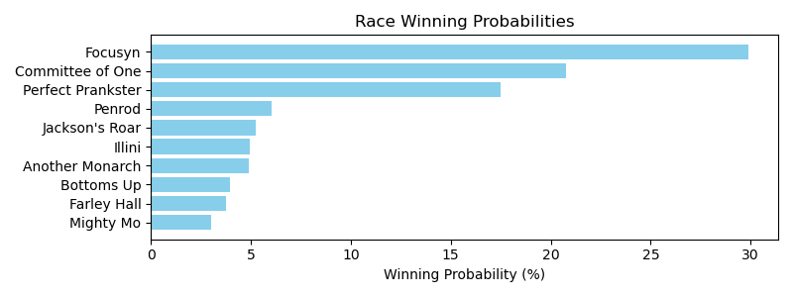

Exacta advice: key 7 → 10 (1 ticket)

NOTE: GCSF - Global Combined Speed Figure

# Race: TCD | 2025-04-30 | Race #6 | Post: 21:16 | Track: CHURCHILL DOWNS

Track: CHURCHILL DOWNS

|  |  |  |  |  |  |
| --- | --- | --- | --- | --- | --- |
| Program # | Horse Name | Morn Odds | GCSF | Model Score | Win Prob (%) |
| 1 | Sir Pistolero | 12-1 | 8.0 | 0.08 | 4.56 |
| 2 | Gift Certificate | 20-1 | 9.0 | -0.16 | 3.87 |
| 3 | Explosively | 4-1 | 3.0 | 1.82 | 15.12 |
| 4 | Manabi | 15-1 | 6.0 | 0.89 | 7.96 |
| 5 | Tiger's Legacy | 5-2 | 2.0 | 2.08 | 18.13 |
| 6 | Norwich | 5-1 | 4.0 | 1.60 | 13.02 |
| 7 | Shipman | 10-1 | 7.0 | 0.73 | 7.14 |
| 8 | Badgeball | 3-1 | 5.0 | 0.91 | 8.09 |
| 9 | Vertrauen | 8-1 | 1.0 | 2.37 | 22.12 |

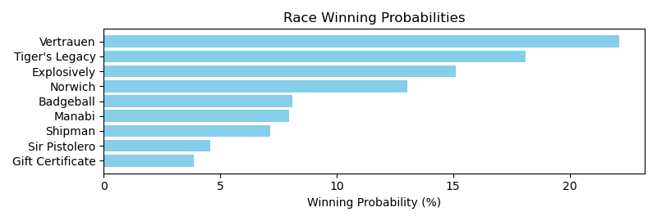

Exacta advice: key 9 → 5 (1 ticket)

NOTE: GCSF - Global Combined Speed Figure

# Race: TCD | 2025-04-30 | Race #7 | Post: 21:47 | Track: CHURCHILL DOWNS

Track: CHURCHILL DOWNS

|  |  |  |  |  |  |
| --- | --- | --- | --- | --- | --- |
| Program # | Horse Name | Morn Odds | GCSF | Model Score | Win Prob (%) |
| 1 | Likely Perspective (IRE) | 20-1 | 8.0 | 0.73 | 5.38 |
| 2 | Yes Indeed | 12-1 | 7.0 | 0.90 | 6.06 |
| 3 | Storm Miami (IRE) | 6-1 | 2.0 | 2.59 | 19.39 |
| 4 | Classic Q | 3-1 | 3.0 | 2.07 | 13.50 |
| 5 | New Rome | 4-1 | 5.0 | 1.36 | 8.31 |
| 6 | Dream On Stormy | 20-1 | 11.0 | -0.81 | 1.87 |
| 7 | Expatriate | 9-2 | 6.0 | 1.21 | 7.51 |
| 8 | Candy Cause | 30-1 | 9.0 | 0.19 | 3.71 |
| 9 | Hope Mission | 7-2 | 1.0 | 2.84 | 23.02 |
| 10 | Hay Stack | 15-1 | 4.0 | 1.45 | 8.84 |
| 11 | Take Shape | 20-1 | 10.0 | -0.44 | 2.41 |

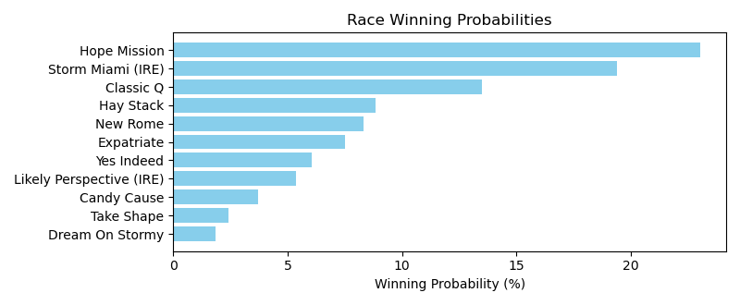

Exacta advice: key 9 → 3 (1 ticket)

NOTE: GCSF - Global Combined Speed Figure

# Race: TCD | 2025-04-30 | Race #8 | Post: 22:19 | Track: CHURCHILL DOWNS

Track: CHURCHILL DOWNS

|  |  |  |  |  |  |
| --- | --- | --- | --- | --- | --- |
| Program # | Horse Name | Morn Odds | GCSF | Model Score | Win Prob (%) |
| 1 | Honor Marie | 7-2 | 4.0 | 1.45 | 14.13 |
| 2 | Game Warden | 3-1 | 5.0 | 1.39 | 13.56 |
| 3 | Speed Bias | 4-1 | 2.0 | 1.70 | 16.72 |
| 4 | Warrior Johny | 10-1 | 3.0 | 1.52 | 14.76 |
| 5 | Lambeth | 2-1 | 1.0 | 1.94 | 19.82 |
| 6 | Le Gris | 20-1 | 8.0 | -0.14 | 4.73 |
| 7 | Baba Voss | 30-1 | 7.0 | 0.10 | 5.57 |
| 8 | Timeout | 8-1 | 6.0 | 1.05 | 10.72 |

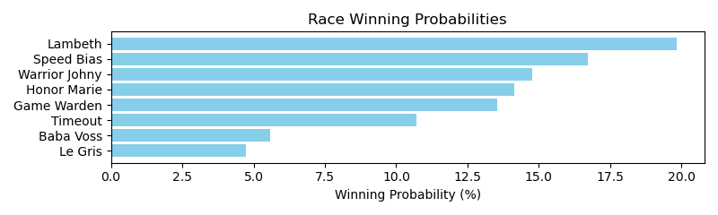

Exacta advice: key 5 → 3 (1 ticket)

NOTE: GCSF - Global Combined Speed Figure

# Race: TCD | 2025-04-30 | Race #9 | Post: 22:52 | Track: CHURCHILL DOWNS

Track: CHURCHILL DOWNS

|  |  |  |  |  |  |
| --- | --- | --- | --- | --- | --- |
| Program # | Horse Name | Morn Odds | GCSF | Model Score | Win Prob (%) |
| 1 | Out On Bail | 7-2 | 3.0 | 1.44 | 13.34 |
| 2 | Altobelli | 30-1 | 10.0 | -0.15 | 4.45 |
| 3 | Bridle a Butterfly | 30-1 | 11.0 | -0.32 | 3.97 |
| 4 | Normandy Coast | 8-1 | 5.0 | 0.76 | 8.33 |
| 5 | Coming in Hot | 12-1 | 4.0 | 1.06 | 10.25 |
| 6 | Makeit to Cheyenne | 4-1 | 2.0 | 1.87 | 17.91 |
| 7 | Jet Sweep Joe | 20-1 | 9.0 | -0.05 | 4.76 |
| 8 | Big Vince | 15-1 | 7.0 | 0.36 | 6.32 |
| 9 | Warheart | 12-1 | 8.0 | 0.08 | 5.23 |
| 10 | Perfect Force | 15-1 | 6.0 | 0.59 | 7.41 |
| 11 | Governor Sam | 13-8 | 1.0 | 1.88 | 18.02 |

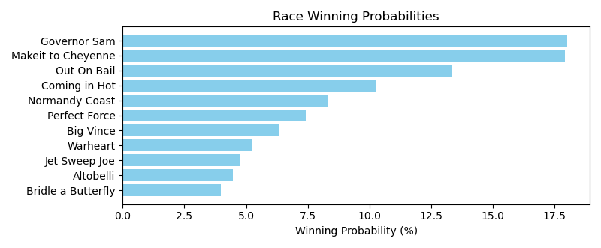

Exacta advice: box [11,6,1] (6 tickets)

NOTE: GCSF - Global Combined Speed Figure

# Race: TCD | 2025-04-30 | Race #10 | Post: 23:25 | Track: CHURCHILL DOWNS

Track: CHURCHILL DOWNS

|  |  |  |  |  |  |
| --- | --- | --- | --- | --- | --- |
| Program # | Horse Name | Morn Odds | GCSF | Model Score | Win Prob (%) |
| 1 | Bright Lights Joe | 9-2 | 7.0 | 1.08 | 6.92 |
| 2 | Mister Woodford | 20-1 | 8.0 | 1.02 | 6.65 |
| 3 | ZOHERE | 15-1 | 10.0 | -0.08 | 3.12 |
| 4 | Good News Rocket | 4-1 | 1.0 | 2.54 | 18.94 |
| 5 | Chado | 5-1 | 3.0 | 1.97 | 12.77 |
| 6 | Silent Breeze | 6-1 | 4.0 | 1.82 | 11.52 |
| 7 | Hasten | 3-1 | 5.0 | 1.73 | 10.83 |
| 8 | Activity | 8-1 | 2.0 | 2.06 | 13.62 |
| 9 | Beezer | 20-1 | 9.0 | 0.88 | 6.06 |
| 10 | Cajun Cruiser | 12-1 | 6.0 | 1.24 | 7.73 |
| 11 | CAUSE IMA BOSS | 20-1 | 11.0 | -0.84 | 1.85 |

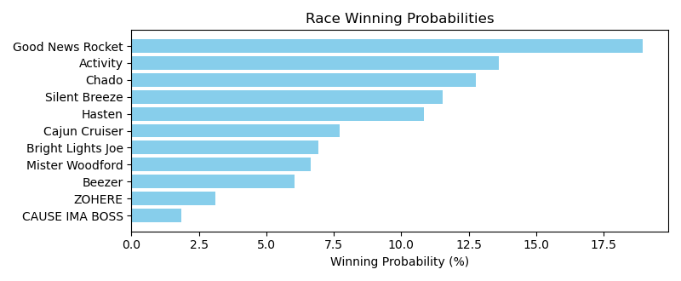

Exacta advice: key 4 → 8 (1 ticket)

NOTE: GCSF - Global Combined Speed Figure

# Race: TGP | 2025-04-26 | Race #1 | Post: 18:50 | Track: GULFSTREAM PARK

Track: GULFSTREAM PARK

|  |  |  |  |  |  |
| --- | --- | --- | --- | --- | --- |
| Program # | Horse Name | Morn Odds | GCSF | Model Score | Win Prob (%) |
| 1 | Blazing Tyreek | 7-2 | 3.0 | 2.22 | 12.91 |
| 2 | Loyal Clement | 10-1 | 4.0 | 2.20 | 12.71 |
| 3 | Triunvirato | 9-2 | 7.0 | 1.63 | 8.59 |
| 4 | Temperature Rising | 50-1 | 8.0 | 0.62 | 4.27 |
| 5 | Sunday Song | 6-1 | 6.0 | 1.77 | 9.46 |
| 6 | Plex | 3-1 | 1.0 | 3.04 | 22.66 |
| 7 | Guys Trip | 5-1 | 5.0 | 1.86 | 10.06 |
| 8 | Valiant Package | 20-1 | 9.0 | 0.61 | 4.26 |
| 9 | Blazing Hot | 6-1 | 2.0 | 2.45 | 15.08 |

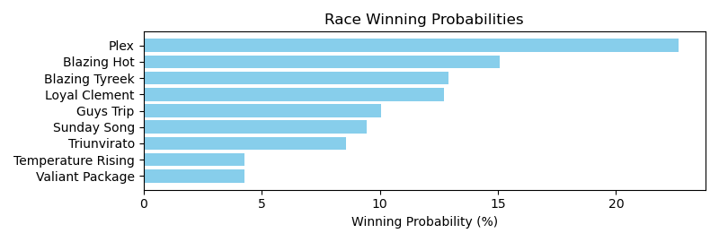

Exacta advice: key 6 → 9 (1 ticket)

NOTE: GCSF - Global Combined Speed Figure

# Race: TGP | 2025-04-26 | Race #2 | Post: 19:22 | Track: GULFSTREAM PARK

Track: GULFSTREAM PARK

|  |  |  |  |  |  |
| --- | --- | --- | --- | --- | --- |
| Program # | Horse Name | Morn Odds | GCSF | Model Score | Win Prob (%) |
| 1 | Last Run | 12-1 | 7.0 | 1.98 | 8.01 |
| 2 | Smooth an Easy | 20-1 | 10.0 | 1.65 | 6.41 |
| 3 | Midnight Maestro | 8-1 | 3.0 | 2.51 | 11.58 |
| 4 | Vino Grigio | 6-1 | 5.0 | 2.39 | 10.60 |
| 5 | Richard Ave | 5-2 | 1.0 | 2.92 | 15.32 |
| 6 | Relentless Raider | 6-1 | 4.0 | 2.49 | 11.41 |
| 7 | Renege | 15-1 | 6.0 | 1.98 | 8.04 |
| 8 | Pudding Lane | 6-1 | 8.0 | 1.84 | 7.26 |
| 9 | Sir Ascot | 15-1 | 9.0 | 1.80 | 7.10 |
| 10 | Imperatus | 7-2 | 2.0 | 2.82 | 14.26 |

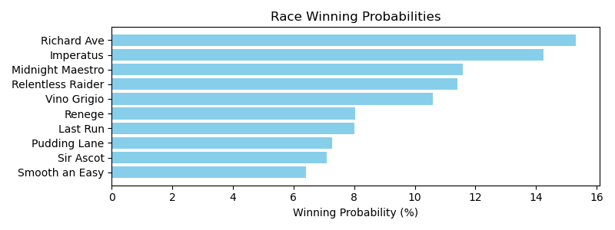

Exacta advice: key 5 → 10 (1 ticket)

NOTE: GCSF - Global Combined Speed Figure

# Race: TGP | 2025-04-26 | Race #3 | Post: 19:54 | Track: GULFSTREAM PARK

Track: GULFSTREAM PARK

|  |  |  |  |  |  |
| --- | --- | --- | --- | --- | --- |
| Program # | Horse Name | Morn Odds | GCSF | Model Score | Win Prob (%) |
| 1 | Lights of Broadway | 8-1 | 4.0 | 1.68 | 13.63 |
| 2 | Tapit Three Times | 15-1 | 7.0 | 0.44 | 5.80 |
| 3 | Bold Advance | 15-1 | 8.0 | 0.36 | 5.50 |
| 4 | Shankar | 7-2 | 2.0 | 1.99 | 16.86 |
| 5 | Clear Destination | 2-1 | 3.0 | 1.77 | 14.55 |
| 6 | Ocala Dream | 6-1 | 5.0 | 1.55 | 12.48 |
| 7 | Honesto | 6-1 | 6.0 | 1.21 | 9.85 |
| 8 | Nate the Great | 4-1 | 1.0 | 2.33 | 21.32 |

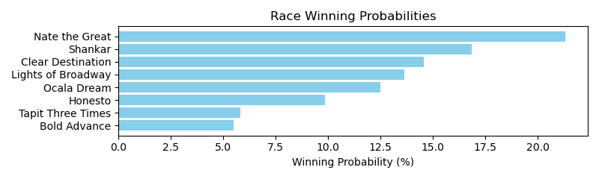

Exacta advice: key 8 → 4 (1 ticket)

NOTE: GCSF - Global Combined Speed Figure

# Race: TGP | 2025-04-26 | Race #4 | Post: 20:26 | Track: GULFSTREAM PARK

Track: GULFSTREAM PARK

|  |  |  |  |  |  |
| --- | --- | --- | --- | --- | --- |
| Program # | Horse Name | Morn Odds | GCSF | Model Score | Win Prob (%) |
| 1 | Meet Me in the Air | 8-1 | 4.0 | 2.08 | 15.11 |
| 2 | In Fact Sheza Zask | 30-1 | 9.0 | -0.51 | 2.53 |
| 3 | LIZ LOVES SHOPPING | 8-1 | 5.0 | 0.30 | 4.45 |
| 4 | Roxy | 2-1 | 3.0 | 2.10 | 15.31 |
| 5 | FURYS CHARM | 10-1 | 6.0 | -0.01 | 3.57 |
| 6 | LADY NETTI | 20-1 | 7.0 | -0.17 | 3.21 |
| 7 | Lois' Courage | 5-1 | 2.0 | 2.33 | 17.92 |
| 8 | Naval Hospital | 20-1 | 8.0 | -0.21 | 3.12 |
| 9 | Maerdama | 9-5 | 1.0 | 3.29 | 34.78 |

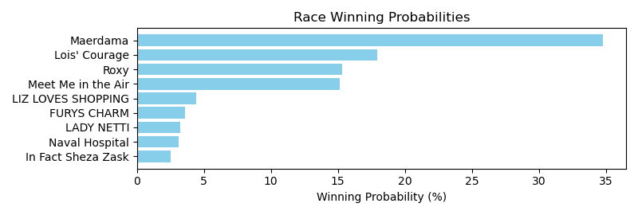

Exacta advice: key 9 → 7 (1 ticket)

NOTE: GCSF - Global Combined Speed Figure

# Race: TGP | 2025-04-26 | Race #5 | Post: 20:58 | Track: GULFSTREAM PARK

Track: GULFSTREAM PARK

|  |  |  |  |  |  |
| --- | --- | --- | --- | --- | --- |
| Program # | Horse Name | Morn Odds | GCSF | Model Score | Win Prob (%) |
| 1 | Beganingreenpoint | 10-1 | 6.0 | 0.22 | 8.04 |
| 2 | Todo Fino (CHI) | 13-8 | 1.0 | 2.07 | 28.84 |
| 3 | Dropkick Murphy | 4-1 | 2.0 | 1.26 | 16.44 |
| 4 | Golden Skull | 7-2 | 4.0 | 1.20 | 15.78 |
| 5 | Mayheminthepalace | 3-1 | 3.0 | 1.26 | 16.43 |
| 6 | Amor Lejano (ARG) | 20-1 | 7.0 | -0.20 | 6.04 |
| 7 | Cross Haste | 15-1 | 5.0 | 0.29 | 8.44 |

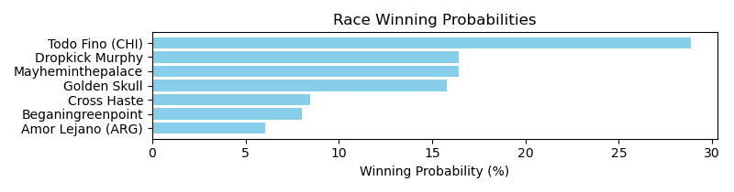

Exacta advice: key 2 → [3,5] (2 tickets)

NOTE: GCSF - Global Combined Speed Figure

# Race: TGP | 2025-04-26 | Race #6 | Post: 21:30 | Track: GULFSTREAM PARK

Track: GULFSTREAM PARK

|  |  |  |  |  |  |
| --- | --- | --- | --- | --- | --- |
| Program # | Horse Name | Morn Odds | GCSF | Model Score | Win Prob (%) |
| 1 | Eldest Son | 10-1 | 6.0 | 1.24 | 8.97 |
| 2 | MALCOLM X (PER) | 20-1 | 4.0 | 1.34 | 9.57 |
| 3 | Lorenz (BRZ) | 2-1 | 2.0 | 1.83 | 13.48 |
| 4 | Union Trail | 8-1 | 7.0 | 1.11 | 8.18 |
| 5 | J P Hellish | 15-1 | 5.0 | 1.31 | 9.42 |
| 6 | American Speed | 30-1 | 11.0 | 0.30 | 4.68 |
| 7 | McAvoy | 5-1 | 3.0 | 1.68 | 12.17 |
| 8 | He'spuregold | 4-1 | 1.0 | 1.86 | 13.74 |
| 9 | Izzy d'Oro | 20-1 | 10.0 | 0.66 | 6.02 |
| 10 | Just a Photo | 6-1 | 8.0 | 0.97 | 7.43 |
| 11 | Swift Delivery | 15-1 | 9.0 | 0.73 | 6.32 |

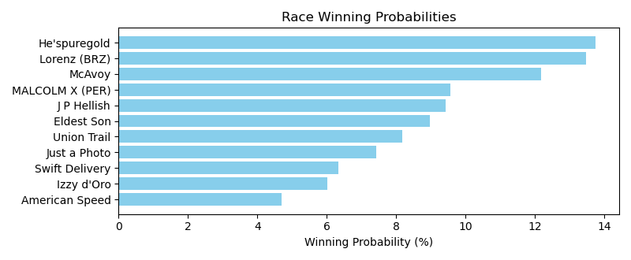

Exacta advice: box [8,3,7] (6 tickets)

NOTE: GCSF - Global Combined Speed Figure

# Race: TGP | 2025-04-26 | Race #7 | Post: 22:05 | Track: GULFSTREAM PARK

Track: GULFSTREAM PARK

|  |  |  |  |  |  |
| --- | --- | --- | --- | --- | --- |
| Program # | Horse Name | Morn Odds | GCSF | Model Score | Win Prob (%) |
| 1 | Steelin Bases | 6-1 | 1.0 | 2.71 | 24.84 |
| 2 | Dimanche Gras | 4-1 | 2.0 | 2.69 | 24.60 |
| 3 | Big Boy Jak | 5-1 | 5.0 | 1.05 | 7.92 |
| 4 | River of Time | 5-2 | 6.0 | 0.78 | 6.60 |
| 5 | Messagefromtheking | 15-1 | 3.0 | 2.02 | 15.46 |
| 6 | Tepeyac | 6-1 | 7.0 | 0.31 | 4.77 |
| 7 | Esperanzito | 7-2 | 4.0 | 1.64 | 11.94 |
| 8 | Hyper Venom | 15-1 | 8.0 | 0.01 | 3.87 |

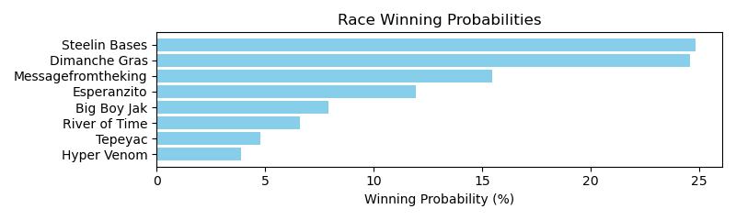

Exacta advice: box [1,2,5] (6 tickets)

NOTE: GCSF - Global Combined Speed Figure

# Race: TGP | 2025-04-26 | Race #8 | Post: 22:37 | Track: GULFSTREAM PARK

Track: GULFSTREAM PARK

|  |  |  |  |  |  |
| --- | --- | --- | --- | --- | --- |
| Program # | Horse Name | Morn Odds | GCSF | Model Score | Win Prob (%) |
| 1 | Starship Legend | 15-1 | 5.0 | -0.48 | 7.50 |
| 2 | Siljim | 15-1 | 6.0 | -0.58 | 6.99 |
| 3 | Nouveau Riche | 20-1 | 9.0 | -1.56 | 3.57 |
| 4 | Sonny's Goldenlady | 5-1 | 8.0 | -0.73 | 6.32 |
| 5 | Sevilla | 12-1 | 7.0 | -0.64 | 6.72 |
| 6 | Rocky Seas | 9-2 | 4.0 | -0.05 | 10.11 |
| 7 | Queen of Soul | 7-2 | 3.0 | 0.32 | 13.04 |
| 8 | Shiloh | 4-1 | 1.0 | 1.63 | 32.12 |
| 9 | Wink of an Eye | 3-1 | 2.0 | 0.39 | 13.64 |

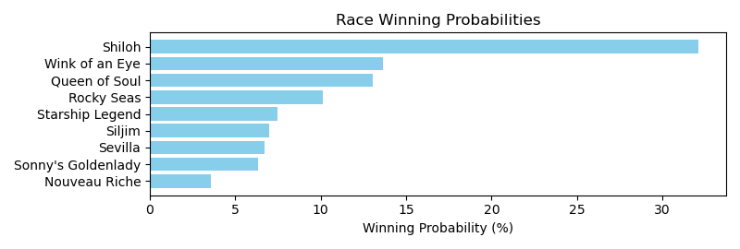

Exacta advice: key 8 → 9 (1 ticket)

NOTE: GCSF - Global Combined Speed Figure

# Race: TGP | 2025-04-26 | Race #9 | Post: 23:09 | Track: GULFSTREAM PARK

Track: GULFSTREAM PARK

|  |  |  |  |  |  |
| --- | --- | --- | --- | --- | --- |
| Program # | Horse Name | Morn Odds | GCSF | Model Score | Win Prob (%) |
| 1 | Swoonatra | 30-1 | 10.0 | 0.42 | 4.84 |
| 2 | De Regreso | 8-1 | 6.0 | 0.94 | 6.93 |
| 3 | Pursuit of Liberty | 12-1 | 9.0 | 0.48 | 5.05 |
| 4 | Sensitivity | 15-1 | 8.0 | 0.53 | 5.24 |
| 5 | Dancing N Dixie | 10-1 | 4.0 | 1.19 | 8.25 |
| 6 | Life's an Audible | 6-1 | 3.0 | 1.79 | 12.43 |
| 7 | Breath Away (GB) | 2-1 | 1.0 | 2.75 | 24.09 |
| 8 | Starship Agenda | 15-1 | 5.0 | 1.10 | 7.76 |
| 9 | Ozara (IRE) | 5-2 | 2.0 | 2.16 | 16.07 |
| 10 | Lady Firefoot | 12-1 | 7.0 | 0.61 | 5.50 |
| 11 | Puckered | 30-1 | 11.0 | 0.08 | 3.84 |

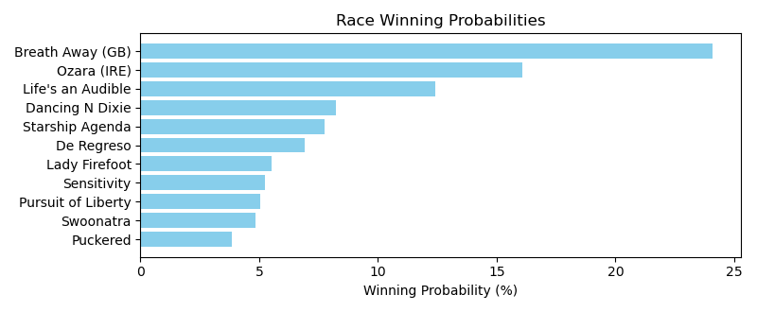

Exacta advice: key 7 → 9 (1 ticket)

NOTE: GCSF - Global Combined Speed Figure

# Race: TGP | 2025-04-26 | Race #10 | Post: 23:41 | Track: GULFSTREAM PARK

Track: GULFSTREAM PARK

|  |  |  |  |  |  |
| --- | --- | --- | --- | --- | --- |
| Program # | Horse Name | Morn Odds | GCSF | Model Score | Win Prob (%) |
| 1 | Miss San Gabriel | 4-1 | 1.0 | 1.79 | 15.86 |
| 2 | Pacific Princess | 5-1 | 2.0 | 1.77 | 15.65 |
| 3 | Amazin Queen | 10-1 | 7.0 | 0.87 | 8.47 |
| 4 | Worldly Beauty | 9-2 | 3.0 | 1.27 | 11.13 |
| 5 | Sense You Left | 10-1 | 8.0 | 0.86 | 8.41 |
| 6 | Misprint | 8-1 | 6.0 | 0.90 | 8.62 |
| 7 | Dontmesswithtess | 8-1 | 5.0 | 1.00 | 9.21 |
| 8 | Sheila's Mission | 7-2 | 4.0 | 1.23 | 10.82 |
| 9 | Khosea | 30-1 | 10.0 | -0.21 | 4.00 |
| 10 | Trendy | 12-1 | 9.0 | 0.76 | 7.83 |

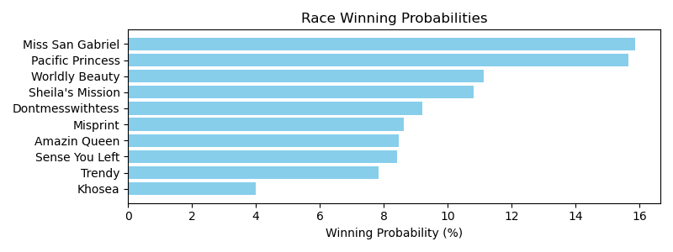

Exacta advice: box [1,2,4] (6 tickets)

NOTE: GCSF - Global Combined Speed Figure

# Race: TGP | 2025-04-26 | Race #11 | Post: 00:13 | Track: GULFSTREAM PARK

Track: GULFSTREAM PARK

|  |  |  |  |  |  |
| --- | --- | --- | --- | --- | --- |
| Program # | Horse Name | Morn Odds | GCSF | Model Score | Win Prob (%) |
| 1 | dh-Kid Cairo | 9-2 | 3.0 | 2.06 | 11.61 |
| 2 | Ehsaan | 10-1 | 7.0 | 1.14 | 6.16 |
| 3 | Game Keeper | 30-1 | 12.0 | 0.32 | 3.50 |
| 4 | O Captain | 10-1 | 6.0 | 1.37 | 7.19 |
| 5 | Omni King | 12-1 | 10.0 | 1.04 | 5.73 |
| 6 | Brawn | 10-1 | 4.0 | 1.80 | 9.69 |
| 7 | Centrodelantero | 15-1 | 1.0 | 2.73 | 18.34 |
| 8 | Themanupfront | 8-1 | 5.0 | 1.58 | 8.32 |
| 9 | Bring Me a Check | 4-1 | 2.0 | 2.12 | 12.05 |
| 10 | Barrage | 5-1 | 8.0 | 1.13 | 6.12 |
| 11 | Nantasket Beach | 6-1 | 11.0 | 0.96 | 5.42 |
| 12 | Bless America | 20-1 | 9.0 | 1.07 | 5.85 |

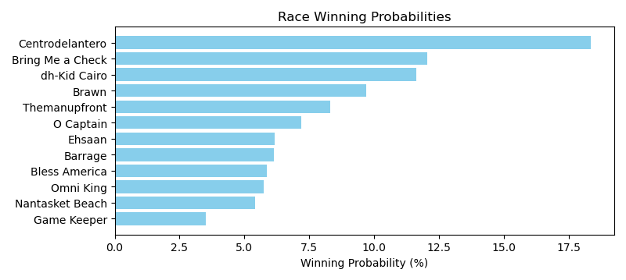

Exacta advice: key 7 → 9 (1 ticket)

NOTE: GCSF - Global Combined Speed Figure

# Race: TGP | 2025-04-26 | Race #12 | Post: 01:00 | Track: GULFSTREAM PARK

Track: GULFSTREAM PARK

|  |  |  |  |  |  |
| --- | --- | --- | --- | --- | --- |
| Program # | Horse Name | Morn Odds | GCSF | Model Score | Win Prob (%) |
| 1 | TATTOO RICH (ARG) | 12-1 | 7.0 | -0.12 | 6.30 |
| 2 | GALAN DE ALTAMIRA (ARG) | 15-1 | 6.0 | -0.06 | 6.57 |
| 3 | GOOGLE SEARCH (ARG) | 7-5 | 2.0 | 1.21 | 15.76 |
| 4 | VIENE FACIL (ARG) | 10-1 | 5.0 | 0.07 | 7.15 |
| 5 | HURACAN KEY (ARG) | 50-1 | 11.0 | -0.36 | 5.32 |
| 6 | HORSE REAL (ARG) | 3-1 | 1.0 | 1.26 | 16.24 |
| 7 | MORE SOUND (ARG) | 20-1 | 8.0 | -0.15 | 6.19 |
| 8 | INCLUDED (ARG) | 30-1 | 9.0 | -0.23 | 5.84 |
| 9 | STORMY BLOOD (ARG) | 30-1 | 12.0 | -0.41 | 5.15 |
| 10 | APOLO SKY (ARG) | 2-1 | 3.0 | 0.64 | 10.63 |
| 11 | TENNESSEE WHISKEY (ARG) | 15-1 | 10.0 | -0.32 | 5.50 |
| 12 | BRITANICO CHUCK (ARG) | 5-1 | 4.0 | 0.45 | 9.35 |

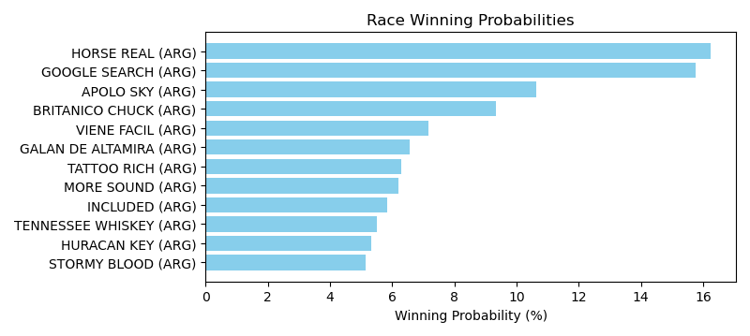

Exacta advice: box [6,3,10] (6 tickets)

NOTE: GCSF - Global Combined Speed Figure

# Race: TGP | 2025-04-26 | Race #13 | Post: 01:30 | Track: GULFSTREAM PARK

Track: GULFSTREAM PARK

|  |  |  |  |  |  |
| --- | --- | --- | --- | --- | --- |
| Program # | Horse Name | Morn Odds | GCSF | Model Score | Win Prob (%) |
| 1 | SLEEP AWAY (ARG) | 30-1 | 14.0 | -0.94 | 4.12 |
| 2 | CITY TATTOO (ARG) | 20-1 | 12.0 | -0.67 | 4.99 |
| 3 | DULOK (ARG) | 20-1 | 8.0 | -0.34 | 6.24 |
| 4 | SOY NOQUEADOR (ARG) | 10-1 | 9.0 | -0.37 | 6.11 |
| 5 | EXTRA PARTNER (ARG) | 15-1 | 11.0 | -0.55 | 5.40 |
| 6 | EL SOLIDARIO (ARG) | 10-1 | 3.0 | 0.40 | 10.36 |
| 7 | MR. TOMASITO (ARG) | 5-2 | 1.0 | 0.60 | 11.94 |
| 8 | HIT EMPENOSO (ARG) | 6-5 | 2.0 | 0.49 | 11.06 |
| 9 | PRINCIPE DE MONACO (ARG) | 5-1 | 4.0 | 0.19 | 8.98 |
| 10 | BRICIO (ARG) | 8-1 | 7.0 | -0.23 | 6.75 |
| 11 | SOLO RAP (ARG) | 10-1 | 6.0 | -0.19 | 6.92 |
| 12 | CANDY DARK (ARG) | 20-1 | 5.0 | -0.17 | 7.01 |
| 13 | SUPER MAR (ARG) | 50-1 | 10.0 | -0.50 | 5.60 |
| 14 | CLASE B (ARG) | 30-1 | 13.0 | -0.81 | 4.53 |

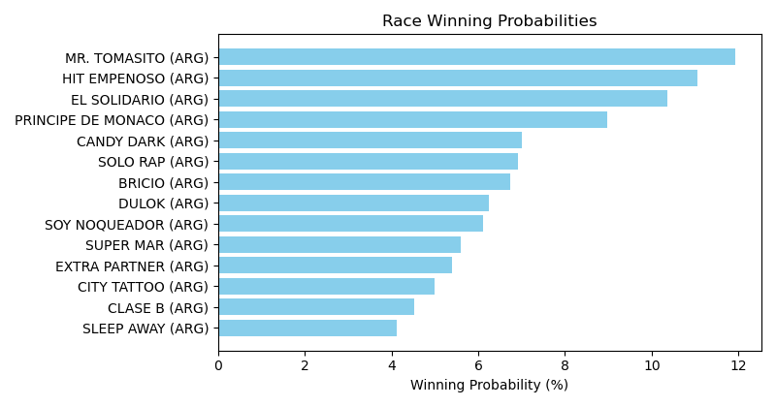

Exacta advice: key 7 → 8 (1 ticket)

NOTE: GCSF - Global Combined Speed Figure

# Race: TGP | 2025-04-27 | Race #1 | Post: 18:50 | Track: GULFSTREAM PARK

Track: GULFSTREAM PARK

|  |  |  |  |  |  |
| --- | --- | --- | --- | --- | --- |
| Program # | Horse Name | Morn Odds | GCSF | Model Score | Win Prob (%) |
| 1 | Dynamic Empire | 3-1 | 2.0 | 3.01 | 19.15 |
| 2 | Neigh Sayer | 12-1 | 7.0 | 1.49 | 6.75 |
| 3 | Willingness | 13-8 | 1.0 | 3.08 | 20.12 |
| 4 | Final Data | 4-1 | 5.0 | 2.26 | 11.44 |
| 5 | Starship Magellan | 8-1 | 4.0 | 2.39 | 12.51 |
| 6 | Game of Power | 20-1 | 8.0 | 1.11 | 5.20 |
| 7 | Devilment | 6-1 | 3.0 | 2.83 | 16.94 |
| 8 | Cryptonym | 15-1 | 6.0 | 1.72 | 7.90 |

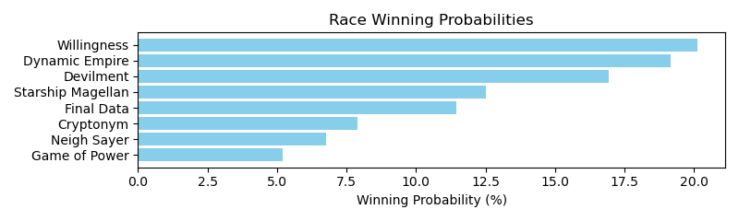

Exacta advice: box [3,1,7] (6 tickets)

NOTE: GCSF - Global Combined Speed Figure

# Race: TGP | 2025-04-27 | Race #2 | Post: 19:22 | Track: GULFSTREAM PARK

Track: GULFSTREAM PARK

|  |  |  |  |  |  |
| --- | --- | --- | --- | --- | --- |
| Program # | Horse Name | Morn Odds | GCSF | Model Score | Win Prob (%) |
| 1 | Close Up | 8-1 | 3.0 | 2.10 | 11.39 |
| 2 | Vekoma's War | 20-1 | 8.0 | 1.48 | 7.48 |
| 3 | Social Love | 12-1 | 7.0 | 1.78 | 9.18 |
| 4 | No Mo Cookies | 6-1 | 6.0 | 1.91 | 10.01 |
| 5 | Beaches and Pearls | 9-2 | 2.0 | 2.35 | 13.61 |
| 6 | Goal | 5-1 | 4.0 | 2.09 | 11.33 |
| 7 | DUDE ON THE RUN | 20-1 | 10.0 | -0.07 | 2.56 |
| 8 | Social Triumph | 12-1 | 9.0 | 0.60 | 4.06 |
| 9 | Dancing On Our Own | 6-1 | 5.0 | 1.97 | 10.46 |
| 10 | Scarlet Sands | 5-2 | 1.0 | 2.91 | 19.92 |

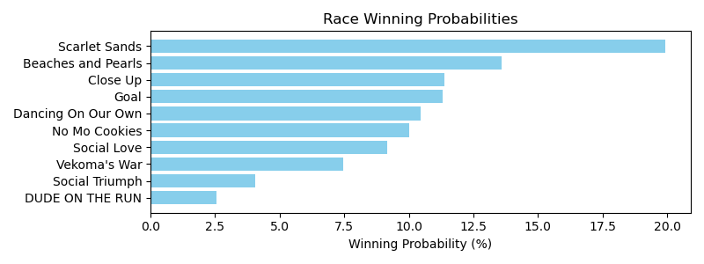

Exacta advice: key 10 → 5 (1 ticket)

NOTE: GCSF - Global Combined Speed Figure

# Race: TGP | 2025-04-27 | Race #3 | Post: 19:54 | Track: GULFSTREAM PARK

Track: GULFSTREAM PARK

|  |  |  |  |  |  |
| --- | --- | --- | --- | --- | --- |
| Program # | Horse Name | Morn Odds | GCSF | Model Score | Win Prob (%) |
| 1 | Spirit of Victory | 5-1 | 4.0 | 0.68 | 13.05 |
| 2 | Sassy Babe | 20-1 | 5.0 | -0.09 | 7.71 |
| 3 | Peggysue I Love U | 9-5 | 3.0 | 1.43 | 21.93 |
| 4 | Solidaria | 2-1 | 1.0 | 1.57 | 24.16 |
| 5 | Good Bright Flames | 20-1 | 7.0 | -1.08 | 3.91 |
| 6 | Love Paradox | 15-1 | 6.0 | -0.17 | 7.29 |
| 7 | Euphima (ARG) | 3-1 | 2.0 | 1.43 | 21.95 |

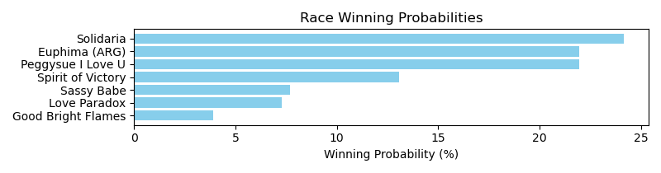

Exacta advice: key 4 → [7,3] (2 tickets)

NOTE: GCSF - Global Combined Speed Figure

# Race: TGP | 2025-04-27 | Race #4 | Post: 20:26 | Track: GULFSTREAM PARK

Track: GULFSTREAM PARK

|  |  |  |  |  |  |
| --- | --- | --- | --- | --- | --- |
| Program # | Horse Name | Morn Odds | GCSF | Model Score | Win Prob (%) |
| 1 | Mi Triguena | 7-2 | 3.0 | 1.03 | 15.17 |
| 2 | Compass Rises | 5-2 | 1.0 | 1.63 | 22.96 |
| 3 | Nanananabooboo | 15-1 | 7.0 | -0.94 | 3.90 |
| 4 | My Happy Holiday | 15-1 | 6.0 | 0.49 | 10.48 |
| 5 | Saweetie Girl | 30-1 | 8.0 | -1.02 | 3.70 |
| 6 | Some of It | 20-1 | 4.0 | 0.93 | 14.12 |
| 7 | China Blue | 3-1 | 5.0 | 0.74 | 12.42 |
| 8 | Evanora | 2-1 | 2.0 | 1.21 | 17.24 |

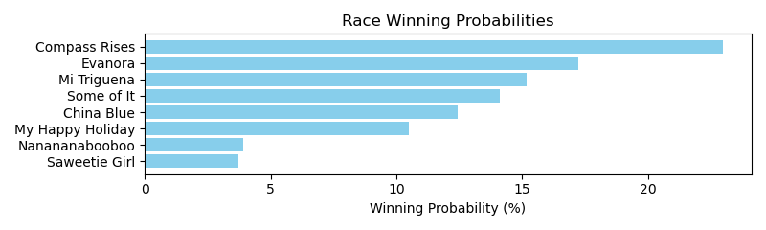

Exacta advice: key 2 → 8 (1 ticket)

NOTE: GCSF - Global Combined Speed Figure

# Race: TGP | 2025-04-27 | Race #5 | Post: 21:02 | Track: GULFSTREAM PARK

Track: GULFSTREAM PARK

|  |  |  |  |  |  |
| --- | --- | --- | --- | --- | --- |
| Program # | Horse Name | Morn Odds | GCSF | Model Score | Win Prob (%) |
| 1 | Cajun Fantasy | 12-1 | 6.0 | -0.19 | 7.31 |
| 2 | Star of Saturn | 5-1 | 4.0 | 1.06 | 17.26 |
| 3 | Emirates Affair | 7-5 | 1.0 | 1.61 | 25.31 |
| 4 | Amy the Butcher | 20-1 | 7.0 | -0.87 | 4.57 |
| 5 | Major Pryce | 4-1 | 2.0 | 1.22 | 19.37 |
| 6 | Atalanta Alexandra | 7-2 | 3.0 | 1.09 | 17.63 |
| 7 | Just a Philly | 6-1 | 5.0 | 0.03 | 8.54 |

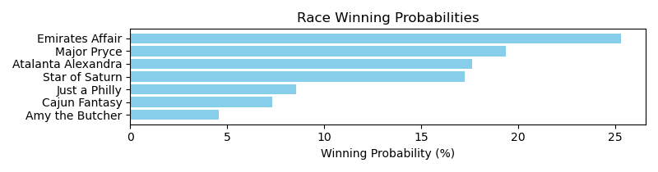

Exacta advice: key 3 → 5 (1 ticket)

NOTE: GCSF - Global Combined Speed Figure

# Race: TGP | 2025-04-27 | Race #6 | Post: 21:32 | Track: GULFSTREAM PARK

Track: GULFSTREAM PARK

|  |  |  |  |  |  |
| --- | --- | --- | --- | --- | --- |
| Program # | Horse Name | Morn Odds | GCSF | Model Score | Win Prob (%) |
| 1 | Outlaw Country | 15-1 | 6.0 | 1.35 | 8.14 |
| 2 | Refuel | 5-2 | 3.0 | 2.00 | 12.78 |
| 3 | Like a Saltshaker | 20-1 | 9.0 | 0.96 | 6.22 |
| 4 | Louie the Sun King | 15-1 | 10.0 | 0.38 | 4.18 |
| 5 | Seaver | 15-1 | 8.0 | 1.17 | 7.22 |
| 6 | Yes I Am Free | 5-1 | 4.0 | 1.78 | 10.96 |
| 7 | If Not for Luck | 10-1 | 5.0 | 1.60 | 9.69 |
| 8 | Abrir Caminos (CHI) | 12-1 | 7.0 | 1.24 | 7.59 |
| 9 | Panther Island | 9-2 | 2.0 | 2.27 | 15.33 |
| 10 | Mattingly | 3-1 | 1.0 | 2.49 | 17.88 |

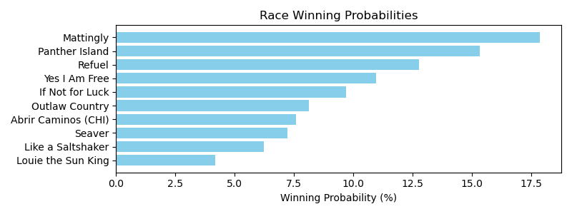

Exacta advice: key 10 → 9 (1 ticket)

NOTE: GCSF - Global Combined Speed Figure

# Race: TGP | 2025-04-27 | Race #7 | Post: 22:04 | Track: GULFSTREAM PARK

Track: GULFSTREAM PARK

|  |  |  |  |  |  |
| --- | --- | --- | --- | --- | --- |
| Program # | Horse Name | Morn Odds | GCSF | Model Score | Win Prob (%) |
| 1 | Duty | 9-2 | 5.0 | 2.22 | 11.74 |
| 2 | Cash the Money | 4-1 | 1.0 | 3.61 | 30.53 |
| 3 | Social Majesty | 10-1 | 2.0 | 2.83 | 17.85 |
| 4 | Folktale | 6-1 | 4.0 | 2.27 | 12.14 |
| 5 | Daham | 5-2 | 3.0 | 2.66 | 15.84 |
| 6 | Nudge | 2-1 | 6.0 | 1.90 | 9.41 |
| 7 | The Rizzer | 15-1 | 7.0 | -0.03 | 2.49 |

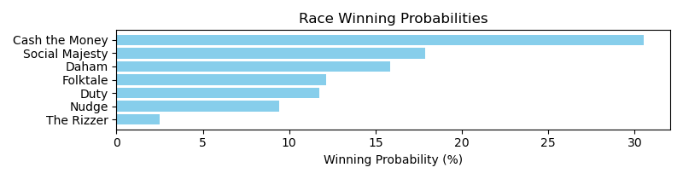

Exacta advice: key 2 → 3 (1 ticket)

NOTE: GCSF - Global Combined Speed Figure

# Race: TGP | 2025-04-27 | Race #8 | Post: 22:36 | Track: GULFSTREAM PARK

Track: GULFSTREAM PARK

|  |  |  |  |  |  |
| --- | --- | --- | --- | --- | --- |
| Program # | Horse Name | Morn Odds | GCSF | Model Score | Win Prob (%) |
| 1 | Great Venezuela | 2-1 | 1.0 | 2.72 | 26.87 |
| 2 | Tiffany Gold | 5-1 | 2.0 | 2.32 | 20.38 |
| 3 | Drum Roll | 15-1 | 5.0 | 1.09 | 8.72 |
| 4 | Heaven Rules | 20-1 | 6.0 | 0.92 | 7.77 |
| 5 | Mrs. Gambolini | 13-8 | 4.0 | 1.39 | 10.77 |
| 6 | Musical Design | 20-1 | 8.0 | -0.03 | 4.05 |
| 7 | Oh Darlin | 20-1 | 7.0 | 0.75 | 6.90 |
| 8 | Sol Hope | 9-2 | 3.0 | 1.83 | 14.54 |

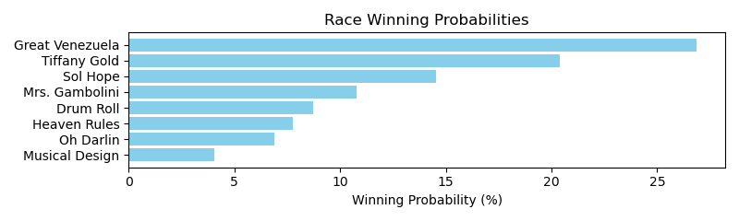

Exacta advice: key 1 → 2 (1 ticket)

NOTE: GCSF - Global Combined Speed Figure

# Race: TGP | 2025-04-27 | Race #9 | Post: 23:08 | Track: GULFSTREAM PARK

Track: GULFSTREAM PARK

|  |  |  |  |  |  |
| --- | --- | --- | --- | --- | --- |
| Program # | Horse Name | Morn Odds | GCSF | Model Score | Win Prob (%) |
| 1 | Ensign Parker | 7-2 | 2.0 | 1.58 | 14.04 |
| 2 | Cosmic Speculation | 10-1 | 8.0 | 0.43 | 6.35 |
| 3 | Lunar Rocket | 8-1 | 5.0 | 0.96 | 9.15 |
| 4 | Jet Wings | 9-2 | 3.0 | 1.26 | 11.28 |
| 5 | Dr Oseran | 10-1 | 4.0 | 1.02 | 9.56 |
| 6 | Midnight Special | 20-1 | 7.0 | 0.80 | 8.20 |
| 7 | Neophyte | 8-1 | 6.0 | 0.88 | 8.68 |
| 8 | Aries Reigns | 30-1 | 10.0 | -0.45 | 3.47 |
| 9 | Oxymore | 50-1 | 9.0 | 0.12 | 5.14 |
| 10 | Ship Cadet | 13-8 | 1.0 | 2.37 | 24.12 |

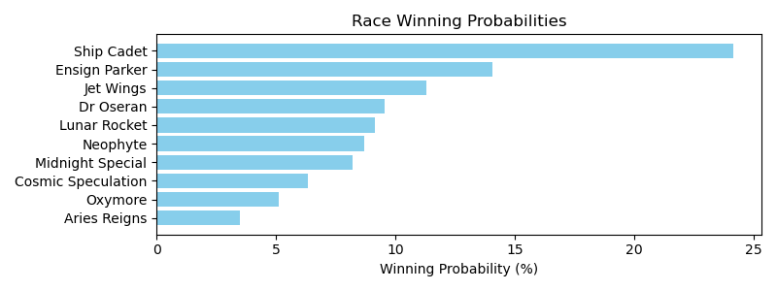

Exacta advice: key 10 → 1 (1 ticket)

NOTE: GCSF - Global Combined Speed Figure

# Race: TGP | 2025-04-27 | Race #10 | Post: 23:40 | Track: GULFSTREAM PARK

Track: GULFSTREAM PARK

|  |  |  |  |  |  |
| --- | --- | --- | --- | --- | --- |
| Program # | Horse Name | Morn Odds | GCSF | Model Score | Win Prob (%) |
| 1 | Clear Vision | 6-1 | 6.0 | 1.45 | 11.08 |
| 2 | Fredo | 5-1 | 5.0 | 1.59 | 12.20 |
| 3 | Mister Abarrio | 6-1 | 4.0 | 1.60 | 12.27 |
| 4 | Battle Call | 4-1 | 7.0 | 0.95 | 7.89 |
| 5 | Uncle John | 9-2 | 2.0 | 1.90 | 15.11 |
| 6 | My Sea Cottage (IRE) | 5-1 | 1.0 | 2.06 | 16.83 |
| 7 | Alley Oop Johnny | 7-2 | 3.0 | 1.60 | 12.32 |
| 8 | Game Keeper | 30-1 | 9.0 | 0.33 | 5.13 |
| 9 | Swashbuckle | 30-1 | 8.0 | 0.82 | 7.17 |

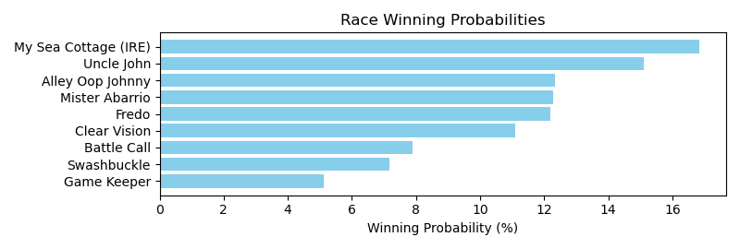

Exacta advice: key 6 → 5 (1 ticket)

NOTE: GCSF - Global Combined Speed Figure

# Race: TGP | 2025-04-27 | Race #11 | Post: 00:25 | Track: GULFSTREAM PARK

Track: GULFSTREAM PARK

|  |  |  |  |  |  |
| --- | --- | --- | --- | --- | --- |
| Program # | Horse Name | Morn Odds | GCSF | Model Score | Win Prob (%) |
| 1 | ALAMBRADORA SI (ARG) | 8-1 | 3.0 | 0.40 | 15.75 |
| 2 | MAXIMIANA (ARG) | 3-1 | 2.0 | 0.52 | 17.09 |
| 3 | CONI BELLA (ARG) | 30-1 | 8.0 | -0.93 | 6.31 |
| 4 | SAFE WITH ME (ARG) | 9-5 | 1.0 | 0.54 | 17.32 |
| 5 | PERSOFONA (ARG) | 5-2 | 4.0 | 0.33 | 15.02 |
| 6 | DIVA DUNE (ARG) | 12-1 | 6.0 | -0.43 | 8.91 |
| 7 | ESPADA Y ORO (ARG) | 12-1 | 7.0 | -0.53 | 8.28 |
| 8 | QUARRY GIRL (ARG) | 10-1 | 5.0 | -0.08 | 11.31 |

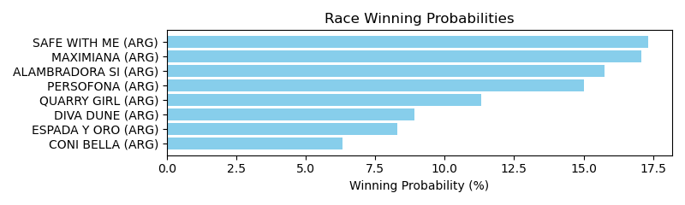

Exacta advice: box [4,2,1] (6 tickets)

NOTE: GCSF - Global Combined Speed Figure

# Race: TGP | 2025-04-27 | Race #12 | Post: 00:55 | Track: GULFSTREAM PARK

Track: GULFSTREAM PARK

|  |  |  |  |  |  |
| --- | --- | --- | --- | --- | --- |
| Program # | Horse Name | Morn Odds | GCSF | Model Score | Win Prob (%) |
| 1 | ATOMIC LEVEL (ARG) | 5-2 | 2.0 | 0.90 | 18.34 |
| 2 | GAZA HURRICANE (ARG) | 50-1 | 9.0 | -0.82 | 5.61 |
| 3 | DEMOB (ARG) | 9-2 | 4.0 | 0.37 | 12.77 |
| 4 | SIRO'S KING (ARG) | 7-2 | 1.0 | 0.91 | 18.51 |
| 5 | MOUNTAIN PRINCE (ARG) | 6-1 | 5.0 | 0.10 | 10.57 |
| 6 | EL SENTIMENTAL (ARG) | 30-1 | 8.0 | -0.82 | 5.61 |
| 7 | EXCELSUM HIT (ARG) | 2-1 | 3.0 | 0.51 | 14.00 |
| 8 | PORTENO Y BAILARIN (ARG) | 20-1 | 7.0 | -0.57 | 6.68 |
| 9 | MERCATO SEA (ARG) | 30-1 | 6.0 | -0.32 | 7.91 |

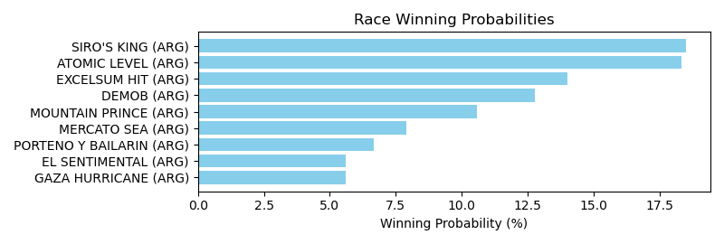

Exacta advice: box [4,1,7] (6 tickets)

NOTE: GCSF - Global Combined Speed Figure

# Race: IND | 2025-04-29 | Race #1 | Post: 20:10 | Track: HORSESHOE INDIANAPOLIS

Track: HORSESHOE INDIANAPOLIS

|  |  |  |  |  |  |
| --- | --- | --- | --- | --- | --- |
| Program # | Horse Name | Morn Odds | GCSF | Model Score | Win Prob (%) |
| 1 | Paige Perfect | 7-2 | 2.0 | 2.28 | 22.72 |
| 2 | Mi Sargento | 20-1 | 5.0 | 0.97 | 9.24 |
| 3 | Michigan Left | 9-2 | 3.0 | 1.20 | 10.82 |
| 4 | THE LAST ONE | 6-1 | 7.0 | 0.14 | 5.24 |
| 5 | Midnitestateofmind | 4-5 | 1.0 | 2.82 | 33.07 |
| 6 | Work Release | 15-1 | 4.0 | 1.16 | 10.53 |
| 7 | Taneycomo | 20-1 | 6.0 | 0.83 | 8.39 |

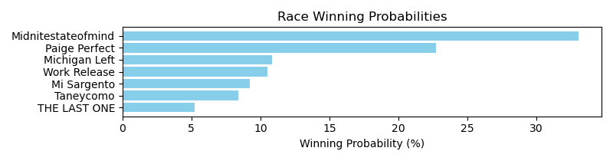

Exacta advice: key 5 → 1 (1 ticket)

NOTE: GCSF - Global Combined Speed Figure

# Race: IND | 2025-04-29 | Race #2 | Post: 20:41 | Track: HORSESHOE INDIANAPOLIS

Track: HORSESHOE INDIANAPOLIS

|  |  |  |  |  |  |
| --- | --- | --- | --- | --- | --- |
| Program # | Horse Name | Morn Odds | GCSF | Model Score | Win Prob (%) |
| 1 | Jova | 20-1 | 5.0 | 0.40 | 11.71 |
| 2 | Do Ya Wanna Dance | 9-2 | 3.0 | 0.83 | 15.76 |
| 3 | Cielo Azul | 6-1 | 4.0 | 0.63 | 13.79 |
| 4 | Loademupjustice | 30-1 | 6.0 | -0.02 | 8.81 |
| 5 | Cupid's Runaway | 2-5 | 1.0 | 1.65 | 27.81 |
| 6 | D'oro's Wish | 10-1 | 2.0 | 1.32 | 22.12 |

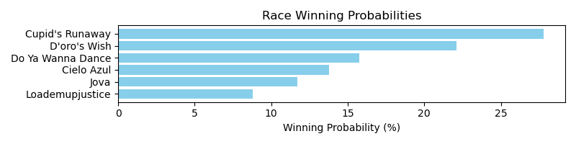

Exacta advice: key 5 → 6 (1 ticket)

NOTE: GCSF - Global Combined Speed Figure

# Race: IND | 2025-04-29 | Race #3 | Post: 21:12 | Track: HORSESHOE INDIANAPOLIS

Track: HORSESHOE INDIANAPOLIS

|  |  |  |  |  |  |
| --- | --- | --- | --- | --- | --- |
| Program # | Horse Name | Morn Odds | GCSF | Model Score | Win Prob (%) |
| 1 | Commander Storm | 20-1 | 6.0 | 0.30 | 7.02 |
| 2 | Prove Right | 20-1 | 7.0 | -0.77 | 3.35 |
| 3 | Alcove | 12-1 | 4.0 | 1.48 | 15.76 |
| 4 | Bushido | 5-1 | 5.0 | 1.33 | 14.25 |
| 5 | Big Hat Willie | 4-5 | 1.0 | 2.11 | 24.39 |
| 6 | Field Day | 9-2 | 3.0 | 1.56 | 16.69 |
| 7 | Swift as I Am | 6-1 | 2.0 | 1.71 | 18.52 |

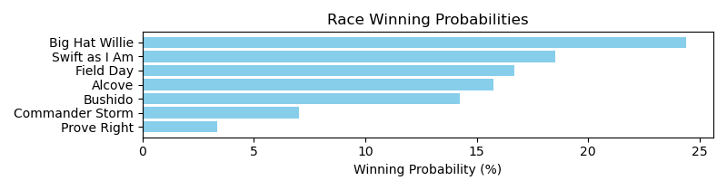

Exacta advice: key 5 → 7 (1 ticket)

NOTE: GCSF - Global Combined Speed Figure

# Race: IND | 2025-04-29 | Race #4 | Post: 21:43 | Track: HORSESHOE INDIANAPOLIS

Track: HORSESHOE INDIANAPOLIS

|  |  |  |  |  |  |
| --- | --- | --- | --- | --- | --- |
| Program # | Horse Name | Morn Odds | GCSF | Model Score | Win Prob (%) |
| 1 | Captain Case | 30-1 | 6.0 | 1.08 | 7.78 |
| 2 | Tabloid City | 6-5 | 1.0 | 3.06 | 30.38 |
| 3 | Left Pocket Money | 5-2 | 2.0 | 2.27 | 17.69 |
| 4 | Cosmic Lute | 30-1 | 8.0 | 0.16 | 4.14 |
| 5 | Mor Success | 5-1 | 3.0 | 2.23 | 17.20 |
| 6 | Improbable Cause | 30-1 | 7.0 | 0.32 | 4.62 |
| 7 | Thundering Heart | 8-1 | 5.0 | 1.09 | 7.83 |
| 8 | No Rematch | 6-1 | 4.0 | 1.49 | 10.35 |

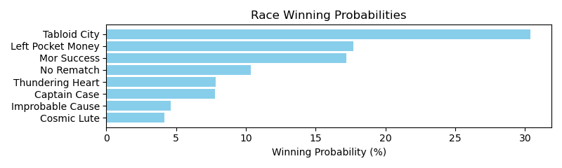

Exacta advice: key 2 → [3,5] (2 tickets)

NOTE: GCSF - Global Combined Speed Figure

# Race: IND | 2025-04-29 | Race #5 | Post: 22:14 | Track: HORSESHOE INDIANAPOLIS

Track: HORSESHOE INDIANAPOLIS

|  |  |  |  |  |  |
| --- | --- | --- | --- | --- | --- |
| Program # | Horse Name | Morn Odds | GCSF | Model Score | Win Prob (%) |
| 1 | One Finale | 7-2 | 2.0 | 2.08 | 22.29 |
| 2 | LA NANA | 30-1 | 7.0 | -0.58 | 3.57 |
| 3 | La Medora | 20-1 | 6.0 | -0.37 | 4.12 |
| 4 | Abra Abra | 2-1 | 3.0 | 2.02 | 21.32 |
| 5 | Stella Di Luce | 5-1 | 4.0 | 1.52 | 15.13 |
| 6 | Mabel Sue Jolene | 15-1 | 5.0 | 0.47 | 7.31 |
| 7 | Julee Forever | 13-8 | 1.0 | 2.32 | 26.26 |

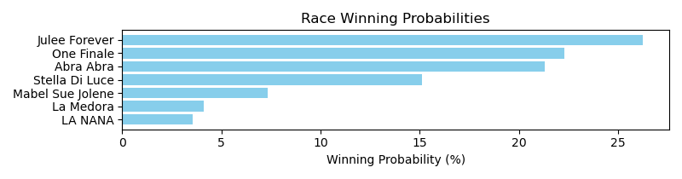

Exacta advice: key 7 → 1 (1 ticket)

NOTE: GCSF - Global Combined Speed Figure

# Race: IND | 2025-04-29 | Race #6 | Post: 22:45 | Track: HORSESHOE INDIANAPOLIS

Track: HORSESHOE INDIANAPOLIS

|  |  |  |  |  |  |
| --- | --- | --- | --- | --- | --- |
| Program # | Horse Name | Morn Odds | GCSF | Model Score | Win Prob (%) |
| 1 | R Guy Max | 7-2 | 2.0 | 1.94 | 15.56 |
| 2 | Bozaano | 10-1 | 3.0 | 1.68 | 12.98 |
| 3 | SIR XANDER | 4-1 | 7.0 | 0.55 | 5.97 |
| 4 | Playing the Angles | 5-1 | 5.0 | 1.38 | 10.59 |
| 5 | Billy's Reward | 20-1 | 6.0 | 0.62 | 6.24 |
| 6 | Henry the Hank | 3-1 | 1.0 | 2.77 | 27.49 |
| 7 | AMAZING MIKE | 12-1 | 9.0 | -0.20 | 3.55 |
| 8 | Thiscatsabullet | 6-1 | 4.0 | 1.55 | 11.86 |
| 9 | Whiskey Tryst | 20-1 | 8.0 | 0.50 | 5.76 |

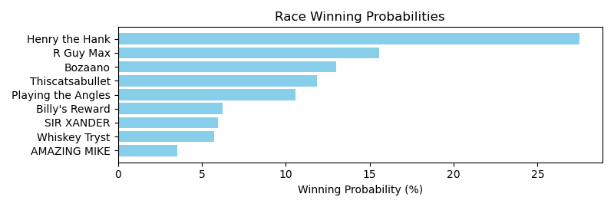

Exacta advice: key 6 → 1 (1 ticket)

NOTE: GCSF - Global Combined Speed Figure

# Race: IND | 2025-04-29 | Race #7 | Post: 23:16 | Track: HORSESHOE INDIANAPOLIS

Track: HORSESHOE INDIANAPOLIS

|  |  |  |  |  |  |
| --- | --- | --- | --- | --- | --- |
| Program # | Horse Name | Morn Odds | GCSF | Model Score | Win Prob (%) |
| 1 | Woodaz | 4-5 | 1.0 | 2.57 | 34.41 |
| 2 | RYAN'S WISH | 10-1 | 8.0 | -0.02 | 5.78 |
| 3 | Embrujo de Amor | 20-1 | 9.0 | -0.27 | 4.87 |
| 4 | SLEEPY | 5-1 | 4.0 | 0.38 | 7.64 |
| 5 | INNISFREE LAD | 15-1 | 6.0 | 0.15 | 6.53 |
| 6 | HEZ ALL OUT | 6-1 | 5.0 | 0.38 | 7.60 |
| 7 | Air Charger | 30-1 | 10.0 | -1.02 | 2.91 |
| 8 | Kentucky Justice | 20-1 | 3.0 | 1.00 | 11.68 |
| 9 | The Irish Ranter | 30-1 | 7.0 | 0.13 | 6.40 |
| 10 | Bourbon Curiosity | 10-1 | 2.0 | 1.06 | 12.19 |

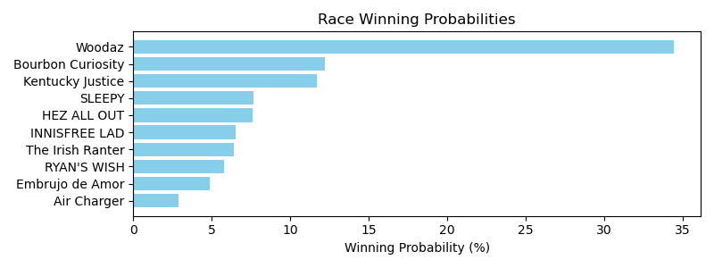

Exacta advice: key 1 → 10 (1 ticket)

NOTE: GCSF - Global Combined Speed Figure

# Race: IND | 2025-04-29 | Race #8 | Post: 23:47 | Track: HORSESHOE INDIANAPOLIS

Track: HORSESHOE INDIANAPOLIS

|  |  |  |  |  |  |
| --- | --- | --- | --- | --- | --- |
| Program # | Horse Name | Morn Odds | GCSF | Model Score | Win Prob (%) |
| 1 | Signature Day | 20-1 | 8.0 | -2.10 | 1.90 |
| 2 | Off Pitch | 15-1 | 5.0 | 0.08 | 8.46 |
| 3 | Galoshes | 15-1 | 7.0 | -0.69 | 4.99 |
| 4 | Crickenberger | 10-1 | 2.0 | 1.16 | 17.82 |
| 5 | Don't Miss Out | 8-1 | 3.0 | 1.05 | 16.58 |
| 6 | Watcher | 6-1 | 4.0 | 0.30 | 9.86 |
| 7 | Lil Gin N Class | 5-8 | 1.0 | 2.10 | 34.03 |
| 8 | First Elkton | 12-1 | 6.0 | -0.34 | 6.36 |

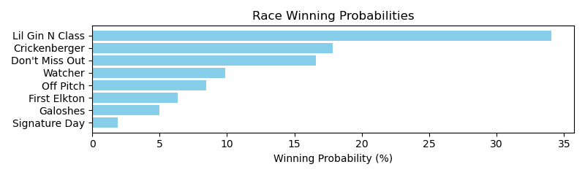

Exacta advice: key 7 → 4 (1 ticket)

NOTE: GCSF - Global Combined Speed Figure

# Race: IND | 2025-04-30 | Race #1 | Post: 20:10 | Track: HORSESHOE INDIANAPOLIS

Track: HORSESHOE INDIANAPOLIS

|  |  |  |  |  |  |
| --- | --- | --- | --- | --- | --- |
| Program # | Horse Name | Morn Odds | GCSF | Model Score | Win Prob (%) |
| 1 | Kykeon | 5-2 | 4.0 | 1.04 | 14.45 |
| 2 | Fierce Assault | 6-1 | 5.0 | 0.80 | 12.27 |
| 3 | Wissam Sharaf | 15-1 | 6.0 | 0.45 | 9.60 |
| 4 | My Brother Keith | 8-1 | 3.0 | 1.29 | 17.15 |
| 5 | Sixwillberich | 9-2 | 2.0 | 1.51 | 19.90 |
| 6 | Tiverton | 12-1 | 7.0 | -0.62 | 4.59 |
| 7 | Daddy Justify | 9-5 | 1.0 | 1.66 | 22.04 |

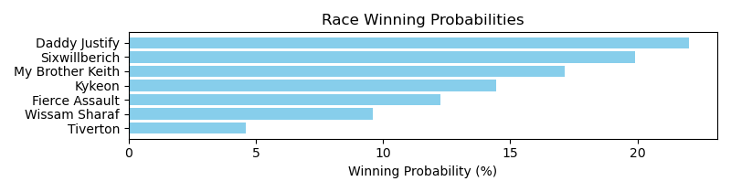

Exacta advice: key 7 → 5 (1 ticket)

NOTE: GCSF - Global Combined Speed Figure

# Race: IND | 2025-04-30 | Race #2 | Post: 20:41 | Track: HORSESHOE INDIANAPOLIS

Track: HORSESHOE INDIANAPOLIS

|  |  |  |  |  |  |
| --- | --- | --- | --- | --- | --- |
| Program # | Horse Name | Morn Odds | GCSF | Model Score | Win Prob (%) |
| 1 | Unbridled Devine | 7-2 | 1.0 | 1.49 | 20.32 |
| 2 | Beach Kitten | 2-1 | 3.0 | 1.30 | 17.87 |
| 3 | The Princess Says | 5-1 | 4.0 | 1.08 | 15.33 |
| 4 | Lucky Phoenix | 6-1 | 5.0 | 0.49 | 10.19 |
| 5 | Flat Discount | 12-1 | 6.0 | 0.25 | 8.64 |
| 6 | Pioneer Parade | 4-1 | 2.0 | 1.48 | 20.23 |
| 7 | Banned From Midway | 10-1 | 7.0 | 0.02 | 7.41 |

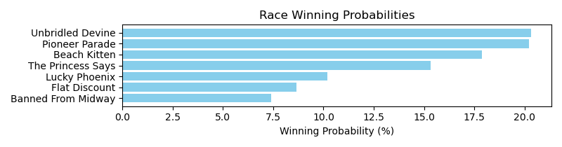

Exacta advice: box [1,6,2] (6 tickets)

NOTE: GCSF - Global Combined Speed Figure

# Race: IND | 2025-04-30 | Race #3 | Post: 21:12 | Track: HORSESHOE INDIANAPOLIS

Track: HORSESHOE INDIANAPOLIS

|  |  |  |  |  |  |
| --- | --- | --- | --- | --- | --- |
| Program # | Horse Name | Morn Odds | GCSF | Model Score | Win Prob (%) |
| 1 | Trew Violence | 6-1 | 6.0 | -0.03 | 10.21 |
| 2 | El Sargento | 8-1 | 4.0 | 0.14 | 11.48 |
| 3 | Special Caliber | 5-1 | 3.0 | 0.44 | 14.07 |
| 4 | Up to No Good | 7-2 | 2.0 | 0.60 | 15.75 |
| 5 | Canisius | 8-1 | 5.0 | 0.13 | 11.35 |
| 6 | Pagode | 2-1 | 1.0 | 1.52 | 29.69 |
| 7 | Via Del Corso | 9-2 | 7.0 | -0.49 | 7.45 |

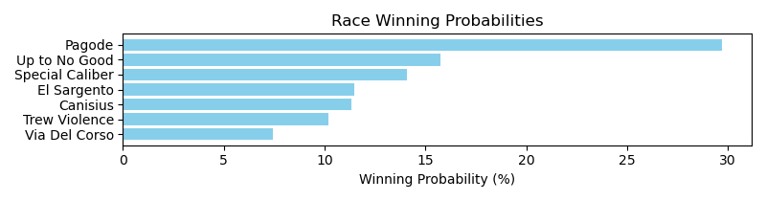

Exacta advice: key 6 → 4 (1 ticket)

NOTE: GCSF - Global Combined Speed Figure

# Race: IND | 2025-04-30 | Race #4 | Post: 21:43 | Track: HORSESHOE INDIANAPOLIS

Track: HORSESHOE INDIANAPOLIS

|  |  |  |  |  |  |
| --- | --- | --- | --- | --- | --- |
| Program # | Horse Name | Morn Odds | GCSF | Model Score | Win Prob (%) |
| 1 | Shipshape | 20-1 | 5.0 | 0.21 | 9.18 |
| 2 | Me and Chili | 15-1 | 7.0 | -0.16 | 7.12 |
| 3 | Zappinit | 7-5 | 1.0 | 1.47 | 21.87 |
| 4 | Mr Negativity | 6-1 | 4.0 | 0.68 | 12.72 |
| 5 | Good Sugar | 5-1 | 3.0 | 1.13 | 17.33 |
| 6 | Turbonator | 10-1 | 8.0 | -0.26 | 6.65 |
| 7 | Binge | 7-2 | 2.0 | 1.15 | 17.51 |
| 8 | For Mama | 12-1 | 6.0 | -0.06 | 7.62 |

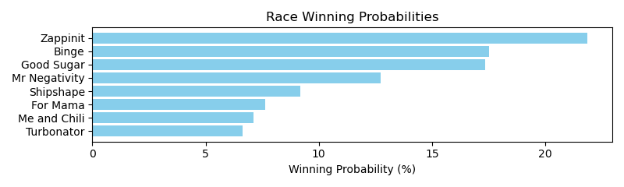

Exacta advice: key 3 → [7,5] (2 tickets)

NOTE: GCSF - Global Combined Speed Figure

# Race: IND | 2025-04-30 | Race #5 | Post: 22:14 | Track: HORSESHOE INDIANAPOLIS

Track: HORSESHOE INDIANAPOLIS

|  |  |  |  |  |  |
| --- | --- | --- | --- | --- | --- |
| Program # | Horse Name | Morn Odds | GCSF | Model Score | Win Prob (%) |
| 1 | Monarch of Motion | 15-1 | 8.0 | -0.40 | 5.28 |
| 2 | Barca Billy | 12-1 | 6.0 | -0.22 | 5.97 |
| 3 | Slink | 10-1 | 5.0 | 0.19 | 7.93 |
| 4 | Justiceonemoretime | 5-1 | 2.0 | 1.05 | 14.35 |
| 5 | Star Review | 9-2 | 4.0 | 0.67 | 11.00 |
| 6 | Specialty Act | 6-1 | 7.0 | -0.22 | 5.96 |
| 7 | Neon Leon | 13-8 | 3.0 | 1.01 | 13.94 |
| 8 | Covert Kid | 6-1 | 1.0 | 2.37 | 35.56 |

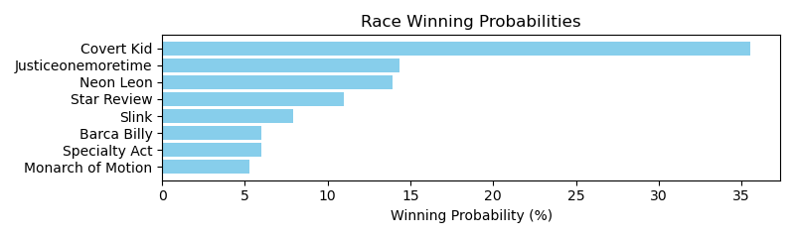

Exacta advice: key 8 → [4,7] (2 tickets)

NOTE: GCSF - Global Combined Speed Figure

# Race: IND | 2025-04-30 | Race #6 | Post: 22:45 | Track: HORSESHOE INDIANAPOLIS

Track: HORSESHOE INDIANAPOLIS

|  |  |  |  |  |  |
| --- | --- | --- | --- | --- | --- |
| Program # | Horse Name | Morn Odds | GCSF | Model Score | Win Prob (%) |
| 1 | Littleransomsfire | 3-1 | 1.0 | 2.48 | 23.92 |
| 2 | B On the Loose | 9-2 | 4.0 | 1.69 | 13.92 |
| 3 | TIGER JUMPER | 5-1 | 5.0 | 1.28 | 10.51 |
| 4 | Mc Baby | 20-1 | 8.0 | -1.00 | 2.18 |
| 5 | SEASHELLSALLYSELLS | 15-1 | 6.0 | 0.87 | 7.92 |
| 6 | Micki Valentine | 2-1 | 2.0 | 2.23 | 20.25 |
| 7 | RIBS AND SAUSAGE | 12-1 | 7.0 | 0.54 | 6.32 |
| 8 | Lady Artist | 8-1 | 3.0 | 1.80 | 14.98 |

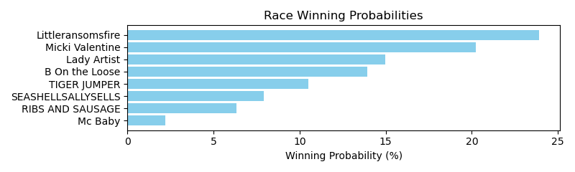

Exacta advice: key 1 → 6 (1 ticket)

NOTE: GCSF - Global Combined Speed Figure

# Race: IND | 2025-04-30 | Race #7 | Post: 23:16 | Track: HORSESHOE INDIANAPOLIS

Track: HORSESHOE INDIANAPOLIS

|  |  |  |  |  |  |
| --- | --- | --- | --- | --- | --- |
| Program # | Horse Name | Morn Odds | GCSF | Model Score | Win Prob (%) |
| 1 | July Four | 20-1 | 5.0 | 0.85 | 7.67 |
| 2 | Quibble | 30-1 | 6.0 | 0.75 | 7.16 |
| 3 | Gold Delight | 7-2 | 1.0 | 2.09 | 17.92 |
| 4 | FAT CHANCE | 4-1 | 7.0 | 0.58 | 6.37 |
| 5 | Copper Chrome | 15-1 | 4.0 | 1.29 | 10.38 |
| 6 | No Self Control | 15-1 | 2.0 | 1.84 | 15.19 |
| 7 | OSO FANCY | 5-1 | 8.0 | 0.42 | 5.69 |
| 8 | Hazel My Candy | 8-1 | 3.0 | 1.80 | 14.68 |
| 9 | LO MACHAR | 12-1 | 11.0 | -0.33 | 3.40 |
| 10 | Yotowin | 30-1 | 12.0 | -0.81 | 2.44 |
| 11 | SWIFT BEE | 12-1 | 10.0 | -0.07 | 4.06 |
| 12 | AD LITTERAM | 6-1 | 9.0 | 0.24 | 5.04 |

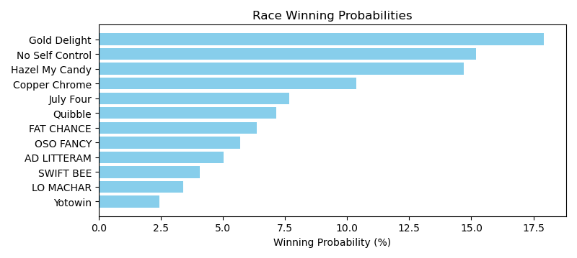

Exacta advice: key 3 → [6,8] (2 tickets)

NOTE: GCSF - Global Combined Speed Figure

# Race: IND | 2025-04-30 | Race #8 | Post: 23:47 | Track: HORSESHOE INDIANAPOLIS

Track: HORSESHOE INDIANAPOLIS

|  |  |  |  |  |  |
| --- | --- | --- | --- | --- | --- |
| Program # | Horse Name | Morn Odds | GCSF | Model Score | Win Prob (%) |
| 1 | Sarah's Smiles | 30-1 | 10.0 | -1.38 | 2.64 |
| 2 | She's a Whirlwind | 30-1 | 11.0 | -2.02 | 1.70 |
| 3 | Redhotjustice | 15-1 | 9.0 | -0.51 | 4.81 |
| 4 | D' Kitten | 5-2 | 3.0 | 0.75 | 11.46 |
| 5 | Enchanted Melody | 6-1 | 6.0 | 0.21 | 7.92 |
| 6 | Mygaljustice | 4-1 | 7.0 | 0.11 | 7.38 |
| 7 | Luna Diva | 8-1 | 1.0 | 1.60 | 20.55 |
| 8 | Lotta Latte | 20-1 | 4.0 | 0.70 | 11.10 |
| 9 | Hard Truth Wins | 5-1 | 5.0 | 0.33 | 8.59 |
| 10 | No Trust | 15-1 | 2.0 | 1.33 | 17.11 |
| 11 | When's Forever | 10-1 | 8.0 | -0.02 | 6.74 |

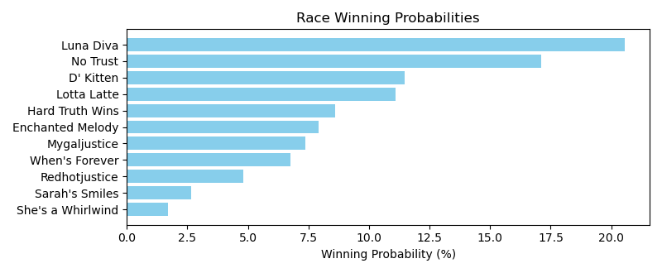

Exacta advice: key 7 → 10 (1 ticket)

NOTE: GCSF - Global Combined Speed Figure

# Race: LRL | 2025-04-26 | Race #1 | Post: 18:10 | Track: LAUREL PARK

Track: LAUREL PARK

|  |  |  |  |  |  |
| --- | --- | --- | --- | --- | --- |
| Program # | Horse Name | Morn Odds | GCSF | Model Score | Win Prob (%) |
| 1 | Before the Wind | 15-1 | 13.0 | -0.27 | 1.71 |
| 2 | Fortheloveofrun | 20-1 | 11.0 | 0.77 | 3.48 |
| 3 | Simply Disregarded | 9-2 | 1.0 | 3.18 | 18.23 |
| 4 | Cooper | 5-1 | 4.0 | 2.58 | 12.08 |
| 5 | REGALO PERFETTO | 12-1 | 12.0 | -0.26 | 1.72 |
| 6 | Kitty's Son | 8-1 | 6.0 | 1.89 | 7.53 |
| 7 | Tell 'Em I'm Comin | 3-1 | 3.0 | 2.61 | 12.36 |
| 8 | Mach Two Blue | 30-1 | 10.0 | 0.78 | 3.51 |
| 9 | Richard Feynman | 7-2 | 8.0 | 1.02 | 4.13 |
| 10 | JURISPRUDENCE | 5-2 | 9.0 | 0.80 | 3.56 |
| 11 | Then What Time | 6-1 | 5.0 | 2.48 | 11.27 |
| 12 | Egypt | 7-2 | 2.0 | 2.83 | 14.37 |
| 13 | Arjay | 8-1 | 7.0 | 1.57 | 6.05 |

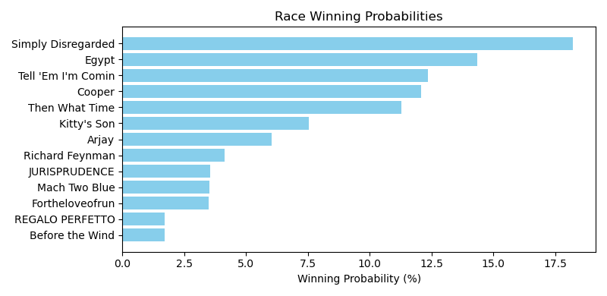

Exacta advice: key 3 → 12 (1 ticket)

NOTE: GCSF - Global Combined Speed Figure

# Race: LRL | 2025-04-26 | Race #2 | Post: 18:38 | Track: LAUREL PARK

Track: LAUREL PARK

|  |  |  |  |  |  |
| --- | --- | --- | --- | --- | --- |
| Program # | Horse Name | Morn Odds | GCSF | Model Score | Win Prob (%) |
| 1 | Destined to Dance | 30-1 | 6.0 | -0.96 | 5.67 |
| 2 | Lachicafortequila | 8-1 | 4.0 | 0.15 | 12.17 |
| 3 | Voodoo Priestess | 20-1 | 5.0 | -0.59 | 7.29 |
| 4 | Gilda's Girl | 5-2 | 1.0 | 1.45 | 29.69 |
| 5 | Magic Eight Ball | 13-8 | 2.0 | 0.96 | 21.24 |
| 6 | Ghee for the Win | 9-5 | 3.0 | 0.92 | 20.65 |
| 7 | Rascallion | 15-1 | 7.0 | -1.75 | 3.29 |

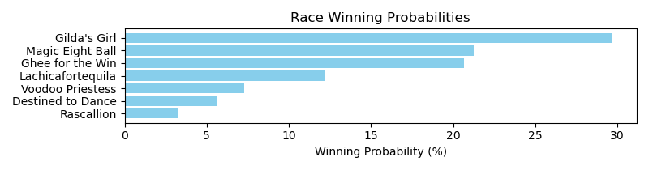

Exacta advice: key 4 → [5,6] (2 tickets)

NOTE: GCSF - Global Combined Speed Figure

# Race: LRL | 2025-04-26 | Race #3 | Post: 19:06 | Track: LAUREL PARK

Track: LAUREL PARK

|  |  |  |  |  |  |
| --- | --- | --- | --- | --- | --- |
| Program # | Horse Name | Morn Odds | GCSF | Model Score | Win Prob (%) |
| 1 | Hyteck Prince | 4-1 | 4.0 | 1.04 | 9.66 |
| 2 | Elusive Image | 20-1 | 12.0 | -0.59 | 3.16 |
| 3 | This Is Good | 8-1 | 7.0 | 0.68 | 7.54 |
| 4 | Colonel Bob | 5-1 | 11.0 | -0.58 | 3.19 |
| 5 | J R Jone Z | 8-1 | 8.0 | 0.06 | 4.92 |
| 6 | Lothario | 6-1 | 5.0 | 1.00 | 9.39 |
| 7 | Contemplation | 7-2 | 1.0 | 2.13 | 20.53 |
| 8 | Just for the Money | 15-1 | 13.0 | -0.68 | 2.97 |
| 9 | Bourbon Boss | 10-1 | 6.0 | 0.87 | 8.60 |
| 10 | Robert's Moon | 20-1 | 10.0 | -0.14 | 4.29 |
| 11 | Mo Joke | 15-1 | 2.0 | 1.21 | 10.89 |
| 12 | Lou's Birthday | 12-1 | 9.0 | 0.02 | 4.79 |
| 13 | Watch Out World | 3-1 | 3.0 | 1.10 | 10.09 |

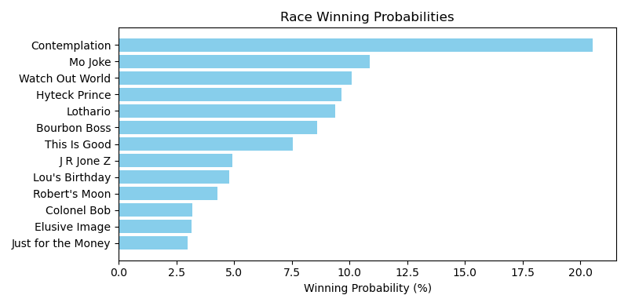

Exacta advice: key 7 → 11 (1 ticket)

NOTE: GCSF - Global Combined Speed Figure

# Race: LRL | 2025-04-26 | Race #4 | Post: 19:37 | Track: LAUREL PARK

Track: LAUREL PARK

|  |  |  |  |  |  |
| --- | --- | --- | --- | --- | --- |
| Program # | Horse Name | Morn Odds | GCSF | Model Score | Win Prob (%) |
| 1 | Joe the Jet | 6-1 | 3.0 | 1.26 | 16.96 |
| 2 | Night Preacher | 12-1 | 8.0 | -1.00 | 3.58 |
| 3 | Set for Life | 8-1 | 6.0 | 0.12 | 7.72 |
| 4 | Square Slice | 12-1 | 5.0 | 0.23 | 8.39 |
| 5 | Magic Express | 3-2 | 1.0 | 2.03 | 28.80 |
| 6 | Fear Nothing | 10-1 | 7.0 | -0.53 | 4.95 |
| 7 | Uncle Cat | 5-1 | 4.0 | 0.82 | 12.54 |
| 8 | Medagooch | 7-2 | 2.0 | 1.27 | 17.06 |

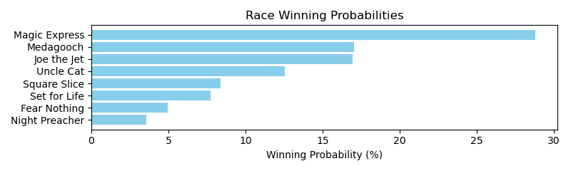

Exacta advice: key 5 → [8,1] (2 tickets)

NOTE: GCSF - Global Combined Speed Figure

# Race: LRL | 2025-04-26 | Race #5 | Post: 20:09 | Track: LAUREL PARK

Track: LAUREL PARK

|  |  |  |  |  |  |
| --- | --- | --- | --- | --- | --- |
| Program # | Horse Name | Morn Odds | GCSF | Model Score | Win Prob (%) |
| 1 | Birravino Blvd | 20-1 | 8.0 | 1.20 | 7.10 |
| 2 | Virginia City | 8-1 | 7.0 | 1.20 | 7.11 |
| 3 | Derz Smart | 12-1 | 13.0 | -0.26 | 2.60 |
| 4 | Mr. Mendelslew | 15-1 | 14.0 | -0.35 | 2.45 |
| 5 | Collection Day | 5-2 | 4.0 | 1.51 | 8.81 |
| 6 | Whizbang | 15-1 | 11.0 | 0.48 | 4.32 |
| 7 | Hanksdiviningrod | 9-2 | 6.0 | 1.22 | 7.21 |
| 8 | Soleil Volant | 3-1 | 3.0 | 1.74 | 10.27 |
| 9 | Coringa | 6-1 | 5.0 | 1.28 | 7.51 |
| 10 | Rampagius | 7-2 | 1.0 | 2.26 | 14.71 |
| 11 | Vax a Nation | 5-1 | 2.0 | 1.74 | 10.30 |
| 12 | Artwell | 15-1 | 12.0 | 0.24 | 3.67 |
| 13 | Bonded | 20-1 | 15.0 | -0.56 | 2.11 |
| 14 | Chris's Revenge | 5-1 | 9.0 | 0.95 | 5.98 |
| 15 | Modica | 10-1 | 10.0 | 0.92 | 5.86 |

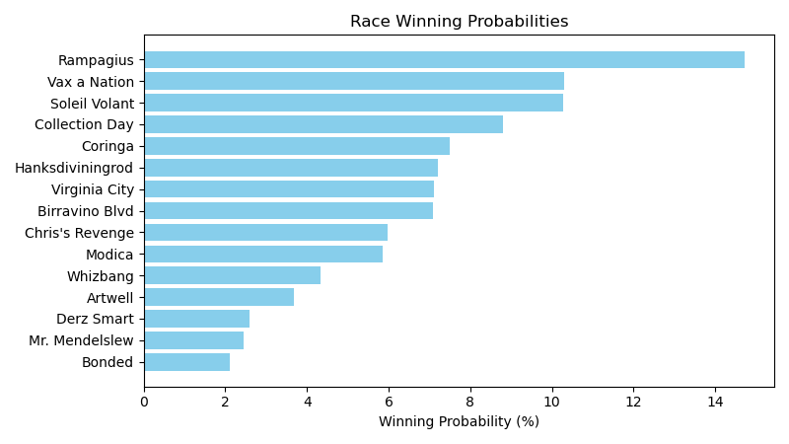

Exacta advice: key 10 → [11,8] (2 tickets)

NOTE: GCSF - Global Combined Speed Figure

# Race: LRL | 2025-04-26 | Race #6 | Post: 20:40 | Track: LAUREL PARK

Track: LAUREL PARK

|  |  |  |  |  |  |
| --- | --- | --- | --- | --- | --- |
| Program # | Horse Name | Morn Odds | GCSF | Model Score | Win Prob (%) |
| 1 | D Hopper | 6-1 | 9.0 | 1.23 | 4.95 |
| 2 | City Panda | 10-1 | 8.0 | 1.66 | 6.67 |
| 3 | GREAT ARTIST | 15-1 | 14.0 | 0.34 | 2.69 |
| 4 | ROYAL RENEGADE | 4-1 | 12.0 | 0.68 | 3.39 |
| 5 | Elon | 7-2 | 3.0 | 2.44 | 11.43 |
| 6 | ONE TRUE DUDE | 15-1 | 16.0 | -0.04 | 2.06 |
| 7 | Finn d'Oro | 12-1 | 10.0 | 1.08 | 4.48 |
| 8 | Dats Tap | 8-1 | 5.0 | 1.84 | 7.54 |
| 9 | Superlastingsecret | 5-1 | 7.0 | 1.68 | 6.74 |
| 10 | Z BOGDAN | 12-1 | 15.0 | 0.30 | 2.62 |
| 11 | Basic Miles | 10-1 | 1.0 | 2.65 | 13.13 |
| 12 | Warrior's Notion | 30-1 | 11.0 | 1.05 | 4.38 |
| 13 | RAILROAD INN | 8-1 | 13.0 | 0.43 | 2.86 |
| 14 | Enduring Gold | 2-1 | 4.0 | 1.92 | 7.96 |
| 15 | Knockanara | 3-1 | 2.0 | 2.53 | 12.11 |
| 16 | Minister | 6-1 | 6.0 | 1.73 | 7.00 |

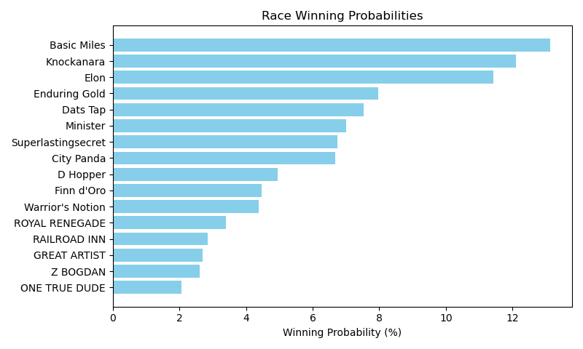

Exacta advice: key 11 → 15 (1 ticket)

NOTE: GCSF - Global Combined Speed Figure

# Race: LRL | 2025-04-26 | Race #7 | Post: 21:12 | Track: LAUREL PARK

Track: LAUREL PARK

|  |  |  |  |  |  |
| --- | --- | --- | --- | --- | --- |
| Program # | Horse Name | Morn Odds | GCSF | Model Score | Win Prob (%) |
| 1 | Gold Lightning | 6-5 | 1.0 | 2.40 | 25.25 |
| 2 | Sister Supream | 5-2 | 4.0 | 1.67 | 15.34 |
| 3 | Wine and Roses | 12-1 | 2.0 | 2.18 | 21.76 |
| 4 | Chase by the Moon | 15-1 | 6.0 | 0.78 | 8.32 |
| 5 | Rowsie Express | 7-2 | 3.0 | 1.67 | 15.35 |
| 6 | Skip Thru Da Fire | 5-1 | 5.0 | 1.54 | 13.97 |

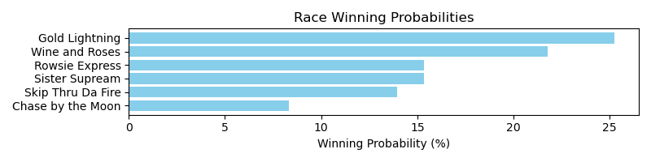

Exacta advice: key 1 → 3 (1 ticket)

NOTE: GCSF - Global Combined Speed Figure

# Race: LRL | 2025-04-26 | Race #8 | Post: 21:44 | Track: LAUREL PARK

Track: LAUREL PARK

|  |  |  |  |  |  |
| --- | --- | --- | --- | --- | --- |
| Program # | Horse Name | Morn Odds | GCSF | Model Score | Win Prob (%) |
| 1 | Monster Mason | 10-1 | 9.0 | 0.74 | 4.96 |
| 2 | Island d'Lite | 6-1 | 2.0 | 2.00 | 11.83 |
| 3 | The Wolfman | 2-1 | 3.0 | 1.59 | 8.93 |
| 4 | Star Weaver | 15-1 | 14.0 | -0.12 | 2.75 |
| 5 | Cactus | 4-1 | 4.0 | 1.52 | 8.53 |
| 6 | Power Back | 15-1 | 11.0 | 0.50 | 4.21 |
| 7 | Joe Phillips | 20-1 | 13.0 | 0.10 | 3.21 |
| 8 | Silverbullettwenty | 20-1 | 16.0 | -0.21 | 2.60 |
| 9 | Speakerit | 30-1 | 8.0 | 1.08 | 6.26 |
| 10 | Rad Paisley | 6-1 | 7.0 | 1.35 | 7.56 |
| 11 | Boss Is a Pal | 5-2 | 1.0 | 2.15 | 13.17 |
| 12 | dh-Up in Flames | 20-1 | 15.0 | -0.12 | 2.75 |
| 13 | Southern Horse (ARG) | 9-2 | 5.0 | 1.35 | 7.59 |
| 14 | Bourbon Currency | 30-1 | 10.0 | 0.53 | 4.31 |
| 15 | Sue Loves Barbados | 6-1 | 6.0 | 1.35 | 7.56 |
| 16 | Louisianimal | 15-1 | 12.0 | 0.35 | 3.80 |

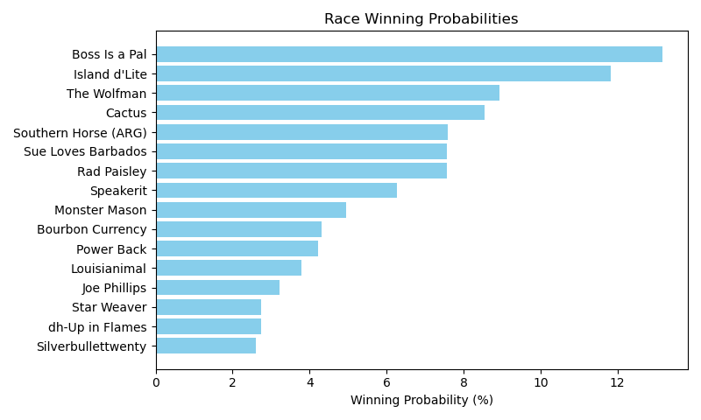

Exacta advice: key 11 → 2 (1 ticket)

NOTE: GCSF - Global Combined Speed Figure

# Race: LRL | 2025-04-26 | Race #9 | Post: 22:17 | Track: LAUREL PARK

Track: LAUREL PARK

|  |  |  |  |  |  |
| --- | --- | --- | --- | --- | --- |
| Program # | Horse Name | Morn Odds | GCSF | Model Score | Win Prob (%) |
| 1 | Factor It In | 3-1 | 2.0 | 1.99 | 16.25 |
| 2 | War Master | 6-1 | 3.0 | 1.69 | 13.17 |
| 3 | Don't Wait Up | 15-1 | 7.0 | 1.01 | 8.29 |
| 4 | Brother Conway | 8-1 | 4.0 | 1.64 | 12.79 |
| 5 | Retained | 20-1 | 8.0 | 0.75 | 6.93 |
| 6 | Play Harder | 5-2 | 5.0 | 1.60 | 12.43 |
| 7 | Haileysfirstnotion | 2-1 | 1.0 | 2.41 | 21.67 |
| 8 | Squire Creek | 15-1 | 6.0 | 1.05 | 8.48 |

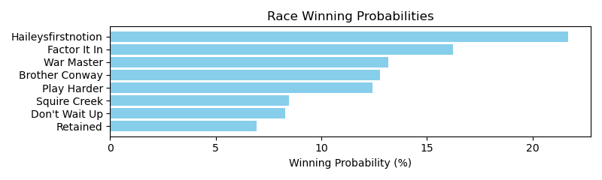

Exacta advice: key 7 → 1 (1 ticket)

NOTE: GCSF - Global Combined Speed Figure

# Race: LRL | 2025-04-26 | Race #10 | Post: 22:49 | Track: LAUREL PARK

Track: LAUREL PARK

|  |  |  |  |  |  |
| --- | --- | --- | --- | --- | --- |
| Program # | Horse Name | Morn Odds | GCSF | Model Score | Win Prob (%) |
| 1 | Sunny Spell (IRE) | 6-1 | 6.0 | 0.84 | 7.70 |
| 2 | Miss Ellary | 10-1 | 8.0 | 0.35 | 5.52 |
| 3 | Force of Law | 15-1 | 1.0 | 2.16 | 19.17 |
| 4 | Tuck Check | 12-1 | 10.0 | 0.03 | 4.42 |
| 5 | Youmakemecharlie | 20-1 | 11.0 | -1.13 | 1.99 |
| 6 | Magic in the Park | 8-1 | 2.0 | 2.01 | 17.30 |
| 7 | Turf Rocket | 5-1 | 5.0 | 0.86 | 7.83 |
| 8 | Magically Vanished | 20-1 | 9.0 | 0.21 | 5.00 |
| 9 | Royal Wintour | 9-5 | 3.0 | 1.72 | 14.14 |
| 10 | Chantilly Road | 7-2 | 4.0 | 1.18 | 9.77 |
| 11 | Miss Anna Bella | 12-1 | 7.0 | 0.73 | 7.15 |

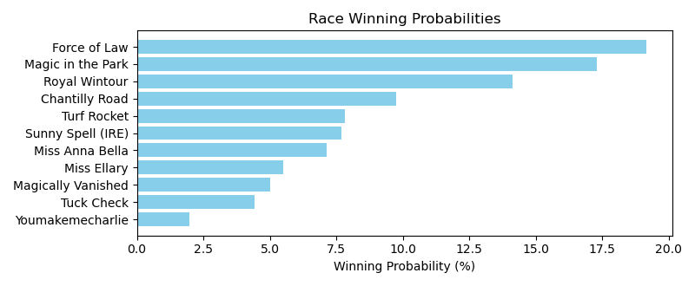

Exacta advice: key 3 → 6 (1 ticket)

NOTE: GCSF - Global Combined Speed Figure

# Race: LRL | 2025-04-26 | Race #11 | Post: 23:21 | Track: LAUREL PARK

Track: LAUREL PARK

|  |  |  |  |  |  |
| --- | --- | --- | --- | --- | --- |
| Program # | Horse Name | Morn Odds | GCSF | Model Score | Win Prob (%) |
| 1 | Perfect Pink | 15-1 | 8.0 | -0.56 | 5.85 |
| 2 | Just the Thing | 4-1 | 4.0 | 0.49 | 12.03 |
| 3 | Sweet No No | 2-1 | 3.0 | 0.83 | 15.23 |
| 4 | Bond's Belle | 8-1 | 7.0 | -0.24 | 7.28 |
| 5 | She's a Gem | 12-1 | 2.0 | 1.12 | 18.58 |
| 6 | Thunder in Paris | 3-1 | 6.0 | 0.07 | 9.01 |
| 7 | Wampy | 6-1 | 5.0 | 0.16 | 9.60 |
| 8 | Sippin' Time | 10-1 | 1.0 | 1.40 | 22.43 |

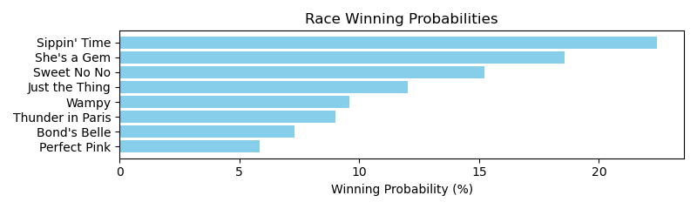

Exacta advice: key 8 → 5 (1 ticket)

NOTE: GCSF - Global Combined Speed Figure

# Race: LRL | 2025-04-27 | Race #1 | Post: 18:10 | Track: LAUREL PARK

Track: LAUREL PARK

|  |  |  |  |  |  |
| --- | --- | --- | --- | --- | --- |
| Program # | Horse Name | Morn Odds | GCSF | Model Score | Win Prob (%) |
| 1 | Hazelmoor Beach | 20-1 | 8.0 | -0.49 | 4.73 |
| 2 | Celtic Tiger | 6-1 | 5.0 | 0.39 | 8.67 |
| 3 | Come to Mama | 5-1 | 1.0 | 1.51 | 18.85 |
| 4 | Lift the Lid | 2-1 | 2.0 | 1.19 | 15.10 |
| 5 | Seafarer | 30-1 | 12.0 | -1.17 | 2.97 |
| 6 | Bossy Kate | 12-1 | 9.0 | -0.54 | 4.58 |
| 7 | Police Woman | 15-1 | 11.0 | -0.75 | 3.96 |
| 8 | Sally's Gold | 4-1 | 3.0 | 1.00 | 13.20 |
| 9 | Nuwanda | 30-1 | 7.0 | -0.43 | 4.95 |
| 10 | Shared Authority | 10-1 | 10.0 | -0.55 | 4.54 |
| 11 | Spoils of War | 3-1 | 4.0 | 0.63 | 10.29 |
| 12 | Sugar Bee | 7-2 | 6.0 | 0.29 | 8.14 |

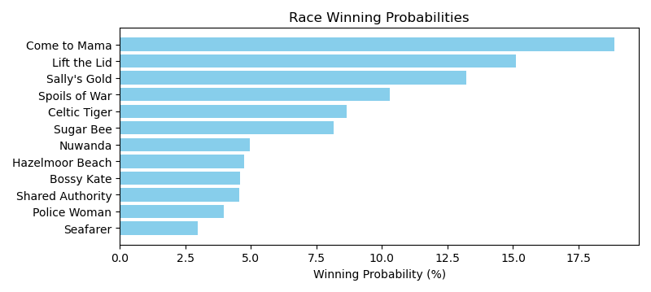

Exacta advice: key 3 → 4 (1 ticket)

NOTE: GCSF - Global Combined Speed Figure

# Race: LRL | 2025-04-27 | Race #2 | Post: 18:38 | Track: LAUREL PARK

Track: LAUREL PARK

|  |  |  |  |  |  |
| --- | --- | --- | --- | --- | --- |
| Program # | Horse Name | Morn Odds | GCSF | Model Score | Win Prob (%) |
| 1 | Beachfront Breeze | 6-1 | 4.0 | 0.73 | 12.89 |
| 2 | Dwelling Legacy | 5-1 | 5.0 | 0.36 | 10.04 |
| 3 | Feelin So Lucky | 10-1 | 6.0 | 0.35 | 9.95 |
| 4 | Profitunity | 7-2 | 2.0 | 1.69 | 24.97 |
| 5 | Kilo Road | 9-2 | 3.0 | 0.99 | 15.46 |
| 6 | Proud Divi | 6-5 | 1.0 | 1.79 | 26.69 |

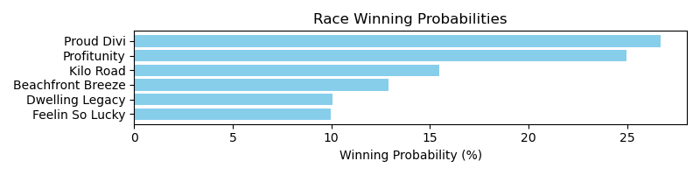

Exacta advice: box [6,4,5] (6 tickets)

NOTE: GCSF - Global Combined Speed Figure

# Race: LRL | 2025-04-27 | Race #3 | Post: 19:06 | Track: LAUREL PARK

Track: LAUREL PARK

|  |  |  |  |  |  |
| --- | --- | --- | --- | --- | --- |
| Program # | Horse Name | Morn Odds | GCSF | Model Score | Win Prob (%) |
| 1 | Lucky Partners | 30-1 | 16.0 | -1.09 | 1.01 |
| 2 | Sweet and Feisty | 8-1 | 15.0 | 0.16 | 2.38 |
| 3 | Missy's Map | 3-1 | 2.0 | 2.60 | 12.69 |
| 4 | Holy Fit | 12-1 | 11.0 | 0.62 | 3.25 |
| 5 | Laughing Fit | 7-2 | 1.0 | 2.81 | 14.71 |
| 6 | Empire's Treat | 3-1 | 3.0 | 2.58 | 12.54 |
| 7 | Nearly a Lady | 20-1 | 12.0 | 0.59 | 3.19 |
| 8 | Radiant Tones | 4-1 | 9.0 | 1.20 | 4.84 |
| 9 | Pegster | 20-1 | 8.0 | 1.23 | 4.96 |
| 10 | Rasta Girl | 2-1 | 6.0 | 1.85 | 7.58 |
| 11 | HIGH VIEW | 9-2 | 13.0 | 0.53 | 3.07 |
| 12 | Map to the Moon | 6-1 | 5.0 | 1.88 | 7.73 |
| 13 | Steam Knot | 8-1 | 4.0 | 2.19 | 9.61 |
| 14 | Spice Gal | 15-1 | 10.0 | 1.12 | 4.58 |
| 15 | Clare Court | 8-1 | 7.0 | 1.36 | 5.42 |
| 16 | Moon Baby | 20-1 | 14.0 | 0.21 | 2.45 |

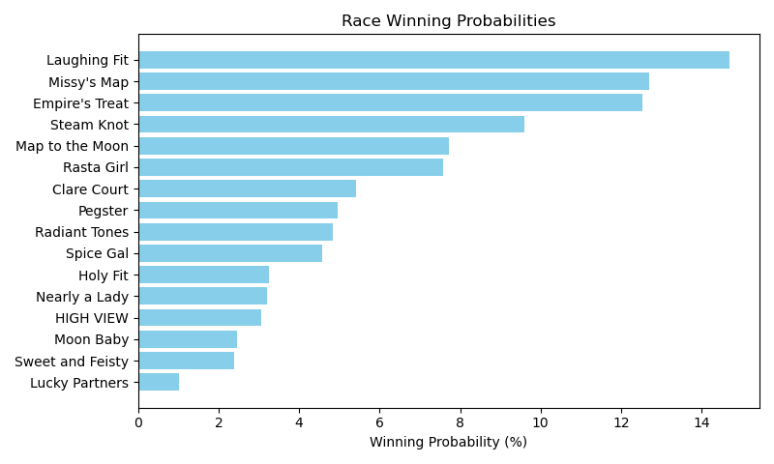

Exacta advice: key 5 → [3,6] (2 tickets)

NOTE: GCSF - Global Combined Speed Figure

# Race: LRL | 2025-04-27 | Race #4 | Post: 19:37 | Track: LAUREL PARK

Track: LAUREL PARK

|  |  |  |  |  |  |
| --- | --- | --- | --- | --- | --- |
| Program # | Horse Name | Morn Odds | GCSF | Model Score | Win Prob (%) |
| 1 | Stormy Hollow | 5-2 | 1.0 | 3.01 | 27.64 |
| 2 | Half a League | 7-2 | 4.0 | 1.54 | 10.02 |
| 3 | Big Dilemma | 15-1 | 6.0 | 1.01 | 6.98 |
| 4 | Wrightsville | 4-1 | 2.0 | 2.07 | 14.47 |
| 5 | Northern Cardinal | 10-1 | 5.0 | 1.32 | 8.66 |
| 6 | Cooltrain | 15-1 | 9.0 | 0.70 | 5.62 |
| 7 | Brushback | 8-1 | 8.0 | 0.87 | 6.36 |
| 8 | Skylar's Brother | 5-1 | 3.0 | 2.00 | 13.83 |
| 9 | Repeatingofcourse | 10-1 | 7.0 | 0.89 | 6.41 |

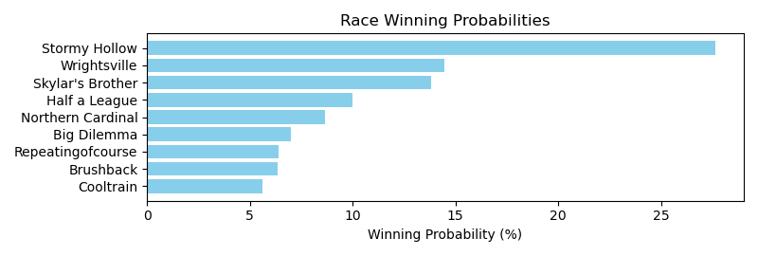

Exacta advice: key 1 → 4 (1 ticket)

NOTE: GCSF - Global Combined Speed Figure

# Race: LRL | 2025-04-27 | Race #5 | Post: 20:09 | Track: LAUREL PARK

Track: LAUREL PARK

|  |  |  |  |  |  |
| --- | --- | --- | --- | --- | --- |
| Program # | Horse Name | Morn Odds | GCSF | Model Score | Win Prob (%) |
| 1 | Addicted to You | 12-1 | 7.0 | 0.25 | 5.03 |
| 2 | Bermuda Run | 15-1 | 10.0 | 0.11 | 4.59 |
| 3 | Street Rockin | 12-1 | 9.0 | 0.20 | 4.87 |
| 4 | One Last Bid | 10-1 | 11.0 | 0.08 | 4.49 |
| 5 | Passioned | 7-2 | 4.0 | 1.35 | 10.74 |
| 6 | Missionaire | 3-1 | 5.0 | 1.34 | 10.66 |
| 7 | Top Blood | 15-1 | 8.0 | 0.23 | 4.97 |
| 8 | My Imagination | 6-1 | 1.0 | 1.95 | 16.21 |
| 9 | Fletcher | 5-2 | 2.0 | 1.89 | 15.57 |
| 10 | Wine Collector | 5-1 | 6.0 | 1.11 | 9.10 |
| 11 | Classic Joke | 8-1 | 3.0 | 1.71 | 13.79 |

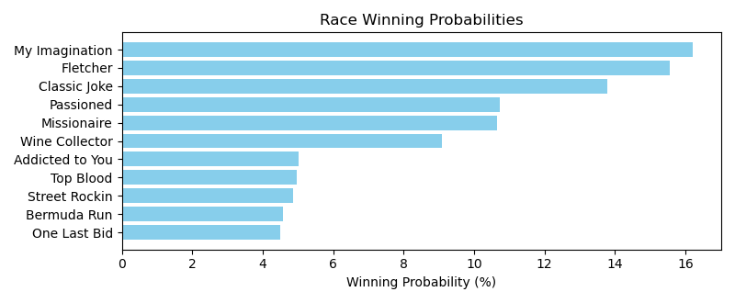

Exacta advice: box [8,9,11] (6 tickets)

NOTE: GCSF - Global Combined Speed Figure

# Race: LRL | 2025-04-27 | Race #6 | Post: 20:40 | Track: LAUREL PARK

Track: LAUREL PARK

|  |  |  |  |  |  |
| --- | --- | --- | --- | --- | --- |
| Program # | Horse Name | Morn Odds | GCSF | Model Score | Win Prob (%) |
| 1 | SILLY RABBIT | 4-1 | 12.0 | 1.02 | 3.80 |
| 2 | Uncle Grey | 20-1 | 10.0 | 1.45 | 5.11 |
| 3 | Tasker | 20-1 | 16.0 | -0.22 | 1.61 |
| 4 | Wrap and Send | 15-1 | 11.0 | 1.33 | 4.69 |
| 5 | Tell 'Em I'm Comin | 10-1 | 4.0 | 1.98 | 7.35 |
| 6 | Grey Biggsy | 5-1 | 6.0 | 1.81 | 6.55 |
| 7 | Work Hard | 10-1 | 3.0 | 2.05 | 7.74 |
| 8 | Armed N Dangerous | 10-1 | 9.0 | 1.48 | 5.21 |
| 9 | TATE'S WAR CRY | 15-1 | 14.0 | 0.23 | 2.20 |
| 10 | Christmas Spirit | 6-1 | 5.0 | 1.92 | 7.08 |
| 11 | Homestead | 5-2 | 1.0 | 3.40 | 19.46 |
| 12 | Triple Sec | 20-1 | 15.0 | -0.03 | 1.84 |
| 13 | Arjay | 8-1 | 7.0 | 1.67 | 5.94 |
| 14 | Silk Suit | 8-1 | 2.0 | 2.71 | 12.15 |
| 15 | Nothingbutbluesky | 10-1 | 13.0 | 0.98 | 3.70 |
| 16 | Gladstone | 6-1 | 8.0 | 1.58 | 5.58 |

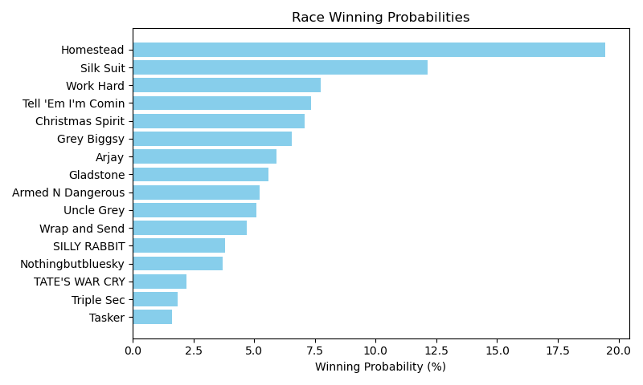

Exacta advice: key 11 → 14 (1 ticket)

NOTE: GCSF - Global Combined Speed Figure

# Race: LRL | 2025-04-27 | Race #7 | Post: 21:12 | Track: LAUREL PARK

Track: LAUREL PARK

|  |  |  |  |  |  |
| --- | --- | --- | --- | --- | --- |
| Program # | Horse Name | Morn Odds | GCSF | Model Score | Win Prob (%) |
| 1 | Navani | 3-1 | 4.0 | 1.30 | 15.12 |
| 2 | Ecliptical Gina | 20-1 | 6.0 | 0.53 | 8.91 |
| 3 | Weekend Wife | 4-1 | 2.0 | 1.68 | 19.67 |
| 4 | Nick's Notion | 6-1 | 1.0 | 1.89 | 22.73 |
| 5 | Mischievousness | 5-1 | 5.0 | 0.77 | 10.52 |
| 6 | Dazzy | 9-5 | 3.0 | 1.44 | 16.70 |
| 7 | Cluck Cluck | 8-1 | 7.0 | 0.04 | 6.36 |

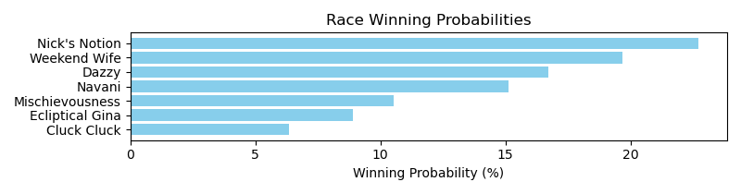

Exacta advice: key 4 → 3 (1 ticket)

NOTE: GCSF - Global Combined Speed Figure

# Race: LRL | 2025-04-27 | Race #8 | Post: 21:44 | Track: LAUREL PARK

Track: LAUREL PARK

|  |  |  |  |  |  |
| --- | --- | --- | --- | --- | --- |
| Program # | Horse Name | Morn Odds | GCSF | Model Score | Win Prob (%) |
| 1 | Anonymously | 5-1 | 3.0 | 1.47 | 9.79 |
| 2 | Golden Can | 6-1 | 4.0 | 1.46 | 9.70 |
| 3 | Instparty | 12-1 | 11.0 | -0.00 | 3.55 |
| 4 | Smooth Pebble | 9-2 | 5.0 | 1.23 | 8.29 |
| 5 | Social Whirl | 12-1 | 1.0 | 2.35 | 17.87 |
| 6 | Neolithica | 3-1 | 2.0 | 1.67 | 11.23 |
| 7 | Gold Time Vixen | 30-1 | 13.0 | -0.65 | 2.27 |
| 8 | Quit Quay | 10-1 | 10.0 | 0.70 | 5.78 |
| 9 | Attached | 9-2 | 8.0 | 1.00 | 7.09 |
| 10 | Tap It Up | 3-1 | 6.0 | 1.20 | 8.14 |
| 11 | Love to Eat | 5-1 | 9.0 | 0.73 | 5.88 |
| 12 | Watch Me Disappear | 10-1 | 7.0 | 1.20 | 8.11 |
| 13 | Sweet Summer Love | 20-1 | 12.0 | -0.63 | 2.31 |

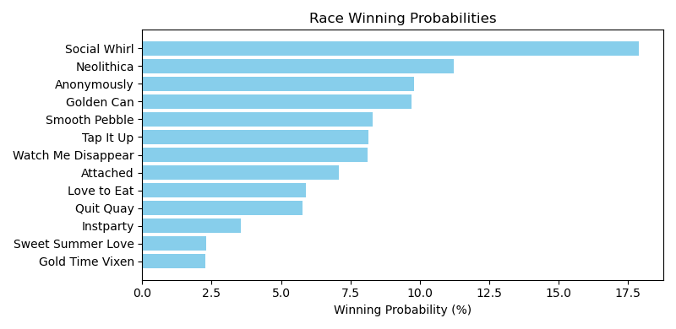

Exacta advice: key 5 → 6 (1 ticket)

NOTE: GCSF - Global Combined Speed Figure

# Race: LRL | 2025-04-27 | Race #9 | Post: 22:17 | Track: LAUREL PARK

Track: LAUREL PARK

|  |  |  |  |  |  |
| --- | --- | --- | --- | --- | --- |
| Program # | Horse Name | Morn Odds | GCSF | Model Score | Win Prob (%) |
| 1 | Centre Court Champ | 5-2 | 1.0 | 2.44 | 31.84 |
| 2 | Di's Surprise | 8-1 | 4.0 | 0.96 | 11.46 |
| 3 | Cap Classique | 2-1 | 3.0 | 1.46 | 16.18 |
| 4 | Miss Harriett | 7-2 | 6.0 | 0.69 | 9.54 |
| 5 | Happy Clouds | 10-1 | 5.0 | 0.94 | 11.35 |
| 6 | Alani | 4-1 | 2.0 | 1.74 | 19.64 |

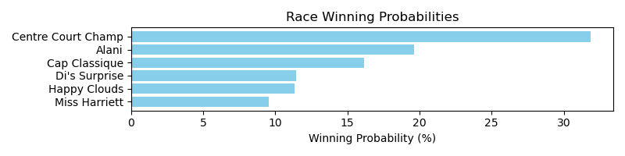

Exacta advice: key 1 → 6 (1 ticket)

NOTE: GCSF - Global Combined Speed Figure

# Race: LRL | 2025-04-27 | Race #10 | Post: 22:49 | Track: LAUREL PARK

Track: LAUREL PARK

|  |  |  |  |  |  |
| --- | --- | --- | --- | --- | --- |
| Program # | Horse Name | Morn Odds | GCSF | Model Score | Win Prob (%) |
| 1 | Let Fly | 20-1 | 7.0 | 0.30 | 5.35 |
| 2 | We Called Sol | 7-2 | 1.0 | 2.48 | 23.86 |
| 3 | Docsgotallthecandy | 13-8 | 6.0 | 0.86 | 7.85 |
| 4 | Tyson's Delivery | 4-1 | 3.0 | 1.80 | 14.99 |
| 5 | Wall Street Magic | 5-1 | 2.0 | 2.37 | 22.17 |
| 6 | Lucky One Time | 15-1 | 4.0 | 0.94 | 8.27 |
| 7 | Flatbed Ford | 10-1 | 5.0 | 0.93 | 8.22 |
| 8 | ROYAL FLUSH HEARTS | 10-1 | 9.0 | -0.00 | 4.33 |
| 9 | Imperial Brut | 20-1 | 8.0 | 0.19 | 4.95 |

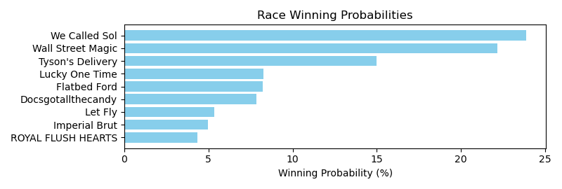

Exacta advice: key 2 → 5 (1 ticket)

NOTE: GCSF - Global Combined Speed Figure

# Race: LRL | 2025-04-27 | Race #11 | Post: 23:10 | Track: LAUREL PARK

Track: LAUREL PARK

|  |  |  |  |  |  |
| --- | --- | --- | --- | --- | --- |
| Program # | Horse Name | Morn Odds | GCSF | Model Score | Win Prob (%) |
| 1 | TUPI NAMBA (URU) | 10-1 | 9.0 | 0.18 | 6.18 |
| 2 | KAMAQUA (BRZ) | 8-1 | 12.0 | 0.12 | 5.93 |
| 4 | MR. SCANDAL (URU) | 5-1 | 1.0 | 0.93 | 10.37 |
| 5 | MAMBO GANDHI (URU) | 8-1 | 6.0 | 0.37 | 7.05 |
| 7 | VERY RICH MAN (URU) | 20-1 | 15.0 | -0.47 | 3.94 |
| 8 | ILUSTRE DON (URU) | 6-1 | 5.0 | 0.48 | 7.59 |
| 9 | ACANTO (URU) | 12-1 | 7.0 | 0.35 | 6.95 |
| 10 | EL CLEVER (URU) | 6-1 | 4.0 | 0.53 | 7.87 |
| 11 | ESPARTACO (URU) | 12-1 | 8.0 | 0.29 | 6.65 |
| 12 | RADIAZIONE (URU) | 6-1 | 11.0 | 0.14 | 6.02 |
| 13 | CHINGOLO (URU) | 4-1 | 3.0 | 0.61 | 8.33 |
| 14 | WAKI PINS (URU) | 6-1 | 2.0 | 0.65 | 8.52 |
| 15 | VA PA I (URU) | 20-1 | 13.0 | -0.34 | 4.32 |
| 16 | BALEADOR (URU) | 6-1 | 10.0 | 0.18 | 6.18 |
| 17 | CRAZYANALYZE (URU) | 50-1 | 14.0 | -0.42 | 4.10 |

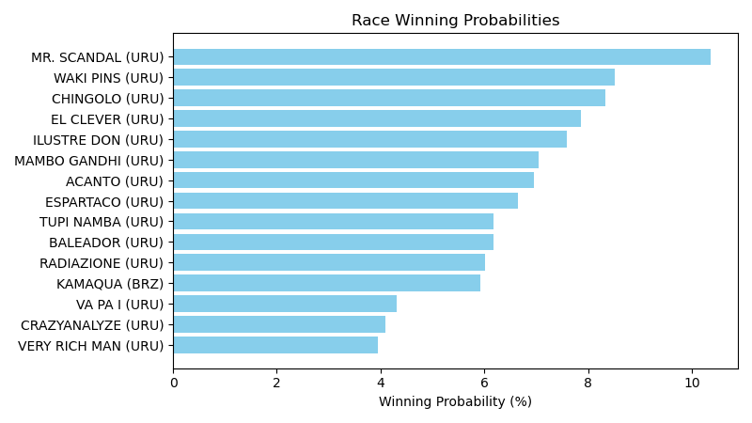

Exacta advice: key 4 → [14,13] (2 tickets)

NOTE: GCSF - Global Combined Speed Figure

# Race: LRL | 2025-04-27 | Race #12 | Post: 23:40 | Track: LAUREL PARK

Track: LAUREL PARK

|  |  |  |  |  |  |
| --- | --- | --- | --- | --- | --- |
| Program # | Horse Name | Morn Odds | GCSF | Model Score | Win Prob (%) |
| 1 | AGOSTINA (URU) | 4-1 | 1.0 | 0.64 | 10.53 |
| 2 | ORQUIDEA BLANCA (URU) | 8-1 | 10.0 | -0.01 | 6.74 |
| 3 | HAVANA (URU) | 8-1 | 12.0 | -0.02 | 6.70 |
| 4 | PELINEGRA (URU) | 8-1 | 8.0 | 0.10 | 7.26 |
| 5 | GOLDEN TREAT (BRZ) | 8-1 | 4.0 | 0.31 | 8.41 |
| 6 | HORA FELIZ (URU) | 6-1 | 5.0 | 0.28 | 8.21 |
| 7 | KANTA MINHA GENTE (URU) | 8-1 | 9.0 | 0.02 | 6.88 |
| 8 | QUATRO SUENOS (URU) | 50-1 | 13.0 | -0.57 | 4.57 |
| 10 | CONTRATADA FEVER (URU) | 8-1 | 6.0 | 0.20 | 7.75 |
| 11 | PRETTY FLOWER (URU) | 8-1 | 7.0 | 0.10 | 7.28 |
| 12 | CRISTINA F (URU) | 4-1 | 2.0 | 0.61 | 10.28 |
| 13 | ITACA (URU) | 8-1 | 11.0 | -0.01 | 6.71 |
| 14 | TENGO UN AMOR (BRZ) | 5-1 | 3.0 | 0.36 | 8.69 |

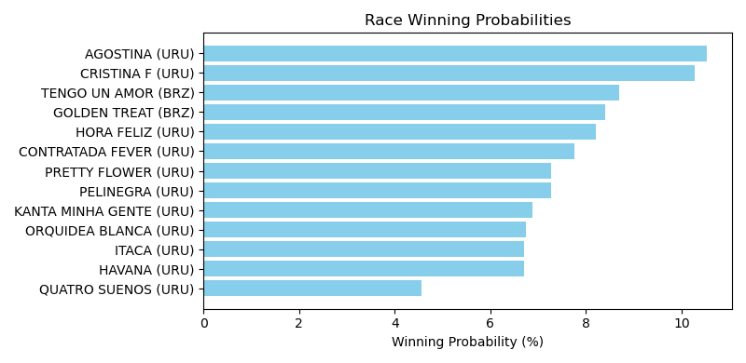

Exacta advice: box [1,12,14] (6 tickets)

NOTE: GCSF - Global Combined Speed Figure

# Race: LRL | 2025-04-27 | Race #13 | Post: 00:10 | Track: LAUREL PARK

Track: LAUREL PARK

|  |  |  |  |  |  |
| --- | --- | --- | --- | --- | --- |
| Program # | Horse Name | Morn Odds | GCSF | Model Score | Win Prob (%) |
| 1 | SALAM ALEIKUM (URU) | 20-1 | 14.0 | -0.42 | 4.25 |
| 2 | LUNANUEVA (URU) | 10-1 | 9.0 | -0.10 | 5.30 |
| 3 | RENZITA (URU) | 10-1 | 8.0 | 0.20 | 6.49 |
| 4 | PERFUME DE MUJER (URU) | 50-1 | 16.0 | -0.59 | 3.79 |
| 5 | MAJESTUOSA Z (URU) | 15-1 | 11.0 | -0.22 | 4.89 |
| 6 | MADISON DAM (URU) | 6-1 | 7.0 | 0.22 | 6.60 |
| 7 | SUBITAMENTE (URU) | 4-1 | 1.0 | 0.80 | 9.87 |
| 9 | ALCELESTE (URU) | 9-2 | 2.0 | 0.76 | 9.59 |
| 10 | COOPERATIVA (URU) | 4-1 | 3.0 | 0.65 | 8.86 |
| 11 | ERRATICA (URU) | 12-1 | 10.0 | -0.17 | 5.03 |
| 12 | QUE PANORAMA (URU) | 6-1 | 4.0 | 0.44 | 7.67 |
| 13 | BAD ROMANCE (URU) | 20-1 | 15.0 | -0.45 | 4.17 |
| 14 | VIVIR MI VIDA (URU) | 6-1 | 5.0 | 0.36 | 7.26 |
| 15 | SOLAR CHARGE (URU) | 6-1 | 6.0 | 0.32 | 7.08 |
| 16 | APRESURADA E (URU) | 20-1 | 12.0 | -0.23 | 4.83 |
| 17 | NAVARRA (URU) | 50-1 | 13.0 | -0.40 | 4.31 |

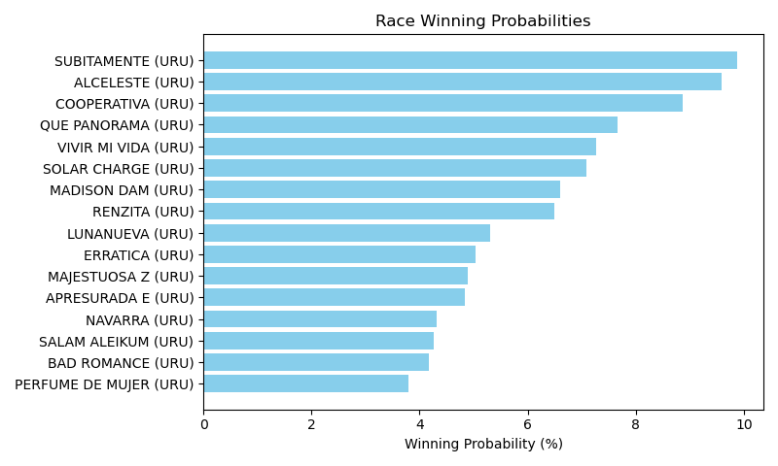

Exacta advice: box [7,9,10] (6 tickets)

NOTE: GCSF - Global Combined Speed Figure

# Race: LRL | 2025-04-27 | Race #14 | Post: 00:40 | Track: LAUREL PARK

Track: LAUREL PARK

|  |  |  |  |  |  |
| --- | --- | --- | --- | --- | --- |
| Program # | Horse Name | Morn Odds | GCSF | Model Score | Win Prob (%) |
| 1 | TUBER SOME (URU) | 15-1 | 8.0 | 0.10 | 6.40 |
| 2 | ALSERIO (URU) | 10-1 | 10.0 | -0.08 | 5.66 |
| 3 | JUAN BALAZO (URU) | 6-1 | 2.0 | 0.62 | 9.17 |
| 4 | CONTIGONOES (URU) | 10-1 | 9.0 | 0.04 | 6.12 |
| 5 | HONORLOD (URU) | 8-1 | 5.0 | 0.26 | 7.16 |
| 6 | VALE QUATRO (URU) | 20-1 | 13.0 | -0.34 | 4.71 |
| 7 | SATURDAY FEVER (URU) | 4-1 | 4.0 | 0.49 | 8.39 |
| 8 | THE MEDITERRANEAN (URU) | 6-1 | 7.0 | 0.19 | 6.80 |
| 9 | TU SONADOR (URU) | 15-1 | 11.0 | -0.08 | 5.65 |
| 10 | PIBE DE ORO (URU) | 20-1 | 14.0 | -0.36 | 4.65 |
| 11 | DON SERVANDO (URU) | 6-1 | 6.0 | 0.23 | 6.97 |
| 12 | CURIOSO FEVER (URU) | 50-1 | 15.0 | -0.55 | 4.10 |
| 13 | GOOD SIDE (URU) | 9-2 | 3.0 | 0.55 | 8.71 |
| 14 | CARIBENO INC (URU) | 3-1 | 1.0 | 0.79 | 10.27 |
| 15 | TONKS (URU) | 20-1 | 12.0 | -0.19 | 5.25 |

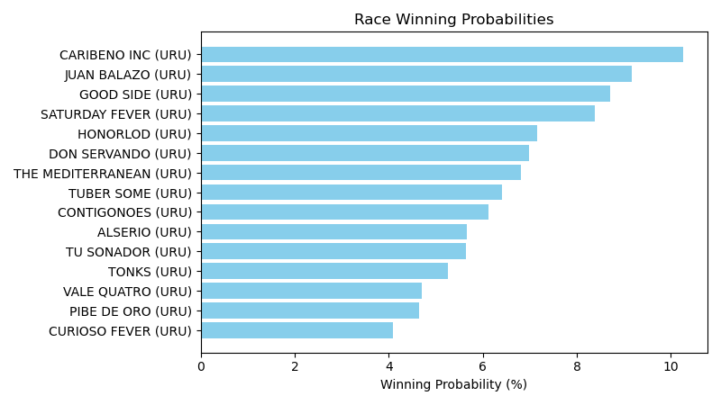

Exacta advice: key 14 → 3 (1 ticket)

NOTE: GCSF - Global Combined Speed Figure

# Race: LRL | 2025-04-27 | Race #15 | Post: 01:10 | Track: LAUREL PARK

Track: LAUREL PARK

|  |  |  |  |  |  |
| --- | --- | --- | --- | --- | --- |
| Program # | Horse Name | Morn Odds | GCSF | Model Score | Win Prob (%) |
| 2 | LA KARIBE (URU) | 4-1 | 1.0 | 0.64 | 9.47 |
| 3 | SEREIA MATAOJO (URU) | 10-1 | 6.0 | 0.34 | 7.65 |
| 4 | PAISANA FEVER (URU) | 5-1 | 4.0 | 0.39 | 7.93 |
| 5 | MOTIVADA DE MELO (URU) | 20-1 | 14.0 | -0.42 | 4.54 |
| 6 | LUNA LLENA VH (URU) | 20-1 | 12.0 | -0.22 | 5.24 |
| 7 | WANDA MIA (URU) | 9-2 | 2.0 | 0.56 | 8.96 |
| 8 | JUMPING HIGH (URU) | 10-1 | 11.0 | 0.13 | 6.66 |
| 9 | ALL MAJESTIC (URU) | 10-1 | 8.0 | 0.20 | 6.99 |
| 10 | IDOLA LOCAL (ARG) | 5-1 | 7.0 | 0.24 | 7.16 |
| 11 | JUCALU (URU) | 15-1 | 13.0 | -0.29 | 4.98 |
| 12 | QUE MAS PUES (URU) | 10-1 | 9.0 | 0.19 | 6.91 |
| 13 | GHOST RIDER (URU) | 6-1 | 5.0 | 0.38 | 7.90 |
| 14 | YOURSELF (URU) | 6-1 | 3.0 | 0.55 | 8.84 |
| 15 | SUGAR CROCS (URU) | 8-1 | 10.0 | 0.15 | 6.75 |

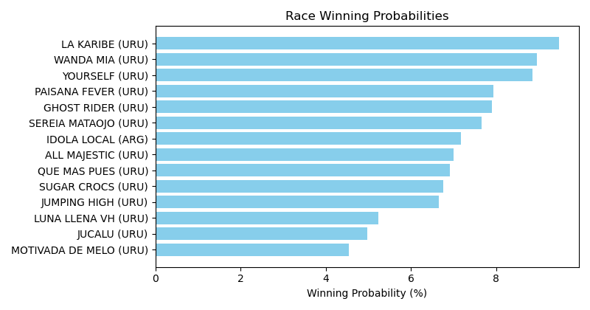

Exacta advice: box [2,7,14] (6 tickets)

NOTE: GCSF - Global Combined Speed Figure

# Race: TLS | 2025-04-26 | Race #1 | Post: 19:35 | Track: LONE STAR PARK

Track: LONE STAR PARK

|  |  |  |  |  |  |
| --- | --- | --- | --- | --- | --- |
| Program # | Horse Name | Morn Odds | GCSF | Model Score | Win Prob (%) |
| 1 | Tiff With Jimmy | 2-1 | 1.0 | 1.64 | 32.51 |
| 2 | Atta Moy Girl | 12-1 | 6.0 | -0.35 | 8.25 |
| 3 | Bossadusu | 5-1 | 5.0 | -0.03 | 10.27 |
| 4 | Cranky Sheila | 9-5 | 2.0 | 0.86 | 19.00 |
| 5 | Lexington Diva | 4-1 | 3.0 | 0.73 | 17.32 |
| 6 | Lady With a Cause | 12-1 | 4.0 | 0.27 | 12.65 |

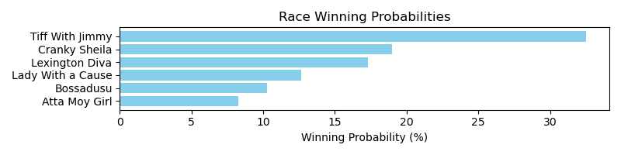

Exacta advice: key 1 → 4 (1 ticket)

NOTE: GCSF - Global Combined Speed Figure

# Race: TLS | 2025-04-26 | Race #2 | Post: 20:03 | Track: LONE STAR PARK

Track: LONE STAR PARK

|  |  |  |  |  |  |
| --- | --- | --- | --- | --- | --- |
| Program # | Horse Name | Morn Odds | GCSF | Model Score | Win Prob (%) |
| 1 | Perceptive | 5-2 | 1.0 | 1.51 | 26.72 |
| 2 | Ron's Lavender | 15-1 | 6.0 | -0.27 | 7.85 |
| 3 | Dazzling Duchess | 9-2 | 5.0 | -0.12 | 8.70 |
| 4 | Single Saturday | 20-1 | 7.0 | -0.47 | 6.86 |
| 5 | Tribe | 9-5 | 4.0 | 0.44 | 12.83 |
| 6 | Capetown Candy | 3-1 | 3.0 | 0.73 | 15.64 |
| 7 | Not a Word | 10-1 | 2.0 | 1.19 | 21.40 |

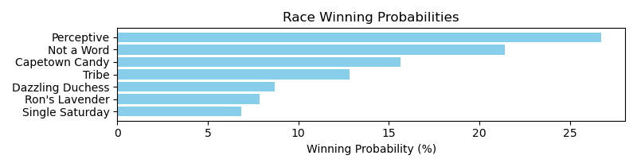

Exacta advice: key 1 → 7 (1 ticket)

NOTE: GCSF - Global Combined Speed Figure

# Race: TLS | 2025-04-26 | Race #3 | Post: 20:43 | Track: LONE STAR PARK

Track: LONE STAR PARK

|  |  |  |  |  |  |
| --- | --- | --- | --- | --- | --- |
| Program # | Horse Name | Morn Odds | GCSF | Model Score | Win Prob (%) |
| 1 | Ima Bling Cat | 6-1 | 9.0 | 1.07 | 8.16 |
| 2 | Saturday's Gold | 9-2 | 2.0 | 1.40 | 10.26 |
| 3 | Bandera Azteca | 12-1 | 7.0 | 1.20 | 8.90 |
| 4 | Northvale Road | 12-1 | 1.0 | 1.75 | 13.01 |
| 5 | dh-Atras | 15-1 | 10.0 | 0.67 | 6.21 |
| 6 | Pudding | 12-1 | 5.0 | 1.34 | 9.81 |
| 7 | Bling Bling Bling | 10-1 | 8.0 | 1.16 | 8.68 |
| 8 | Yacht Rock (IRE) | 2-1 | 6.0 | 1.20 | 8.95 |
| 9 | Philo Beddoe | 7-2 | 3.0 | 1.39 | 10.18 |
| 10 | Malibu Thunder | 20-1 | 11.0 | -0.24 | 3.31 |
| 11 | Imma Blingy Lad | 30-1 | 12.0 | -0.72 | 2.38 |
| 12 | Prince Rama | 2-1 | 4.0 | 1.39 | 10.15 |

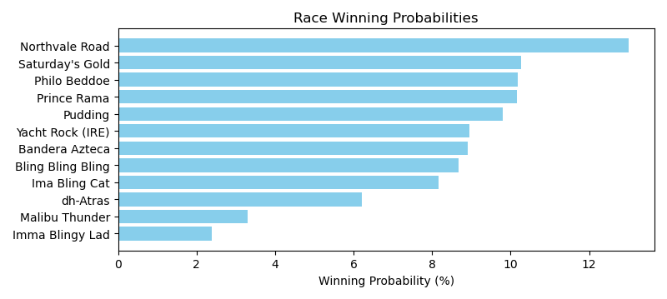

Exacta advice: key 4 → [2,9] (2 tickets)

NOTE: GCSF - Global Combined Speed Figure

# Race: TLS | 2025-04-26 | Race #4 | Post: 21:11 | Track: LONE STAR PARK

Track: LONE STAR PARK

|  |  |  |  |  |  |
| --- | --- | --- | --- | --- | --- |
| Program # | Horse Name | Morn Odds | GCSF | Model Score | Win Prob (%) |
| 1 | Sonneman | 5-2 | 2.0 | 1.48 | 16.77 |
| 2 | Veracruzin | 6-1 | 4.0 | 1.04 | 12.37 |
| 3 | Send Off | 20-1 | 8.0 | -0.12 | 5.59 |
| 4 | Twelve Volt | 7-2 | 5.0 | 0.89 | 11.18 |
| 5 | Cousin Larry | 3-1 | 1.0 | 1.98 | 23.73 |
| 6 | Levy | 4-1 | 3.0 | 1.13 | 13.21 |
| 7 | Cool Memory | 15-1 | 6.0 | 0.77 | 10.30 |
| 8 | Absaroka | 12-1 | 7.0 | 0.17 | 6.83 |

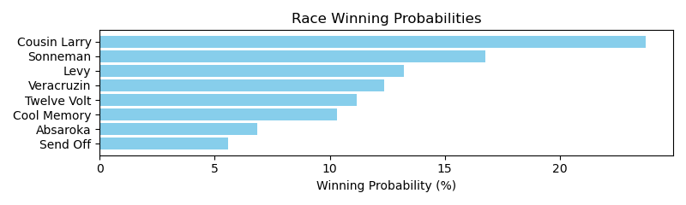

Exacta advice: key 5 → 1 (1 ticket)

NOTE: GCSF - Global Combined Speed Figure

# Race: TLS | 2025-04-26 | Race #5 | Post: 21:51 | Track: LONE STAR PARK

Track: LONE STAR PARK

|  |  |  |  |  |  |
| --- | --- | --- | --- | --- | --- |
| Program # | Horse Name | Morn Odds | GCSF | Model Score | Win Prob (%) |
| 1 | Magic Monday | 20-1 | 7.0 | -0.93 | 4.00 |
| 2 | Playboy Style | 20-1 | 5.0 | 0.51 | 10.79 |
| 3 | Cajun Eddie | 2-1 | 3.0 | 1.14 | 16.60 |
| 4 | Catholic Guilt | 5-2 | 2.0 | 1.50 | 21.33 |
| 5 | Shamayim | 8-1 | 4.0 | 0.53 | 10.91 |
| 6 | Nautical Moon | 9-5 | 1.0 | 1.79 | 25.97 |
| 7 | Fast Traffic | 12-1 | 6.0 | 0.46 | 10.41 |

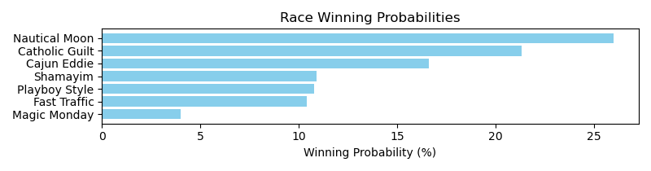

Exacta advice: key 6 → 4 (1 ticket)

NOTE: GCSF - Global Combined Speed Figure

# Race: TLS | 2025-04-26 | Race #6 | Post: 22:19 | Track: LONE STAR PARK

Track: LONE STAR PARK

|  |  |  |  |  |  |
| --- | --- | --- | --- | --- | --- |
| Program # | Horse Name | Morn Odds | GCSF | Model Score | Win Prob (%) |
| 1 | Marquette Warrior | 7-2 | 5.0 | 0.87 | 9.49 |
| 2 | Rumpus | 9-2 | 3.0 | 1.27 | 12.44 |
| 3 | How Bout Me | 12-1 | 7.0 | 0.55 | 7.58 |
| 4 | Texas Red Bel | 12-1 | 9.0 | 0.30 | 6.40 |
| 5 | City Ghost | 5-2 | 4.0 | 1.21 | 11.99 |
| 6 | Fayette Blue | 12-1 | 6.0 | 0.56 | 7.65 |
| 7 | Fella's Sister | 6-1 | 10.0 | 0.30 | 6.38 |
| 8 | Tay Tay's Baby | 20-1 | 8.0 | 0.53 | 7.51 |
| 9 | Miss Carmen Cibo | 20-1 | 11.0 | -0.68 | 3.27 |
| 10 | Pleasingly | 12-1 | 2.0 | 1.33 | 12.97 |
| 11 | Gray Zone | 10-1 | 1.0 | 1.47 | 14.32 |

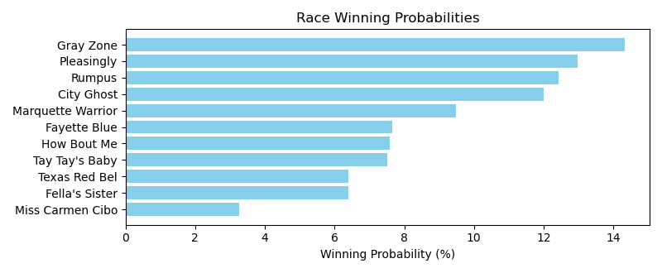

Exacta advice: key 11 → 10 (1 ticket)

NOTE: GCSF - Global Combined Speed Figure

# Race: TLS | 2025-04-26 | Race #7 | Post: 22:59 | Track: LONE STAR PARK

Track: LONE STAR PARK

|  |  |  |  |  |  |
| --- | --- | --- | --- | --- | --- |
| Program # | Horse Name | Morn Odds | GCSF | Model Score | Win Prob (%) |
| 1 | It Makes Sense | 3-1 | 2.0 | 1.71 | 17.93 |
| 2 | Sir Sterling | 9-2 | 5.0 | 1.16 | 12.31 |
| 3 | Campfire Creed | 5-2 | 4.0 | 1.36 | 14.14 |
| 4 | Vodka Martini | 12-1 | 8.0 | 0.15 | 6.13 |
| 5 | Lea Me Be | 7-2 | 1.0 | 1.82 | 19.39 |
| 6 | Hezakoolkat | 15-1 | 6.0 | 0.56 | 8.17 |
| 7 | American Outlaw | 20-1 | 7.0 | 0.31 | 6.87 |
| 8 | Prince of Pharoahs | 4-1 | 3.0 | 1.45 | 15.07 |

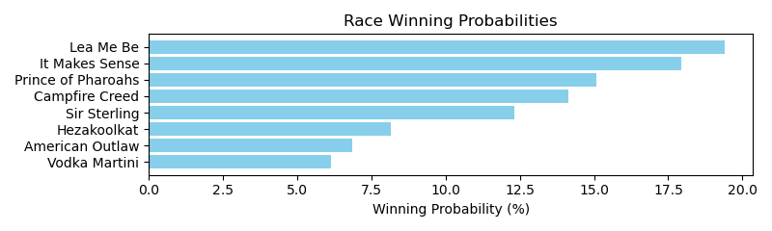

Exacta advice: key 5 → 1 (1 ticket)

NOTE: GCSF - Global Combined Speed Figure

# Race: TLS | 2025-04-26 | Race #8 | Post: 23:27 | Track: LONE STAR PARK

Track: LONE STAR PARK

|  |  |  |  |  |  |
| --- | --- | --- | --- | --- | --- |
| Program # | Horse Name | Morn Odds | GCSF | Model Score | Win Prob (%) |
| 1 | Number One Dude | 12-1 | 8.0 | 0.70 | 7.39 |
| 2 | Chrome Baby | 8-1 | 5.0 | 0.93 | 8.68 |
| 3 | Mazuma | 10-1 | 4.0 | 1.21 | 10.52 |
| 4 | U. S. Army | 3-1 | 1.0 | 2.67 | 28.64 |
| 5 | Without a Trace | 4-1 | 3.0 | 1.56 | 13.37 |
| 6 | Tiburon | 15-1 | 6.0 | 0.83 | 8.08 |
| 7 | Victory for Vets | 13-8 | 2.0 | 1.81 | 15.82 |
| 8 | Machine Gun Man | 12-1 | 7.0 | 0.72 | 7.49 |

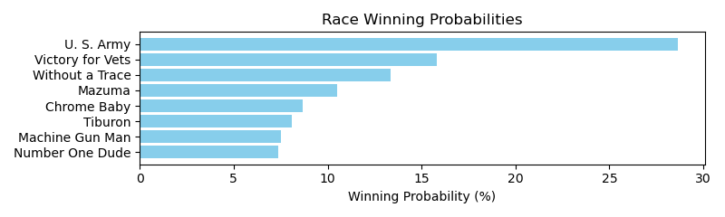

Exacta advice: key 4 → 7 (1 ticket)

NOTE: GCSF - Global Combined Speed Figure

# Race: TLS | 2025-04-26 | Race #9 | Post: 23:55 | Track: LONE STAR PARK

Track: LONE STAR PARK

|  |  |  |  |  |  |
| --- | --- | --- | --- | --- | --- |
| Program # | Horse Name | Morn Odds | GCSF | Model Score | Win Prob (%) |
| 1 | Magic Glass | 20-1 | 6.0 | 0.51 | 6.50 |
| 2 | Ziti (FR) | 7-2 | 3.0 | 1.16 | 10.17 |
| 3 | Wilburnsclassylady | 3-1 | 4.0 | 1.05 | 9.43 |
| 4 | Legacy Defined | 12-1 | 9.0 | 0.18 | 5.17 |
| 5 | Moonlight Warrior | 12-1 | 7.0 | 0.40 | 6.00 |
| 6 | Catalyst | 12-1 | 2.0 | 1.77 | 15.42 |
| 7 | Kinky Moon | 30-1 | 14.0 | -1.17 | 2.05 |
| 8 | Strike the Bell | 20-1 | 10.0 | -0.15 | 4.13 |
| 9 | Peak Earnings (GB) | 12-1 | 13.0 | -0.48 | 3.29 |
| 10 | Girls Got Game | 20-1 | 12.0 | -0.39 | 3.50 |
| 11 | Moonlight Gambler | 4-1 | 1.0 | 1.78 | 15.53 |
| 12 | Cafezinho | 5-1 | 5.0 | 0.95 | 8.79 |
| 13 | Promising | 6-1 | 8.0 | 0.37 | 5.90 |
| 14 | Alamo | 20-1 | 11.0 | -0.15 | 4.13 |

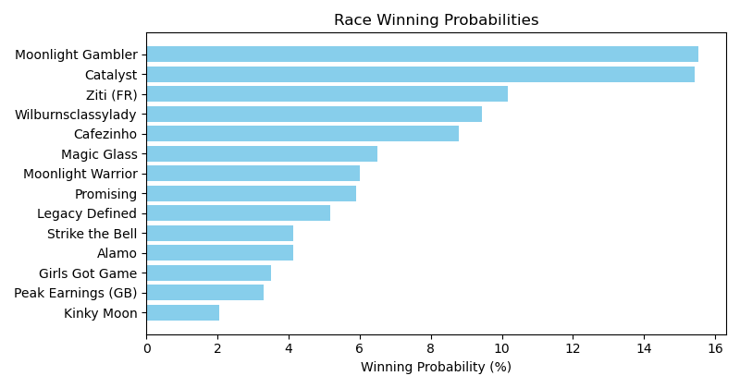

Exacta advice: box [11,6,2] (6 tickets)

NOTE: GCSF - Global Combined Speed Figure

# Race: TLS | 2025-04-27 | Race #1 | Post: 19:35 | Track: LONE STAR PARK

Track: LONE STAR PARK

|  |  |  |  |  |  |
| --- | --- | --- | --- | --- | --- |
| Program # | Horse Name | Morn Odds | GCSF | Model Score | Win Prob (%) |
| 1 | Texas Moon | 7-2 | 3.0 | 0.85 | 17.53 |
| 2 | Bali Girlee | 3-1 | 4.0 | 0.71 | 15.89 |
| 3 | Mariah | 9-2 | 1.0 | 1.39 | 25.38 |
| 4 | Clipper Cove | 8-1 | 6.0 | -0.46 | 7.11 |
| 5 | The Next Big Bling | 5-2 | 2.0 | 1.24 | 22.92 |
| 6 | Okie Bling | 4-1 | 5.0 | 0.20 | 11.18 |

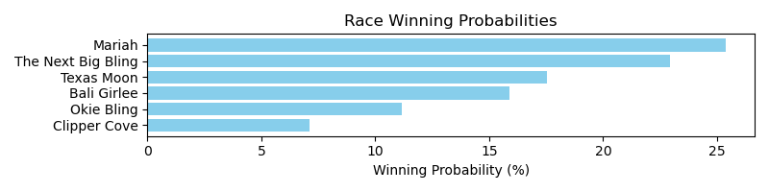

Exacta advice: key 3 → 5 (1 ticket)

NOTE: GCSF - Global Combined Speed Figure

# Race: TLS | 2025-04-27 | Race #2 | Post: 20:03 | Track: LONE STAR PARK

Track: LONE STAR PARK

|  |  |  |  |  |  |
| --- | --- | --- | --- | --- | --- |
| Program # | Horse Name | Morn Odds | GCSF | Model Score | Win Prob (%) |
| 1 | Thousand Angels | 5-1 | 5.0 | 1.10 | 13.31 |
| 2 | Along Came Thunder | 3-1 | 1.0 | 1.74 | 20.72 |
| 3 | Checker's Song | 15-1 | 3.0 | 1.36 | 15.96 |
| 4 | Knotty Kitty | 8-1 | 6.0 | 0.67 | 9.87 |
| 5 | Come On Sing | 4-1 | 4.0 | 1.36 | 15.92 |
| 6 | School Teacher | 6-5 | 2.0 | 1.66 | 19.50 |
| 7 | Shezasweetpea | 20-1 | 7.0 | -0.41 | 4.72 |

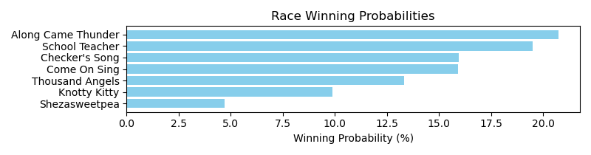

Exacta advice: box [2,6,3] (6 tickets)

NOTE: GCSF - Global Combined Speed Figure

# Race: TLS | 2025-04-27 | Race #3 | Post: 20:43 | Track: LONE STAR PARK

Track: LONE STAR PARK

|  |  |  |  |  |  |
| --- | --- | --- | --- | --- | --- |
| Program # | Horse Name | Morn Odds | GCSF | Model Score | Win Prob (%) |
| 1 | Get Ready Gal | 12-1 | 5.0 | 0.85 | 11.28 |
| 2 | She'sskysthelimit | 6-5 | 1.0 | 2.11 | 26.82 |
| 3 | Kentucky Angel | 12-1 | 6.0 | -0.04 | 6.08 |
| 4 | Maturity Date | 5-1 | 4.0 | 1.19 | 14.19 |
| 5 | Talkin Cadee | 7-2 | 3.0 | 1.71 | 20.33 |
| 6 | Fine Finish | 3-1 | 2.0 | 1.78 | 21.31 |

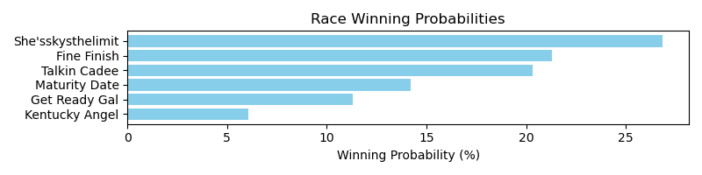

Exacta advice: key 2 → 6 (1 ticket)

NOTE: GCSF - Global Combined Speed Figure

# Race: TLS | 2025-04-27 | Race #4 | Post: 21:11 | Track: LONE STAR PARK

Track: LONE STAR PARK

|  |  |  |  |  |  |
| --- | --- | --- | --- | --- | --- |
| Program # | Horse Name | Morn Odds | GCSF | Model Score | Win Prob (%) |
| 1 | Mucho Macho Cam | 7-2 | 2.0 | 0.29 | 16.08 |
| 2 | Brody's Treasure | 15-1 | 7.0 | -0.58 | 8.81 |
| 3 | Going to Sanantone | 4-1 | 6.0 | -0.24 | 11.15 |
| 4 | Tap to Connect | 5-1 | 5.0 | -0.22 | 11.28 |
| 5 | Mr Jaws | 9-5 | 1.0 | 1.09 | 27.88 |
| 6 | Keepmovingforward | 6-1 | 4.0 | -0.19 | 11.52 |
| 7 | Ru Mor Starter | 8-1 | 3.0 | 0.01 | 13.27 |

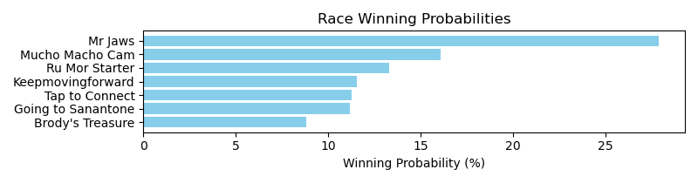

Exacta advice: key 5 → 1 (1 ticket)

NOTE: GCSF - Global Combined Speed Figure

# Race: TLS | 2025-04-27 | Race #5 | Post: 21:51 | Track: LONE STAR PARK

Track: LONE STAR PARK

|  |  |  |  |  |  |
| --- | --- | --- | --- | --- | --- |
| Program # | Horse Name | Morn Odds | GCSF | Model Score | Win Prob (%) |
| 1 | Autism Rights | 20-1 | 8.0 | 0.03 | 4.40 |
| 2 | Texas Kiss | 30-1 | 7.0 | 0.34 | 5.46 |
| 3 | Silivas | 15-1 | 5.0 | 1.02 | 8.70 |
| 4 | Run Judy Run | 13-8 | 1.0 | 2.86 | 30.83 |
| 5 | Medaglia's Song | 20-1 | 4.0 | 1.05 | 8.87 |
| 6 | Isobela | 2-1 | 3.0 | 1.33 | 10.73 |
| 7 | Mya Way | 3-1 | 2.0 | 2.50 | 24.09 |
| 8 | Pebbles B Awesome | 12-1 | 6.0 | 0.69 | 6.92 |

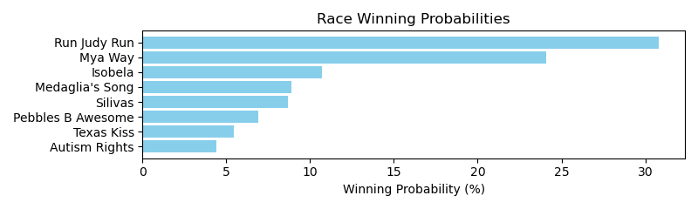

Exacta advice: key 4 → 7 (1 ticket)

NOTE: GCSF - Global Combined Speed Figure

# Race: TLS | 2025-04-27 | Race #6 | Post: 22:19 | Track: LONE STAR PARK

Track: LONE STAR PARK

|  |  |  |  |  |  |
| --- | --- | --- | --- | --- | --- |
| Program # | Horse Name | Morn Odds | GCSF | Model Score | Win Prob (%) |
| 1 | Map This Out | 15-1 | 5.0 | 1.59 | 8.77 |
| 2 | Time to Collect | 12-1 | 8.0 | 0.86 | 5.33 |
| 3 | Golden Pursuit | 12-1 | 9.0 | 0.74 | 4.89 |
| 4 | Keep the Kingdom | 15-1 | 7.0 | 0.90 | 5.48 |
| 5 | Atlantic Storm | 2-1 | 1.0 | 2.94 | 22.34 |
| 6 | Bishop Creek | 4-1 | 4.0 | 2.13 | 12.80 |
| 7 | Expat | 20-1 | 6.0 | 1.19 | 6.67 |
| 8 | King of the Disco | 5-2 | 2.0 | 2.71 | 19.07 |
| 9 | Extravagant Prince | 5-1 | 3.0 | 2.33 | 14.65 |

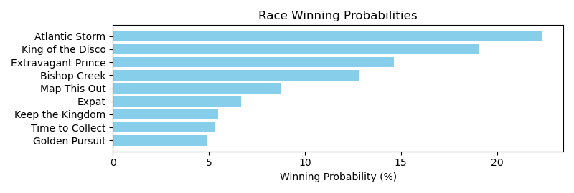

Exacta advice: key 5 → 8 (1 ticket)

NOTE: GCSF - Global Combined Speed Figure

# Race: TLS | 2025-04-27 | Race #7 | Post: 22:59 | Track: LONE STAR PARK

Track: LONE STAR PARK

|  |  |  |  |  |  |
| --- | --- | --- | --- | --- | --- |
| Program # | Horse Name | Morn Odds | GCSF | Model Score | Win Prob (%) |
| 1 | Red Summerbird | 5-1 | 5.0 | 0.81 | 10.01 |
| 2 | Runhappy d'Oro | 3-1 | 4.0 | 1.36 | 14.62 |
| 3 | Loco Luna | 4-1 | 2.0 | 1.52 | 16.30 |
| 4 | Hezakoolkat | 6-1 | 3.0 | 1.49 | 16.01 |
| 5 | Playing Hardball | 20-1 | 8.0 | 0.59 | 8.64 |
| 6 | Cinco Majestic | 12-1 | 6.0 | 0.67 | 9.08 |
| 7 | Jeeps Stride | 8-1 | 7.0 | 0.63 | 8.82 |
| 8 | Runway Magic | 5-2 | 1.0 | 1.54 | 16.51 |

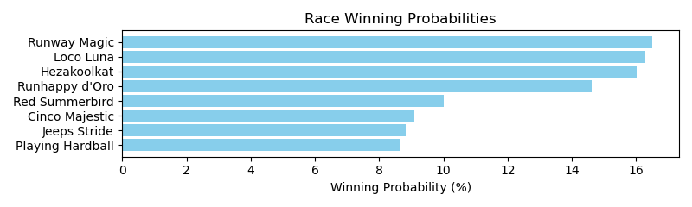

Exacta advice: box [8,3,4] (6 tickets)

NOTE: GCSF - Global Combined Speed Figure

# Race: TLS | 2025-04-27 | Race #8 | Post: 23:27 | Track: LONE STAR PARK

Track: LONE STAR PARK

|  |  |  |  |  |  |
| --- | --- | --- | --- | --- | --- |
| Program # | Horse Name | Morn Odds | GCSF | Model Score | Win Prob (%) |
| 1 | Fort Hood | 9-2 | 5.0 | 0.71 | 9.40 |
| 2 | Chief Brady | 20-1 | 3.0 | 0.94 | 11.01 |
| 3 | Tizabling | 2-1 | 1.0 | 1.66 | 18.09 |
| 4 | Uptown Tappin | 20-1 | 9.0 | 0.01 | 5.82 |
| 5 | Tom Sawyer | 10-1 | 10.0 | -0.76 | 3.41 |
| 6 | My Boy Bling | 15-1 | 8.0 | 0.18 | 6.51 |
| 7 | Bling Mountain | 8-1 | 6.0 | 0.70 | 9.31 |
| 8 | Mister Monte Carlo | 6-1 | 7.0 | 0.62 | 8.82 |
| 9 | Son of a Bling | 12-1 | 4.0 | 0.76 | 9.69 |
| 10 | Turn North | 7-2 | 2.0 | 1.65 | 17.95 |

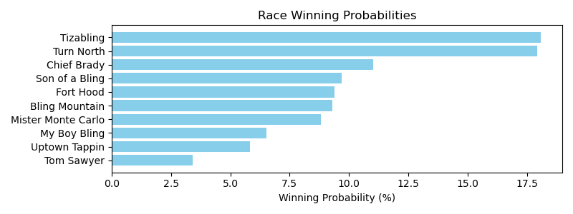

Exacta advice: box [3,10,2] (6 tickets)

NOTE: GCSF - Global Combined Speed Figure

# Race: TLS | 2025-04-27 | Race #9 | Post: 23:55 | Track: LONE STAR PARK

Track: LONE STAR PARK

|  |  |  |  |  |  |
| --- | --- | --- | --- | --- | --- |
| Program # | Horse Name | Morn Odds | GCSF | Model Score | Win Prob (%) |
| 1 | Unbridled Bling | 20-1 | 13.0 | -0.46 | 3.33 |
| 2 | Specialsortastorm | 8-1 | 5.0 | 0.91 | 8.56 |
| 3 | The Devil's Bet | 15-1 | 4.0 | 0.97 | 8.91 |
| 4 | Jed | 20-1 | 10.0 | 0.08 | 4.83 |
| 5 | Gabarra | 3-1 | 2.0 | 1.52 | 12.98 |
| 6 | Dose's Dream | 20-1 | 9.0 | 0.08 | 4.83 |
| 7 | Wild West Justice | 2-1 | 3.0 | 1.35 | 11.51 |
| 8 | Classic Moment | 8-1 | 1.0 | 1.73 | 14.99 |
| 9 | Imperial Red Bird | 9-2 | 6.0 | 0.83 | 8.10 |
| 10 | Get Ripped | 15-1 | 8.0 | 0.21 | 5.27 |
| 11 | Sponge Bath | 15-1 | 11.0 | 0.08 | 4.82 |
| 12 | Noble Eagle | 20-1 | 7.0 | 0.68 | 7.30 |
| 13 | Louisiana Flash | 15-1 | 12.0 | 0.00 | 4.57 |

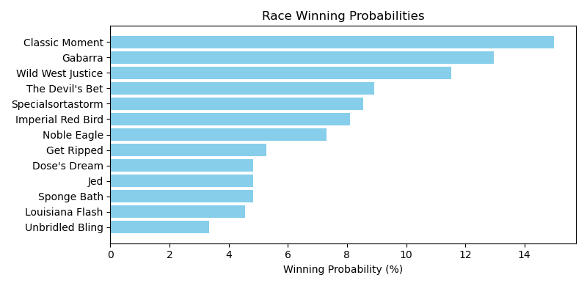

Exacta advice: key 8 → 5 (1 ticket)

NOTE: GCSF - Global Combined Speed Figure

# Race: TOP | 2025-04-26 | Race #1 | Post: 18:30 | Track: OAKLAWN PARK

Track: OAKLAWN PARK

|  |  |  |  |  |  |
| --- | --- | --- | --- | --- | --- |
| Program # | Horse Name | Morn Odds | GCSF | Model Score | Win Prob (%) |
| 1 | Fearless Lady | 12-1 | 1.0 | 1.98 | 20.41 |
| 2 | Seraphia | 8-1 | 2.0 | 1.96 | 20.05 |
| 3 | Spankerboom | 20-1 | 7.0 | 0.39 | 6.80 |
| 4 | Ensorcell | 5-1 | 6.0 | 0.59 | 7.84 |
| 5 | Kinzie Queen | 7-5 | 4.0 | 1.73 | 17.20 |
| 6 | Paradise City | 13-8 | 5.0 | 0.78 | 8.94 |
| 7 | Stipulate | 15-1 | 3.0 | 1.86 | 18.75 |

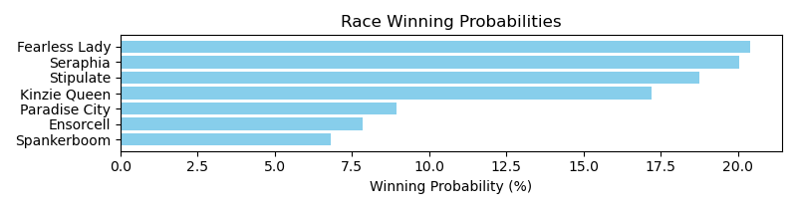

Exacta advice: box [1,2,7] (6 tickets)

NOTE: GCSF - Global Combined Speed Figure

# Race: TOP | 2025-04-26 | Race #2 | Post: 19:02 | Track: OAKLAWN PARK

Track: OAKLAWN PARK

|  |  |  |  |  |  |
| --- | --- | --- | --- | --- | --- |
| Program # | Horse Name | Morn Odds | GCSF | Model Score | Win Prob (%) |
| 1 | Presleys Turn | 10-1 | 4.0 | 1.31 | 10.72 |
| 2 | Lilly Mae | 5-1 | 3.0 | 1.97 | 16.92 |
| 3 | CHARMIT | 20-1 | 9.0 | -0.03 | 4.27 |
| 4 | Who Lu | 20-1 | 8.0 | 0.42 | 5.81 |
| 5 | Rockitretta | 12-1 | 7.0 | 0.60 | 6.58 |
| 6 | Steel Spun | 8-1 | 6.0 | 0.60 | 6.62 |
| 7 | A Vision of Hope | 6-1 | 5.0 | 0.62 | 6.67 |
| 8 | Avalon Girl | 7-5 | 1.0 | 2.31 | 21.35 |
| 9 | Nip It in the Bud | 9-2 | 2.0 | 2.29 | 21.06 |

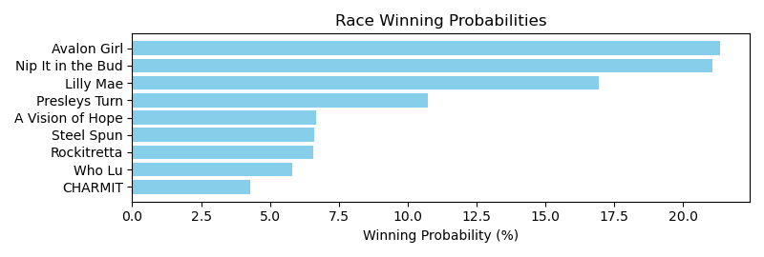

Exacta advice: box [8,9,2] (6 tickets)

NOTE: GCSF - Global Combined Speed Figure

# Race: TOP | 2025-04-26 | Race #3 | Post: 19:34 | Track: OAKLAWN PARK

Track: OAKLAWN PARK

|  |  |  |  |  |  |
| --- | --- | --- | --- | --- | --- |
| Program # | Horse Name | Morn Odds | GCSF | Model Score | Win Prob (%) |
| 1 | Holding Pattern | 8-1 | 3.0 | 1.33 | 13.48 |
| 2 | Miri a Coincidence | 9-2 | 2.0 | 1.60 | 16.27 |
| 3 | Chupapi Munyayo | 20-1 | 10.0 | -0.52 | 3.77 |
| 4 | Reef's Destiny | 20-1 | 9.0 | -0.33 | 4.31 |
| 5 | Choctaw Zip | 12-1 | 8.0 | 0.24 | 6.36 |
| 6 | Midnight Taxes | 7-5 | 1.0 | 2.24 | 25.23 |
| 7 | Amazing Success | 8-1 | 4.0 | 0.63 | 8.32 |
| 8 | Allo Enry | 5-1 | 6.0 | 0.47 | 7.45 |
| 9 | Citrus Bay | 8-1 | 5.0 | 0.52 | 7.69 |
| 10 | Blame J D | 20-1 | 7.0 | 0.41 | 7.13 |

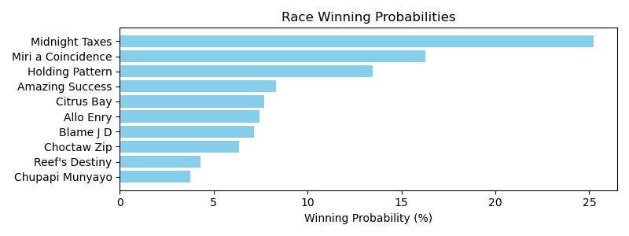

Exacta advice: key 6 → 2 (1 ticket)

NOTE: GCSF - Global Combined Speed Figure

# Race: TOP | 2025-04-26 | Race #4 | Post: 20:06 | Track: OAKLAWN PARK

Track: OAKLAWN PARK

|  |  |  |  |  |  |
| --- | --- | --- | --- | --- | --- |
| Program # | Horse Name | Morn Odds | GCSF | Model Score | Win Prob (%) |
| 1 | Deviletta | 9-2 | 6.0 | 0.58 | 9.39 |
| 2 | Wildwood Bye | 20-1 | 5.0 | 0.78 | 10.82 |
| 3 | Lady Commander | 20-1 | 8.0 | -0.08 | 6.00 |
| 4 | Feeling Beachy | 13-8 | 1.0 | 1.57 | 18.62 |
| 5 | Our Davina | 7-2 | 3.0 | 1.05 | 13.04 |
| 6 | Miss Tappy Tone | 20-1 | 9.0 | -0.20 | 5.51 |
| 7 | Blameitonmidnight | 15-1 | 7.0 | 0.06 | 6.59 |
| 8 | She's Not a Joke | 5-1 | 4.0 | 0.91 | 11.85 |
| 9 | She Makes a Point | 6-1 | 2.0 | 1.53 | 18.17 |

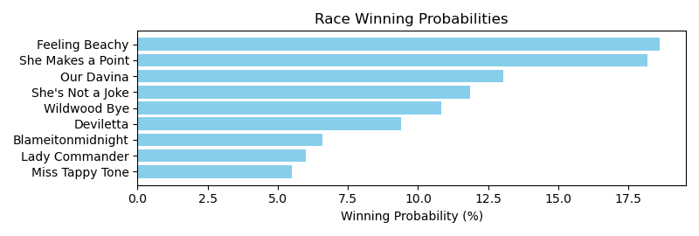

Exacta advice: box [4,9,5] (6 tickets)

NOTE: GCSF - Global Combined Speed Figure

# Race: TOP | 2025-04-26 | Race #5 | Post: 20:38 | Track: OAKLAWN PARK

Track: OAKLAWN PARK

|  |  |  |  |  |  |
| --- | --- | --- | --- | --- | --- |
| Program # | Horse Name | Morn Odds | GCSF | Model Score | Win Prob (%) |
| 1 | Dawson James | 5-1 | 4.0 | 1.69 | 9.95 |
| 2 | Butch | 20-1 | 9.0 | 0.83 | 5.47 |
| 3 | Razorback Army | 4-1 | 1.0 | 2.42 | 16.40 |
| 4 | Flat Out Blessed | 30-1 | 11.0 | 0.79 | 5.34 |
| 5 | Crue's N Control | 12-1 | 6.0 | 1.25 | 7.32 |
| 6 | Perfect Dial | 5-2 | 2.0 | 2.17 | 13.84 |
| 7 | POSSE ON THE PROWL | 50-1 | 13.0 | -1.05 | 1.50 |
| 8 | Hey Mister | 15-1 | 10.0 | 0.82 | 5.45 |
| 9 | Uncle Tater | 15-1 | 8.0 | 0.94 | 5.93 |
| 10 | Spinthekat | 12-1 | 12.0 | -0.26 | 2.59 |
| 11 | Bradford | 9-2 | 3.0 | 1.95 | 11.87 |
| 12 | Perscripture | 6-1 | 5.0 | 1.39 | 8.09 |
| 13 | Conway | 6-1 | 7.0 | 1.02 | 6.25 |

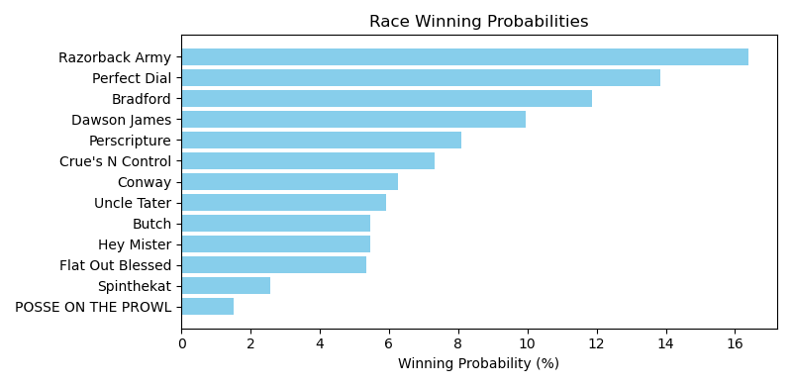

Exacta advice: key 3 → 6 (1 ticket)

NOTE: GCSF - Global Combined Speed Figure

# Race: TOP | 2025-04-26 | Race #6 | Post: 21:10 | Track: OAKLAWN PARK

Track: OAKLAWN PARK

|  |  |  |  |  |  |
| --- | --- | --- | --- | --- | --- |
| Program # | Horse Name | Morn Odds | GCSF | Model Score | Win Prob (%) |
| 1 | Payton's Beauty | 5-1 | 5.0 | 1.68 | 9.43 |
| 2 | BL FORTY | 30-1 | 13.0 | -0.90 | 1.60 |
| 3 | Blue Dazzler | 6-1 | 3.0 | 2.01 | 11.87 |
| 4 | CRUEL | 15-1 | 11.0 | -0.47 | 2.16 |
| 5 | C. C. Foxii | 12-1 | 10.0 | -0.25 | 2.50 |
| 6 | Foxy's Honor | 20-1 | 9.0 | 0.60 | 4.49 |
| 7 | Vickie's Halo | 30-1 | 14.0 | -1.02 | 1.47 |
| 8 | La Dinamita | 6-1 | 1.0 | 2.56 | 17.36 |
| 9 | Buzzworthy | 6-1 | 4.0 | 1.76 | 9.96 |
| 10 | Let'sgojlo | 9-2 | 7.0 | 1.00 | 5.92 |
| 11 | Miss Elle | 10-1 | 6.0 | 1.59 | 8.85 |
| 12 | Briscoe County | 4-1 | 8.0 | 0.93 | 5.64 |
| 13 | St. Albans Raid | 5-2 | 2.0 | 2.54 | 17.02 |
| 14 | UNOITDON'TCOMEEASY | 30-1 | 12.0 | -0.80 | 1.72 |

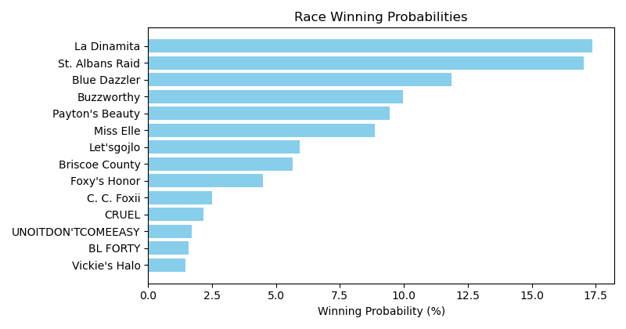

Exacta advice: box [8,13,3] (6 tickets)

NOTE: GCSF - Global Combined Speed Figure

# Race: TOP | 2025-04-26 | Race #7 | Post: 21:42 | Track: OAKLAWN PARK

Track: OAKLAWN PARK

|  |  |  |  |  |  |
| --- | --- | --- | --- | --- | --- |
| Program # | Horse Name | Morn Odds | GCSF | Model Score | Win Prob (%) |
| 1 | I Got No Munny | 7-2 | 1.0 | 3.22 | 31.68 |
| 2 | Algebra | 30-1 | 10.0 | 0.25 | 4.11 |
| 3 | Circle Back Jack | 20-1 | 7.0 | 0.69 | 5.54 |
| 4 | Shackleford Strong | 12-1 | 9.0 | 0.37 | 4.45 |
| 5 | Espionage | 3-1 | 2.0 | 2.01 | 13.77 |
| 6 | El Diablo Rojo | 10-1 | 6.0 | 0.78 | 5.92 |
| 7 | Dazzlemesilver | 10-1 | 8.0 | 0.61 | 5.26 |
| 8 | Therideofalifetime | 4-1 | 3.0 | 1.95 | 13.19 |
| 9 | Lightning Struck | 8-1 | 5.0 | 1.09 | 7.33 |
| 10 | Favorite Outlaw | 5-1 | 4.0 | 1.35 | 8.74 |

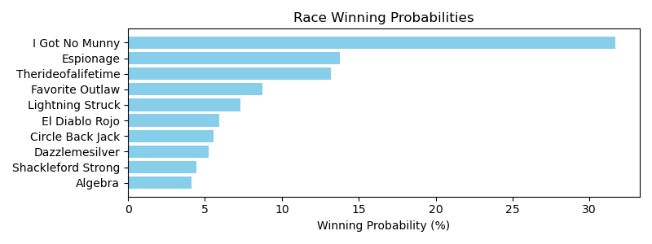

Exacta advice: key 1 → 5 (1 ticket)

NOTE: GCSF - Global Combined Speed Figure

# Race: TOP | 2025-04-26 | Race #8 | Post: 22:14 | Track: OAKLAWN PARK

Track: OAKLAWN PARK

|  |  |  |  |  |  |
| --- | --- | --- | --- | --- | --- |
| Program # | Horse Name | Morn Odds | GCSF | Model Score | Win Prob (%) |
| 1 | Fire Bryan | 20-1 | 8.0 | 0.49 | 6.85 |
| 2 | Bellamys Roan | 30-1 | 12.0 | -0.56 | 3.33 |
| 3 | Enjoy It Strait | 4-1 | 3.0 | 1.25 | 11.59 |
| 4 | Seven Flat | 3-1 | 2.0 | 1.45 | 13.32 |
| 5 | Home Run Trick | 20-1 | 9.0 | 0.18 | 5.57 |
| 6 | Mighty Message | 8-1 | 7.0 | 0.50 | 6.94 |
| 7 | Tapsasional | 7-2 | 1.0 | 1.58 | 14.53 |
| 8 | Fort Warren | 10-1 | 5.0 | 1.09 | 10.42 |
| 9 | Mo Rum | 20-1 | 10.0 | -0.14 | 4.47 |
| 10 | Deflater | 8-1 | 6.0 | 0.58 | 7.32 |
| 11 | Southern Sunset | 6-1 | 4.0 | 1.23 | 11.46 |
| 12 | Macho Ronnie | 20-1 | 11.0 | -0.23 | 4.20 |

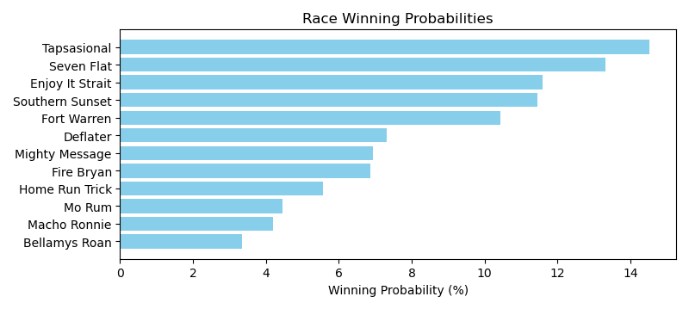

Exacta advice: key 7 → 4 (1 ticket)

NOTE: GCSF - Global Combined Speed Figure

# Race: TOP | 2025-04-26 | Race #9 | Post: 22:46 | Track: OAKLAWN PARK

Track: OAKLAWN PARK

|  |  |  |  |  |  |
| --- | --- | --- | --- | --- | --- |
| Program # | Horse Name | Morn Odds | GCSF | Model Score | Win Prob (%) |
| 1 | W W Scout's Honor | 9-2 | 2.0 | 1.83 | 13.36 |
| 2 | Okie Clipper | 30-1 | 10.0 | -0.20 | 3.31 |
| 3 | Bohemian Bo | 20-1 | 8.0 | 0.74 | 6.30 |
| 4 | Eglise | 6-1 | 5.0 | 1.65 | 11.78 |
| 5 | Classify | 4-1 | 1.0 | 1.96 | 14.62 |
| 6 | Red State | 5-2 | 3.0 | 1.82 | 13.28 |
| 7 | Slider | 8-1 | 7.0 | 1.26 | 8.98 |
| 8 | Excitable Boy | 30-1 | 9.0 | 0.21 | 4.37 |
| 9 | Northern Chill | 5-1 | 6.0 | 1.65 | 11.76 |
| 10 | Suncroft | 8-1 | 4.0 | 1.71 | 12.24 |

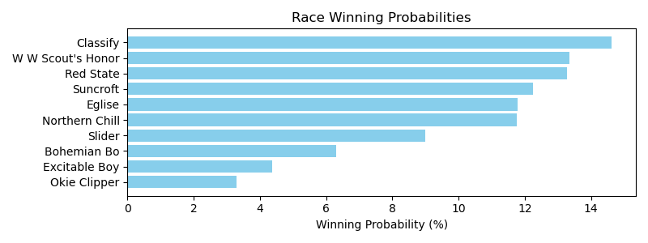

Exacta advice: key 5 → [1,6] (2 tickets)

NOTE: GCSF - Global Combined Speed Figure

# Race: TOP | 2025-04-26 | Race #10 | Post: 23:21 | Track: OAKLAWN PARK

Track: OAKLAWN PARK

|  |  |  |  |  |  |
| --- | --- | --- | --- | --- | --- |
| Program # | Horse Name | Morn Odds | GCSF | Model Score | Win Prob (%) |
| 1 | Bru Na Boinne | 6-1 | 3.0 | 1.64 | 15.38 |
| 2 | Hoosier Philly | 13-8 | 1.0 | 1.86 | 17.89 |
| 3 | In Just My Heels | 12-1 | 6.0 | 0.97 | 9.69 |
| 4 | Flashy Lass | 15-1 | 8.0 | 0.70 | 8.07 |
| 5 | Our Pretty Woman | 5-2 | 2.0 | 1.84 | 17.69 |
| 6 | Pretty Layla | 15-1 | 7.0 | 0.88 | 9.13 |
| 7 | Rose Palace | 5-1 | 4.0 | 1.33 | 12.45 |
| 8 | Majestic Oops | 8-1 | 5.0 | 0.97 | 9.71 |

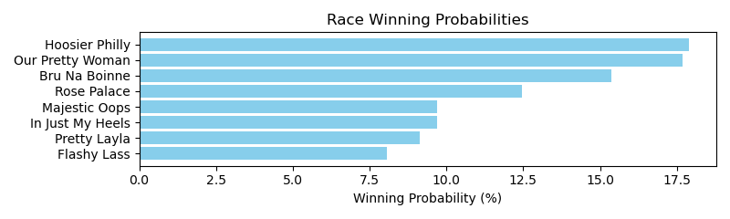

Exacta advice: box [2,5,1] (6 tickets)

NOTE: GCSF - Global Combined Speed Figure

# Race: TOP | 2025-04-26 | Race #11 | Post: 23:53 | Track: OAKLAWN PARK

Track: OAKLAWN PARK

|  |  |  |  |  |  |
| --- | --- | --- | --- | --- | --- |
| Program # | Horse Name | Morn Odds | GCSF | Model Score | Win Prob (%) |
| 1 | Miracle Mack | 5-2 | 3.0 | 2.23 | 13.46 |
| 2 | Mayor | 12-1 | 10.0 | 0.13 | 3.18 |
| 3 | Kensington Cove | 10-1 | 2.0 | 2.28 | 13.95 |
| 4 | Get the Boss | 30-1 | 12.0 | -0.25 | 2.43 |
| 5 | MAJOR JESSE | 30-1 | 13.0 | -0.44 | 2.14 |
| 6 | Low On Funds | 6-1 | 6.0 | 1.34 | 7.27 |
| 7 | BO BO DOUGH | 15-1 | 11.0 | -0.15 | 2.61 |
| 8 | Get Away With It | 3-1 | 4.0 | 2.13 | 12.54 |
| 9 | Cash App Mike | 30-1 | 9.0 | 0.23 | 3.39 |
| 10 | Swift Key | 20-1 | 7.0 | 1.19 | 6.57 |
| 11 | Coach Sam P | 7-2 | 1.0 | 2.61 | 17.50 |
| 12 | Denali Lightning | 20-1 | 8.0 | 0.94 | 5.53 |
| 13 | Stillbilly | 9-2 | 5.0 | 1.71 | 9.43 |

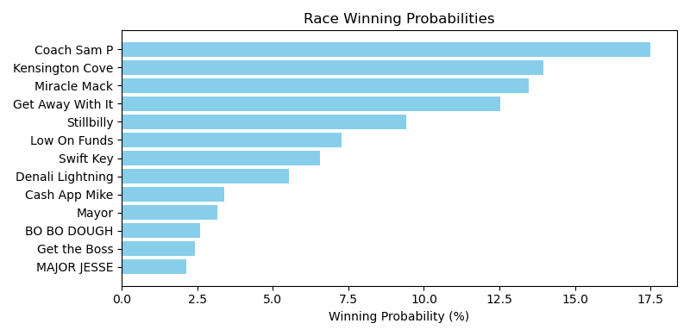

Exacta advice: key 11 → 3 (1 ticket)

NOTE: GCSF - Global Combined Speed Figure

# Race: TOP | 2025-04-27 | Race #1 | Post: 18:30 | Track: OAKLAWN PARK

Track: OAKLAWN PARK

|  |  |  |  |  |  |
| --- | --- | --- | --- | --- | --- |
| Program # | Horse Name | Morn Odds | GCSF | Model Score | Win Prob (%) |
| 1 | End of Innocence | 13-8 | 2.0 | 1.29 | 18.89 |
| 2 | Peppers Girlfriend | 5-1 | 4.0 | 0.73 | 12.86 |
| 3 | Floating | 8-1 | 6.0 | 0.45 | 10.56 |
| 4 | Chipotle Pepper | 9-5 | 1.0 | 1.65 | 24.10 |
| 5 | Sweet Mother Mary | 12-1 | 3.0 | 0.80 | 13.45 |
| 6 | Chasing Shadows | 10-1 | 5.0 | 0.71 | 12.66 |
| 7 | Legally Lucky | 15-1 | 7.0 | -0.05 | 7.48 |

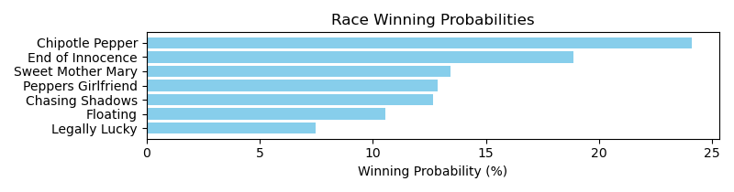

Exacta advice: key 4 → 1 (1 ticket)

NOTE: GCSF - Global Combined Speed Figure

# Race: TOP | 2025-04-27 | Race #2 | Post: 19:02 | Track: OAKLAWN PARK

Track: OAKLAWN PARK

|  |  |  |  |  |  |
| --- | --- | --- | --- | --- | --- |
| Program # | Horse Name | Morn Odds | GCSF | Model Score | Win Prob (%) |
| 1 | Rewire | 9-2 | 3.0 | 0.68 | 10.44 |
| 2 | A La Carte | 7-5 | 1.0 | 2.42 | 34.54 |
| 3 | Natorade | 8-1 | 6.0 | 0.06 | 6.83 |
| 4 | Clear Echo | 15-1 | 7.0 | -0.15 | 5.89 |
| 5 | Statler | 30-1 | 10.0 | -0.67 | 4.12 |
| 6 | Hayahlookatme | 6-1 | 5.0 | 0.11 | 7.09 |
| 7 | Cravensworth | 12-1 | 9.0 | -0.65 | 4.20 |
| 8 | Rev Too | 30-1 | 8.0 | -0.53 | 4.54 |
| 9 | Big Gain | 5-1 | 2.0 | 0.97 | 12.74 |
| 10 | To too Twentytwo | 10-1 | 4.0 | 0.56 | 9.62 |

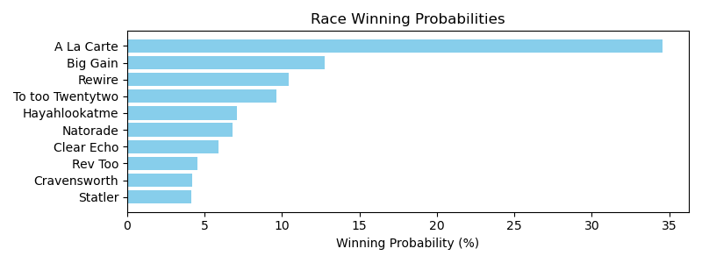

Exacta advice: key 2 → 9 (1 ticket)

NOTE: GCSF - Global Combined Speed Figure

# Race: TOP | 2025-04-27 | Race #3 | Post: 19:34 | Track: OAKLAWN PARK

Track: OAKLAWN PARK

|  |  |  |  |  |  |
| --- | --- | --- | --- | --- | --- |
| Program # | Horse Name | Morn Odds | GCSF | Model Score | Win Prob (%) |
| 1 | Sir Exton | 4-1 | 1.0 | 2.65 | 29.23 |
| 2 | Higginsville | 3-1 | 3.0 | 1.51 | 13.29 |
| 3 | Bettera | 5-2 | 2.0 | 2.31 | 23.20 |
| 4 | Ten Days Later | 10-1 | 5.0 | 0.95 | 9.09 |
| 5 | Moneyshot | 15-1 | 7.0 | 0.17 | 5.31 |
| 6 | Wicked Melody | 5-1 | 6.0 | 0.90 | 8.76 |
| 7 | Rivetage | 9-2 | 4.0 | 1.25 | 11.13 |

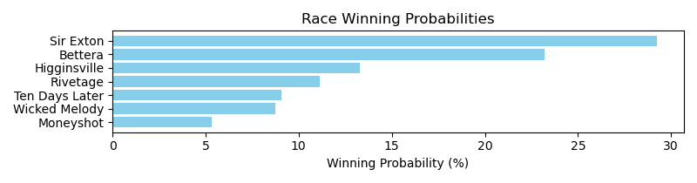

Exacta advice: key 1 → 3 (1 ticket)

NOTE: GCSF - Global Combined Speed Figure

# Race: TOP | 2025-04-27 | Race #4 | Post: 20:06 | Track: OAKLAWN PARK

Track: OAKLAWN PARK

|  |  |  |  |  |  |
| --- | --- | --- | --- | --- | --- |
| Program # | Horse Name | Morn Odds | GCSF | Model Score | Win Prob (%) |
| 1 | K C Rocket | 5-1 | 8.0 | 0.80 | 6.21 |
| 1A | Luv to Win | 5-1 | 5.0 | 1.31 | 8.86 |
| 2 | Cane Creek Road | 6-1 | 2.0 | 2.44 | 19.20 |
| 3 | Mid Day Image | 3-1 | 1.0 | 2.46 | 19.47 |
| 4 | Macho Ronnie | 15-1 | 10.0 | -0.10 | 3.35 |
| 5 | Tee Burns | 12-1 | 9.0 | 0.69 | 5.77 |
| 6 | Vulcan | 5-2 | 3.0 | 1.91 | 13.34 |
| 7 | The Queens Jules | 10-1 | 4.0 | 1.41 | 9.49 |
| 8 | Derby Date | 8-1 | 7.0 | 0.98 | 7.04 |
| 9 | Super Brady | 15-1 | 6.0 | 1.02 | 7.26 |

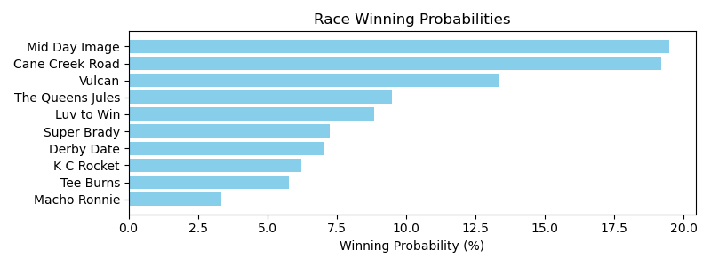

Exacta advice: box [3,2,6] (6 tickets)

NOTE: GCSF - Global Combined Speed Figure

# Race: TOP | 2025-04-27 | Race #5 | Post: 20:38 | Track: OAKLAWN PARK

Track: OAKLAWN PARK

|  |  |  |  |  |  |
| --- | --- | --- | --- | --- | --- |
| Program # | Horse Name | Morn Odds | GCSF | Model Score | Win Prob (%) |
| 1 | Sicilian Grandma | 30-1 | 9.0 | -0.86 | 3.38 |
| 2 | Lil Town Sis | 8-1 | 4.0 | 0.82 | 10.78 |
| 3 | Saranac Lake | 10-1 | 5.0 | 0.76 | 10.31 |
| 4 | Marina's Gold | 6-1 | 6.0 | 0.31 | 7.56 |
| 5 | Delphia | 3-1 | 3.0 | 1.21 | 14.08 |
| 6 | Class Code | 20-1 | 8.0 | -0.40 | 4.63 |
| 7 | Blaze On | 2-1 | 1.0 | 2.08 | 25.51 |
| 8 | Baby Gundin | 7-2 | 2.0 | 1.42 | 16.25 |
| 9 | It'sfiftyshadetime | 12-1 | 7.0 | 0.30 | 7.50 |

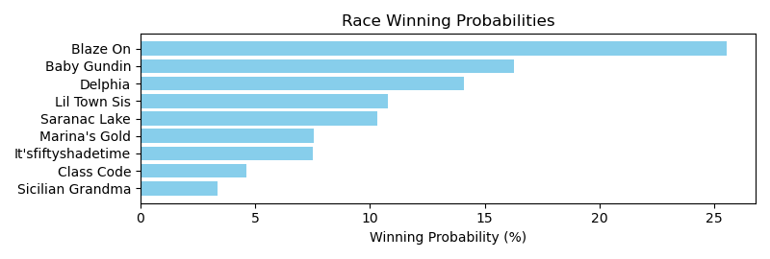

Exacta advice: key 7 → 8 (1 ticket)

NOTE: GCSF - Global Combined Speed Figure

# Race: TOP | 2025-04-27 | Race #6 | Post: 21:12 | Track: OAKLAWN PARK

Track: OAKLAWN PARK

|  |  |  |  |  |  |
| --- | --- | --- | --- | --- | --- |
| Program # | Horse Name | Morn Odds | GCSF | Model Score | Win Prob (%) |
| 1 | Belle Cherie | 6-1 | 5.0 | 1.40 | 9.80 |
| 2 | Songmaker | 9-2 | 1.0 | 3.13 | 32.23 |
| 3 | Kerry's Kiss | 10-1 | 3.0 | 2.19 | 16.85 |
| 4 | Perfect Shot | 2-1 | 4.0 | 1.40 | 9.84 |
| 5 | Lady Woopig | 15-1 | 6.0 | 0.22 | 4.35 |
| 6 | Standoutsensation | 9-5 | 2.0 | 2.46 | 20.36 |
| 7 | Georgia On E'smind | 30-1 | 8.0 | -0.43 | 2.80 |
| 8 | Catching Heat | 15-1 | 7.0 | 0.01 | 3.78 |

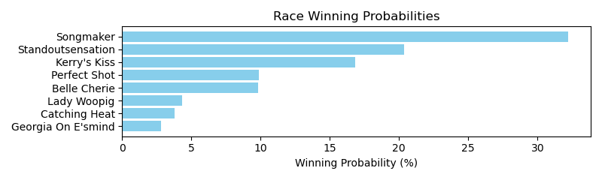

Exacta advice: key 2 → 6 (1 ticket)

NOTE: GCSF - Global Combined Speed Figure

# Race: TOP | 2025-04-27 | Race #7 | Post: 21:44 | Track: OAKLAWN PARK

Track: OAKLAWN PARK

|  |  |  |  |  |  |
| --- | --- | --- | --- | --- | --- |
| Program # | Horse Name | Morn Odds | GCSF | Model Score | Win Prob (%) |
| 1 | REACH'NFORRAINBOWS | 20-1 | 12.0 | -0.76 | 2.56 |
| 2 | Maxie Lady | 12-1 | 5.0 | 1.07 | 9.03 |
| 3 | Lottery Ticket | 2-1 | 9.0 | 0.24 | 5.11 |
| 4 | CUR NON | 15-1 | 10.0 | 0.08 | 4.57 |
| 5 | Call Sadie | 3-1 | 1.0 | 2.29 | 20.93 |
| 6 | Miss Makenna | 8-1 | 4.0 | 1.23 | 10.07 |
| 7 | Mazarn | 12-1 | 2.0 | 1.78 | 14.68 |
| 8 | Line Runner | 20-1 | 6.0 | 0.66 | 6.82 |
| 9 | UNOITDON'TCOMEEASY | 30-1 | 11.0 | -0.59 | 2.88 |
| 10 | Myspittinimage | 30-1 | 7.0 | 0.51 | 6.16 |
| 11 | Y City | 30-1 | 8.0 | 0.43 | 5.80 |
| 12 | Love Restrained | 7-2 | 3.0 | 1.41 | 11.39 |

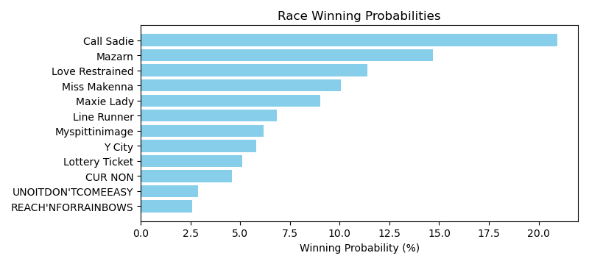

Exacta advice: key 5 → 7 (1 ticket)

NOTE: GCSF - Global Combined Speed Figure

# Race: TOP | 2025-04-27 | Race #8 | Post: 22:16 | Track: OAKLAWN PARK

Track: OAKLAWN PARK

|  |  |  |  |  |  |
| --- | --- | --- | --- | --- | --- |
| Program # | Horse Name | Morn Odds | GCSF | Model Score | Win Prob (%) |
| 1 | HEY BIG UN | 15-1 | 10.0 | -0.06 | 2.17 |
| 2 | Heavenly Deacon | 30-1 | 12.0 | -1.12 | 1.05 |
| 3 | dq-Major Mack | 9-2 | 4.0 | 2.51 | 12.76 |
| 4 | Heavenlyconveyance | 15-1 | 9.0 | 1.07 | 4.73 |
| 5 | Joewilly | 15-1 | 6.0 | 2.06 | 9.34 |
| 6 | Trojan Pride | 20-1 | 11.0 | -0.55 | 1.55 |
| 7 | American Litigator | 3-1 | 1.0 | 3.18 | 20.22 |
| 8 | Solevo | 6-1 | 5.0 | 2.12 | 9.73 |
| 9 | Jester Sang | 10-1 | 2.0 | 2.64 | 13.93 |
| 10 | World Fair | 7-2 | 3.0 | 2.56 | 13.17 |
| 11 | Tartarian | 12-1 | 7.0 | 1.48 | 6.25 |
| 12 | McMusic | 10-1 | 8.0 | 1.18 | 5.10 |

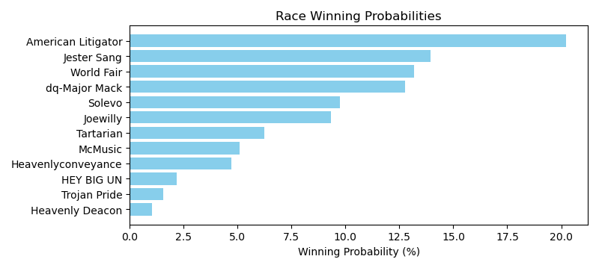

Exacta advice: key 7 → 9 (1 ticket)

NOTE: GCSF - Global Combined Speed Figure

# Race: TOP | 2025-04-27 | Race #9 | Post: 22:48 | Track: OAKLAWN PARK

Track: OAKLAWN PARK

|  |  |  |  |  |  |
| --- | --- | --- | --- | --- | --- |
| Program # | Horse Name | Morn Odds | GCSF | Model Score | Win Prob (%) |
| 1 | Bennykayandsuzytoo | 15-1 | 6.0 | 0.63 | 10.21 |
| 2 | Punchy Girl | 3-1 | 2.0 | 1.40 | 17.33 |
| 3 | She's a Dreamer | 20-1 | 10.0 | -1.69 | 2.07 |
| 4 | Caliente Star | 5-2 | 3.0 | 1.05 | 13.59 |
| 5 | Gold Strategy | 20-1 | 8.0 | -0.40 | 5.02 |
| 6 | Kantex | 9-5 | 1.0 | 1.54 | 19.02 |
| 7 | Courtney Fay | 30-1 | 9.0 | -1.37 | 2.58 |
| 8 | Arr Piratetreasure | 12-1 | 7.0 | 0.01 | 6.63 |
| 9 | Appealing Addie | 10-1 | 4.0 | 0.92 | 12.42 |
| 10 | Lassie My Girl | 8-1 | 5.0 | 0.76 | 11.13 |

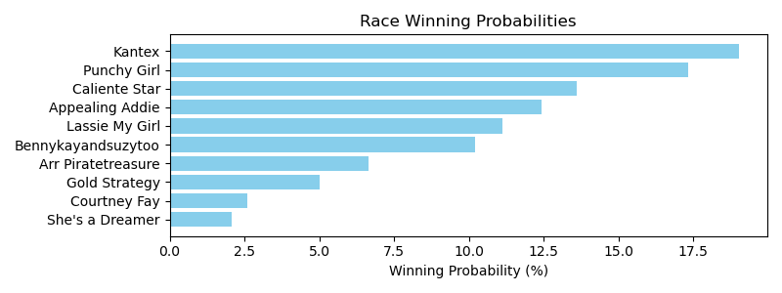

Exacta advice: key 6 → 2 (1 ticket)

NOTE: GCSF - Global Combined Speed Figure

# Race: TOP | 2025-04-27 | Race #10 | Post: 23:20 | Track: OAKLAWN PARK

Track: OAKLAWN PARK

|  |  |  |  |  |  |
| --- | --- | --- | --- | --- | --- |
| Program # | Horse Name | Morn Odds | GCSF | Model Score | Win Prob (%) |
| 1 | Oink | 20-1 | 9.0 | 0.32 | 3.44 |
| 2 | Giant Moon | 4-1 | 6.0 | 1.37 | 7.09 |
| 3 | TAKEN ON THE RUN | 15-1 | 11.0 | 0.17 | 3.10 |
| 4 | Golden City Street | 30-1 | 8.0 | 0.40 | 3.63 |
| 5 | Bigwrigdude | 15-1 | 5.0 | 1.74 | 9.13 |
| 6 | FERRIS STAR | 15-1 | 10.0 | 0.19 | 3.14 |
| 7 | Mr. Butch | 3-1 | 3.0 | 2.35 | 13.92 |
| 8 | Lord Hennessy | 8-1 | 2.0 | 2.51 | 15.54 |
| 9 | Red River | 30-1 | 7.0 | 0.54 | 4.00 |
| 10 | Tizmarkus | 13-8 | 1.0 | 3.32 | 27.21 |
| 11 | Kensington Cove | 15-1 | 4.0 | 1.84 | 9.81 |

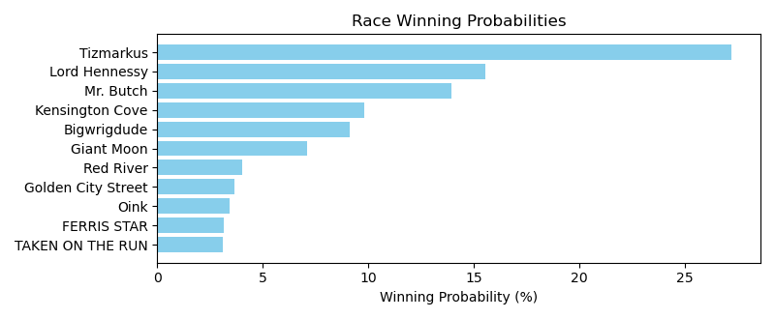

Exacta advice: key 10 → 8 (1 ticket)

NOTE: GCSF - Global Combined Speed Figure

# Race: PEN | 2025-05-01 | Race #1 | Post: 23:45 | Track: PENN NATIONAL

Track: PENN NATIONAL

|  |  |  |  |  |  |
| --- | --- | --- | --- | --- | --- |
| Program # | Horse Name | Morn Odds | GCSF | Model Score | Win Prob (%) |
| 1 | Dynamite Karma | 8-1 | 7.0 | 0.38 | 7.79 |
| 2 | First Glimpse | 7-2 | 1.0 | 1.70 | 19.45 |
| 3 | Debate | 12-1 | 5.0 | 0.92 | 11.36 |
| 4 | Memory Bouquet | 9-2 | 4.0 | 1.37 | 15.46 |
| 5 | Styner | 3-1 | 3.0 | 1.46 | 16.49 |
| 6 | Curlington | 5-2 | 2.0 | 1.64 | 18.61 |
| 7 | Tallahatchiebridge | 6-1 | 6.0 | 0.85 | 10.83 |

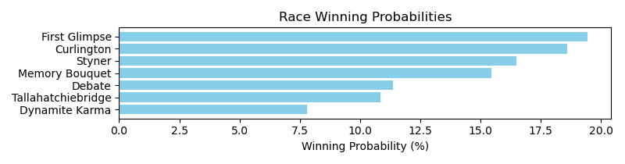

Exacta advice: box [2,6,5] (6 tickets)

NOTE: GCSF - Global Combined Speed Figure

# Race: PEN | 2025-05-01 | Race #2 | Post: 00:14 | Track: PENN NATIONAL

Track: PENN NATIONAL

|  |  |  |  |  |  |
| --- | --- | --- | --- | --- | --- |
| Program # | Horse Name | Morn Odds | GCSF | Model Score | Win Prob (%) |
| 1 | Pretty Lily | 6-1 | 7.0 | -1.18 | 4.71 |
| 2 | Ladro Di Fichi | 5-1 | 3.0 | 0.89 | 19.52 |
| 3 | Early Frost | 50-1 | 6.0 | -0.95 | 5.52 |
| 4 | Bella Prima | 7-2 | 4.0 | 0.53 | 15.32 |
| 5 | Stormy Spell | 5-1 | 5.0 | -0.23 | 9.09 |
| 6 | Kaz Music | 4-1 | 1.0 | 1.12 | 22.92 |
| 7 | Tilted Tiara | 2-1 | 2.0 | 1.12 | 22.91 |

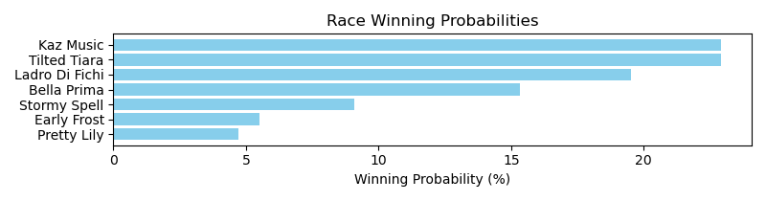

Exacta advice: box [6,7,2] (6 tickets)

NOTE: GCSF - Global Combined Speed Figure

# Race: PEN | 2025-05-01 | Race #3 | Post: 00:43 | Track: PENN NATIONAL

Track: PENN NATIONAL

|  |  |  |  |  |  |
| --- | --- | --- | --- | --- | --- |
| Program # | Horse Name | Morn Odds | GCSF | Model Score | Win Prob (%) |
| 1 | Head of the Class | 6-1 | 4.0 | 1.91 | 11.17 |
| 2 | Built by Khozan | 5-1 | 3.0 | 2.46 | 16.38 |
| 3 | Siete Siete Siete | 30-1 | 8.0 | 0.43 | 4.06 |
| 4 | MUNTAGE | 8-1 | 10.0 | 0.26 | 3.60 |
| 5 | Minister | 8-1 | 5.0 | 1.70 | 9.68 |
| 6 | SAFFIE JUNIOR | 15-1 | 11.0 | 0.06 | 3.14 |
| 7 | Jace Is No Joke | 10-1 | 6.0 | 1.23 | 7.03 |
| 8 | Manseeyasway | 30-1 | 7.0 | 1.19 | 6.85 |
| 9 | Pump It Up | 4-1 | 2.0 | 2.49 | 16.74 |
| 10 | THICK AND JUICY | 10-1 | 9.0 | 0.30 | 3.70 |
| 11 | Pilote Comete | 3-1 | 1.0 | 2.57 | 17.65 |

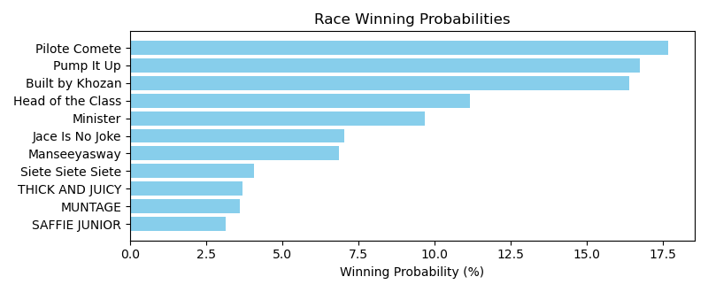

Exacta advice: box [11,9,2] (6 tickets)

NOTE: GCSF - Global Combined Speed Figure

# Race: PEN | 2025-05-01 | Race #4 | Post: 01:12 | Track: PENN NATIONAL

Track: PENN NATIONAL

|  |  |  |  |  |  |
| --- | --- | --- | --- | --- | --- |
| Program # | Horse Name | Morn Odds | GCSF | Model Score | Win Prob (%) |
| 1 | Desi's Reward | 2-1 | 1.0 | 1.14 | 29.83 |
| 2 | A Bit Bad N Boujee | 10-1 | 6.0 | -0.76 | 8.08 |
| 3 | My Jo Jo | 6-1 | 4.0 | -0.04 | 13.23 |
| 4 | Louella Street | 5-2 | 2.0 | 0.61 | 20.72 |
| 5 | Mikey's Jewel | 5-2 | 3.0 | 0.18 | 15.45 |
| 6 | Scott Alaia | 8-1 | 5.0 | -0.10 | 12.70 |

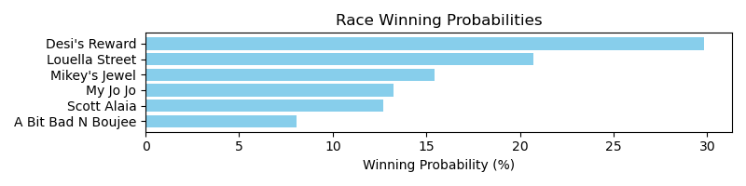

Exacta advice: key 1 → 4 (1 ticket)

NOTE: GCSF - Global Combined Speed Figure

# Race: PEN | 2025-05-01 | Race #5 | Post: 01:41 | Track: PENN NATIONAL

Track: PENN NATIONAL

|  |  |  |  |  |  |
| --- | --- | --- | --- | --- | --- |
| Program # | Horse Name | Morn Odds | GCSF | Model Score | Win Prob (%) |
| 1 | Cardinal War Cry | 4-1 | 4.0 | 0.03 | 9.19 |
| 2 | Cruzin Anna | 15-1 | 10.0 | -1.64 | 2.93 |
| 3 | Dakota Springs | 6-1 | 7.0 | -0.29 | 7.37 |
| 4 | Warrior's Defense | 9-2 | 2.0 | 0.75 | 15.12 |
| 5 | Dancing Chime | 12-1 | 8.0 | -0.86 | 5.01 |
| 6 | Fleeting Ember | 5-1 | 3.0 | 0.08 | 9.57 |
| 7 | Quivira Crane | 15-1 | 5.0 | 0.02 | 9.18 |
| 8 | Cloud in the Wind | 7-2 | 1.0 | 1.75 | 30.11 |
| 9 | Dancing Diana | 8-1 | 6.0 | -0.16 | 8.09 |
| 10 | Kashmir Witch | 12-1 | 9.0 | -1.41 | 3.43 |

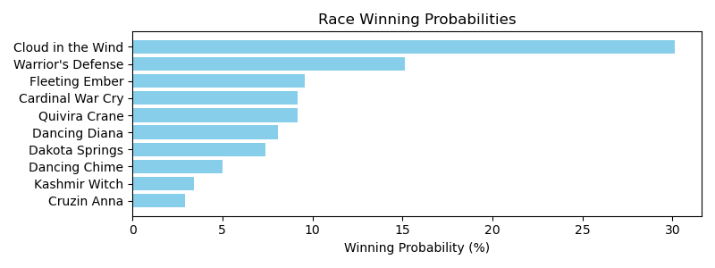

Exacta advice: key 8 → 4 (1 ticket)

NOTE: GCSF - Global Combined Speed Figure

# Race: PEN | 2025-05-01 | Race #6 | Post: 02:10 | Track: PENN NATIONAL

Track: PENN NATIONAL

|  |  |  |  |  |  |
| --- | --- | --- | --- | --- | --- |
| Program # | Horse Name | Morn Odds | GCSF | Model Score | Win Prob (%) |
| 1 | Episteme | 10-1 | 6.0 | 0.04 | 8.66 |
| 2 | Red Betty | 2-1 | 3.0 | 1.09 | 17.81 |
| 3 | Daisy's Angel | 7-2 | 1.0 | 1.25 | 19.88 |
| 4 | Cashpoint | 5-1 | 4.0 | 1.03 | 17.07 |
| 5 | R Serenity | 20-1 | 7.0 | -0.34 | 6.66 |
| 6 | One Eyed Jackie | 5-2 | 2.0 | 1.18 | 18.95 |
| 7 | Analog | 8-1 | 5.0 | 0.38 | 10.97 |

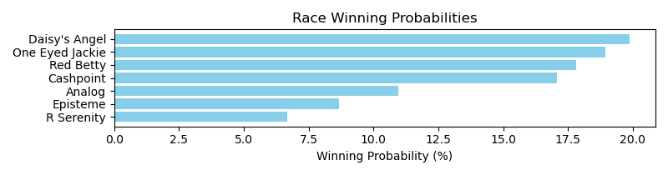

Exacta advice: box [3,6,2] (6 tickets)

NOTE: GCSF - Global Combined Speed Figure

# Race: PEN | 2025-05-01 | Race #7 | Post: 02:39 | Track: PENN NATIONAL

Track: PENN NATIONAL

|  |  |  |  |  |  |
| --- | --- | --- | --- | --- | --- |
| Program # | Horse Name | Morn Odds | GCSF | Model Score | Win Prob (%) |
| 1 | Phancy Philly | 5-1 | 3.0 | 0.12 | 11.40 |
| 2 | Bahama Pearl | 7-2 | 5.0 | -0.03 | 10.26 |
| 3 | Road to Dreams | 10-1 | 9.0 | -0.87 | 5.75 |
| 4 | Prussian Blue | 6-1 | 4.0 | 0.07 | 10.98 |
| 5 | Bowtothequeen | 6-1 | 1.0 | 0.24 | 12.42 |
| 6 | Amirati | 30-1 | 10.0 | -1.04 | 5.15 |
| 7 | Shinelikeadiamond | 4-1 | 2.0 | 0.21 | 12.09 |
| 8 | Kelly's Party Girl | 12-1 | 6.0 | -0.09 | 9.90 |
| 9 | La Lima | 20-1 | 11.0 | -1.07 | 5.02 |
| 10 | Bonita Lassie | 10-1 | 7.0 | -0.09 | 9.83 |
| 11 | Luckbealadytonight | 12-1 | 8.0 | -0.55 | 7.20 |

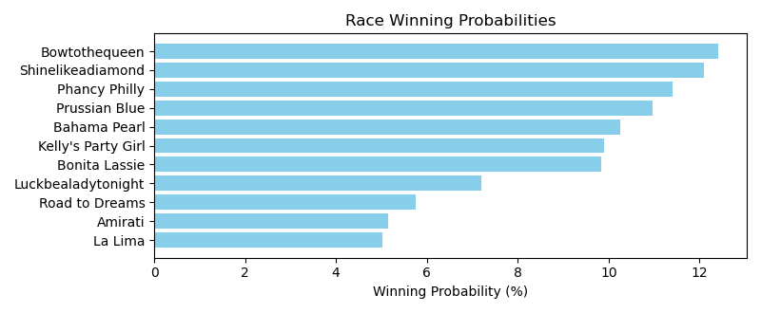

Exacta advice: box [5,7,1] (6 tickets)

NOTE: GCSF - Global Combined Speed Figure

# Race: PEN | 2025-05-02 | Race #1 | Post: 23:45 | Track: PENN NATIONAL

Track: PENN NATIONAL

|  |  |  |  |  |  |
| --- | --- | --- | --- | --- | --- |
| Program # | Horse Name | Morn Odds | GCSF | Model Score | Win Prob (%) |
| 1 | Combat Hoofs | 2-1 | 3.0 | 0.79 | 19.05 |
| 2 | Charm Alarm | 5-1 | 2.0 | 0.90 | 20.62 |
| 3 | Xerces | 7-2 | 4.0 | 0.16 | 12.35 |
| 4 | Emily's On Fire | 13-8 | 1.0 | 1.51 | 31.35 |
| 5 | Amplio Esquema | 15-1 | 6.0 | -0.43 | 8.23 |
| 6 | Olivia Dee | 12-1 | 5.0 | -0.40 | 8.41 |

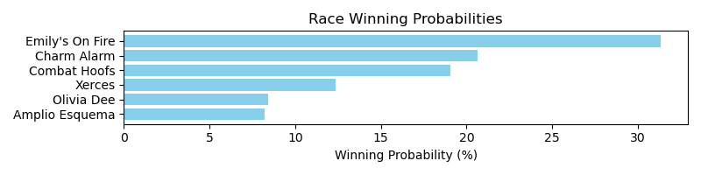

Exacta advice: key 4 → 2 (1 ticket)

NOTE: GCSF - Global Combined Speed Figure

# Race: PEN | 2025-05-02 | Race #2 | Post: 00:14 | Track: PENN NATIONAL

Track: PENN NATIONAL

|  |  |  |  |  |  |
| --- | --- | --- | --- | --- | --- |
| Program # | Horse Name | Morn Odds | GCSF | Model Score | Win Prob (%) |
| 1 | HOARDING | 3-1 | 3.0 | 1.13 | 15.00 |
| 2 | My Detroit City | 2-1 | 1.0 | 1.88 | 25.14 |
| 3 | Viral Video | 6-1 | 5.0 | 0.92 | 12.99 |
| 4 | Chucky Our Law | 7-2 | 2.0 | 1.84 | 24.47 |
| 5 | MO SAYS | 3-1 | 4.0 | 0.99 | 13.67 |
| 6 | It's Saul Goodman | 15-1 | 6.0 | 0.34 | 8.72 |

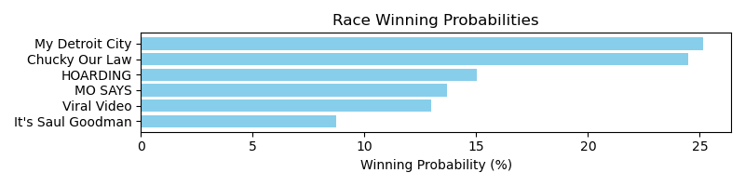

Exacta advice: box [2,4,1] (6 tickets)

NOTE: GCSF - Global Combined Speed Figure

# Race: PEN | 2025-05-02 | Race #3 | Post: 00:43 | Track: PENN NATIONAL

Track: PENN NATIONAL

|  |  |  |  |  |  |
| --- | --- | --- | --- | --- | --- |
| Program # | Horse Name | Morn Odds | GCSF | Model Score | Win Prob (%) |
| 1 | Abby's Spirit | 5-1 | 6.0 | -0.34 | 10.43 |
| 2 | Grumpy Brooksie | 15-1 | 8.0 | -1.15 | 5.97 |
| 3 | Long Tom | 30-1 | 4.0 | 0.05 | 13.67 |
| 4 | Leonids | 5-2 | 1.0 | 0.59 | 19.85 |
| 5 | Strasse | 3-1 | 3.0 | 0.09 | 14.08 |
| 6 | Keep Dem Talking | 8-1 | 7.0 | -0.45 | 9.68 |
| 7 | Purecrazigroove | 6-1 | 5.0 | -0.13 | 12.10 |
| 8 | Freedom's Start | 4-1 | 2.0 | 0.11 | 14.23 |

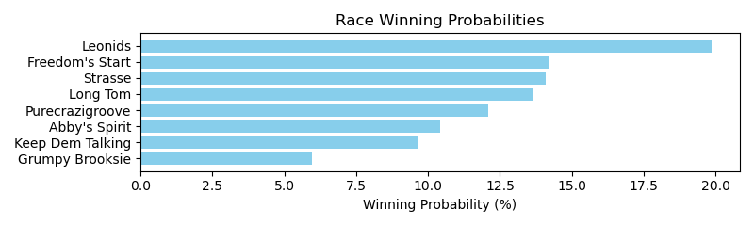

Exacta advice: key 4 → [8,5] (2 tickets)

NOTE: GCSF - Global Combined Speed Figure

# Race: PEN | 2025-05-02 | Race #4 | Post: 01:12 | Track: PENN NATIONAL

Track: PENN NATIONAL

|  |  |  |  |  |  |
| --- | --- | --- | --- | --- | --- |
| Program # | Horse Name | Morn Odds | GCSF | Model Score | Win Prob (%) |
| 1 | Normandy Life | 12-1 | 7.0 | -0.58 | 5.40 |
| 2 | Three Polks | 2-1 | 2.0 | 1.50 | 22.66 |
| 3 | Pink Rose | 7-2 | 1.0 | 1.60 | 24.34 |
| 4 | Undici | 12-1 | 6.0 | -0.39 | 6.17 |
| 5 | Queen Wiggy | 12-1 | 5.0 | 0.07 | 8.48 |
| 6 | Diane's Merlot | 4-1 | 4.0 | 0.47 | 11.15 |
| 7 | Marion Grace | 5-2 | 3.0 | 1.44 | 21.80 |

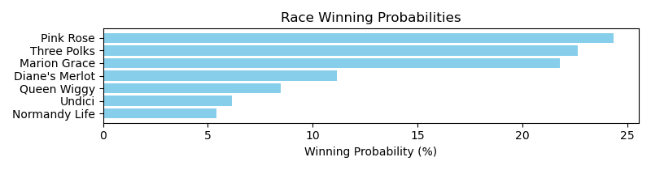

Exacta advice: key 3 → 2 (1 ticket)

NOTE: GCSF - Global Combined Speed Figure

# Race: PEN | 2025-05-02 | Race #5 | Post: 01:41 | Track: PENN NATIONAL

Track: PENN NATIONAL

|  |  |  |  |  |  |
| --- | --- | --- | --- | --- | --- |
| Program # | Horse Name | Morn Odds | GCSF | Model Score | Win Prob (%) |
| 1 | King of Hollywood | 2-1 | 1.0 | 1.77 | 25.25 |
| 2 | Martini Martin | 7-2 | 2.0 | 1.61 | 22.71 |
| 3 | Last Romance | 10-1 | 6.0 | 0.17 | 8.40 |
| 4 | Tubtimsiam | 8-1 | 5.0 | 0.54 | 10.88 |
| 5 | Entrust | 4-1 | 4.0 | 0.90 | 13.88 |
| 6 | Brett's World | 5-2 | 3.0 | 1.35 | 18.89 |

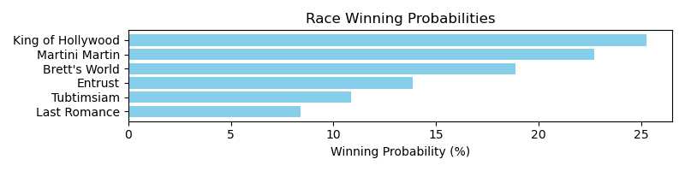

Exacta advice: key 1 → 2 (1 ticket)

NOTE: GCSF - Global Combined Speed Figure

# Race: PEN | 2025-05-02 | Race #6 | Post: 02:10 | Track: PENN NATIONAL

Track: PENN NATIONAL

|  |  |  |  |  |  |
| --- | --- | --- | --- | --- | --- |
| Program # | Horse Name | Morn Odds | GCSF | Model Score | Win Prob (%) |
| 1 | Skellig Island | 4-1 | 1.0 | 0.84 | 24.96 |
| 2 | Malibu Warrior | 3-1 | 2.0 | 0.55 | 20.46 |
| 3 | Town Kisser | 5-2 | 3.0 | 0.49 | 19.56 |
| 4 | Runawaytothemoon | 8-1 | 5.0 | -0.96 | 7.22 |
| 5 | Red Abarrio | 3-1 | 4.0 | 0.07 | 14.71 |
| 6 | Nightscape | 8-1 | 6.0 | -1.04 | 6.86 |
| 7 | Ramblin Chrome | 20-1 | 7.0 | -1.17 | 6.24 |

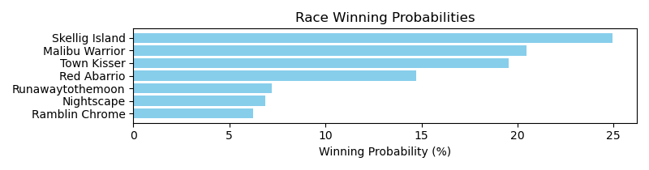

Exacta advice: key 1 → 2 (1 ticket)

NOTE: GCSF - Global Combined Speed Figure

# Race: PEN | 2025-05-02 | Race #7 | Post: 02:39 | Track: PENN NATIONAL

Track: PENN NATIONAL

|  |  |  |  |  |  |
| --- | --- | --- | --- | --- | --- |
| Program # | Horse Name | Morn Odds | GCSF | Model Score | Win Prob (%) |
| 1 | Spinning Musician | 5-2 | 3.0 | 0.63 | 16.75 |
| 2 | Pylon | 8-1 | 4.0 | 0.28 | 13.15 |
| 3 | Mighty Minion | 10-1 | 5.0 | -0.36 | 8.46 |
| 4 | Hibachi | 15-1 | 6.0 | -0.78 | 6.34 |
| 5 | dh-We Be There | 2-1 | 1.0 | 1.44 | 29.07 |
| 6 | Birthday Bond Rob | 10-1 | 7.0 | -0.90 | 5.84 |
| 7 | Gimmebackmybullets | 5-2 | 2.0 | 0.92 | 20.39 |

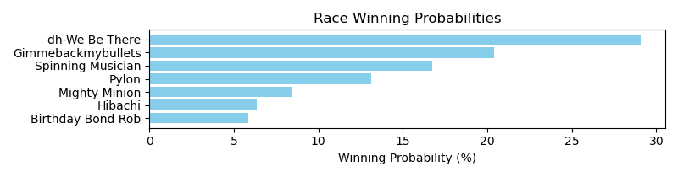

Exacta advice: key 5 → 7 (1 ticket)

NOTE: GCSF - Global Combined Speed Figure

# Race: PEN | 2025-05-03 | Race #1 | Post: 20:00 | Track: PENN NATIONAL

Track: PENN NATIONAL

|  |  |  |  |  |  |
| --- | --- | --- | --- | --- | --- |
| Program # | Horse Name | Morn Odds | GCSF | Model Score | Win Prob (%) |
| 1 | Peaceoftastycake | 6-1 | 6.0 | 0.18 | 7.77 |
| 2 | R Penelope | 5-1 | 5.0 | 0.54 | 9.92 |
| 3 | Simply Tenacious | 12-1 | 7.0 | -0.31 | 5.52 |
| 4 | Warriors Jewel | 5-2 | 1.0 | 2.57 | 40.04 |
| 5 | Nittany Lioness | 4-1 | 3.0 | 0.87 | 12.44 |
| 6 | Diamond Essence | 7-2 | 2.0 | 0.95 | 13.21 |
| 7 | Avril | 5-1 | 4.0 | 0.70 | 11.10 |

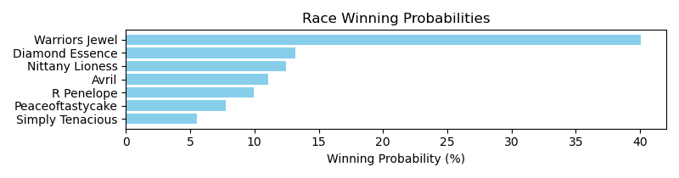

Exacta advice: key 4 → 6 (1 ticket)

NOTE: GCSF - Global Combined Speed Figure

# Race: PEN | 2025-05-03 | Race #2 | Post: 20:28 | Track: PENN NATIONAL

Track: PENN NATIONAL

|  |  |  |  |  |  |
| --- | --- | --- | --- | --- | --- |
| Program # | Horse Name | Morn Odds | GCSF | Model Score | Win Prob (%) |
| 1 | Pentatonic | 6-1 | 4.0 | 0.45 | 16.47 |
| 2 | Helms Deep | 13-8 | 2.0 | 1.00 | 24.01 |
| 3 | Saint Templar | 9-5 | 1.0 | 1.12 | 26.01 |
| 4 | Warrior On Tap | 5-2 | 3.0 | 0.62 | 18.46 |
| 5 | Mastermind | 12-1 | 5.0 | 0.32 | 15.05 |

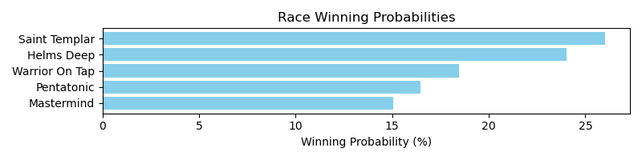

Exacta advice: key 3 → 2 (1 ticket)

NOTE: GCSF - Global Combined Speed Figure

# Race: PEN | 2025-05-03 | Race #3 | Post: 20:56 | Track: PENN NATIONAL

Track: PENN NATIONAL

|  |  |  |  |  |  |
| --- | --- | --- | --- | --- | --- |
| Program # | Horse Name | Morn Odds | GCSF | Model Score | Win Prob (%) |
| 1 | Pit Stop Man | 2-1 | 2.0 | 2.08 | 23.45 |
| 2 | Yes It's Roo | 15-1 | 8.0 | 0.01 | 5.65 |
| 3 | Mat Matters | 12-1 | 6.0 | 0.19 | 6.39 |
| 4 | One Way Farrior | 8-1 | 4.0 | 0.61 | 8.56 |
| 5 | Mask Patrol | 8-1 | 7.0 | 0.02 | 5.67 |
| 6 | Byk | 5-2 | 1.0 | 2.47 | 30.70 |
| 7 | Mobeer | 7-2 | 3.0 | 1.16 | 12.48 |
| 8 | Majestic Tiger | 12-1 | 5.0 | 0.34 | 7.09 |

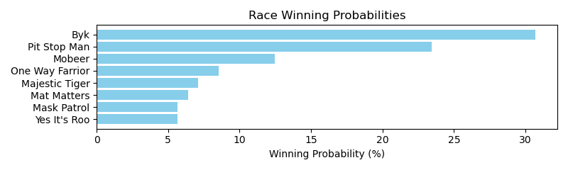

Exacta advice: key 6 → 1 (1 ticket)

NOTE: GCSF - Global Combined Speed Figure

# Race: PEN | 2025-05-03 | Race #4 | Post: 21:24 | Track: PENN NATIONAL

Track: PENN NATIONAL

|  |  |  |  |  |  |
| --- | --- | --- | --- | --- | --- |
| Program # | Horse Name | Morn Odds | GCSF | Model Score | Win Prob (%) |
| 1 | Picture This | 3-1 | 1.0 | 1.83 | 30.62 |
| 2 | Quilling | 7-2 | 4.0 | 0.62 | 13.27 |
| 3 | Capt. Candy | 6-1 | 5.0 | 0.60 | 13.12 |
| 4 | Tactical Humor | 4-1 | 3.0 | 0.66 | 13.73 |
| 5 | Mr Sandman | 2-1 | 2.0 | 1.28 | 21.02 |
| 6 | Force of Justice | 8-1 | 6.0 | -0.08 | 8.24 |

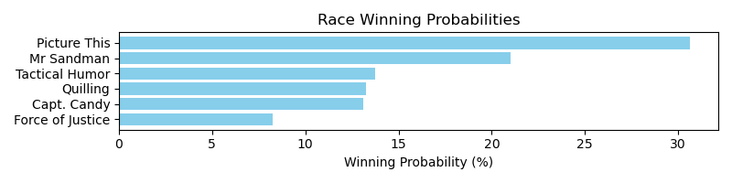

Exacta advice: key 1 → 5 (1 ticket)

NOTE: GCSF - Global Combined Speed Figure

# Race: PEN | 2025-05-03 | Race #5 | Post: 21:52 | Track: PENN NATIONAL

Track: PENN NATIONAL

|  |  |  |  |  |  |
| --- | --- | --- | --- | --- | --- |
| Program # | Horse Name | Morn Odds | GCSF | Model Score | Win Prob (%) |
| 1 | Donnelly's Hollow | 5-1 | 5.0 | 0.70 | 10.29 |
| 2 | Kevin Mac | 3-1 | 2.0 | 1.62 | 19.32 |
| 3 | Spezia's Son | 30-1 | 7.0 | -0.00 | 6.33 |
| 4 | Pops Harper | 5-2 | 1.0 | 2.23 | 29.35 |
| 5 | Michaelshatrick | 50-1 | 6.0 | 0.04 | 6.50 |
| 6 | Sapphire Prince | 9-5 | 3.0 | 1.43 | 17.00 |
| 7 | Sams After Party | 6-1 | 4.0 | 0.83 | 11.20 |

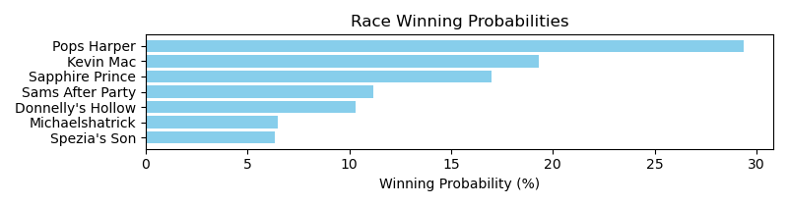

Exacta advice: key 4 → 2 (1 ticket)

NOTE: GCSF - Global Combined Speed Figure

# Race: PEN | 2025-05-03 | Race #6 | Post: 22:20 | Track: PENN NATIONAL

Track: PENN NATIONAL

|  |  |  |  |  |  |
| --- | --- | --- | --- | --- | --- |
| Program # | Horse Name | Morn Odds | GCSF | Model Score | Win Prob (%) |
| 1 | Mischief Warrior | 30-1 | 8.0 | -0.58 | 5.70 |
| 2 | Magnificent Ride | 10-1 | 4.0 | 0.65 | 13.29 |
| 3 | Termsofengagement | 5-2 | 2.0 | 0.98 | 16.60 |
| 4 | Trophy Room | 3-1 | 1.0 | 1.00 | 16.87 |
| 5 | My Blue Eyes | 8-1 | 7.0 | -0.07 | 8.10 |
| 6 | Kbcya Later | 4-1 | 3.0 | 0.97 | 16.56 |
| 7 | Eddiemush | 6-1 | 6.0 | 0.30 | 10.39 |
| 8 | Swing Oil | 6-1 | 5.0 | 0.56 | 12.49 |

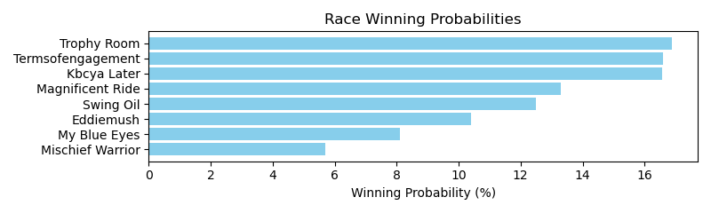

Exacta advice: box [4,3,6] (6 tickets)

NOTE: GCSF - Global Combined Speed Figure

# Race: PEN | 2025-05-03 | Race #7 | Post: 22:48 | Track: PENN NATIONAL

Track: PENN NATIONAL

|  |  |  |  |  |  |
| --- | --- | --- | --- | --- | --- |
| Program # | Horse Name | Morn Odds | GCSF | Model Score | Win Prob (%) |
| 1 | Sunshine Johnny | 4-1 | 2.0 | 1.97 | 25.43 |
| 2 | Harbour Bridge | 2-1 | 1.0 | 2.13 | 28.42 |
| 3 | Rolly | 4-1 | 4.0 | 0.28 | 7.93 |
| 4 | Midnight Ambition | 6-1 | 3.0 | 1.77 | 22.18 |
| 5 | Sylvia I Am | 8-1 | 6.0 | -0.56 | 4.46 |
| 6 | Wizardofez | 7-2 | 5.0 | 0.19 | 7.49 |
| 7 | Private Cabana | 20-1 | 7.0 | -0.69 | 4.09 |

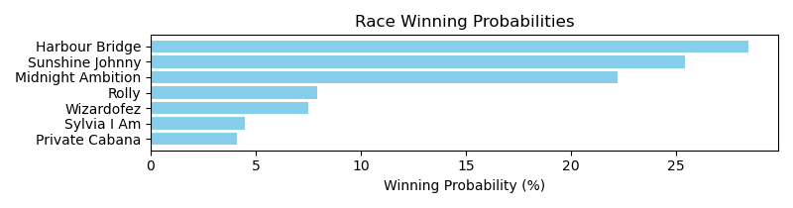

Exacta advice: key 2 → 1 (1 ticket)

NOTE: GCSF - Global Combined Speed Figure

# Race: TSA | 2025-04-26 | Race #1 | Post: 19:00 | Track: SANTA ANITA PARK

Track: SANTA ANITA PARK

|  |  |  |  |  |  |
| --- | --- | --- | --- | --- | --- |
| Program # | Horse Name | Morn Odds | GCSF | Model Score | Win Prob (%) |
| 1 | dq-Broski (IRE) | 6-1 | 1.0 | 3.55 | 19.22 |
| 2 | Midnight Strike | 15-1 | 5.0 | 2.43 | 8.92 |
| 3 | Tapit Dynasty | 12-1 | 6.0 | 2.04 | 6.81 |
| 4 | Redial | 20-1 | 7.0 | 1.65 | 5.20 |
| 5 | Unrivaled Hero | 5-1 | 3.0 | 3.36 | 16.94 |
| 6 | Catch the Breeze | 10-1 | 2.0 | 3.54 | 19.07 |
| 7 | Cuban Confusion (GB) | 5-2 | 4.0 | 3.30 | 16.19 |
| 8 | Day and Age | 30-1 | 8.0 | 0.99 | 3.30 |
| 9 | MUTAZ | 2-1 | 9.0 | 0.86 | 3.03 |
| 10 | Wolf Away | 30-1 | 10.0 | -0.35 | 1.31 |

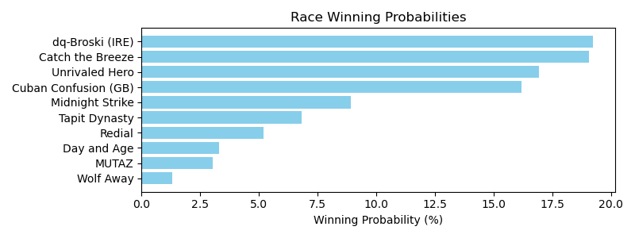

Exacta advice: box [1,6,5] (6 tickets)

NOTE: GCSF - Global Combined Speed Figure

# Race: TSA | 2025-04-26 | Race #2 | Post: 19:32 | Track: SANTA ANITA PARK

Track: SANTA ANITA PARK

|  |  |  |  |  |  |
| --- | --- | --- | --- | --- | --- |
| Program # | Horse Name | Morn Odds | GCSF | Model Score | Win Prob (%) |
| 1 | Momad | 2-1 | 2.0 | 1.88 | 26.46 |
| 2 | Shady Tiger | 3-1 | 3.0 | 1.69 | 23.14 |
| 3 | Positivity | 9-5 | 1.0 | 2.19 | 32.67 |
| 4 | Self Sufficient | 8-1 | 5.0 | -0.08 | 6.85 |
| 5 | Smooth Cruisein | 9-2 | 4.0 | 0.59 | 10.88 |

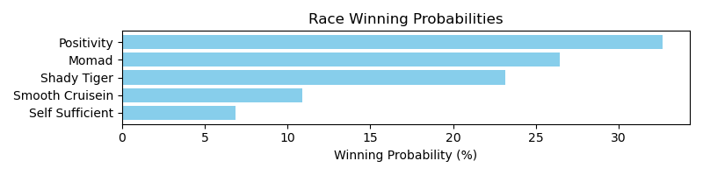

Exacta advice: key 3 → 1 (1 ticket)

NOTE: GCSF - Global Combined Speed Figure

# Race: TSA | 2025-04-26 | Race #3 | Post: 20:05 | Track: SANTA ANITA PARK

Track: SANTA ANITA PARK

|  |  |  |  |  |  |
| --- | --- | --- | --- | --- | --- |
| Program # | Horse Name | Morn Odds | GCSF | Model Score | Win Prob (%) |
| 1 | Stan From Malibu | 12-1 | 10.0 | -0.03 | 4.76 |
| 2 | Tamarando Star | 15-1 | 11.0 | -0.35 | 3.83 |
| 3 | Idiot's Gold | 20-1 | 7.0 | 0.61 | 7.43 |
| 4 | Harcyn | 10-1 | 4.0 | 0.97 | 9.51 |
| 5 | Carol's Comic | 8-1 | 5.0 | 0.86 | 8.79 |
| 6 | Fireman Dan | 12-1 | 8.0 | 0.46 | 6.68 |
| 7 | Barsabas | 10-1 | 1.0 | 1.86 | 17.57 |
| 8 | Goldensunrise | 9-2 | 6.0 | 0.68 | 7.78 |
| 9 | Navy Man | 7-2 | 2.0 | 1.79 | 16.67 |
| 10 | Havoc | 6-1 | 3.0 | 1.15 | 10.76 |
| 11 | Halo Uncle | 5-1 | 9.0 | 0.35 | 6.21 |

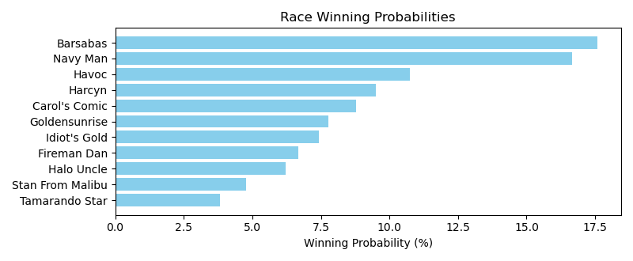

Exacta advice: box [7,9,10] (6 tickets)

NOTE: GCSF - Global Combined Speed Figure

# Race: TSA | 2025-04-26 | Race #4 | Post: 20:36 | Track: SANTA ANITA PARK

Track: SANTA ANITA PARK

|  |  |  |  |  |  |
| --- | --- | --- | --- | --- | --- |
| Program # | Horse Name | Morn Odds | GCSF | Model Score | Win Prob (%) |
| 1 | For All Mankind | 4-1 | 2.0 | 2.16 | 23.94 |
| 2 | Mirahmadi | 9-5 | 3.0 | 2.05 | 22.17 |
| 3 | Eagles Flight | 6-5 | 1.0 | 2.63 | 33.18 |
| 4 | Midnight Mammoth | 8-1 | 4.0 | 1.10 | 11.58 |
| 5 | Arrowthegreat | 6-1 | 5.0 | 0.76 | 9.13 |

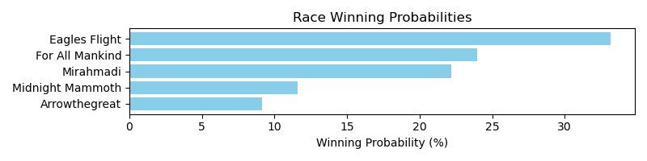

Exacta advice: key 3 → 1 (1 ticket)

NOTE: GCSF - Global Combined Speed Figure

# Race: TSA | 2025-04-26 | Race #5 | Post: 21:08 | Track: SANTA ANITA PARK

Track: SANTA ANITA PARK

|  |  |  |  |  |  |
| --- | --- | --- | --- | --- | --- |
| Program # | Horse Name | Morn Odds | GCSF | Model Score | Win Prob (%) |
| 1 | Elwood Blues | 4-1 | 5.0 | 1.57 | 11.51 |
| 2 | Go Joe Won | 30-1 | 7.0 | 1.08 | 8.24 |
| 3 | Mucho Del Oro | 5-2 | 1.0 | 2.24 | 18.32 |
| 4 | Dandy Man Shines (IRE) | 6-1 | 2.0 | 2.17 | 17.37 |
| 5 | Charge for Gold | 20-1 | 8.0 | 0.67 | 6.21 |
| 6 | We're in Trouble | 3-1 | 3.0 | 1.95 | 14.92 |
| 7 | Sharp Aza Tack | 6-1 | 6.0 | 1.40 | 10.28 |
| 8 | Fast Buck | 5-1 | 4.0 | 1.76 | 13.16 |

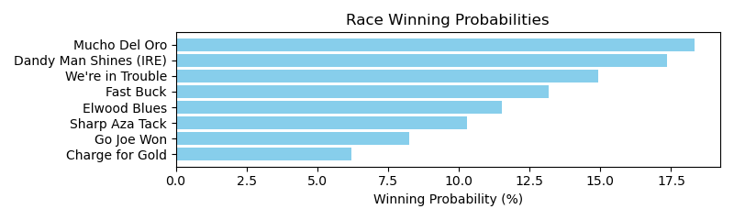

Exacta advice: box [3,4,6] (6 tickets)

NOTE: GCSF - Global Combined Speed Figure

# Race: TSA | 2025-04-26 | Race #6 | Post: 21:38 | Track: SANTA ANITA PARK

Track: SANTA ANITA PARK

|  |  |  |  |  |  |
| --- | --- | --- | --- | --- | --- |
| Program # | Horse Name | Morn Odds | GCSF | Model Score | Win Prob (%) |
| 1 | Aggro | 13-8 | 1.0 | 4.00 | 35.16 |
| 2 | Siempre Naman | 12-1 | 7.0 | 1.22 | 5.20 |
| 3 | Wild Texas Rose | 30-1 | 10.0 | -0.63 | 1.45 |
| 4 | Mrazek's Old Dream | 8-1 | 3.0 | 2.34 | 11.22 |
| 5 | Coconut Girl | 15-1 | 8.0 | 1.20 | 5.14 |
| 6 | Union Heiress | 20-1 | 6.0 | 1.40 | 5.89 |
| 7 | Petite Ange | 5-2 | 2.0 | 3.14 | 19.48 |
| 8 | Be a Goldfish | 6-1 | 5.0 | 1.58 | 6.65 |
| 9 | Japhar's Girl | 10-1 | 9.0 | 0.08 | 2.37 |
| 10 | My Eliana | 20-1 | 4.0 | 1.74 | 7.42 |

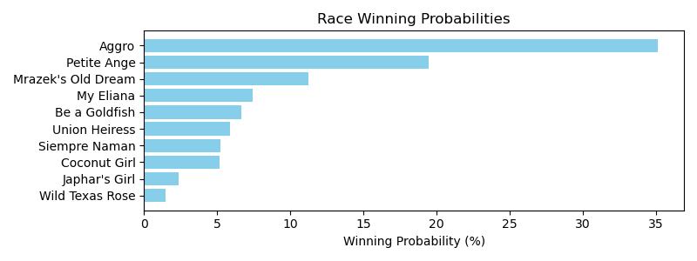

Exacta advice: key 1 → 7 (1 ticket)

NOTE: GCSF - Global Combined Speed Figure

# Race: TSA | 2025-04-26 | Race #7 | Post: 22:08 | Track: SANTA ANITA PARK

Track: SANTA ANITA PARK

|  |  |  |  |  |  |
| --- | --- | --- | --- | --- | --- |
| Program # | Horse Name | Morn Odds | GCSF | Model Score | Win Prob (%) |
| 1 | Public Assembly | 5-1 | 4.0 | 2.10 | 11.26 |
| 2 | Raw Ability (IRE) | 9-2 | 5.0 | 1.87 | 9.56 |
| 3 | Sneaker | 15-1 | 8.0 | 1.18 | 5.98 |
| 4 | Uncorked (AUS) | 7-2 | 3.0 | 2.11 | 11.33 |
| 5 | Venganza | 15-1 | 9.0 | 1.00 | 5.27 |
| 6 | Tirupati | 2-1 | 1.0 | 2.40 | 13.75 |
| 7 | Sun Of Hill (BRZ) | 20-1 | 2.0 | 2.24 | 12.40 |
| 8 | Mucho Macho Girl | 20-1 | 6.0 | 1.55 | 7.67 |
| 9 | Eternal Reign (IRE) | 12-1 | 7.0 | 1.27 | 6.33 |
| 10 | Valence | 15-1 | 12.0 | 0.61 | 4.02 |
| 11 | Hamwood Flier (IRE) | 10-1 | 10.0 | 0.81 | 4.62 |
| 12 | Baltic Fire | 30-1 | 13.0 | 0.41 | 3.52 |
| 13 | Lunar Impact (GB) | 20-1 | 11.0 | 0.71 | 4.31 |

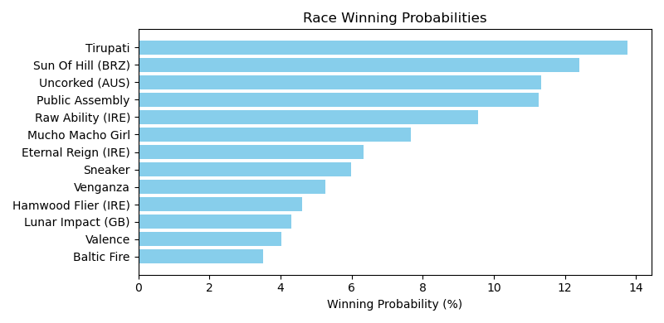

Exacta advice: key 6 → 7 (1 ticket)

NOTE: GCSF - Global Combined Speed Figure

# Race: TSA | 2025-04-26 | Race #8 | Post: 22:38 | Track: SANTA ANITA PARK

Track: SANTA ANITA PARK

|  |  |  |  |  |  |
| --- | --- | --- | --- | --- | --- |
| Program # | Horse Name | Morn Odds | GCSF | Model Score | Win Prob (%) |
| 1 | Woodbine Way | 12-1 | 1.0 | 2.19 | 18.28 |
| 2 | Lady's Sermon | 8-1 | 4.0 | 1.31 | 10.00 |
| 3 | Cee's the Image | 10-1 | 5.0 | 1.14 | 8.86 |
| 4 | Twilight Empire | 8-1 | 7.0 | 0.92 | 7.64 |
| 5 | Respect the Crown | 12-1 | 10.0 | 0.45 | 5.53 |
| 6 | Discrepancy | 8-1 | 9.0 | 0.67 | 6.42 |
| 7 | Mo Town Gal | 15-1 | 8.0 | 0.73 | 6.69 |
| 8 | Just Is | 6-1 | 3.0 | 1.45 | 11.02 |
| 9 | Uffda | 8-1 | 6.0 | 1.06 | 8.41 |
| 10 | Champagne Camie | 2-1 | 2.0 | 1.71 | 13.16 |
| 11 | Chollima | 30-1 | 11.0 | -0.02 | 4.01 |

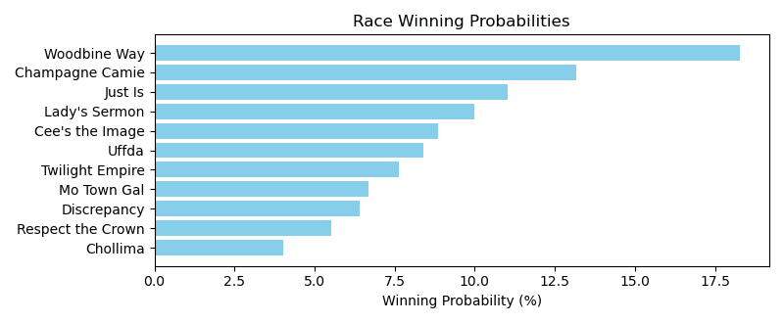

Exacta advice: key 1 → 10 (1 ticket)

NOTE: GCSF - Global Combined Speed Figure

# Race: TSA | 2025-04-26 | Race #9 | Post: 23:08 | Track: SANTA ANITA PARK

Track: SANTA ANITA PARK

|  |  |  |  |  |  |
| --- | --- | --- | --- | --- | --- |
| Program # | Horse Name | Morn Odds | GCSF | Model Score | Win Prob (%) |
| 1 | Clouseau | 9-2 | 5.0 | 1.44 | 9.04 |
| 2 | Canani | 10-1 | 1.0 | 2.99 | 26.27 |
| 3 | It's a Factor | 30-1 | 7.0 | 0.98 | 6.61 |
| 4 | Table for Two | 6-1 | 4.0 | 1.64 | 10.42 |
| 5 | Brazenly | 5-2 | 3.0 | 1.93 | 12.68 |
| 6 | Shortman | 20-1 | 9.0 | 0.12 | 3.66 |
| 7 | Jimmy Blue Jeans | 9-5 | 2.0 | 2.43 | 17.95 |
| 8 | Blame the Classic | 15-1 | 8.0 | 0.65 | 5.25 |
| 9 | Rodrigoknows | 12-1 | 6.0 | 1.28 | 8.12 |

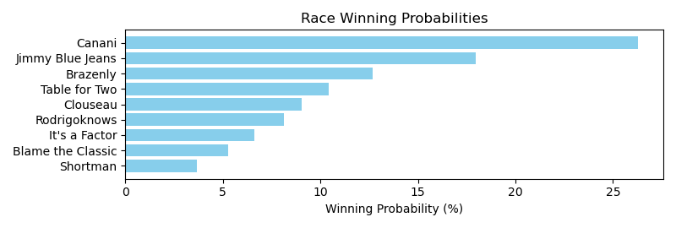

Exacta advice: key 2 → 7 (1 ticket)

NOTE: GCSF - Global Combined Speed Figure

# Race: TSA | 2025-04-26 | Race #10 | Post: 23:38 | Track: SANTA ANITA PARK

Track: SANTA ANITA PARK

|  |  |  |  |  |  |
| --- | --- | --- | --- | --- | --- |
| Program # | Horse Name | Morn Odds | GCSF | Model Score | Win Prob (%) |
| 1 | Big Splash | 15-1 | 8.0 | -0.02 | 3.66 |
| 2 | Valentines Candy | 7-2 | 5.0 | 1.34 | 9.32 |
| 3 | Petesoldfashioned | 8-1 | 6.0 | 1.12 | 8.00 |
| 4 | Battle Cruiser | 9-2 | 3.0 | 1.69 | 11.90 |
| 5 | Top Gun Classic | 20-1 | 9.0 | -0.03 | 3.64 |
| 6 | White Mountain | 6-1 | 1.0 | 2.80 | 25.50 |
| 7 | Mighty Kai | 10-1 | 7.0 | 0.77 | 6.30 |
| 8 | Canyahearmeknockin | 5-1 | 2.0 | 2.30 | 18.12 |
| 9 | Tiger Strength | 30-1 | 10.0 | -0.08 | 3.52 |
| 10 | Asmodeus | 4-1 | 4.0 | 1.45 | 10.04 |

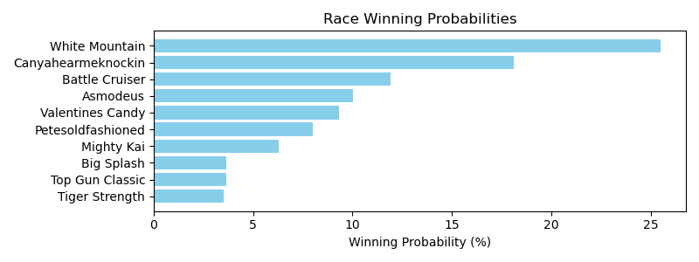

Exacta advice: key 6 → 8 (1 ticket)

NOTE: GCSF - Global Combined Speed Figure

# Race: TSA | 2025-04-26 | Race #11 | Post: 00:08 | Track: SANTA ANITA PARK

Track: SANTA ANITA PARK

|  |  |  |  |  |  |
| --- | --- | --- | --- | --- | --- |
| Program # | Horse Name | Morn Odds | GCSF | Model Score | Win Prob (%) |
| 1 | WIND SPEED | 12-1 | 12.0 | 0.52 | 3.93 |
| 2 | RELIGIOUSLY | 15-1 | 14.0 | 0.05 | 2.84 |
| 3 | Big City Miss | 5-1 | 3.0 | 1.67 | 8.65 |
| 4 | ZAP THE COMMAND | 10-1 | 11.0 | 0.61 | 4.17 |
| 5 | Godavri | 6-1 | 7.0 | 0.90 | 5.11 |
| 6 | TIS SUNRISE | 20-1 | 13.0 | 0.46 | 3.78 |
| 7 | FRENCH MOONLIGHT | 12-1 | 8.0 | 0.89 | 5.08 |
| 8 | Sasafran | 12-1 | 5.0 | 1.47 | 7.57 |
| 9 | Naturally Blonde | 10-1 | 2.0 | 1.75 | 9.16 |
| 10 | Have Patience | 7-2 | 1.0 | 3.21 | 25.09 |
| 11 | Miss Mrazek | 6-1 | 4.0 | 1.60 | 8.26 |
| 12 | Clubhouse Cutie | 15-1 | 10.0 | 0.70 | 4.46 |
| 13 | Sexy Blue | 30-1 | 9.0 | 0.83 | 4.85 |
| 14 | Dertien | 5-1 | 6.0 | 1.37 | 7.04 |

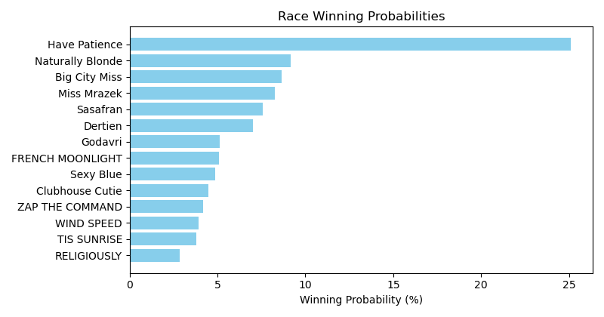

Exacta advice: key 10 → 9 (1 ticket)

NOTE: GCSF - Global Combined Speed Figure

# Race: TSA | 2025-04-27 | Race #1 | Post: 19:00 | Track: SANTA ANITA PARK

Track: SANTA ANITA PARK

|  |  |  |  |  |  |
| --- | --- | --- | --- | --- | --- |
| Program # | Horse Name | Morn Odds | GCSF | Model Score | Win Prob (%) |
| 1 | Kentucky Gal (IRE) | 2-1 | 1.0 | 3.61 | 38.91 |
| 2 | Starts Now | 9-2 | 5.0 | 1.49 | 9.01 |
| 3 | Vincero Grande | 5-1 | 3.0 | 1.99 | 12.77 |
| 4 | Esmeray (IRE) | 10-1 | 7.0 | 0.60 | 4.90 |
| 5 | Tiaraqueen (GB) | 6-1 | 4.0 | 1.89 | 11.92 |
| 6 | Mizzyaan | 5-2 | 2.0 | 2.36 | 16.40 |
| 7 | Cheekiest | 15-1 | 6.0 | 0.91 | 6.08 |

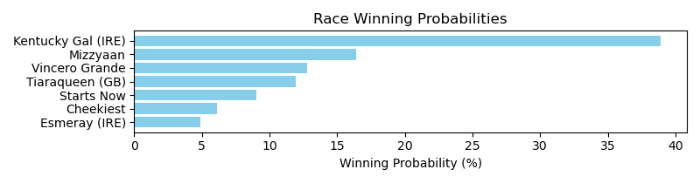

Exacta advice: key 1 → 6 (1 ticket)

NOTE: GCSF - Global Combined Speed Figure

# Race: TSA | 2025-04-27 | Race #2 | Post: 19:32 | Track: SANTA ANITA PARK

Track: SANTA ANITA PARK

|  |  |  |  |  |  |
| --- | --- | --- | --- | --- | --- |
| Program # | Horse Name | Morn Odds | GCSF | Model Score | Win Prob (%) |
| 1 | They'renotlikeus | 12-1 | 8.0 | 0.55 | 4.97 |
| 2 | Master Jacques | 8-1 | 4.0 | 1.73 | 11.23 |
| 3 | Buster's Way | 10-1 | 5.0 | 1.67 | 10.73 |
| 4 | Unbreakable Trust | 7-5 | 1.0 | 2.92 | 25.42 |
| 5 | Torleif | 30-1 | 7.0 | 0.65 | 5.32 |
| 6 | Adebayo | 3-1 | 2.0 | 2.69 | 21.66 |
| 7 | SIXHOOFSEVENHOOF | 5-1 | 6.0 | 0.70 | 5.50 |
| 8 | Hot Tiger Nights | 20-1 | 9.0 | -0.36 | 2.66 |
| 9 | Soul Music | 12-1 | 3.0 | 1.89 | 12.50 |

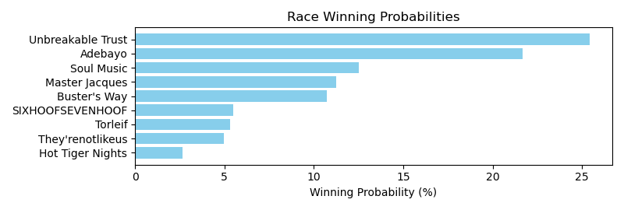

Exacta advice: key 4 → 6 (1 ticket)

NOTE: GCSF - Global Combined Speed Figure

# Race: TSA | 2025-04-27 | Race #3 | Post: 20:05 | Track: SANTA ANITA PARK

Track: SANTA ANITA PARK

|  |  |  |  |  |  |
| --- | --- | --- | --- | --- | --- |
| Program # | Horse Name | Morn Odds | GCSF | Model Score | Win Prob (%) |
| 1 | Mr. Leasure | 4-1 | 3.0 | 2.23 | 12.40 |
| 2 | Bad to the Bones | 5-2 | 6.0 | 1.69 | 8.61 |
| 3 | Malibu Rocks | 5-1 | 5.0 | 1.76 | 9.01 |
| 4 | Feel the Magic | 3-1 | 1.0 | 3.28 | 25.59 |
| 5 | Spun Not Stirred | 8-1 | 2.0 | 3.27 | 25.51 |
| 6 | Excel Calculator | 6-1 | 4.0 | 2.21 | 12.28 |
| 7 | Mongolian Altai | 10-1 | 7.0 | 1.31 | 6.59 |

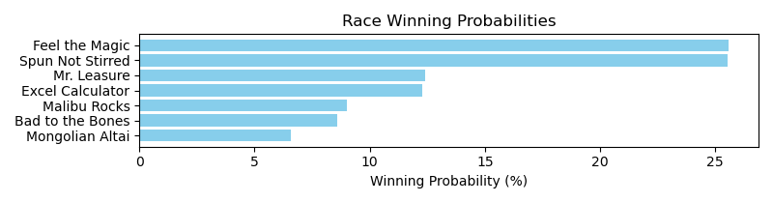

Exacta advice: box [4,5,1] (6 tickets)

NOTE: GCSF - Global Combined Speed Figure

# Race: TSA | 2025-04-27 | Race #4 | Post: 20:36 | Track: SANTA ANITA PARK

Track: SANTA ANITA PARK

|  |  |  |  |  |  |
| --- | --- | --- | --- | --- | --- |
| Program # | Horse Name | Morn Odds | GCSF | Model Score | Win Prob (%) |
| 1 | Daddy's Quest | 8-1 | 6.0 | 1.10 | 6.16 |
| 2 | One Bold Bid | 30-1 | 8.0 | 0.59 | 4.33 |
| 3 | Hoser Satrapa | 10-1 | 4.0 | 2.17 | 12.87 |
| 4 | Klimt A. P. | 15-1 | 7.0 | 0.72 | 4.75 |
| 5 | Cangrejo | 5-2 | 1.0 | 3.14 | 25.12 |
| 6 | Slewscion | 30-1 | 9.0 | 0.10 | 3.09 |
| 7 | WAR COUNCIL | 30-1 | 11.0 | -0.86 | 1.59 |
| 8 | Spectacular Tiger | 6-1 | 5.0 | 1.64 | 8.92 |
| 9 | Sark | 8-1 | 2.0 | 2.47 | 15.77 |
| 10 | Far Over Loaded | 5-2 | 3.0 | 2.35 | 14.54 |
| 11 | JAGUAR JON | 10-1 | 10.0 | -0.02 | 2.85 |

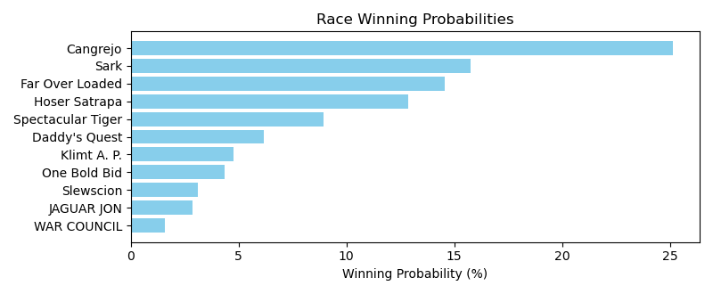

Exacta advice: key 5 → 9 (1 ticket)

NOTE: GCSF - Global Combined Speed Figure

# Race: TSA | 2025-04-27 | Race #5 | Post: 21:08 | Track: SANTA ANITA PARK

Track: SANTA ANITA PARK

|  |  |  |  |  |  |
| --- | --- | --- | --- | --- | --- |
| Program # | Horse Name | Morn Odds | GCSF | Model Score | Win Prob (%) |
| 1 | Mega Moon | 5-1 | 2.0 | 1.89 | 12.55 |
| 2 | Saqeel | 6-1 | 5.0 | 1.51 | 9.65 |
| 3 | Cowboy Mike | 9-2 | 6.0 | 1.48 | 9.43 |
| 4 | Father Delay | 12-1 | 11.0 | 0.20 | 3.92 |
| 5 | Mongolian Max | 10-1 | 10.0 | 0.63 | 5.28 |
| 6 | Clampett | 7-2 | 4.0 | 1.62 | 10.43 |
| 7 | Joint Venture | 15-1 | 8.0 | 0.84 | 6.09 |
| 8 | Ready to Pounce | 8-1 | 3.0 | 1.65 | 10.60 |
| 9 | Navajo Warrior | 5-1 | 1.0 | 2.54 | 19.62 |
| 10 | Trusty Rusty | 20-1 | 9.0 | 0.73 | 5.66 |
| 11 | Touchdown Brown | 5-1 | 7.0 | 0.99 | 6.77 |

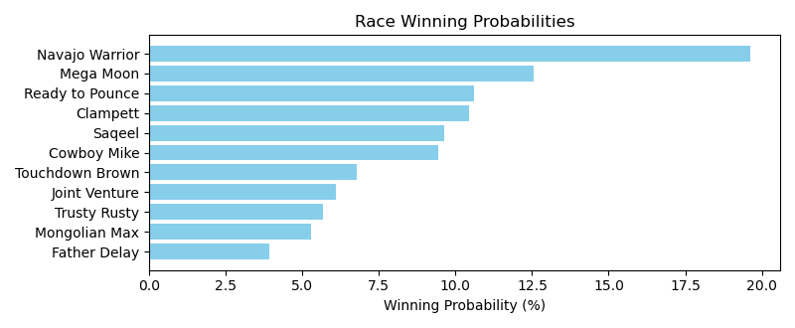

Exacta advice: key 9 → 1 (1 ticket)

NOTE: GCSF - Global Combined Speed Figure

# Race: TSA | 2025-04-27 | Race #6 | Post: 21:38 | Track: SANTA ANITA PARK

Track: SANTA ANITA PARK

|  |  |  |  |  |  |
| --- | --- | --- | --- | --- | --- |
| Program # | Horse Name | Morn Odds | GCSF | Model Score | Win Prob (%) |
| 1 | Dorie Miller | 5-1 | 3.0 | 1.57 | 16.55 |
| 2 | Lady Gregory | 6-5 | 1.0 | 1.99 | 22.06 |
| 3 | Sand to Sea | 30-1 | 7.0 | -0.11 | 5.18 |
| 4 | No Cap | 3-1 | 2.0 | 1.75 | 18.70 |
| 5 | Stay in Line | 6-1 | 4.0 | 1.22 | 12.93 |
| 6 | Full Moon Grazen | 12-1 | 8.0 | -0.18 | 4.96 |
| 7 | Shanghai Sunrise | 20-1 | 5.0 | 0.57 | 8.29 |
| 8 | Clubhouse Bride | 20-1 | 9.0 | -0.81 | 3.20 |
| 9 | Lady Maryann | 20-1 | 6.0 | 0.54 | 8.12 |

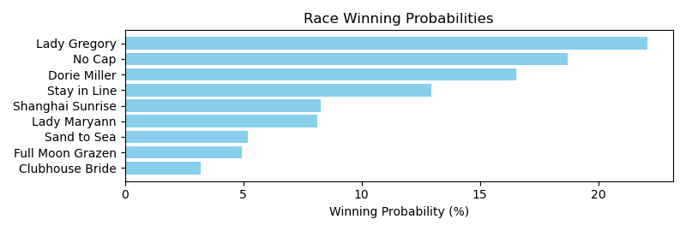

Exacta advice: key 2 → 4 (1 ticket)

NOTE: GCSF - Global Combined Speed Figure

# Race: TSA | 2025-04-27 | Race #7 | Post: 22:08 | Track: SANTA ANITA PARK

Track: SANTA ANITA PARK

|  |  |  |  |  |  |
| --- | --- | --- | --- | --- | --- |
| Program # | Horse Name | Morn Odds | GCSF | Model Score | Win Prob (%) |
| 1 | Cloe | 2-1 | 4.0 | 2.33 | 12.53 |
| 2 | Jungle Peace (IRE) | 5-2 | 3.0 | 2.43 | 13.42 |
| 3 | Schilflied | 5-1 | 2.0 | 3.35 | 25.32 |
| 4 | Velocity | 6-1 | 1.0 | 3.43 | 26.67 |
| 5 | Polythene Pam | 20-1 | 7.0 | 1.05 | 5.21 |
| 6 | Maximun Gold | 30-1 | 6.0 | 1.26 | 6.02 |
| 7 | Amorita | 3-1 | 5.0 | 2.12 | 10.84 |

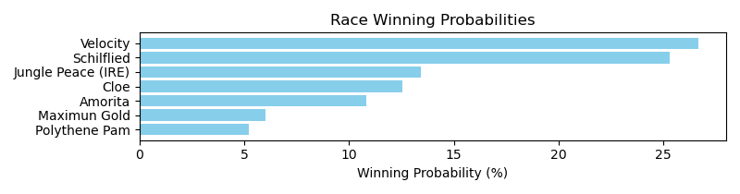

Exacta advice: box [4,3,2] (6 tickets)

NOTE: GCSF - Global Combined Speed Figure

# Race: TSA | 2025-04-27 | Race #8 | Post: 22:38 | Track: SANTA ANITA PARK

Track: SANTA ANITA PARK

|  |  |  |  |  |  |
| --- | --- | --- | --- | --- | --- |
| Program # | Horse Name | Morn Odds | GCSF | Model Score | Win Prob (%) |
| 1 | Nala | 4-1 | 5.0 | 0.39 | 11.58 |
| 2 | Spinning | 30-1 | 3.0 | 0.69 | 14.21 |
| 3 | Princess Daddy | 3-1 | 6.0 | -0.06 | 8.49 |
| 4 | Autism Inspiration | 6-1 | 4.0 | 0.42 | 11.83 |
| 5 | A Kitten for Sue | 20-1 | 9.0 | -1.34 | 3.51 |
| 6 | Misty Dancer | 30-1 | 10.0 | -1.36 | 3.49 |
| 7 | Cioppina Pasadina | 10-1 | 7.0 | -0.74 | 5.33 |
| 8 | Care for Autism | 15-1 | 8.0 | -1.16 | 4.00 |
| 9 | Liquid Spirit | 9-2 | 1.0 | 1.22 | 20.46 |
| 10 | Feisty Mitole | 7-2 | 2.0 | 0.96 | 17.11 |

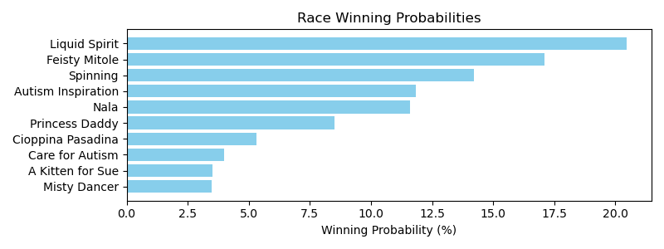

Exacta advice: key 9 → 10 (1 ticket)

NOTE: GCSF - Global Combined Speed Figure

# Race: TSA | 2025-04-27 | Race #9 | Post: 23:08 | Track: SANTA ANITA PARK

Track: SANTA ANITA PARK

|  |  |  |  |  |  |
| --- | --- | --- | --- | --- | --- |
| Program # | Horse Name | Morn Odds | GCSF | Model Score | Win Prob (%) |
| 1 | dq-War to Remember | 7-2 | 1.0 | 3.72 | 25.90 |
| 2 | CALL ME CORY | 12-1 | 7.0 | 1.38 | 5.18 |
| 3 | A Day to Remember | 3-1 | 3.0 | 3.29 | 19.34 |
| 4 | Hamlin | 15-1 | 9.0 | -0.11 | 1.86 |
| 5 | Smiling Tizzy | 20-1 | 4.0 | 2.27 | 9.54 |
| 7 | Power Play | 12-1 | 6.0 | 1.66 | 6.29 |
| 8 | WAR THEORY | 30-1 | 8.0 | 0.35 | 2.55 |
| 9 | Metro | 8-1 | 5.0 | 2.24 | 9.36 |
| 10 | Helicity | 4-1 | 2.0 | 3.34 | 19.96 |

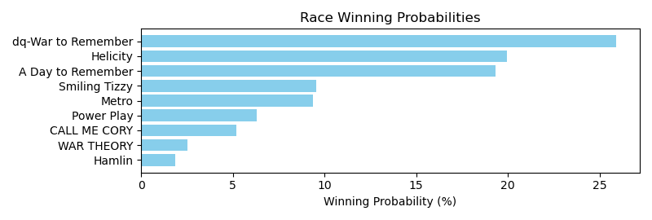

Exacta advice: key 1 → [10,3] (2 tickets)

NOTE: GCSF - Global Combined Speed Figure

# Race: TSA | 2025-04-27 | Race #10 | Post: 23:38 | Track: SANTA ANITA PARK

Track: SANTA ANITA PARK

|  |  |  |  |  |  |
| --- | --- | --- | --- | --- | --- |
| Program # | Horse Name | Morn Odds | GCSF | Model Score | Win Prob (%) |
| 1 | Brother o' Brien | 4-1 | 2.0 | 1.68 | 16.71 |
| 2 | Chief Jackson | 12-1 | 6.0 | 0.50 | 7.40 |
| 3 | Littlebrotherjoey | 15-1 | 8.0 | 0.19 | 5.96 |
| 4 | Mischief's Thirsty | 20-1 | 10.0 | -0.43 | 3.90 |
| 5 | Contrary Chieftain | 8-1 | 7.0 | 0.26 | 6.28 |
| 6 | Runnin Ute | 2-1 | 4.0 | 1.26 | 12.50 |
| 7 | Supermazel | 5-2 | 1.0 | 1.79 | 17.92 |
| 8 | Touch of Zen | 10-1 | 5.0 | 0.59 | 7.87 |
| 9 | Movietime | 30-1 | 11.0 | -0.79 | 3.05 |
| 10 | Wild Wager | 30-1 | 9.0 | -0.33 | 4.17 |
| 11 | Roister | 3-1 | 3.0 | 1.45 | 14.25 |

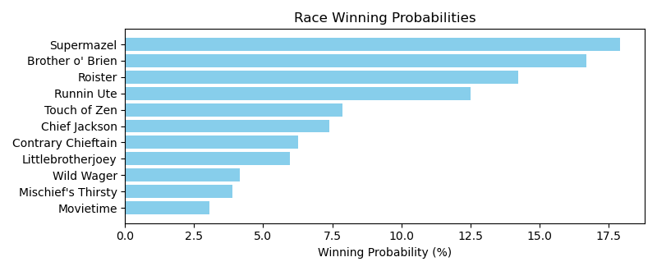

Exacta advice: key 7 → 1 (1 ticket)

NOTE: GCSF - Global Combined Speed Figure

# Race: TSA | 2025-04-27 | Race #11 | Post: 00:08 | Track: SANTA ANITA PARK

Track: SANTA ANITA PARK

|  |  |  |  |  |  |
| --- | --- | --- | --- | --- | --- |
| Program # | Horse Name | Morn Odds | GCSF | Model Score | Win Prob (%) |
| 1 | Annan | 5-1 | 8.0 | 2.69 | 7.03 |
| 2 | Zagreus | 6-1 | 2.0 | 3.70 | 14.13 |
| 3 | Johnny Whispers | 30-1 | 14.0 | -0.28 | 0.91 |
| 4 | Just a Graze | 8-1 | 4.0 | 3.10 | 9.32 |
| 5 | Sogno Di Vino | 30-1 | 10.0 | 1.70 | 3.57 |
| 6 | WINNING PATRIOT | 6-1 | 12.0 | 1.60 | 3.33 |
| 7 | Shapoval | 4-1 | 5.0 | 3.09 | 9.28 |
| 8 | Giant Luther | 30-1 | 9.0 | 2.15 | 4.86 |
| 9 | Millbo Baggins | 30-1 | 11.0 | 1.66 | 3.46 |
| 10 | Harbor Code | 10-1 | 13.0 | 1.39 | 2.87 |
| 11 | Miles Finch | 5-2 | 1.0 | 3.82 | 15.33 |
| 12 | Fight Back | 10-1 | 6.0 | 2.77 | 7.43 |
| 13 | Going Nowhere | 12-1 | 7.0 | 2.73 | 7.22 |
| 14 | Outworker | 7-2 | 3.0 | 3.37 | 11.24 |

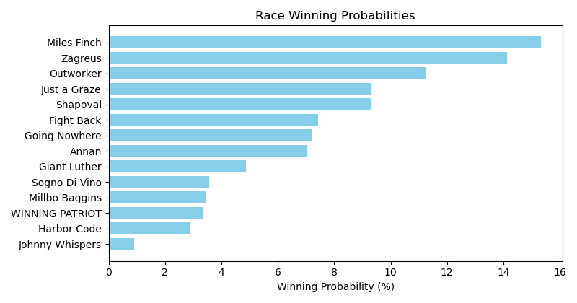

Exacta advice: key 11 → 2 (1 ticket)

NOTE: GCSF - Global Combined Speed Figure

# Race: TAM | 2025-04-26 | Race #1 | Post: 18:15 | Track: TAMPA BAY DOWNS

Track: TAMPA BAY DOWNS

|  |  |  |  |  |  |
| --- | --- | --- | --- | --- | --- |
| Program # | Horse Name | Morn Odds | GCSF | Model Score | Win Prob (%) |
| 1 | Norfie | 12-1 | 7.0 | 0.01 | 6.22 |
| 2 | Silver Style | 8-1 | 2.0 | 1.39 | 16.04 |
| 3 | Practical Way | 4-1 | 3.0 | 1.28 | 14.90 |
| 4 | Chromed Impulse | 13-8 | 1.0 | 1.99 | 24.19 |
| 5 | Copazo | 3-1 | 4.0 | 1.27 | 14.77 |
| 6 | Blame Bishop | 30-1 | 8.0 | -0.53 | 4.27 |
| 7 | Mean Tweets | 6-1 | 6.0 | 0.67 | 9.73 |
| 8 | Inbound | 15-1 | 5.0 | 0.69 | 9.88 |

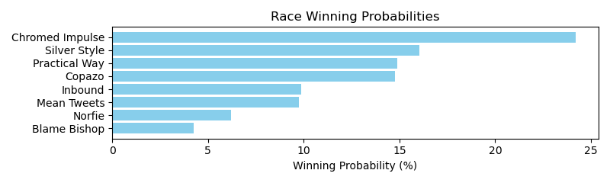

Exacta advice: key 4 → 2 (1 ticket)

NOTE: GCSF - Global Combined Speed Figure

# Race: TAM | 2025-04-26 | Race #2 | Post: 18:45 | Track: TAMPA BAY DOWNS

Track: TAMPA BAY DOWNS

|  |  |  |  |  |  |
| --- | --- | --- | --- | --- | --- |
| Program # | Horse Name | Morn Odds | GCSF | Model Score | Win Prob (%) |
| 1 | David H | 30-1 | 9.0 | 0.25 | 3.66 |
| 2 | Venezuelan Hope | 7-2 | 1.0 | 2.65 | 19.07 |
| 3 | Iron Edge | 2-1 | 4.0 | 2.05 | 12.58 |
| 4 | Authentic Honour | 5-1 | 2.0 | 2.58 | 18.13 |
| 5 | Twelve Treasures | 6-1 | 3.0 | 2.43 | 16.39 |
| 6 | NELSON GATE | 4-1 | 7.0 | 1.09 | 6.52 |
| 7 | My Pal Max | 30-1 | 5.0 | 1.76 | 10.34 |
| 8 | Grand Liam | 8-1 | 6.0 | 1.57 | 9.09 |
| 9 | Surprise Package | 15-1 | 8.0 | 0.45 | 4.21 |

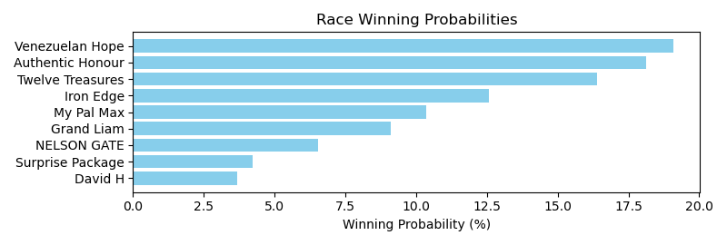

Exacta advice: box [2,4,5] (6 tickets)

NOTE: GCSF - Global Combined Speed Figure

# Race: TAM | 2025-04-26 | Race #3 | Post: 19:15 | Track: TAMPA BAY DOWNS

Track: TAMPA BAY DOWNS

|  |  |  |  |  |  |
| --- | --- | --- | --- | --- | --- |
| Program # | Horse Name | Morn Odds | GCSF | Model Score | Win Prob (%) |
| 1 | Ragtap Girl | 3-1 | 3.0 | 0.57 | 16.20 |
| 2 | Shemightdancesalsa | 15-1 | 4.0 | -0.03 | 10.73 |
| 3 | Blues Cross | 20-1 | 8.0 | -1.26 | 4.61 |
| 4 | Wonderfulvenezuela | 2-1 | 2.0 | 0.86 | 19.78 |
| 5 | Alma Pura | 15-1 | 6.0 | -0.40 | 8.33 |
| 6 | Mia's Angel | 15-1 | 7.0 | -1.01 | 5.47 |
| 7 | Miggi | 9-5 | 1.0 | 1.26 | 26.03 |
| 8 | Step Lightly | 12-1 | 5.0 | -0.31 | 8.85 |

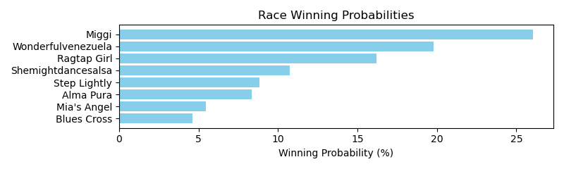

Exacta advice: key 7 → 4 (1 ticket)

NOTE: GCSF - Global Combined Speed Figure

# Race: TAM | 2025-04-26 | Race #4 | Post: 19:47 | Track: TAMPA BAY DOWNS

Track: TAMPA BAY DOWNS

|  |  |  |  |  |  |
| --- | --- | --- | --- | --- | --- |
| Program # | Horse Name | Morn Odds | GCSF | Model Score | Win Prob (%) |
| 1 | Firstflashofmoon | 5-2 | 2.0 | 2.28 | 15.74 |
| 2 | Air Force Royalty | 8-1 | 4.0 | 1.50 | 9.26 |
| 3 | Still Sharp | 30-1 | 11.0 | 0.75 | 5.50 |
| 4 | This Time Yes | 12-1 | 5.0 | 1.33 | 8.22 |
| 5 | Zen Air | 20-1 | 10.0 | 0.85 | 5.89 |
| 6 | Protest | 6-1 | 8.0 | 0.93 | 6.23 |
| 7 | D Lover | 12-1 | 7.0 | 0.97 | 6.42 |
| 8 | Fourty Four | 12-1 | 6.0 | 1.01 | 6.58 |
| 9 | The Elusive Drwong | 5-1 | 3.0 | 2.03 | 13.26 |
| 10 | Frankie R. | 15-1 | 9.0 | 0.89 | 6.08 |
| 11 | Muchomachomac | 3-1 | 1.0 | 2.37 | 16.83 |

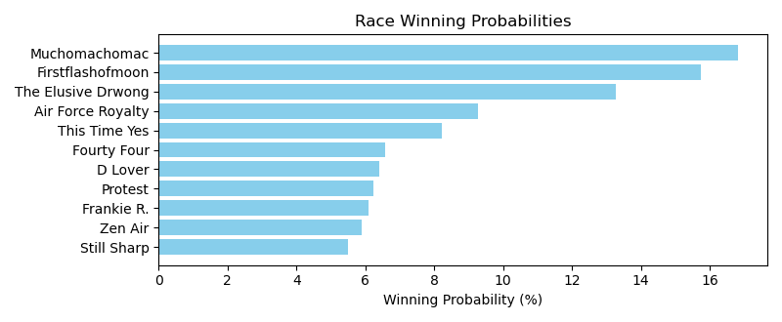

Exacta advice: box [11,1,9] (6 tickets)

NOTE: GCSF - Global Combined Speed Figure

# Race: TAM | 2025-04-26 | Race #5 | Post: 20:19 | Track: TAMPA BAY DOWNS

Track: TAMPA BAY DOWNS

|  |  |  |  |  |  |
| --- | --- | --- | --- | --- | --- |
| Program # | Horse Name | Morn Odds | GCSF | Model Score | Win Prob (%) |
| 1 | Deportivo | 6-1 | 5.0 | 0.67 | 11.81 |
| 2 | Spartacus's Dude | 8-1 | 2.0 | 1.09 | 15.82 |
| 3 | Makoa | 5-1 | 7.0 | 0.07 | 7.82 |
| 4 | Wolf Beach | 20-1 | 9.0 | -1.32 | 3.01 |
| 5 | El Dollar | 10-1 | 4.0 | 0.76 | 12.57 |
| 6 | Grey Shadow | 6-1 | 8.0 | -0.46 | 5.41 |
| 7 | Flamingproposition | 9-5 | 1.0 | 1.35 | 18.87 |
| 8 | Buck Springs | 30-1 | 3.0 | 1.05 | 15.33 |
| 9 | Bingo's Grind | 4-1 | 6.0 | 0.33 | 9.36 |

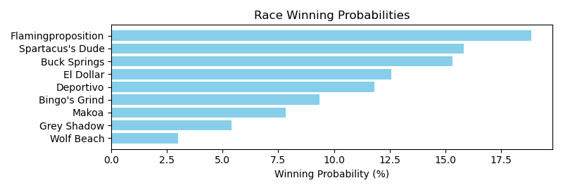

Exacta advice: key 7 → [2,8] (2 tickets)

NOTE: GCSF - Global Combined Speed Figure

# Race: TAM | 2025-04-26 | Race #6 | Post: 20:51 | Track: TAMPA BAY DOWNS

Track: TAMPA BAY DOWNS

|  |  |  |  |  |  |
| --- | --- | --- | --- | --- | --- |
| Program # | Horse Name | Morn Odds | GCSF | Model Score | Win Prob (%) |
| 1 | dq-El Tinmarin | 15-1 | 3.0 | 0.74 | 10.54 |
| 2 | Troops | 15-1 | 4.0 | 0.51 | 9.04 |
| 3 | Shadow Factor | 8-1 | 5.0 | 0.42 | 8.49 |
| 4 | Grand Joker | 10-1 | 7.0 | -1.15 | 2.87 |
| 5 | Simo | 8-1 | 6.0 | 0.12 | 6.90 |
| 6 | King Gerald | 9-2 | 2.0 | 1.94 | 24.04 |
| 7 | Here Comes Francis | 5-8 | 1.0 | 2.61 | 38.12 |

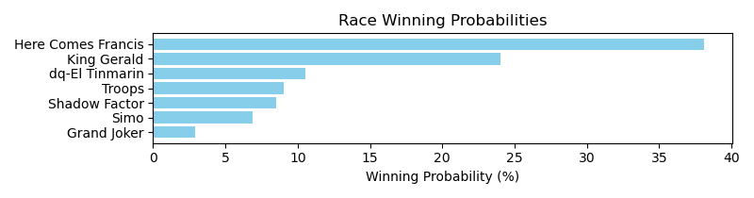

Exacta advice: key 7 → 6 (1 ticket)

NOTE: GCSF - Global Combined Speed Figure

# Race: TAM | 2025-04-26 | Race #7 | Post: 21:24 | Track: TAMPA BAY DOWNS

Track: TAMPA BAY DOWNS

|  |  |  |  |  |  |
| --- | --- | --- | --- | --- | --- |
| Program # | Horse Name | Morn Odds | GCSF | Model Score | Win Prob (%) |
| 1 | Tarhe | 4-1 | 2.0 | 1.38 | 12.37 |
| 2 | Paxton | 12-1 | 5.0 | 0.77 | 8.13 |
| 3 | Joe From Kiev | 30-1 | 8.0 | 0.31 | 5.93 |
| 4 | Guaio | 12-1 | 7.0 | 0.36 | 6.13 |
| 5 | Micro Brewsky | 12-1 | 9.0 | 0.08 | 5.04 |
| 6 | Caller | 9-2 | 1.0 | 2.72 | 31.00 |
| 7 | Halon | 10-1 | 6.0 | 0.74 | 7.96 |
| 8 | Jamestown | 5-2 | 3.0 | 1.33 | 11.91 |
| 9 | Drunk On Sake | 3-1 | 4.0 | 1.28 | 11.53 |

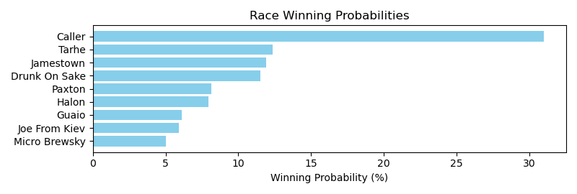

Exacta advice: key 6 → 1 (1 ticket)

NOTE: GCSF - Global Combined Speed Figure

# Race: TAM | 2025-04-26 | Race #8 | Post: 21:55 | Track: TAMPA BAY DOWNS

Track: TAMPA BAY DOWNS

|  |  |  |  |  |  |
| --- | --- | --- | --- | --- | --- |
| Program # | Horse Name | Morn Odds | GCSF | Model Score | Win Prob (%) |
| 1 | Mad House | 7-2 | 3.0 | 2.22 | 12.40 |
| 2 | Over the Mark | 2-1 | 4.0 | 2.15 | 11.82 |
| 3 | Noble Soul | 30-1 | 9.0 | -0.51 | 1.89 |
| 4 | X Y Prime | 3-1 | 1.0 | 3.29 | 25.83 |
| 5 | Listenupshance | 10-1 | 7.0 | 1.53 | 7.71 |
| 6 | Pico Plat | 12-1 | 5.0 | 2.09 | 11.35 |
| 7 | Bridoza | 8-1 | 6.0 | 2.06 | 11.06 |
| 8 | Persisten | 6-1 | 2.0 | 2.53 | 15.35 |
| 9 | Victor's Dream | 30-1 | 8.0 | -0.06 | 2.58 |

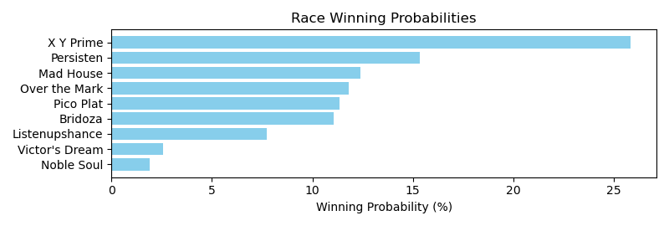

Exacta advice: key 4 → 8 (1 ticket)

NOTE: GCSF - Global Combined Speed Figure

# Race: TAM | 2025-04-26 | Race #9 | Post: 22:27 | Track: TAMPA BAY DOWNS

Track: TAMPA BAY DOWNS

|  |  |  |  |  |  |
| --- | --- | --- | --- | --- | --- |
| Program # | Horse Name | Morn Odds | GCSF | Model Score | Win Prob (%) |
| 1 | Once an Eagle | 30-1 | 12.0 | -0.39 | 3.02 |
| 2 | Woods Hole | 30-1 | 13.0 | -0.50 | 2.80 |
| 3 | Linny Kate | 7-2 | 2.0 | 1.50 | 11.05 |
| 4 | Ruxton Rocks | 20-1 | 11.0 | 0.09 | 4.18 |
| 5 | Girly the Butcher | 4-1 | 5.0 | 1.17 | 8.81 |
| 6 | Diosa Catrina | 10-1 | 9.0 | 0.45 | 5.38 |
| 7 | Tiki Bar | 8-1 | 3.0 | 1.29 | 9.58 |
| 8 | E M's Treasuregirl | 3-1 | 1.0 | 2.37 | 20.07 |
| 9 | Built Different | 10-1 | 8.0 | 0.65 | 6.16 |
| 10 | That's My Cat | 15-1 | 7.0 | 0.74 | 6.53 |
| 11 | Up Her Sleeve | 10-1 | 10.0 | 0.41 | 5.23 |
| 12 | Rozay Summer | 15-1 | 6.0 | 1.05 | 8.09 |
| 13 | Glitter Bay | 9-2 | 4.0 | 1.22 | 9.10 |

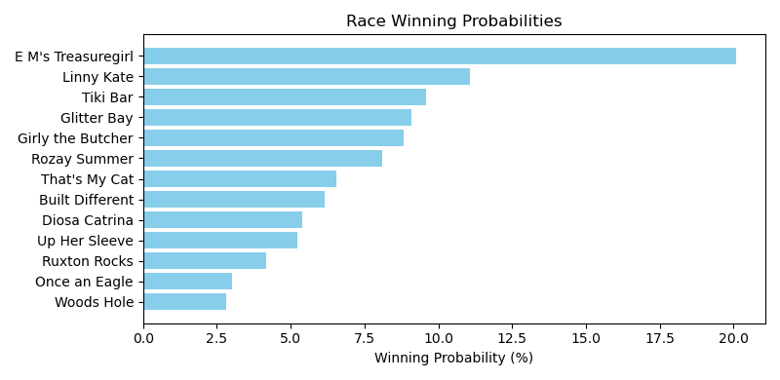

Exacta advice: key 8 → 3 (1 ticket)

NOTE: GCSF - Global Combined Speed Figure

# Race: TAM | 2025-04-27 | Race #1 | Post: 18:16 | Track: TAMPA BAY DOWNS

Track: TAMPA BAY DOWNS

|  |  |  |  |  |  |
| --- | --- | --- | --- | --- | --- |
| Program # | Horse Name | Morn Odds | GCSF | Model Score | Win Prob (%) |
| 1 | Shabam | 2-1 | 1.0 | 1.50 | 23.67 |
| 2 | Prospective Forum | 15-1 | 7.0 | -1.21 | 3.65 |
| 3 | Viking Queen | 6-1 | 3.0 | 1.05 | 17.36 |
| 4 | Ritabook | 4-1 | 4.0 | 0.96 | 16.24 |
| 5 | Catti La Belle | 12-1 | 6.0 | -0.32 | 6.75 |
| 6 | One Violent Affair | 6-1 | 5.0 | 0.32 | 10.48 |
| 7 | Grandma's Pudding | 5-2 | 2.0 | 1.39 | 21.85 |

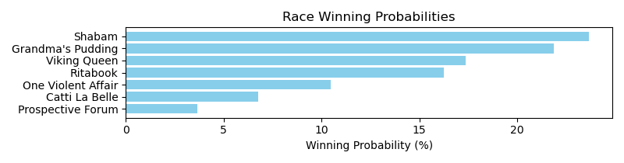

Exacta advice: key 1 → 7 (1 ticket)

NOTE: GCSF - Global Combined Speed Figure

# Race: TAM | 2025-04-27 | Race #2 | Post: 18:45 | Track: TAMPA BAY DOWNS

Track: TAMPA BAY DOWNS

|  |  |  |  |  |  |
| --- | --- | --- | --- | --- | --- |
| Program # | Horse Name | Morn Odds | GCSF | Model Score | Win Prob (%) |
| 1 | Off the Meds | 2-1 | 4.0 | 1.24 | 12.20 |
| 2 | Shoot Themessenger | 10-1 | 7.0 | 0.43 | 7.01 |
| 3 | Tony Small | 6-1 | 5.0 | 0.99 | 10.26 |
| 4 | Funkenstein | 12-1 | 6.0 | 0.86 | 9.39 |
| 5 | Classic King | 5-2 | 2.0 | 2.08 | 21.80 |
| 6 | Mission Key | 3-1 | 3.0 | 1.32 | 12.86 |
| 7 | Hakkimi (CHI) | 15-1 | 1.0 | 2.12 | 22.38 |
| 8 | Redisur | 30-1 | 8.0 | -0.35 | 4.09 |

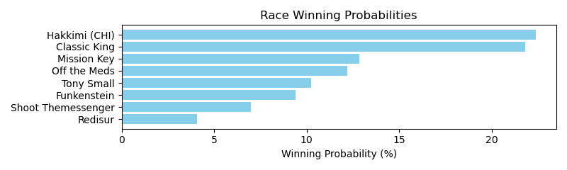

Exacta advice: box [7,5,6] (6 tickets)

NOTE: GCSF - Global Combined Speed Figure

# Race: TAM | 2025-04-27 | Race #3 | Post: 19:15 | Track: TAMPA BAY DOWNS

Track: TAMPA BAY DOWNS

|  |  |  |  |  |  |
| --- | --- | --- | --- | --- | --- |
| Program # | Horse Name | Morn Odds | GCSF | Model Score | Win Prob (%) |
| 1 | In the Blue | 20-1 | 8.0 | -1.47 | 2.90 |
| 2 | Coastal River | 6-1 | 7.0 | -0.60 | 5.26 |
| 3 | Cucuy | 9-5 | 3.0 | 0.86 | 14.38 |
| 4 | Iconic Rock | 6-1 | 2.0 | 0.90 | 14.73 |
| 5 | Immense Faith | 4-1 | 1.0 | 2.12 | 34.13 |
| 6 | Shipwreck | 15-1 | 6.0 | -0.33 | 6.33 |
| 7 | Vino Couragio | 6-1 | 5.0 | 0.38 | 10.34 |
| 8 | Quistmer | 5-1 | 4.0 | 0.59 | 11.92 |

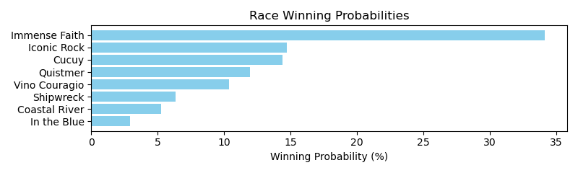

Exacta advice: key 5 → [4,3] (2 tickets)

NOTE: GCSF - Global Combined Speed Figure

# Race: TAM | 2025-04-27 | Race #4 | Post: 19:47 | Track: TAMPA BAY DOWNS

Track: TAMPA BAY DOWNS

|  |  |  |  |  |  |
| --- | --- | --- | --- | --- | --- |
| Program # | Horse Name | Morn Odds | GCSF | Model Score | Win Prob (%) |
| 1 | Explosive Exchange | 6-1 | 4.0 | 0.75 | 12.39 |
| 2 | Bold Baby | 5-2 | 2.0 | 1.18 | 16.61 |
| 3 | Moor Strength | 5-1 | 7.0 | 0.51 | 10.48 |
| 4 | Holy Coffee | 10-1 | 8.0 | -0.46 | 5.39 |
| 5 | Rozay Summer | 12-1 | 3.0 | 0.80 | 12.84 |
| 6 | Sandpiper Memories | 2-1 | 1.0 | 1.45 | 20.06 |
| 7 | Top Look | 10-1 | 6.0 | 0.55 | 10.81 |
| 8 | Oscar Gaze | 12-1 | 5.0 | 0.63 | 11.42 |

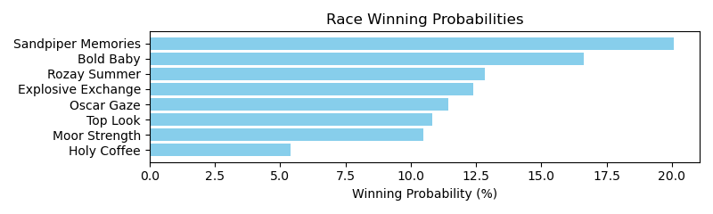

Exacta advice: key 6 → 2 (1 ticket)

NOTE: GCSF - Global Combined Speed Figure

# Race: TAM | 2025-04-27 | Race #5 | Post: 20:19 | Track: TAMPA BAY DOWNS

Track: TAMPA BAY DOWNS

|  |  |  |  |  |  |
| --- | --- | --- | --- | --- | --- |
| Program # | Horse Name | Morn Odds | GCSF | Model Score | Win Prob (%) |
| 1 | Ruiz Junior | 7-2 | 2.0 | 2.47 | 24.77 |
| 2 | Rojo Sky | 20-1 | 9.0 | -0.05 | 4.38 |
| 3 | C'Mon Juan | 6-1 | 8.0 | -0.03 | 4.44 |
| 4 | TONY B | 10-1 | 7.0 | 0.17 | 5.07 |
| 5 | Don Eladio | 9-2 | 6.0 | 0.26 | 5.39 |
| 6 | Ray's Blue Wagon | 13-8 | 1.0 | 2.64 | 27.79 |
| 7 | Yadirayadirayadira | 20-1 | 3.0 | 0.99 | 8.91 |
| 8 | MOR HEART | 15-1 | 10.0 | -0.21 | 3.90 |
| 9 | My Little Caibo | 12-1 | 4.0 | 0.92 | 8.52 |
| 10 | Amor Gitano | 30-1 | 5.0 | 0.60 | 6.83 |

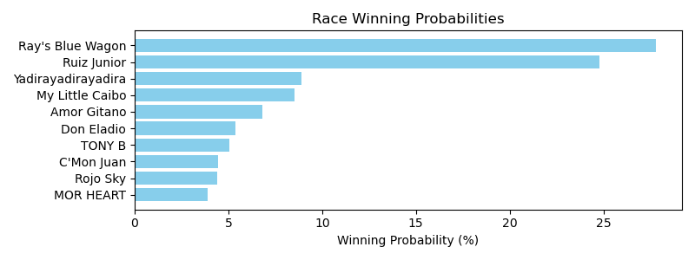

Exacta advice: key 6 → 1 (1 ticket)

NOTE: GCSF - Global Combined Speed Figure

# Race: TAM | 2025-04-27 | Race #6 | Post: 20:51 | Track: TAMPA BAY DOWNS

Track: TAMPA BAY DOWNS

|  |  |  |  |  |  |
| --- | --- | --- | --- | --- | --- |
| Program # | Horse Name | Morn Odds | GCSF | Model Score | Win Prob (%) |
| 1 | El Mango Banilejo | 15-1 | 6.0 | -0.13 | 3.98 |
| 2 | SENOR RESPLANDOR | 8-1 | 5.0 | 0.40 | 5.73 |
| 3 | Fly Commander | 3-1 | 2.0 | 2.38 | 22.37 |
| 4 | Just Relax | 7-5 | 1.0 | 2.98 | 33.69 |
| 5 | STILLNOHASSLEJJ | 15-1 | 8.0 | -0.27 | 3.60 |
| 6 | MCMULLEN | 15-1 | 7.0 | -0.22 | 3.74 |
| 7 | Neoteric | 6-1 | 3.0 | 1.86 | 15.63 |
| 8 | Just Buu | 5-1 | 4.0 | 1.38 | 11.25 |

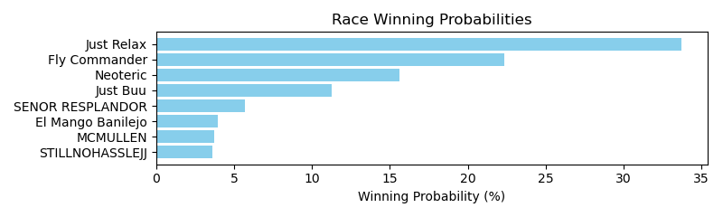

Exacta advice: key 4 → 3 (1 ticket)

NOTE: GCSF - Global Combined Speed Figure

# Race: TAM | 2025-04-27 | Race #7 | Post: 21:24 | Track: TAMPA BAY DOWNS

Track: TAMPA BAY DOWNS

|  |  |  |  |  |  |
| --- | --- | --- | --- | --- | --- |
| Program # | Horse Name | Morn Odds | GCSF | Model Score | Win Prob (%) |
| 1 | No Telling | 30-1 | 6.0 | 0.90 | 7.67 |
| 2 | Bluff | 7-2 | 1.0 | 2.99 | 32.29 |
| 3 | Hymn of Heaven | 15-1 | 5.0 | 1.13 | 8.92 |
| 4 | Mischievous Han | 6-1 | 2.0 | 1.94 | 15.66 |
| 5 | Fully Authorized | 10-1 | 7.0 | 0.58 | 6.14 |
| 6 | Emmett | 5-2 | 4.0 | 1.26 | 9.80 |
| 7 | Flash Frozen | 2-1 | 3.0 | 1.41 | 10.82 |
| 8 | Its Pizza Time | 20-1 | 9.0 | -0.28 | 3.38 |
| 9 | Innately Good | 12-1 | 8.0 | 0.37 | 5.32 |

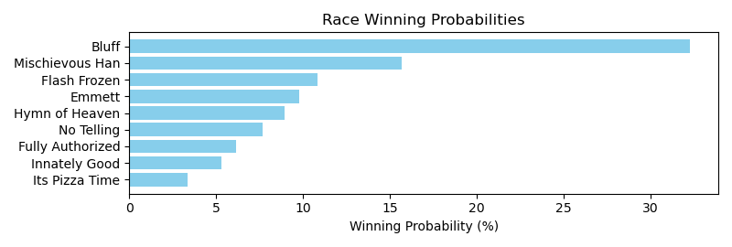

Exacta advice: key 2 → 4 (1 ticket)

NOTE: GCSF - Global Combined Speed Figure

# Race: TAM | 2025-04-27 | Race #8 | Post: 21:55 | Track: TAMPA BAY DOWNS

Track: TAMPA BAY DOWNS

|  |  |  |  |  |  |
| --- | --- | --- | --- | --- | --- |
| Program # | Horse Name | Morn Odds | GCSF | Model Score | Win Prob (%) |
| 1 | Chrome Ghost | 3-1 | 4.0 | 1.68 | 14.52 |
| 2 | Drifaros | 5-1 | 5.0 | 1.59 | 13.67 |
| 3 | Bahamian Moon | 12-1 | 7.0 | 0.32 | 5.71 |
| 4 | Life Is Precious | 4-1 | 3.0 | 1.73 | 15.03 |
| 5 | John Jay | 20-1 | 8.0 | -0.05 | 4.43 |
| 6 | Dreaming of Kona | 7-2 | 1.0 | 2.05 | 18.70 |
| 7 | Doctor Oscar | 4-1 | 2.0 | 1.82 | 15.97 |
| 8 | Impacto | 8-1 | 6.0 | 1.40 | 11.97 |

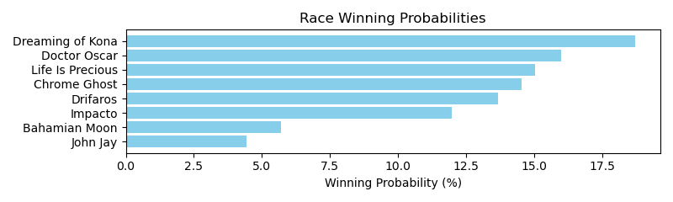

Exacta advice: key 6 → 7 (1 ticket)

NOTE: GCSF - Global Combined Speed Figure

# Race: TAM | 2025-04-27 | Race #9 | Post: 22:27 | Track: TAMPA BAY DOWNS

Track: TAMPA BAY DOWNS

|  |  |  |  |  |  |
| --- | --- | --- | --- | --- | --- |
| Program # | Horse Name | Morn Odds | GCSF | Model Score | Win Prob (%) |
| 1 | True Myth | 5-2 | 4.0 | 1.05 | 10.09 |
| 2 | Gray Enough | 30-1 | 14.0 | -1.73 | 1.49 |
| 3 | Gulf Coast Girl | 9-2 | 6.0 | 0.65 | 7.69 |
| 4 | Forever Again | 20-1 | 1.0 | 1.67 | 15.51 |
| 5 | Holder Close | 15-1 | 10.0 | -0.32 | 3.93 |
| 6 | Girl Dynamite | 30-1 | 5.0 | 0.97 | 9.56 |
| 7 | Udidn'tpay | 20-1 | 7.0 | 0.62 | 7.49 |
| 8 | Nelida | 3-1 | 2.0 | 1.26 | 11.68 |
| 9 | C. S. Vivace | 4-1 | 8.0 | 0.47 | 6.78 |
| 10 | Bolt of Paradise | 12-1 | 9.0 | 0.01 | 4.94 |
| 11 | Tourist Style | 20-1 | 11.0 | -0.54 | 3.39 |
| 12 | Sister Nell | 15-1 | 3.0 | 1.20 | 11.16 |
| 13 | Nicky Jolene | 15-1 | 12.0 | -0.64 | 3.16 |
| 14 | Ain't Noncents | 30-1 | 13.0 | -0.65 | 3.13 |

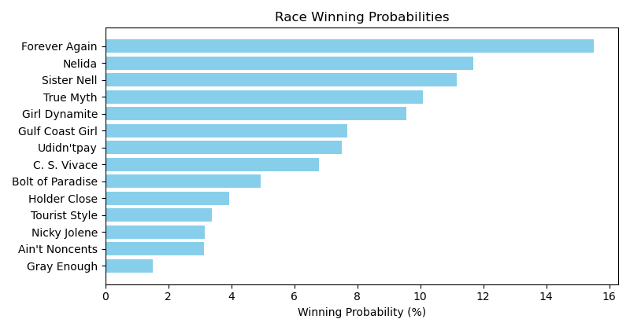

Exacta advice: key 4 → 8 (1 ticket)

NOTE: GCSF - Global Combined Speed Figure

# Race: TWO | 2025-04-26 | Race #1 | Post: 19:05 | Track: WOODBINE

Track: WOODBINE

|  |  |  |  |  |  |
| --- | --- | --- | --- | --- | --- |
| Program # | Horse Name | Morn Odds | GCSF | Model Score | Win Prob (%) |
| 1 | Bob and Jules | 2-1 | 4.0 | 2.02 | 16.57 |
| 2 | Come On Big Lou | 8-1 | 3.0 | 2.13 | 17.84 |
| 3 | Holiday Snooze | 9-2 | 5.0 | 0.25 | 4.90 |
| 4 | People Are People | 3-1 | 2.0 | 2.81 | 28.55 |
| 5 | Indy One | 9-5 | 1.0 | 2.98 | 32.13 |

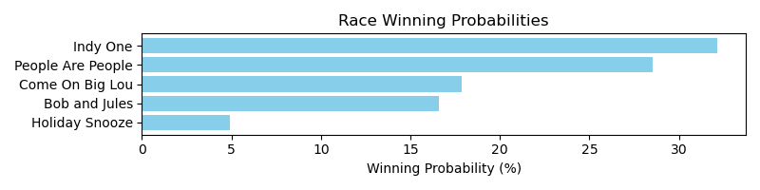

Exacta advice: key 5 → 4 (1 ticket)

NOTE: GCSF - Global Combined Speed Figure

# Race: TWO | 2025-04-26 | Race #2 | Post: 19:34 | Track: WOODBINE

Track: WOODBINE

|  |  |  |  |  |  |
| --- | --- | --- | --- | --- | --- |
| Program # | Horse Name | Morn Odds | GCSF | Model Score | Win Prob (%) |
| 1 | dq-Whiskey N Ice | 13-8 | 1.0 | 2.98 | 27.05 |
| 2 | Sloans Sky | 8-1 | 3.0 | 2.03 | 14.10 |
| 3 | Featherweight | 6-1 | 5.0 | 1.78 | 11.89 |
| 4 | Get Out the Vote | 3-1 | 4.0 | 1.89 | 12.85 |
| 5 | Hyper Holiday | 10-1 | 6.0 | 1.76 | 11.68 |
| 6 | Powaqa | 4-1 | 2.0 | 2.41 | 18.36 |
| 7 | Lady With Attitude | 20-1 | 7.0 | 0.22 | 4.07 |

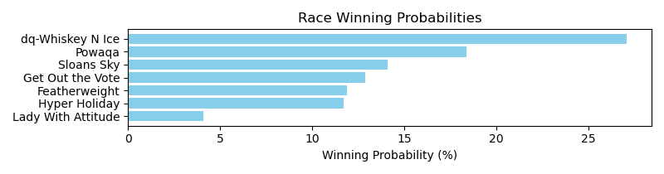

Exacta advice: key 1 → 6 (1 ticket)

NOTE: GCSF - Global Combined Speed Figure

# Race: TWO | 2025-04-26 | Race #3 | Post: 20:04 | Track: WOODBINE

Track: WOODBINE

|  |  |  |  |  |  |
| --- | --- | --- | --- | --- | --- |
| Program # | Horse Name | Morn Odds | GCSF | Model Score | Win Prob (%) |
| 1 | Realloveislucky | 20-1 | 5.0 | 0.78 | 9.27 |
| 2 | Saratoga Empress (GB) | 7-2 | 4.0 | 1.41 | 14.32 |
| 3 | No Malarkey | 20-1 | 6.0 | 0.43 | 7.28 |
| 4 | BUFF BAY | 8-1 | 7.0 | -0.30 | 4.40 |
| 5 | Fanny M | 2-1 | 1.0 | 2.17 | 24.05 |
| 6 | No Visor | 5-2 | 2.0 | 2.03 | 21.88 |
| 7 | Sultry Sophie | 9-2 | 3.0 | 1.81 | 18.79 |

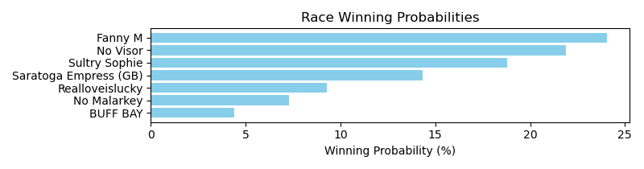

Exacta advice: key 5 → 6 (1 ticket)

NOTE: GCSF - Global Combined Speed Figure

# Race: TWO | 2025-04-26 | Race #4 | Post: 20:35 | Track: WOODBINE

Track: WOODBINE

|  |  |  |  |  |  |
| --- | --- | --- | --- | --- | --- |
| Program # | Horse Name | Morn Odds | GCSF | Model Score | Win Prob (%) |
| 1 | Golden Spring | 20-1 | 7.0 | -1.90 | 2.67 |
| 2 | Miss Bobbit | 5-2 | 3.0 | 0.70 | 16.01 |
| 3 | Hard to Capture | 9-5 | 2.0 | 1.32 | 24.52 |
| 4 | Mi Tormenta | 12-1 | 4.0 | 0.43 | 13.31 |
| 5 | Creativperformance | 10-1 | 6.0 | -1.00 | 4.96 |
| 6 | Cefalo | 7-2 | 1.0 | 1.42 | 26.21 |
| 7 | Hot Omelet | 6-1 | 5.0 | 0.32 | 12.31 |

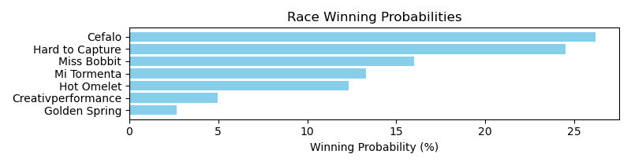

Exacta advice: box [6,3,2] (6 tickets)

NOTE: GCSF - Global Combined Speed Figure

# Race: TWO | 2025-04-26 | Race #5 | Post: 21:06 | Track: WOODBINE

Track: WOODBINE

|  |  |  |  |  |  |
| --- | --- | --- | --- | --- | --- |
| Program # | Horse Name | Morn Odds | GCSF | Model Score | Win Prob (%) |
| 1 | Let's Go Liam | 5-1 | 4.0 | 1.89 | 17.95 |
| 2 | Go Kart Mozart | 8-1 | 5.0 | 0.40 | 6.46 |
| 3 | Glintindaddyseye | 5-2 | 1.0 | 2.78 | 33.17 |
| 4 | Dark Danger | 3-1 | 2.0 | 2.10 | 20.72 |
| 5 | PRINCE ROYCE | 12-1 | 6.0 | -0.44 | 3.61 |
| 6 | Deputy Daddy | 2-1 | 3.0 | 1.90 | 18.09 |

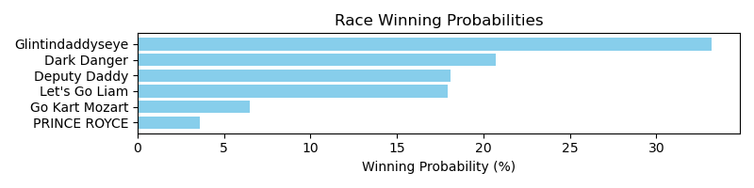

Exacta advice: key 3 → 4 (1 ticket)

NOTE: GCSF - Global Combined Speed Figure

# Race: TWO | 2025-04-26 | Race #6 | Post: 21:37 | Track: WOODBINE

Track: WOODBINE

|  |  |  |  |  |  |
| --- | --- | --- | --- | --- | --- |
| Program # | Horse Name | Morn Odds | GCSF | Model Score | Win Prob (%) |
| 1 | Nata Trouble | 4-1 | 1.0 | 3.13 | 40.86 |
| 2 | French Horn | 8-1 | 6.0 | -0.07 | 4.54 |
| 3 | Shotgun Wedding | 6-1 | 4.0 | 0.62 | 7.26 |
| 4 | Bound to Be True | 20-1 | 7.0 | -0.41 | 3.57 |
| 5 | Orderofthephoenix (IRE) | 2-1 | 3.0 | 1.94 | 18.03 |
| 6 | More Money Hunny | 8-1 | 5.0 | 0.57 | 7.03 |
| 7 | Party On | 5-2 | 2.0 | 1.99 | 18.71 |

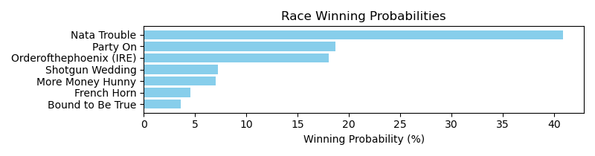

Exacta advice: key 1 → 7 (1 ticket)

NOTE: GCSF - Global Combined Speed Figure

# Race: TWO | 2025-04-26 | Race #7 | Post: 22:09 | Track: WOODBINE

Track: WOODBINE

|  |  |  |  |  |  |
| --- | --- | --- | --- | --- | --- |
| Program # | Horse Name | Morn Odds | GCSF | Model Score | Win Prob (%) |
| 1 | Breezero | 9-5 | 1.0 | 2.09 | 28.80 |
| 2 | Spirit Bear | 15-1 | 6.0 | 0.09 | 7.27 |
| 3 | Little Teddy | 4-1 | 3.0 | 1.35 | 17.36 |
| 4 | Anam Cara | 6-1 | 4.0 | 0.40 | 9.04 |
| 5 | Miss Vyvyanne | 13-8 | 2.0 | 2.08 | 28.55 |
| 6 | Shootin' Amy | 10-1 | 5.0 | 0.40 | 8.98 |

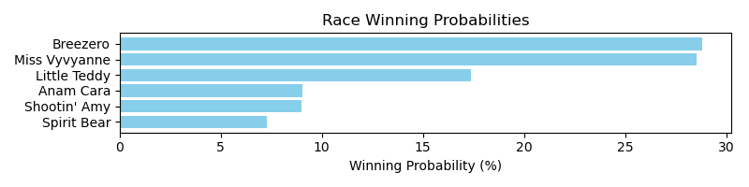

Exacta advice: box [1,5,3] (6 tickets)

NOTE: GCSF - Global Combined Speed Figure

# Race: TWO | 2025-04-26 | Race #8 | Post: 22:41 | Track: WOODBINE

Track: WOODBINE

|  |  |  |  |  |  |
| --- | --- | --- | --- | --- | --- |
| Program # | Horse Name | Morn Odds | GCSF | Model Score | Win Prob (%) |
| 1 | Brindi (IRE) | 10-1 | 5.0 | 0.68 | 8.03 |
| 2 | Salt | 6-1 | 3.0 | 1.92 | 18.91 |
| 3 | Winterberry | 1-1 | 2.0 | 1.93 | 18.95 |
| 4 | Social Code | 15-1 | 4.0 | 1.55 | 14.63 |
| 5 | Listen and Learn | 8-1 | 1.0 | 2.78 | 34.04 |
| 6 | Charlotte's Heart | 2-1 | 6.0 | 0.11 | 5.45 |

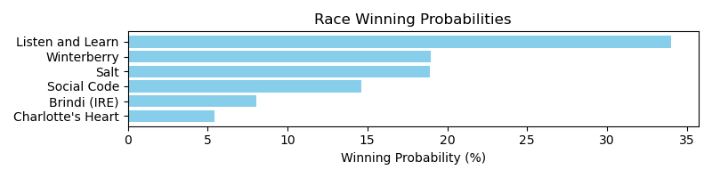

Exacta advice: key 5 → [3,2] (2 tickets)

NOTE: GCSF - Global Combined Speed Figure

# Race: TWO | 2025-04-26 | Race #9 | Post: 23:13 | Track: WOODBINE

Track: WOODBINE

|  |  |  |  |  |  |
| --- | --- | --- | --- | --- | --- |
| Program # | Horse Name | Morn Odds | GCSF | Model Score | Win Prob (%) |
| 1 | Miramichi | 4-1 | 5.0 | 0.78 | 9.75 |
| 2 | Peggy | 12-1 | 8.0 | -0.40 | 4.31 |
| 3 | Kitty'sspeedystarr | 6-1 | 7.0 | -0.06 | 5.46 |
| 4 | Arya's Quest | 15-1 | 6.0 | 0.21 | 6.55 |
| 5 | Onejabtoomany | 5-2 | 3.0 | 1.65 | 17.62 |
| 6 | Helana | 12-1 | 4.0 | 1.37 | 14.54 |
| 7 | Sinclairity | 2-1 | 1.0 | 1.90 | 20.96 |
| 8 | Ondine Lady | 12-1 | 2.0 | 1.89 | 20.81 |

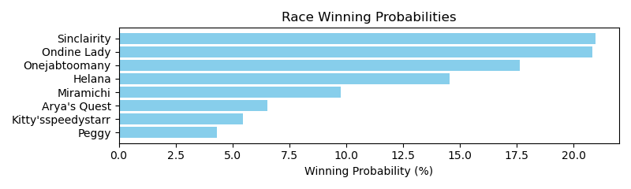

Exacta advice: box [7,8,5] (6 tickets)

NOTE: GCSF - Global Combined Speed Figure

# Race: TWO | 2025-04-27 | Race #1 | Post: 19:05 | Track: WOODBINE

Track: WOODBINE

|  |  |  |  |  |  |
| --- | --- | --- | --- | --- | --- |
| Program # | Horse Name | Morn Odds | GCSF | Model Score | Win Prob (%) |
| 1 | Souper Success | 1-1 | 1.0 | 2.07 | 38.33 |
| 2 | Mr. Marshall | 9-5 | 2.0 | 1.77 | 31.09 |
| 3 | Confusing | 8-1 | 3.0 | 0.64 | 14.30 |
| 4 | Absolute Chairman | 15-1 | 5.0 | -0.65 | 5.87 |
| 5 | Canadian Avro | 4-1 | 4.0 | 0.18 | 10.42 |

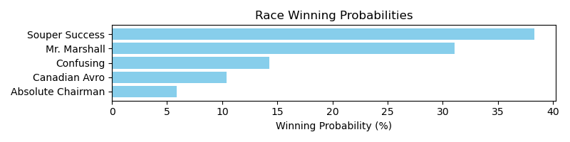

Exacta advice: key 1 → 2 (1 ticket)

NOTE: GCSF - Global Combined Speed Figure

# Race: TWO | 2025-04-27 | Race #2 | Post: 19:34 | Track: WOODBINE

Track: WOODBINE

|  |  |  |  |  |  |
| --- | --- | --- | --- | --- | --- |
| Program # | Horse Name | Morn Odds | GCSF | Model Score | Win Prob (%) |
| 1 | Sehr Schoen | 8-1 | 8.0 | -0.82 | 3.13 |
| 2 | Road to Versailles | 9-5 | 3.0 | 1.56 | 16.04 |
| 3 | Back River | 12-1 | 7.0 | -0.76 | 3.25 |
| 4 | Its Just Money | 8-1 | 6.0 | 0.00 | 5.49 |
| 5 | Attestation | 12-1 | 2.0 | 1.69 | 17.58 |
| 6 | If You Insist | 7-2 | 4.0 | 1.51 | 15.48 |
| 7 | Hanlan | 5-1 | 1.0 | 2.56 | 31.87 |
| 8 | Sparklet | 8-1 | 5.0 | 0.39 | 7.17 |

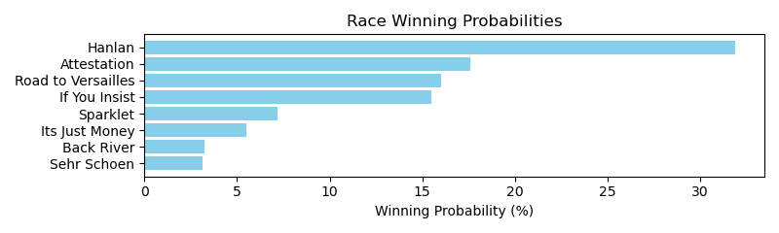

Exacta advice: key 7 → 5 (1 ticket)

NOTE: GCSF - Global Combined Speed Figure

# Race: TWO | 2025-04-27 | Race #3 | Post: 20:04 | Track: WOODBINE

Track: WOODBINE

|  |  |  |  |  |  |
| --- | --- | --- | --- | --- | --- |
| Program # | Horse Name | Morn Odds | GCSF | Model Score | Win Prob (%) |
| 1 | Mo Argento | 4-1 | 6.0 | 1.69 | 8.76 |
| 2 | Silent and Sinful | 2-1 | 2.0 | 2.82 | 19.05 |
| 3 | Scat Girl | 10-1 | 5.0 | 1.86 | 9.80 |
| 4 | Flashy Motor | 5-2 | 1.0 | 3.43 | 29.02 |
| 5 | Haley's Honor | 5-1 | 3.0 | 2.80 | 18.84 |
| 6 | Miss Demanding | 6-1 | 4.0 | 2.43 | 14.53 |

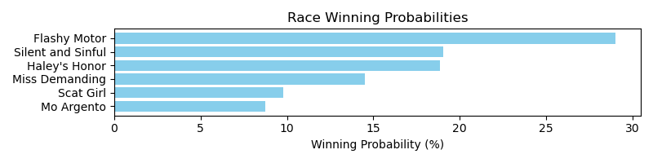

Exacta advice: key 4 → [2,5] (2 tickets)

NOTE: GCSF - Global Combined Speed Figure

# Race: TWO | 2025-04-27 | Race #4 | Post: 20:35 | Track: WOODBINE

Track: WOODBINE

|  |  |  |  |  |  |
| --- | --- | --- | --- | --- | --- |
| Program # | Horse Name | Morn Odds | GCSF | Model Score | Win Prob (%) |
| 1 | Silent Strike | 5-2 | 2.0 | 3.01 | 25.16 |
| 2 | Rhaenyra | 3-1 | 1.0 | 3.02 | 25.27 |
| 3 | JUST PRAY | 6-1 | 5.0 | 1.30 | 7.73 |
| 4 | Misty Eyed | 15-1 | 7.0 | 0.66 | 4.98 |
| 5 | I Love Presents | 20-1 | 6.0 | 1.19 | 7.18 |
| 6 | CITORI | 8-1 | 4.0 | 1.43 | 8.49 |
| 7 | Saratoga Holiday | 2-1 | 3.0 | 2.76 | 21.19 |

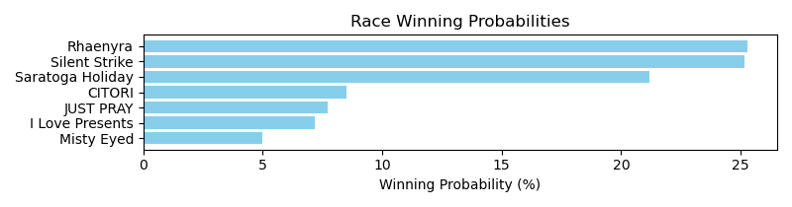

Exacta advice: box [2,1,7] (6 tickets)

NOTE: GCSF - Global Combined Speed Figure

# Race: TWO | 2025-04-27 | Race #5 | Post: 21:06 | Track: WOODBINE

Track: WOODBINE

|  |  |  |  |  |  |
| --- | --- | --- | --- | --- | --- |
| Program # | Horse Name | Morn Odds | GCSF | Model Score | Win Prob (%) |
| 1 | Rat Portage | 4-1 | 4.0 | 1.42 | 12.22 |
| 2 | Speed Figures | 1-1 | 1.0 | 3.14 | 39.75 |
| 3 | Highland Life | 3-1 | 3.0 | 1.43 | 12.31 |
| 4 | He Shoots He Wins | 12-1 | 5.0 | 0.31 | 5.66 |
| 5 | Kinetic Stone | 15-1 | 6.0 | 0.29 | 5.59 |
| 6 | Fracen Macho | 6-1 | 2.0 | 2.43 | 24.46 |

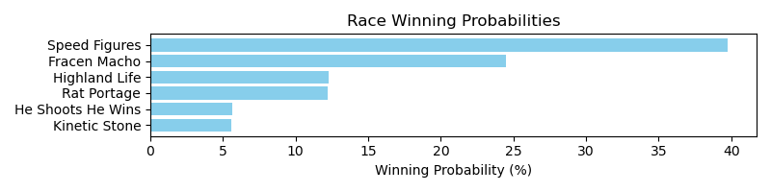

Exacta advice: key 2 → 6 (1 ticket)

NOTE: GCSF - Global Combined Speed Figure

# Race: TWO | 2025-04-27 | Race #6 | Post: 21:37 | Track: WOODBINE

Track: WOODBINE

|  |  |  |  |  |  |
| --- | --- | --- | --- | --- | --- |
| Program # | Horse Name | Morn Odds | GCSF | Model Score | Win Prob (%) |
| 1 | Lucky Romance | 8-1 | 5.0 | 1.21 | 12.38 |
| 2 | Junior Hot Shot | 2-1 | 3.0 | 1.72 | 17.53 |
| 3 | Moon Landing | 5-2 | 2.0 | 1.75 | 18.00 |
| 4 | Roar of the Crowd | 10-1 | 6.0 | 0.89 | 9.97 |
| 5 | Giant Teddy | 7-2 | 1.0 | 2.44 | 28.88 |
| 6 | Sigiloso | 5-1 | 4.0 | 1.31 | 13.23 |

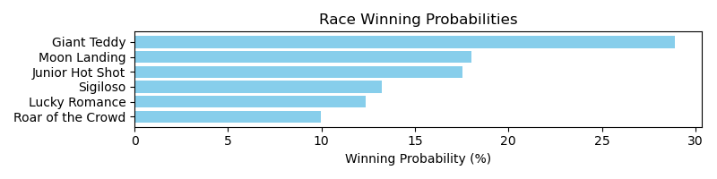

Exacta advice: key 5 → [3,2] (2 tickets)

NOTE: GCSF - Global Combined Speed Figure

# Race: TWO | 2025-04-27 | Race #7 | Post: 22:09 | Track: WOODBINE

Track: WOODBINE

|  |  |  |  |  |  |
| --- | --- | --- | --- | --- | --- |
| Program # | Horse Name | Morn Odds | GCSF | Model Score | Win Prob (%) |
| 1 | War of Destiny | 10-1 | 8.0 | 0.11 | 4.88 |
| 2 | Mansetti | 6-1 | 4.0 | 1.15 | 10.00 |
| 3 | Church and State | 3-1 | 6.0 | 1.02 | 9.12 |
| 4 | Big Vince | 4-1 | 5.0 | 1.09 | 9.56 |
| 5 | Incoming | 20-1 | 1.0 | 2.18 | 20.25 |
| 6 | Most Likely | 10-1 | 7.0 | 0.90 | 8.40 |
| 7 | Kokomo | 20-1 | 9.0 | -0.29 | 3.71 |
| 8 | Thundering | 8-1 | 3.0 | 1.67 | 14.24 |
| 9 | Notorious Gangster | 5-2 | 2.0 | 2.15 | 19.84 |

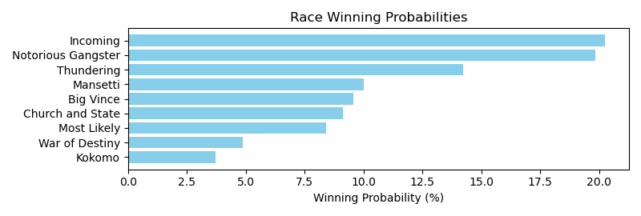

Exacta advice: box [5,9,8] (6 tickets)

NOTE: GCSF - Global Combined Speed Figure

# Race: TWO | 2025-04-27 | Race #8 | Post: 22:41 | Track: WOODBINE

Track: WOODBINE

|  |  |  |  |  |  |
| --- | --- | --- | --- | --- | --- |
| Program # | Horse Name | Morn Odds | GCSF | Model Score | Win Prob (%) |
| 1 | Old Chestnut | 3-1 | 2.0 | 2.13 | 17.02 |
| 2 | Crumlin Lad | 20-1 | 9.0 | 0.39 | 5.14 |
| 3 | dh-Armstrong | 4-1 | 3.0 | 1.71 | 12.81 |
| 4 | Lucky Score | 5-2 | 1.0 | 2.29 | 19.11 |
| 5 | Hunt Master | 10-1 | 5.0 | 1.40 | 10.30 |
| 6 | Rapid Grey | 12-1 | 8.0 | 0.71 | 6.41 |
| 7 | Midnight Mascot | 6-1 | 4.0 | 1.53 | 11.30 |
| 8 | Roi Soleil | 15-1 | 6.0 | 1.29 | 9.55 |
| 9 | Poulin in O T | 8-1 | 7.0 | 1.09 | 8.35 |

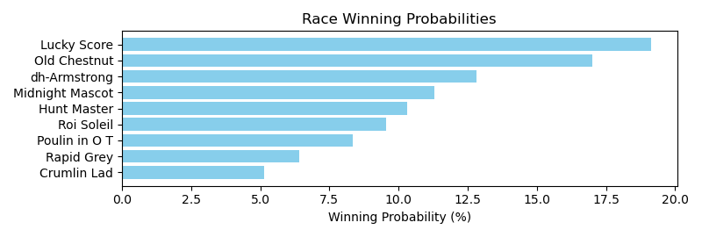

Exacta advice: key 4 → 1 (1 ticket)

NOTE: GCSF - Global Combined Speed Figure

# Multi-Race Bet Recommendations

Daily Double advised: AQU_2025-04-26_2 + AQU_2025-04-26_3

Daily Double advised: AQU_2025-04-26_3 + AQU_2025-04-26_4

Daily Double advised: AQU_2025-04-26_6 + AQU_2025-04-26_7

Daily Double advised: AQU_2025-04-26_7 + AQU_2025-04-26_8

Daily Double advised: AQU_2025-04-26_8 + AQU_2025-04-26_9

Daily Double advised: AQU_2025-04-26_9 + AQU_2025-04-26_10

Daily Double advised: AQU_2025-04-26_10 + AQU_2025-04-27_1

Daily Double advised: AQU_2025-04-27_1 + AQU_2025-04-27_2

Daily Double advised: AQU_2025-04-27_2 + AQU_2025-04-27_3

Daily Double advised: AQU_2025-04-27_3 + AQU_2025-04-27_4

Daily Double advised: AQU_2025-04-27_8 + AQU_2025-04-27_9

Daily Double advised: TCD_2025-04-26_2 + TCD_2025-04-26_3

Daily Double advised: TCD_2025-04-26_3 + TCD_2025-04-26_4

Daily Double advised: TCD_2025-04-26_4 + TCD_2025-04-26_5

Daily Double advised: TCD_2025-04-26_5 + TCD_2025-04-26_6

Daily Double advised: TCD_2025-04-26_6 + TCD_2025-04-26_7

Daily Double advised: TCD_2025-04-26_7 + TCD_2025-04-26_8

Daily Double advised: TCD_2025-04-26_8 + TCD_2025-04-26_9

Daily Double advised: TCD_2025-04-26_9 + TCD_2025-04-26_10

Daily Double advised: TCD_2025-04-26_10 + TCD_2025-04-29_1

Daily Double advised: TCD_2025-04-29_1 + TCD_2025-04-29_2

Daily Double advised: TCD_2025-04-29_2 + TCD_2025-04-29_3

Daily Double advised: TCD_2025-04-29_3 + TCD_2025-04-29_4

Daily Double advised: TCD_2025-04-29_4 + TCD_2025-04-29_5

Daily Double advised: TCD_2025-04-29_5 + TCD_2025-04-29_6

Daily Double advised: TCD_2025-04-29_6 + TCD_2025-04-29_7

Daily Double advised: TCD_2025-04-29_7 + TCD_2025-04-29_8

Daily Double advised: TCD_2025-04-29_8 + TCD_2025-04-29_9

Daily Double advised: TCD_2025-04-29_9 + TCD_2025-04-30_1

Daily Double advised: TCD_2025-04-30_1 + TCD_2025-04-30_2

Daily Double advised: TCD_2025-04-30_2 + TCD_2025-04-30_3

Daily Double advised: TCD_2025-04-30_3 + TCD_2025-04-30_4

Daily Double advised: TCD_2025-04-30_4 + TCD_2025-04-30_5

Daily Double advised: TCD_2025-04-30_5 + TCD_2025-04-30_6

Daily Double advised: TCD_2025-04-30_6 + TCD_2025-04-30_7

Daily Double advised: TCD_2025-04-30_7 + TCD_2025-04-30_8

Daily Double advised: TGP_2025-04-26_1 + TGP_2025-04-26_2

Daily Double advised: TGP_2025-04-26_2 + TGP_2025-04-26_3

Daily Double advised: TGP_2025-04-26_3 + TGP_2025-04-26_4

Daily Double advised: TGP_2025-04-26_4 + TGP_2025-04-26_5

Daily Double advised: TGP_2025-04-26_8 + TGP_2025-04-26_9

Daily Double advised: TGP_2025-04-27_2 + TGP_2025-04-27_3

Daily Double advised: TGP_2025-04-27_3 + TGP_2025-04-27_4

Daily Double advised: TGP_2025-04-27_4 + TGP_2025-04-27_5

Daily Double advised: TGP_2025-04-27_5 + TGP_2025-04-27_6

Daily Double advised: TGP_2025-04-27_6 + TGP_2025-04-27_7

Daily Double advised: TGP_2025-04-27_7 + TGP_2025-04-27_8

Daily Double advised: TGP_2025-04-27_8 + TGP_2025-04-27_9

Daily Double advised: TGP_2025-04-27_9 + TGP_2025-04-27_10

Daily Double advised: IND_2025-04-29_1 + IND_2025-04-29_2

Daily Double advised: IND_2025-04-29_2 + IND_2025-04-29_3

Daily Double advised: IND_2025-04-29_3 + IND_2025-04-29_4

Daily Double advised: IND_2025-04-29_4 + IND_2025-04-29_5

Daily Double advised: IND_2025-04-29_5 + IND_2025-04-29_6

Daily Double advised: IND_2025-04-29_6 + IND_2025-04-29_7

Daily Double advised: IND_2025-04-29_7 + IND_2025-04-29_8

Daily Double advised: IND_2025-04-29_8 + IND_2025-04-30_1

Daily Double advised: IND_2025-04-30_3 + IND_2025-04-30_4

Daily Double advised: IND_2025-04-30_4 + IND_2025-04-30_5

Daily Double advised: IND_2025-04-30_5 + IND_2025-04-30_6

Daily Double advised: IND_2025-04-30_6 + IND_2025-04-30_7

Daily Double advised: IND_2025-04-30_7 + IND_2025-04-30_8

Daily Double advised: LRL_2025-04-26_1 + LRL_2025-04-26_2

Daily Double advised: LRL_2025-04-26_2 + LRL_2025-04-26_3

Daily Double advised: LRL_2025-04-26_3 + LRL_2025-04-26_4

Daily Double advised: LRL_2025-04-26_4 + LRL_2025-04-26_5

Daily Double advised: LRL_2025-04-26_5 + LRL_2025-04-26_6

Daily Double advised: LRL_2025-04-26_6 + LRL_2025-04-26_7

Daily Double advised: LRL_2025-04-26_7 + LRL_2025-04-26_8

Daily Double advised: LRL_2025-04-26_8 + LRL_2025-04-26_9

Daily Double advised: LRL_2025-04-26_9 + LRL_2025-04-26_10

Daily Double advised: LRL_2025-04-26_10 + LRL_2025-04-26_11

Daily Double advised: LRL_2025-04-26_11 + LRL_2025-04-27_1

Daily Double advised: LRL_2025-04-27_3 + LRL_2025-04-27_4

Daily Double advised: LRL_2025-04-27_6 + LRL_2025-04-27_7

Daily Double advised: LRL_2025-04-27_7 + LRL_2025-04-27_8

Daily Double advised: LRL_2025-04-27_8 + LRL_2025-04-27_9

Daily Double advised: LRL_2025-04-27_9 + LRL_2025-04-27_10

Daily Double advised: LRL_2025-04-27_10 + LRL_2025-04-27_11

Daily Double advised: TLS_2025-04-26_1 + TLS_2025-04-26_2

Daily Double advised: TLS_2025-04-26_2 + TLS_2025-04-26_3

Daily Double advised: TLS_2025-04-26_3 + TLS_2025-04-26_4

Daily Double advised: TLS_2025-04-26_4 + TLS_2025-04-26_5

Daily Double advised: TLS_2025-04-26_5 + TLS_2025-04-26_6

Daily Double advised: TLS_2025-04-26_6 + TLS_2025-04-26_7

Daily Double advised: TLS_2025-04-26_7 + TLS_2025-04-26_8

Daily Double advised: TLS_2025-04-27_3 + TLS_2025-04-27_4

Daily Double advised: TLS_2025-04-27_4 + TLS_2025-04-27_5

Daily Double advised: TLS_2025-04-27_5 + TLS_2025-04-27_6

Daily Double advised: TOP_2025-04-26_7 + TOP_2025-04-26_8

Daily Double advised: TOP_2025-04-26_8 + TOP_2025-04-26_9

Daily Double advised: TOP_2025-04-26_11 + TOP_2025-04-27_1

Daily Double advised: TOP_2025-04-27_1 + TOP_2025-04-27_2

Daily Double advised: TOP_2025-04-27_2 + TOP_2025-04-27_3

Daily Double advised: TOP_2025-04-27_5 + TOP_2025-04-27_6

Daily Double advised: TOP_2025-04-27_6 + TOP_2025-04-27_7

Daily Double advised: TOP_2025-04-27_7 + TOP_2025-04-27_8

Daily Double advised: TOP_2025-04-27_8 + TOP_2025-04-27_9

Daily Double advised: TOP_2025-04-27_9 + TOP_2025-04-27_10

Daily Double advised: PEN_2025-05-01_4 + PEN_2025-05-01_5

Daily Double advised: PEN_2025-05-02_3 + PEN_2025-05-02_4

Daily Double advised: PEN_2025-05-02_4 + PEN_2025-05-02_5

Daily Double advised: PEN_2025-05-02_5 + PEN_2025-05-02_6

Daily Double advised: PEN_2025-05-02_6 + PEN_2025-05-02_7

Daily Double advised: PEN_2025-05-02_7 + PEN_2025-05-03_1

Daily Double advised: PEN_2025-05-03_1 + PEN_2025-05-03_2

Daily Double advised: PEN_2025-05-03_2 + PEN_2025-05-03_3

Daily Double advised: PEN_2025-05-03_3 + PEN_2025-05-03_4

Daily Double advised: PEN_2025-05-03_4 + PEN_2025-05-03_5

Daily Double advised: TSA_2025-04-26_6 + TSA_2025-04-26_7

Daily Double advised: TSA_2025-04-26_7 + TSA_2025-04-26_8

Daily Double advised: TSA_2025-04-26_8 + TSA_2025-04-26_9

Daily Double advised: TSA_2025-04-26_9 + TSA_2025-04-26_10

Daily Double advised: TSA_2025-04-26_10 + TSA_2025-04-26_11

Daily Double advised: TSA_2025-04-26_11 + TSA_2025-04-27_1

Daily Double advised: TSA_2025-04-27_1 + TSA_2025-04-27_2

Daily Double advised: TSA_2025-04-27_4 + TSA_2025-04-27_5

Daily Double advised: TSA_2025-04-27_5 + TSA_2025-04-27_6

Daily Double advised: TSA_2025-04-27_8 + TSA_2025-04-27_9

Daily Double advised: TSA_2025-04-27_9 + TSA_2025-04-27_10

Daily Double advised: TSA_2025-04-27_10 + TSA_2025-04-27_11

Daily Double advised: TAM_2025-04-26_5 + TAM_2025-04-26_6

Daily Double advised: TAM_2025-04-26_6 + TAM_2025-04-26_7

Daily Double advised: TAM_2025-04-26_7 + TAM_2025-04-26_8

Daily Double advised: TAM_2025-04-26_8 + TAM_2025-04-26_9

Daily Double advised: TAM_2025-04-26_9 + TAM_2025-04-27_1

Daily Double advised: TAM_2025-04-27_3 + TAM_2025-04-27_4

Daily Double advised: TAM_2025-04-27_4 + TAM_2025-04-27_5

Daily Double advised: TAM_2025-04-27_5 + TAM_2025-04-27_6

Daily Double advised: TAM_2025-04-27_6 + TAM_2025-04-27_7

Daily Double advised: TAM_2025-04-27_7 + TAM_2025-04-27_8

Daily Double advised: TAM_2025-04-27_8 + TAM_2025-04-27_9

Daily Double advised: TWO_2025-04-26_1 + TWO_2025-04-26_2

Daily Double advised: TWO_2025-04-26_2 + TWO_2025-04-26_3

Daily Double advised: TWO_2025-04-26_5 + TWO_2025-04-26_6

Daily Double advised: TWO_2025-04-27_1 + TWO_2025-04-27_2

Daily Double advised: TWO_2025-04-27_2 + TWO_2025-04-27_3

Daily Double advised: TWO_2025-04-27_5 + TWO_2025-04-27_6

Pick 3 advised: AQU_2025-04-26_2, AQU_2025-04-26_3, AQU_2025-04-26_4

Pick 3 advised: AQU_2025-04-26_6, AQU_2025-04-26_7, AQU_2025-04-26_8

Pick 3 advised: AQU_2025-04-26_7, AQU_2025-04-26_8, AQU_2025-04-26_9

Pick 3 advised: AQU_2025-04-26_8, AQU_2025-04-26_9, AQU_2025-04-26_10

Pick 3 advised: AQU_2025-04-26_9, AQU_2025-04-26_10, AQU_2025-04-27_1

Pick 3 advised: AQU_2025-04-26_10, AQU_2025-04-27_1, AQU_2025-04-27_2

Pick 3 advised: AQU_2025-04-27_1, AQU_2025-04-27_2, AQU_2025-04-27_3

Pick 3 advised: AQU_2025-04-27_2, AQU_2025-04-27_3, AQU_2025-04-27_4

Pick 3 advised: TCD_2025-04-26_2, TCD_2025-04-26_3, TCD_2025-04-26_4

Pick 3 advised: TCD_2025-04-26_3, TCD_2025-04-26_4, TCD_2025-04-26_5

Pick 3 advised: TCD_2025-04-26_4, TCD_2025-04-26_5, TCD_2025-04-26_6

Pick 3 advised: TCD_2025-04-26_5, TCD_2025-04-26_6, TCD_2025-04-26_7

Pick 3 advised: TCD_2025-04-26_6, TCD_2025-04-26_7, TCD_2025-04-26_8

Pick 3 advised: TCD_2025-04-26_7, TCD_2025-04-26_8, TCD_2025-04-26_9

Pick 3 advised: TCD_2025-04-26_8, TCD_2025-04-26_9, TCD_2025-04-26_10

Pick 3 advised: TCD_2025-04-26_9, TCD_2025-04-26_10, TCD_2025-04-29_1

Pick 3 advised: TCD_2025-04-26_10, TCD_2025-04-29_1, TCD_2025-04-29_2

Pick 3 advised: TCD_2025-04-29_1, TCD_2025-04-29_2, TCD_2025-04-29_3

Pick 3 advised: TCD_2025-04-29_2, TCD_2025-04-29_3, TCD_2025-04-29_4

Pick 3 advised: TCD_2025-04-29_3, TCD_2025-04-29_4, TCD_2025-04-29_5

Pick 3 advised: TCD_2025-04-29_4, TCD_2025-04-29_5, TCD_2025-04-29_6

Pick 3 advised: TCD_2025-04-29_5, TCD_2025-04-29_6, TCD_2025-04-29_7

Pick 3 advised: TCD_2025-04-29_6, TCD_2025-04-29_7, TCD_2025-04-29_8

Pick 3 advised: TCD_2025-04-29_7, TCD_2025-04-29_8, TCD_2025-04-29_9

Pick 3 advised: TCD_2025-04-29_8, TCD_2025-04-29_9, TCD_2025-04-30_1

Pick 3 advised: TCD_2025-04-29_9, TCD_2025-04-30_1, TCD_2025-04-30_2

Pick 3 advised: TCD_2025-04-30_1, TCD_2025-04-30_2, TCD_2025-04-30_3

Pick 3 advised: TCD_2025-04-30_2, TCD_2025-04-30_3, TCD_2025-04-30_4

Pick 3 advised: TCD_2025-04-30_3, TCD_2025-04-30_4, TCD_2025-04-30_5

Pick 3 advised: TCD_2025-04-30_4, TCD_2025-04-30_5, TCD_2025-04-30_6

Pick 3 advised: TCD_2025-04-30_5, TCD_2025-04-30_6, TCD_2025-04-30_7

Pick 3 advised: TCD_2025-04-30_6, TCD_2025-04-30_7, TCD_2025-04-30_8

Pick 3 advised: TGP_2025-04-26_1, TGP_2025-04-26_2, TGP_2025-04-26_3

Pick 3 advised: TGP_2025-04-26_2, TGP_2025-04-26_3, TGP_2025-04-26_4

Pick 3 advised: TGP_2025-04-26_3, TGP_2025-04-26_4, TGP_2025-04-26_5

Pick 3 advised: TGP_2025-04-27_2, TGP_2025-04-27_3, TGP_2025-04-27_4

Pick 3 advised: TGP_2025-04-27_3, TGP_2025-04-27_4, TGP_2025-04-27_5

Pick 3 advised: TGP_2025-04-27_4, TGP_2025-04-27_5, TGP_2025-04-27_6

Pick 3 advised: TGP_2025-04-27_5, TGP_2025-04-27_6, TGP_2025-04-27_7

Pick 3 advised: TGP_2025-04-27_6, TGP_2025-04-27_7, TGP_2025-04-27_8

Pick 3 advised: TGP_2025-04-27_7, TGP_2025-04-27_8, TGP_2025-04-27_9

Pick 3 advised: TGP_2025-04-27_8, TGP_2025-04-27_9, TGP_2025-04-27_10

Pick 3 advised: IND_2025-04-29_1, IND_2025-04-29_2, IND_2025-04-29_3

Pick 3 advised: IND_2025-04-29_2, IND_2025-04-29_3, IND_2025-04-29_4

Pick 3 advised: IND_2025-04-29_3, IND_2025-04-29_4, IND_2025-04-29_5

Pick 3 advised: IND_2025-04-29_4, IND_2025-04-29_5, IND_2025-04-29_6

Pick 3 advised: IND_2025-04-29_5, IND_2025-04-29_6, IND_2025-04-29_7

Pick 3 advised: IND_2025-04-29_6, IND_2025-04-29_7, IND_2025-04-29_8

Pick 3 advised: IND_2025-04-29_7, IND_2025-04-29_8, IND_2025-04-30_1

Pick 3 advised: IND_2025-04-30_3, IND_2025-04-30_4, IND_2025-04-30_5

Pick 3 advised: IND_2025-04-30_4, IND_2025-04-30_5, IND_2025-04-30_6

Pick 3 advised: IND_2025-04-30_5, IND_2025-04-30_6, IND_2025-04-30_7

Pick 3 advised: IND_2025-04-30_6, IND_2025-04-30_7, IND_2025-04-30_8

Pick 3 advised: LRL_2025-04-26_1, LRL_2025-04-26_2, LRL_2025-04-26_3

Pick 3 advised: LRL_2025-04-26_2, LRL_2025-04-26_3, LRL_2025-04-26_4

Pick 3 advised: LRL_2025-04-26_3, LRL_2025-04-26_4, LRL_2025-04-26_5

Pick 3 advised: LRL_2025-04-26_4, LRL_2025-04-26_5, LRL_2025-04-26_6

Pick 3 advised: LRL_2025-04-26_5, LRL_2025-04-26_6, LRL_2025-04-26_7

Pick 3 advised: LRL_2025-04-26_6, LRL_2025-04-26_7, LRL_2025-04-26_8

Pick 3 advised: LRL_2025-04-26_7, LRL_2025-04-26_8, LRL_2025-04-26_9

Pick 3 advised: LRL_2025-04-26_8, LRL_2025-04-26_9, LRL_2025-04-26_10

Pick 3 advised: LRL_2025-04-26_9, LRL_2025-04-26_10, LRL_2025-04-26_11

Pick 3 advised: LRL_2025-04-26_10, LRL_2025-04-26_11, LRL_2025-04-27_1

Pick 3 advised: LRL_2025-04-27_6, LRL_2025-04-27_7, LRL_2025-04-27_8

Pick 3 advised: LRL_2025-04-27_7, LRL_2025-04-27_8, LRL_2025-04-27_9

Pick 3 advised: LRL_2025-04-27_8, LRL_2025-04-27_9, LRL_2025-04-27_10

Pick 3 advised: LRL_2025-04-27_9, LRL_2025-04-27_10, LRL_2025-04-27_11

Pick 3 advised: TLS_2025-04-26_1, TLS_2025-04-26_2, TLS_2025-04-26_3

Pick 3 advised: TLS_2025-04-26_2, TLS_2025-04-26_3, TLS_2025-04-26_4

Pick 3 advised: TLS_2025-04-26_3, TLS_2025-04-26_4, TLS_2025-04-26_5

Pick 3 advised: TLS_2025-04-26_4, TLS_2025-04-26_5, TLS_2025-04-26_6

Pick 3 advised: TLS_2025-04-26_5, TLS_2025-04-26_6, TLS_2025-04-26_7

Pick 3 advised: TLS_2025-04-26_6, TLS_2025-04-26_7, TLS_2025-04-26_8

Pick 3 advised: TLS_2025-04-27_3, TLS_2025-04-27_4, TLS_2025-04-27_5

Pick 3 advised: TLS_2025-04-27_4, TLS_2025-04-27_5, TLS_2025-04-27_6

Pick 3 advised: TOP_2025-04-26_7, TOP_2025-04-26_8, TOP_2025-04-26_9

Pick 3 advised: TOP_2025-04-26_11, TOP_2025-04-27_1, TOP_2025-04-27_2

Pick 3 advised: TOP_2025-04-27_1, TOP_2025-04-27_2, TOP_2025-04-27_3

Pick 3 advised: TOP_2025-04-27_5, TOP_2025-04-27_6, TOP_2025-04-27_7

Pick 3 advised: TOP_2025-04-27_6, TOP_2025-04-27_7, TOP_2025-04-27_8

Pick 3 advised: TOP_2025-04-27_7, TOP_2025-04-27_8, TOP_2025-04-27_9

Pick 3 advised: TOP_2025-04-27_8, TOP_2025-04-27_9, TOP_2025-04-27_10

Pick 3 advised: PEN_2025-05-02_3, PEN_2025-05-02_4, PEN_2025-05-02_5

Pick 3 advised: PEN_2025-05-02_4, PEN_2025-05-02_5, PEN_2025-05-02_6

Pick 3 advised: PEN_2025-05-02_5, PEN_2025-05-02_6, PEN_2025-05-02_7

Pick 3 advised: PEN_2025-05-02_6, PEN_2025-05-02_7, PEN_2025-05-03_1

Pick 3 advised: PEN_2025-05-02_7, PEN_2025-05-03_1, PEN_2025-05-03_2

Pick 3 advised: PEN_2025-05-03_1, PEN_2025-05-03_2, PEN_2025-05-03_3

Pick 3 advised: PEN_2025-05-03_2, PEN_2025-05-03_3, PEN_2025-05-03_4

Pick 3 advised: PEN_2025-05-03_3, PEN_2025-05-03_4, PEN_2025-05-03_5

Pick 3 advised: TSA_2025-04-26_6, TSA_2025-04-26_7, TSA_2025-04-26_8

Pick 3 advised: TSA_2025-04-26_7, TSA_2025-04-26_8, TSA_2025-04-26_9

Pick 3 advised: TSA_2025-04-26_8, TSA_2025-04-26_9, TSA_2025-04-26_10

Pick 3 advised: TSA_2025-04-26_9, TSA_2025-04-26_10, TSA_2025-04-26_11

Pick 3 advised: TSA_2025-04-26_10, TSA_2025-04-26_11, TSA_2025-04-27_1

Pick 3 advised: TSA_2025-04-26_11, TSA_2025-04-27_1, TSA_2025-04-27_2

Pick 3 advised: TSA_2025-04-27_4, TSA_2025-04-27_5, TSA_2025-04-27_6

Pick 3 advised: TSA_2025-04-27_8, TSA_2025-04-27_9, TSA_2025-04-27_10

Pick 3 advised: TSA_2025-04-27_9, TSA_2025-04-27_10, TSA_2025-04-27_11

Pick 3 advised: TAM_2025-04-26_5, TAM_2025-04-26_6, TAM_2025-04-26_7

Pick 3 advised: TAM_2025-04-26_6, TAM_2025-04-26_7, TAM_2025-04-26_8

Pick 3 advised: TAM_2025-04-26_7, TAM_2025-04-26_8, TAM_2025-04-26_9

Pick 3 advised: TAM_2025-04-26_8, TAM_2025-04-26_9, TAM_2025-04-27_1

Pick 3 advised: TAM_2025-04-27_3, TAM_2025-04-27_4, TAM_2025-04-27_5

Pick 3 advised: TAM_2025-04-27_4, TAM_2025-04-27_5, TAM_2025-04-27_6

Pick 3 advised: TAM_2025-04-27_5, TAM_2025-04-27_6, TAM_2025-04-27_7

Pick 3 advised: TAM_2025-04-27_6, TAM_2025-04-27_7, TAM_2025-04-27_8

Pick 3 advised: TAM_2025-04-27_7, TAM_2025-04-27_8, TAM_2025-04-27_9

Pick 3 advised: TWO_2025-04-26_1, TWO_2025-04-26_2, TWO_2025-04-26_3

Pick 3 advised: TWO_2025-04-27_1, TWO_2025-04-27_2, TWO_2025-04-27_3

Pick 4 advised: AQU_2025-04-26_6, AQU_2025-04-26_7, AQU_2025-04-26_8, AQU_2025-04-26_9

Pick 4 advised: AQU_2025-04-26_7, AQU_2025-04-26_8, AQU_2025-04-26_9, AQU_2025-04-26_10

Pick 4 advised: AQU_2025-04-26_8, AQU_2025-04-26_9, AQU_2025-04-26_10, AQU_2025-04-27_1

Pick 4 advised: AQU_2025-04-26_9, AQU_2025-04-26_10, AQU_2025-04-27_1, AQU_2025-04-27_2

Pick 4 advised: AQU_2025-04-26_10, AQU_2025-04-27_1, AQU_2025-04-27_2, AQU_2025-04-27_3

Pick 4 advised: AQU_2025-04-27_1, AQU_2025-04-27_2, AQU_2025-04-27_3, AQU_2025-04-27_4

Pick 4 advised: TCD_2025-04-26_2, TCD_2025-04-26_3, TCD_2025-04-26_4, TCD_2025-04-26_5

Pick 4 advised: TCD_2025-04-26_3, TCD_2025-04-26_4, TCD_2025-04-26_5, TCD_2025-04-26_6

Pick 4 advised: TCD_2025-04-26_4, TCD_2025-04-26_5, TCD_2025-04-26_6, TCD_2025-04-26_7

Pick 4 advised: TCD_2025-04-26_5, TCD_2025-04-26_6, TCD_2025-04-26_7, TCD_2025-04-26_8

Pick 4 advised: TCD_2025-04-26_6, TCD_2025-04-26_7, TCD_2025-04-26_8, TCD_2025-04-26_9

Pick 4 advised: TCD_2025-04-26_7, TCD_2025-04-26_8, TCD_2025-04-26_9, TCD_2025-04-26_10

Pick 4 advised: TCD_2025-04-26_8, TCD_2025-04-26_9, TCD_2025-04-26_10, TCD_2025-04-29_1

Pick 4 advised: TCD_2025-04-26_9, TCD_2025-04-26_10, TCD_2025-04-29_1, TCD_2025-04-29_2

Pick 4 advised: TCD_2025-04-26_10, TCD_2025-04-29_1, TCD_2025-04-29_2, TCD_2025-04-29_3

Pick 4 advised: TCD_2025-04-29_1, TCD_2025-04-29_2, TCD_2025-04-29_3, TCD_2025-04-29_4

Pick 4 advised: TCD_2025-04-29_2, TCD_2025-04-29_3, TCD_2025-04-29_4, TCD_2025-04-29_5

Pick 4 advised: TCD_2025-04-29_3, TCD_2025-04-29_4, TCD_2025-04-29_5, TCD_2025-04-29_6

Pick 4 advised: TCD_2025-04-29_4, TCD_2025-04-29_5, TCD_2025-04-29_6, TCD_2025-04-29_7

Pick 4 advised: TCD_2025-04-29_5, TCD_2025-04-29_6, TCD_2025-04-29_7, TCD_2025-04-29_8

Pick 4 advised: TCD_2025-04-29_6, TCD_2025-04-29_7, TCD_2025-04-29_8, TCD_2025-04-29_9

Pick 4 advised: TCD_2025-04-29_7, TCD_2025-04-29_8, TCD_2025-04-29_9, TCD_2025-04-30_1

Pick 4 advised: TCD_2025-04-29_8, TCD_2025-04-29_9, TCD_2025-04-30_1, TCD_2025-04-30_2

Pick 4 advised: TCD_2025-04-29_9, TCD_2025-04-30_1, TCD_2025-04-30_2, TCD_2025-04-30_3

Pick 4 advised: TCD_2025-04-30_1, TCD_2025-04-30_2, TCD_2025-04-30_3, TCD_2025-04-30_4

Pick 4 advised: TCD_2025-04-30_2, TCD_2025-04-30_3, TCD_2025-04-30_4, TCD_2025-04-30_5

Pick 4 advised: TCD_2025-04-30_3, TCD_2025-04-30_4, TCD_2025-04-30_5, TCD_2025-04-30_6

Pick 4 advised: TCD_2025-04-30_4, TCD_2025-04-30_5, TCD_2025-04-30_6, TCD_2025-04-30_7

Pick 4 advised: TCD_2025-04-30_5, TCD_2025-04-30_6, TCD_2025-04-30_7, TCD_2025-04-30_8

Pick 4 advised: TGP_2025-04-26_1, TGP_2025-04-26_2, TGP_2025-04-26_3, TGP_2025-04-26_4

Pick 4 advised: TGP_2025-04-26_2, TGP_2025-04-26_3, TGP_2025-04-26_4, TGP_2025-04-26_5

Pick 4 advised: TGP_2025-04-27_2, TGP_2025-04-27_3, TGP_2025-04-27_4, TGP_2025-04-27_5

Pick 4 advised: TGP_2025-04-27_3, TGP_2025-04-27_4, TGP_2025-04-27_5, TGP_2025-04-27_6

Pick 4 advised: TGP_2025-04-27_4, TGP_2025-04-27_5, TGP_2025-04-27_6, TGP_2025-04-27_7

Pick 4 advised: TGP_2025-04-27_5, TGP_2025-04-27_6, TGP_2025-04-27_7, TGP_2025-04-27_8

Pick 4 advised: TGP_2025-04-27_6, TGP_2025-04-27_7, TGP_2025-04-27_8, TGP_2025-04-27_9

Pick 4 advised: TGP_2025-04-27_7, TGP_2025-04-27_8, TGP_2025-04-27_9, TGP_2025-04-27_10

Pick 4 advised: IND_2025-04-29_1, IND_2025-04-29_2, IND_2025-04-29_3, IND_2025-04-29_4

Pick 4 advised: IND_2025-04-29_2, IND_2025-04-29_3, IND_2025-04-29_4, IND_2025-04-29_5

Pick 4 advised: IND_2025-04-29_3, IND_2025-04-29_4, IND_2025-04-29_5, IND_2025-04-29_6

Pick 4 advised: IND_2025-04-29_4, IND_2025-04-29_5, IND_2025-04-29_6, IND_2025-04-29_7

Pick 4 advised: IND_2025-04-29_5, IND_2025-04-29_6, IND_2025-04-29_7, IND_2025-04-29_8

Pick 4 advised: IND_2025-04-29_6, IND_2025-04-29_7, IND_2025-04-29_8, IND_2025-04-30_1

Pick 4 advised: IND_2025-04-30_3, IND_2025-04-30_4, IND_2025-04-30_5, IND_2025-04-30_6

Pick 4 advised: IND_2025-04-30_4, IND_2025-04-30_5, IND_2025-04-30_6, IND_2025-04-30_7

Pick 4 advised: IND_2025-04-30_5, IND_2025-04-30_6, IND_2025-04-30_7, IND_2025-04-30_8

Pick 4 advised: LRL_2025-04-26_1, LRL_2025-04-26_2, LRL_2025-04-26_3, LRL_2025-04-26_4

Pick 4 advised: LRL_2025-04-26_2, LRL_2025-04-26_3, LRL_2025-04-26_4, LRL_2025-04-26_5

Pick 4 advised: LRL_2025-04-26_3, LRL_2025-04-26_4, LRL_2025-04-26_5, LRL_2025-04-26_6

Pick 4 advised: LRL_2025-04-26_4, LRL_2025-04-26_5, LRL_2025-04-26_6, LRL_2025-04-26_7

Pick 4 advised: LRL_2025-04-26_5, LRL_2025-04-26_6, LRL_2025-04-26_7, LRL_2025-04-26_8

Pick 4 advised: LRL_2025-04-26_6, LRL_2025-04-26_7, LRL_2025-04-26_8, LRL_2025-04-26_9

Pick 4 advised: LRL_2025-04-26_7, LRL_2025-04-26_8, LRL_2025-04-26_9, LRL_2025-04-26_10

Pick 4 advised: LRL_2025-04-26_8, LRL_2025-04-26_9, LRL_2025-04-26_10, LRL_2025-04-26_11

Pick 4 advised: LRL_2025-04-26_9, LRL_2025-04-26_10, LRL_2025-04-26_11, LRL_2025-04-27_1

Pick 4 advised: LRL_2025-04-27_6, LRL_2025-04-27_7, LRL_2025-04-27_8, LRL_2025-04-27_9

Pick 4 advised: LRL_2025-04-27_7, LRL_2025-04-27_8, LRL_2025-04-27_9, LRL_2025-04-27_10

Pick 4 advised: LRL_2025-04-27_8, LRL_2025-04-27_9, LRL_2025-04-27_10, LRL_2025-04-27_11

Pick 4 advised: TLS_2025-04-26_1, TLS_2025-04-26_2, TLS_2025-04-26_3, TLS_2025-04-26_4

Pick 4 advised: TLS_2025-04-26_2, TLS_2025-04-26_3, TLS_2025-04-26_4, TLS_2025-04-26_5

Pick 4 advised: TLS_2025-04-26_3, TLS_2025-04-26_4, TLS_2025-04-26_5, TLS_2025-04-26_6

Pick 4 advised: TLS_2025-04-26_4, TLS_2025-04-26_5, TLS_2025-04-26_6, TLS_2025-04-26_7

Pick 4 advised: TLS_2025-04-26_5, TLS_2025-04-26_6, TLS_2025-04-26_7, TLS_2025-04-26_8

Pick 4 advised: TLS_2025-04-27_3, TLS_2025-04-27_4, TLS_2025-04-27_5, TLS_2025-04-27_6

Pick 4 advised: TOP_2025-04-26_11, TOP_2025-04-27_1, TOP_2025-04-27_2, TOP_2025-04-27_3

Pick 4 advised: TOP_2025-04-27_5, TOP_2025-04-27_6, TOP_2025-04-27_7, TOP_2025-04-27_8

Pick 4 advised: TOP_2025-04-27_6, TOP_2025-04-27_7, TOP_2025-04-27_8, TOP_2025-04-27_9

Pick 4 advised: TOP_2025-04-27_7, TOP_2025-04-27_8, TOP_2025-04-27_9, TOP_2025-04-27_10

Pick 4 advised: PEN_2025-05-02_3, PEN_2025-05-02_4, PEN_2025-05-02_5, PEN_2025-05-02_6

Pick 4 advised: PEN_2025-05-02_4, PEN_2025-05-02_5, PEN_2025-05-02_6, PEN_2025-05-02_7

Pick 4 advised: PEN_2025-05-02_5, PEN_2025-05-02_6, PEN_2025-05-02_7, PEN_2025-05-03_1

Pick 4 advised: PEN_2025-05-02_6, PEN_2025-05-02_7, PEN_2025-05-03_1, PEN_2025-05-03_2

Pick 4 advised: PEN_2025-05-02_7, PEN_2025-05-03_1, PEN_2025-05-03_2, PEN_2025-05-03_3

Pick 4 advised: PEN_2025-05-03_1, PEN_2025-05-03_2, PEN_2025-05-03_3, PEN_2025-05-03_4

Pick 4 advised: PEN_2025-05-03_2, PEN_2025-05-03_3, PEN_2025-05-03_4, PEN_2025-05-03_5

Pick 4 advised: TSA_2025-04-26_6, TSA_2025-04-26_7, TSA_2025-04-26_8, TSA_2025-04-26_9

Pick 4 advised: TSA_2025-04-26_7, TSA_2025-04-26_8, TSA_2025-04-26_9, TSA_2025-04-26_10

Pick 4 advised: TSA_2025-04-26_8, TSA_2025-04-26_9, TSA_2025-04-26_10, TSA_2025-04-26_11

Pick 4 advised: TSA_2025-04-26_9, TSA_2025-04-26_10, TSA_2025-04-26_11, TSA_2025-04-27_1

Pick 4 advised: TSA_2025-04-26_10, TSA_2025-04-26_11, TSA_2025-04-27_1, TSA_2025-04-27_2

Pick 4 advised: TSA_2025-04-27_8, TSA_2025-04-27_9, TSA_2025-04-27_10, TSA_2025-04-27_11

Pick 4 advised: TAM_2025-04-26_5, TAM_2025-04-26_6, TAM_2025-04-26_7, TAM_2025-04-26_8

Pick 4 advised: TAM_2025-04-26_6, TAM_2025-04-26_7, TAM_2025-04-26_8, TAM_2025-04-26_9

Pick 4 advised: TAM_2025-04-26_7, TAM_2025-04-26_8, TAM_2025-04-26_9, TAM_2025-04-27_1

Pick 4 advised: TAM_2025-04-27_3, TAM_2025-04-27_4, TAM_2025-04-27_5, TAM_2025-04-27_6

Pick 4 advised: TAM_2025-04-27_4, TAM_2025-04-27_5, TAM_2025-04-27_6, TAM_2025-04-27_7

Pick 4 advised: TAM_2025-04-27_5, TAM_2025-04-27_6, TAM_2025-04-27_7, TAM_2025-04-27_8

Pick 4 advised: TAM_2025-04-27_6, TAM_2025-04-27_7, TAM_2025-04-27_8, TAM_2025-04-27_9